**ECE 438 Image Analysis & Computer Vision Sample Test #2 NAME____KEY_____________**

Answer all questions in space provided. Use back of the pages for extra work. Note that each question is not weighted equally. Show all your work. You should have 6 pages. You have 75 minutes.

#1) Mark the following statements True (T) or False (F)

___T__ Image analysis can be performed in both the spatial and spectral domains

___F__ Multiresolution is the best image segmentation method

___F__ In image analysis, application-specific feedback is of minor importance

___F__ With the Fourier transform, the phase contains information about the image contrast

___F__ Nearest neighbor classification is less computationally intensive then nearest centroid

___F__ Minimizing the number of mis‑classifications is the only consideration when designing a classifier

___F__ When developing a classification algorithm it is a good idea to test it with the same samples used for developing it.

__T___ During image segmentation we look for objects that are homogeneous

__T___ When using a neural network it is best to preprocess the feature data with a PCT

__T___ Euclidean and city block distance metrics are special cases of the Minkowski metric

__F___ Edges in images consist of primarily low frequency information

__T___ Split and merge segmentation requires use if a homogeneity test

#2) a) Find the 5x5 Laws texture energy mask for spots and edges, b) Find the 5x5 Laws texture energy mask for gray level and ripples c) Find the 5x5 Laws texture energy mask for ripples and waves d) What, if any, preprocessing is necessary to use the Laws energy masks?

1. Vector outer product =

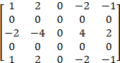

1. Vector outer product =

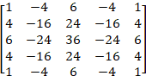

1. Vector outer product =

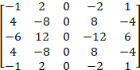

1. Preprocess the image to remove artifacts caused by uneven lighting. This can be done by subtracting the local average in a moving window.

#3) Given the following two feature vectors, find the following distance and similarity metrics:

 

a) Euclidean distance=2.5, b) city block distance=4, c) maximum value=2, d) Minkowski distance, with *r* = 2,=2.5 e) vector inner product=112, f) Tanimoto metric=0.95

#4) Sketch a bimodal histogram, label the axes. Draw a line to threshold the corresponding image. Briefly describe a method to automatically find the threshold.

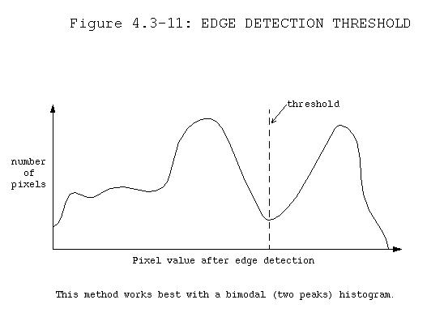

This method is called *minimizing within group variance*, or the *Otsu method*:

Find the value of the threshold *t* that will minimize the within group variance, using equations in 4.3.3. This can done calculating the values for σ2w(t) for each possible gray level value and selecting the one that provides the smallest σ2w(t). We can usually streamline this search by limiting the possible threshold values to those between the modes, the two peaks, in the histogram.

#5) a) Define a feature space of at least 4 dimensions, and b) a classification rule to classify image processing systems for computer vision applications versus human vision applications.

a) [output type, input type, lighting, image type]

output type: for computer or human

input type: camera or other

lighting: artificial or natural

image type: color or gray

b) Classification rule: If output type = computer

then “computer vision application”

else “human vision application”

#6) We need to devise a computer vision algorithm to identify different types of tools. Specifically hammers, wrenches and screw drivers. a) Describe the procedure you would use with CVIPtools to devise such an algorithm. b) Which features do you think will work the best, and why?

a)

1) Collect images of the tools. At least 20 of each.

2) Split into training and test sets. Put test set images aside.

3) Using the training images, apply image analysis process:

a) preprocess for noise and artifact removal. Try mean and median filters.

b) experiment with segmentation methods, followed by morphological filters to get clean object outlines.

c) Extract features: projections, thinness, RST-invariants

d) analyze the features in terms of application: repeat a-d as needed.

b) The shape based features listed above will probably work the best as each of these objects has a unique shape.

#7) Given the following image and structuring element, perform an opening operation. Assume the origin of the structuring element is in the center. Ignore cases where the structuring element extends beyond the image. OPENING -> Erosion then Dilation

STRUCTURING ELEMENT IMAGE

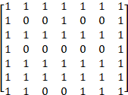

After Erosion:

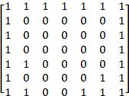

After Dilation:

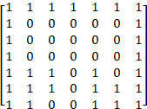

#8) Given the following feature vectors, with two classes:

Class 1:  Class 2: 

a) Using the Nearest Neighbor classification method, and the absolute value distance metric, classify the following unknown sample vector as Class 1 or Class 2:



Class 1: d1= 6, d2 = 11, d3 = 10; Class 2: d1=7, d2= 2, d3=6

Smallest distance is 2, therefore Class 2.

b) Use K Nearest Neighbor, with K = 3

The closest 3 have distances of 2 (class2), 6 (class2) and 6 (class1), therefore answer is Class 2.

#9) Given the following, what will be the resultant pixel values after operating on the following image? Assume all rotations of the surrounds are included in S.

IMAGE



a) S = {2,3,4,5,6}, L(a,b) = , n = 1. Find the resultant pixel values at (r,c) = (3,2)->0 ; (r,c) = (3,3)->0; (r,c) = (4,5)->0 and (r,c) = (3,5)->1. b) S = {7}, L(a,b) = a+b, n = 1. Find the resultant pixel values at (r,c) = (4,5)->1; (r,c) = (2,2)->1; (r,c) = (4,2)->1; and (r,c) = (4,4) ->1



#10) Find the Fourier transform of the following row of an image (4 columns wide):

[ 4 8 8 4 ].

Answer: F(v) = [6, -1- j, 0, -1+ j]

#11) Find the gray level co-occurrence matrix for the left diagonal direction (135 and 315 degrees), with d = 1, for the following 2-bit-per-pixel image:

Answer:

