FIBER OPTICS SMART STRUCTURES FOR NON-DESTRUCTIVE APPLICATIONS
ABSTRACT
Optical fiber sensors are becoming increasingly famous and are well accepted for structural sensing and monitoring in variety of fields at the same time they are developing fast. For non-destructive testing applications optical fiber sensors are best devices because of their unique properties like small size, light weight and importantly dielectric glass construction that render them immune to electrical noise and EM interference which you cannot find in conventional electronic sensing system that use electronic components. In this particular paper we study how fiber operates using various principles, different sensors types followed by advantages and applications of optical fiber sensors for NDT(non-destructive testing) like structural sensing and monitoring in civil engineering, aerospace oil and gas and the most recent that includes monitoring of natural landscapes that extend over area such as earthquake fault lines and volcanic motion.[1]-[2]
1.0 INTRODUCTION
Living plants and animals can be “smart structure” as they can sense and simultaneously react to environment.[3]-[7] Animal responds to the environment effect like heat, pressure or light by sensing the parameters through one nerve and processing the parameters and given decisions in the form of reflexes through other nerve. Similarly manmade structures can be designed “smart” by providing above capabilities to design. For example system that consists of embedded sensors (nerve endings), data links (nerves), a programmed data processor (brain), and actuators (muscle hormones). Man made nervous system can be best implemented by using optic sensors which are best compatible to wide variety of composite materials than electric sensors!
1.1 Advantages of optical fiber sensors over conventional electronic sensors
(1)Very micro thin, overall diameter can be 125$μm$ or less. Therefore given a hair thin sensor can be made compatible with different composite material without changing mechanical properties.
(2)They can withstand high temperatures and pressure.
(3)Glass fibers are passive dielectric devices, can be amalgamated with organic composite material like carbon epoxy and thermo plastics which can tolerate electrical discharge hazards like lightening on aircraft and space craft which require the elimination of conductive paths.
(4)Costly and bulky shielding is not required as fiber optics sensors are highly immune to electromagnetic interference
(5)Fiber optics sensors can be multiplexed so that many sensors lie along a single fiber line.
(6)They are compatible with fiber optic data lines, which support huge necessary band width, which in turn support large number of sensors.
(7)High degree of synergy between fiber optic sensors and the telecommunication and opto-electronic industry made sensors most economical and improving.
1.2 Smart structure applications can be classified in to four major categories:
(1)First category applications include parameters such as temperature, pressure, viscosity, degree of cure and residual strain. This is done by embedding fiber optic sensors during manufacturing process. This can be categorized as non-destructive testing.
(2)At the same time fiber sensors can be used to measure acoustic signatures, change in strain profiles, delamination and such change in structural characteristics of fabricated parts.
(3)Another class is fiber optics as health and damage assessment system for concrete structures, which monitor the status of buildings, bridges and dams as well support with maintenance of aircraft.
(4)Another developing class is Fiber optics as control systems. Unlike monitoring health of the construction, these control systems measure the environmental effects acting on structure and adopt by reacting and changing.
Examples for these types of structures are buildings which can sense and readjust to earthquakes to minimize damage and smart designed aircraft that are designed to react to structural changes during flight and adjust the flight envelop.
2.0 OVERVIEW OF FIBER OPTIC SENSORS THAT ARE USED FOR FIBER OPTIC SMART STRUCTURES AND THEIR RESPECTIVE APPLICATIONS:
A composite panel with attached fiber optic sensors is used to monitor an environment effect. These sensors are multiplexed and their signals are made to carry on fiber optic data line to an optical electronic processor that demultiplexes the data and preprocess the information. [7]-[8] The data which is then formatted and transmitted to a control system that enhances performance and act to assess damage.[9]-[10] Then the response via fiber optic link actuator system is conveyed with information to respond to the environmental effect as shown in below fig 1.[11]-[13]
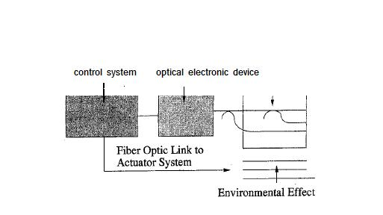
FIG 1: Fiber optic smart structure system.

Two types of sensors are commonly used to carry this operation:
2.1 Extrinsic or hybrid fiber optic sensor: This system consists of black box and an optical fiber. Environmental information is impressed on to the light carried by the optical fiber by modulating amplitude, phase, polarization or other types of modulation of the light beam and passing through the action of ‘black box’ as shown in below figure.[2]
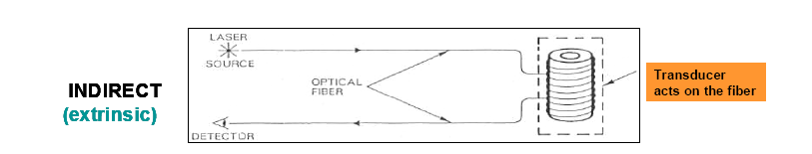
Fig: 2.1

Fig: 2.2
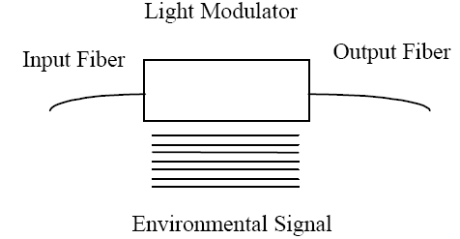
Fig: 2.3 Extrinsic fiber optic sensors consist of optical fibers that lead up to and out of a "black box or light modulator" that modulates the light beam passing through it in response to an environmental effect.

2.1.1 Intrinsic or all fiber sensors: No black box, in this case light beam is modulated in the fiber through the action of environmental effect as shown in fig 3.1.
By keeping structural degradation of composite materials it is desirable for the diameter of cable not exceed the standard telecommunication grade fiber of 125 $μ$ m.
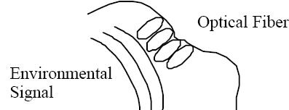Fig: 3.1
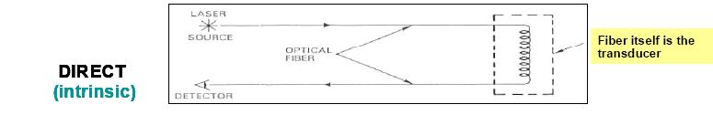
Fig: 3.2
2.2 MICROBEND FIBER: In this fiber when the light source couples light in to an optical fiber and environmental effect acting on micro bend transducer causes the light passing by to be modulated. Greater the localized bending then greater the loss is. When composite materials are used optical fiber is placed orthogonal to the strength members of the composite or by specially designed jackets that optimize micro bend sensitivity. It is very simple device when high accuracy is not a requirement. [14]
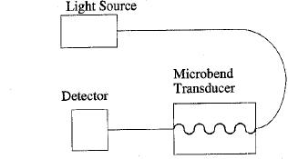
Fig: 4.0 Microbend fiber sensors are configured so that an environmental effect results in an increase
or decrease in loss through the transducer due to light loss resulting from small bends in the fiber.
In case of high precision applications variable loss in connectors, macro bending loss, incidental micro bending loss and mechanical misalignment can be misinterpreted as being due to an environmental effect to be measured.
This can be overcome by adopting spectrally based approaches.
In Intensity based fiber sensors two separate wavelengths are used, one wavelength measures intensity losses and another wavelength measures intensity losses everywhere except in the sensing region. By differentiating both measured signals the environmental effect may be most accurately measured or else use fiber optic sensor that is inherently spectrally based or based on black body radiation of absorption or fluorescence or dispersive elements such as diffraction gratings and etalons or other spectrally sensitive elements.

3.0 Fiber optics sensors based on black body radiation:
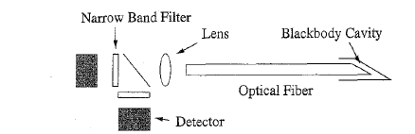
Fig 5.0 Black body radiation based optical sensors are good at measuring temperature and are most effective at temperature above 300$°c$
When black body cavity is subjected to heat or change in temperature radiation is emitted. Light is then passed through optical fiber and spectrally analyzed by a narrow band optical filters that are placed in front of detectors.
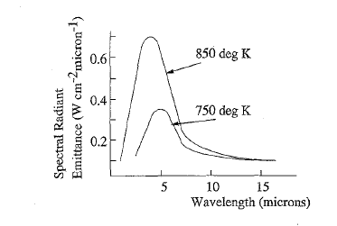
Fig 5.1 Black body Radiation curves for each temperature
If curve shifts to the shorter wavelength it corresponds to higher temperature.
Spectral envelope is then defined by taking samples of the spectrum at various points on those curves thus deriving temperature.
3.1 Fiber sensors based on Fluorescent or absorptive probes: These can be used to sense parameters like temperature, pressure, viscosity and chemical content. In end tip configuration the light beam is made to propagate inside optical fiber to hit a fluroscent material plug.
Material fluroscene is adopted basing on the physical effect like temperature, pressure and also presence/absence of chemical species.
Different operation modes are possible. For a pulsed light source the relevant parameter can be time rate decay of the fluorescence.
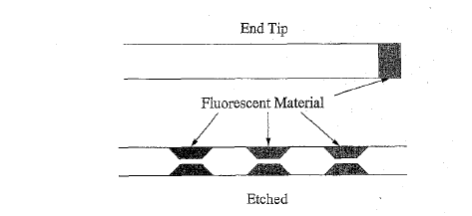
Fig 5.2 Fluorescent fiber optic sensor probe can be used to detect presence of chemical substances along with the physical parameters by special side etch techniques and attaching the fluroscent material to the fiber.

Alternatively we can use evanescent properties of the fiber by etching the regions of the cladding away and there by refilling with fluroscent material looking at the resulting fluroscene of light pulse which travelled down the fiber, a series of sensing regions may be time division multiplexed. By using time division multiplexing, various regions of the fiber could be used to make a distributed measurement along the fiber length.
For concrete structures main factor to be noticed is strain. For such strain measurements short gauge length fiber optic strain sensor are very applicable. Best sensors for this application can be Fiber Grating and Fiber Etalon based fiber optic sensor. Fiber grating sensors can be manufactured with size of 1mm to 1 cm approximately with sensitive comparable to conventional strain gauges.
3.1.2 Fabrication:
Sensor is fabricated by itching a fiber grating over the Germanium dopes optical fiber.
Method 1: Two short wavelengths laser beams are angled to form an interface pattern through the side of the optical fiber. This interference patterns composes of bright and dark bands that locally change the index of refraction in fiber core region.
3.1.3 Extracting the required information from fabricated fiber:
Once fabrication is done next step is to function on the strain sensor. Strain sensor, which is fiber grating is typically attached (or) embedded in a structure.
Grating fiber response is changed accordingly with the fiber motion during expansion or compression.
Example: Say a grating is operating at 1300nm, and the change produced in wavelength is ${10}^{-3}$nm per micro strain. For accurate measuring of strains spectral demodulation techniques are much better than conventional spectrometers.

3.1.4 Demodulation method using a reference fiber grating is shown below.
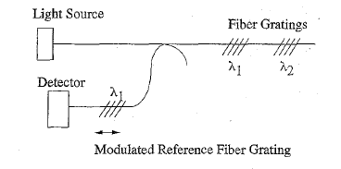
Fig 6.0 Fiber grating demodulation systems require very high resolution spectral measurements. One
way to accomplish this is to beat the spectrum of light reflected by the fiber grating against the light
transmission characteristics of a reference grating.
A reference fiber gratin acts as a modulation filter.
By adjusting gratings of the reference to match up with the signal gratings, an accurate closed loop demodulation can be performed. [15] – [16]
3.2 Filters based on Fabry-Perot Etalons:
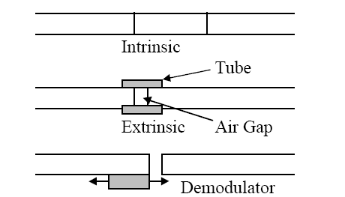
Fig 7.0 Intrinsic fiber etalons are formed by in line reflective mirrors that can be embedded into the
optical fiber. Extrinsic fiber etalons are formed by two mirrored fiber ends in a capillary tube. A fiber
etalon based spectral filter or demodulator is formed by two reflective fiber ends that have a variable
spacing.
Etalon as shown in the figure which consists of two reflective surfaces will transmit with highest efficiency when the wavelength of the light is to be an integral number of waves at that wavelength corresponds to the distance between two mirrors.[17]-[23]
Depending on the reflectivity of the mirrors the transmission peak sharpness will vary.
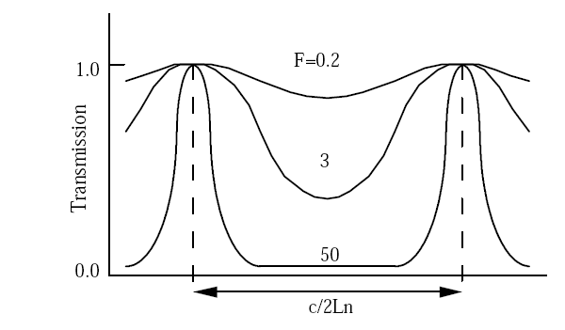
Fig 7.1 Transmission characteristics of Fiber Etalon as a function of fiber fitness
High F denotes higher mirror reflective.
3.3 Intrinsic fiber etalon: These consist of fibers that have been cleaved and coated with a reflective material. Reflective material can be a metal or any dielectric material like titanium dioxide.
Alternate approach is to cleave the fiber ends and insert them in to a capillary tube with an air gap.
3.4 Single Point Etalon sensors: In this situation an etalon can be fabricated and attached to the fiber end.
Different configurations of Etalons that can measure pressure, temperature and refractive index respectively are shown in below figure
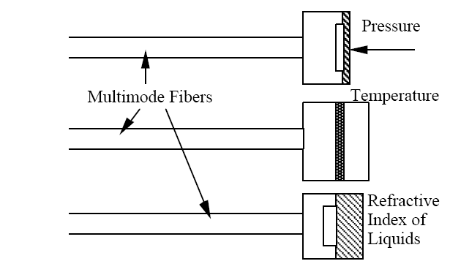
3.4.1 Pressure: Diaphragm has been designed to deflect pressure ranges of 15 to 2000 psi that can be accommodated by changing the diaphragm thickness with accuracy around 0.1% full scale.
3.4.2 For temperature, etalon is interfaced with etalon is interfaced with silicon/silicon dioxide. Temperature over 70 to 500 degree K can be measured with 0.1 degree K accuracy and for RI of liquids a channel is made for liquid to flow in and impact diaphragm to take readings.
3.5 Long gauge length fiber optic strain sensors: They are useful in monitoring earth movement and strain on high tension wires. For this case we use infer metric fiber sensors. Inferometric fiber sensors measure optical phase difference between the two light waves. Examples are sagnac, Micahelson, Mach Zehnder.
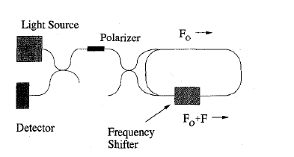
Fig 8.0 Block diagram of Sagnac interferometer
Saganc interferometer configured to measure slowly varying events like strain. A light source and beam condition optics are used to generate light beams counter propagating with each other about a fiber coil.
Frequency shifter in the coil gives us the frequency difference between both counter propagating light beams in the loop.
If any changes in length dL for loop are produced, frequency difference F between these counter propagating beams is changed to keep Relative phase always constant.
From dF/F = -dL/L can be measuring change in length.[24]
3.6 Distributed Fiber-sensors: These too have the potential for wide use. These sensors are built based on variants of optical time domain reflectometry and work on forward or backward scattering of light beams.
Scattering mechanisms that have been used are Rayleigh, Raman, Brillouin and Fluorescence, same as non-linear effects like KERR-EFFECT.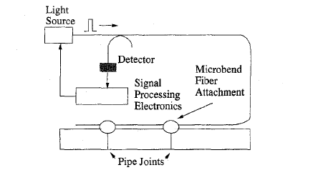
Fig 9.0 Distributed fiber sensors based on Rayleigh scattering
Distributed fiber sensor is based on Rayleigh back scatter which uses micro bend sensitive fiber attached at various strain points of the pipe line. Whenever there is excess scattering and loss at these points that is an indication of strain. Raman type of scattering has strong temperature dependence, so it can be used to measure the temperature along the length.[25]-[27]
3.6.1 Application of Distributed fiber sensor: Distributed fiber sensors especially interlaced inferometeric fiber sensors are used to locate and measure time varying effects like acoustic or vibration disturbance.
They are all based on the position dependent response of sagnac interferometer also comes in combinations like Mach- Zehneder and Sagnac interferometer as well as multiple sagnac configuration.
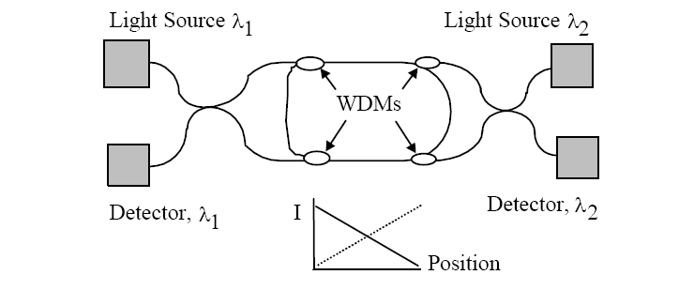
Fig 10.0 Distributed fiber optic acoustic sensor based on interlaced Sagnac loops allows the detection of
the location and the measurement of the amplitude along a length of optical fiber that may be many
kilometers long.
3.6.2 Function: Time varying disturbance occur in the center of the sagnac loop. As beam arrives at a point of the loop at same time the net phase difference between the two counter propagating beams is zero since both beams arrive at the point in same time. As the disturbance moves along the loop back to coupler originating the counter propagating beams the signal level for a fixed frequency scales up linearly as the time difference between the arrivals of the counter propagating beam increases.
By interleaving two sagnac interferometers at two operational wavelengths two linear responses are generated to a time varying effect whose sum is a measure of the amplitude of the effect and whose ratio is an indication of position.[28]-[30]
3.7 Fiber Bragg Gratings are famous for their wide applications in telecommunication industry especially for wavelength division demultiplixing. It’s an wavelength –dependent filter/reflector constructed by making periodic refractive index structure, with spacing in order of a wavelength of light within the core of an optical fiber. Basic principle is when a broad-spectrum light beam is made to incident on the grating, a portion of its energy will transmit through, and other will reflected off as shown below fig
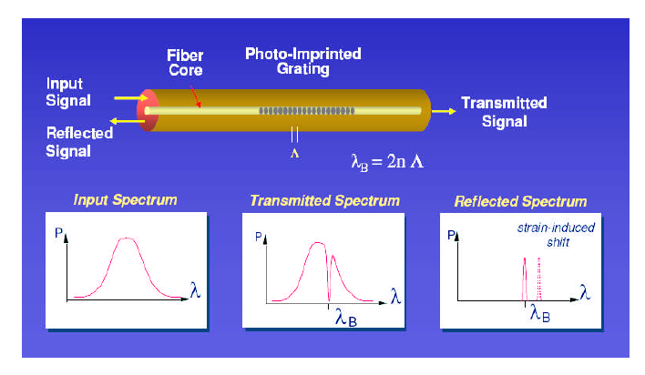
Fig 11.00 Transmission and Reflection spectra of Fiber Bragg Grating
The reflected light signal will be a narrow beam of few nm centered at Bragg wavelength which corresponds to twice the periodic unit spacing$Λ$. When a change in the modal index or grating pitch of the fiber is caused by strain, temperature of polarization changes will result in a Bragg wavelength shift. The one of the advantage of FBG sensors are that detected signal is spectrally encoded eliminating transmission losses in the fiber.
Fiber Bragg grating refractive index profile is given by
n(r) = $n_{0}$ + $n_{1}$ cos (k.r) 1
$n_{0}$ = average index
$n_{1}$ = amplitude of grating (${10}^{-5}$to${10}^{-2}$ )
r = distance along the fiber
Allows light with wave vector $k_{i }$to be scattered along vector $k_{d}$ direction.
That gives $k_{d}$= $k_{i }$– K
Where K is 2p/$Λ$ is a grating vector, K direction is normal to grating planes and $Λ$ grating period. For a single mode fiber core $Λ$ needed to reflect light guided is given by FIRST-ORDER bragg condition.
$Λ$ = $λ_{b}$/${2n}_{m}$
3.7.1 Temperature sensitivity: As refractive index in the fiber material is temperature sensitive, any thermal expansion in the material will change the grating period spacing. As per the standards the fractional wavelength change in the peak Bragg wavelength is of the order of 7-8 pm/$°$c.
3.7.2 Mechanical Strain: Mechanical strain shifts causes Bragg wavelength to change by physically increasing (or) decreasing the grating spacing. There by eventually changing refractive index by strain Optic effect.
As per standards fractional wavelength change is typically 78% of the applied strain, which when solved is 11.8nm, at 1% strain @ 1500nm. [31]-[32]
4.0 FIBER OPTIC SMART STRUCTURE APPLICATIONS
Fiber optic sensors are being developed and used in two major ways.
First is a direct replacement for existing sensors where the fiber sensors can offer significantly improved performance, reliability, safety and /or cost advantages. The second area is the development or deployment of fiber optic sensors in new market areas.
New market areas present opportunities where equivalent sensors do not exist. New market areas present opportunities where equivalent sensors do not exist. At the same time new sensors have to show higher impact in these areas.
A prime example of this is area of fiber optic smart structures. Fiber optic sensors are being embedded in to or attached to materials
(1) during the manufacturing process to enhance process control systems,
(2)to augment nondestructive evaluation once parts have been made.
(3)to form health and damage assessment systems once parts have been assembled in to structures and
(4)to enhance control systems.[33]

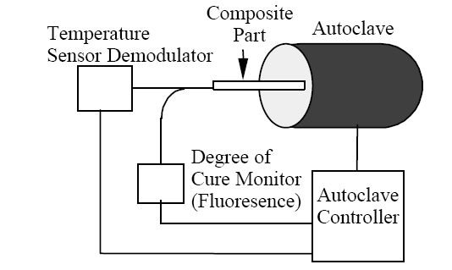
Fig 12 shows how the system might be used in manufacturing. Here fiber sensors are attached to a part to be processes in an autoclave. Sensors could be used to monitor internal temperature, strain, and degree of cure. The measurements could be used to control autoclaving process, improving the yield and quality of the parts.
For measuring strain fields on entire wing of a large jet liner like Boeing 777,707 will require 200 sensors atleast.
A module that could be used to support a system with a large number of sensors. Strings of fiber sensors can be fiber gratings (or) fiber etalons, all are multiplexed along a single fiber line by selective switching b/w sensors the information over particular areas detailed damage assessments is sent as information via demodulator to fiber optic data link which further passes it to signal process subsystem which is routed in to health management bus.[34]
For avionics system will be like the fallowing one provided in fig 13
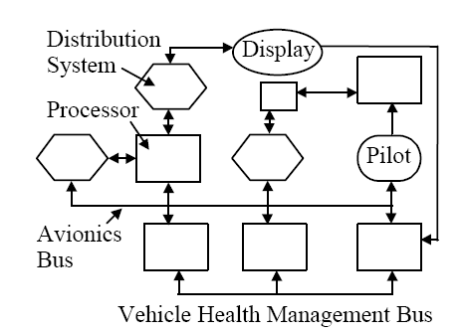

In the above figure the final information on the bus would be processed and routed via distribution systems to pilot or any other automotive system.
4.2 SAGNAC STRAIN SENSOR FOR MONITORING VERY LARGE NATURAL STRUCTURES:
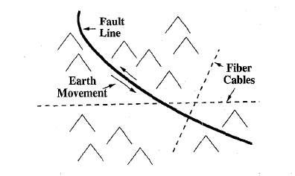Fig 14
This can be achieved by using very long fiber optic strain sensors in combination with existing fiber optic telecommunication to provide information of fault areas. The data thus collected from fault lines helps in predicting earth quake in years to come. Fiber optic sensors like sagnac strain sensors are used to measure small changes in strain parallel to the fault line. This information is converted in to digital from
analog form and transmitted back to a central processing location. Such fault lines are employed in Japan and Canada earthquake prone regions. Similar examples are by measuring the strain buildup in volcanoes.[35]-[37]
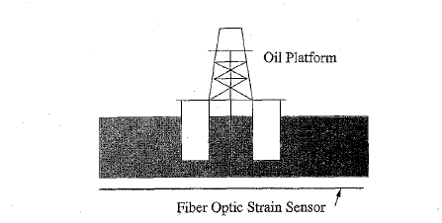fig 15
Above figure shows the fiber optic sensors can measure stress by river or stream flow on the oil refinery platform and create a smart structure system.
Other application are where the fiber optic strain sensors can be placed in along power or telecommunication cables to measure strain buildup during situations like ice storms or earth slippage.[38]
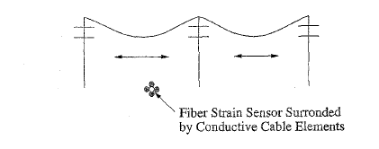
Fig 16 Detecting stress on power lines
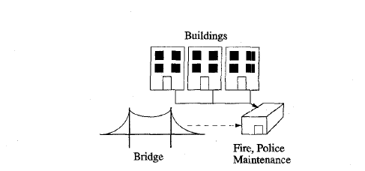
Fig 17 Fiber optics application for civil structures
4.3 Application in Civil structures:
Optical fiber sensors can be embedded, prior to curing in to a reinforced concrete elements and structures such as buildings, bridges, dams and tanks for structural integrity at the same time for measuring internal state of stress.
Sensors can be surface-mounted on to concrete or steel surfaces. Once installed they can provide high resolution temperature and strain measurements, detect abrasions and thermal stress.
Actual location of a fault can be found from the back reflected signal coming out from the fiber, using a technique called Optical time domain reflectometry(OTDR). Other suggestive ways are by means of distributed sensing systems based on Raman or Brillouin scattering.[39]
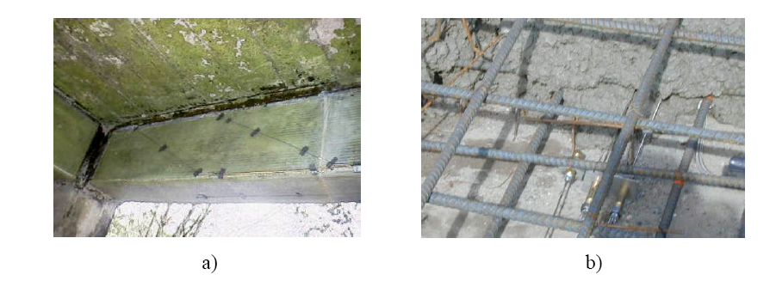
Fig 18 (a) Surface mounted fiber strain sensors on a bridge girder and, b) sensor
embedment into a concrete slab prior to curing.
Conclusion:
Fiber optic smart sensors with innumerable benefits and Non-Destructive testing applications in advanced fields made them more commercial in optoelectronic market, fiber optic communication and industrial and constructing engineering fields. These advancements continue to excel in many other fields of application making optical sensors as most depending and expanding branch of physics.
Glossary:
Below described some of the technical terms and studies I made while writing this paper.
OPTICAL TIME DOMAIN REFLECTOMETRY: Optical Time Domain Reflectometer is an instrument that analyzes the light loss in an optical fiber
Functioning: At first OTDR injects a series of optical pulses into the fiber under test. From the same end from where it ejected pulse it also collects the reflected pulse where by analyzing it characteristics judges where the refractive index of the fiber link is changing, there by exactly locating the place of fiber loss.
For example:
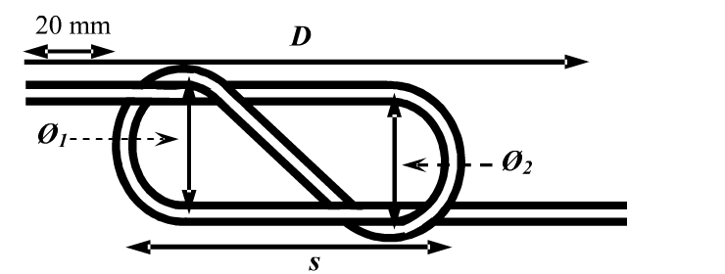
For example in the middle of a single – mode fiber optic link a sensor probe in the shape of eight is placed. For testing the above sensor introduces power losses in the link by applying displacement D which reduces fiber loop diameter $∅_{1}$ and displacement S [40]
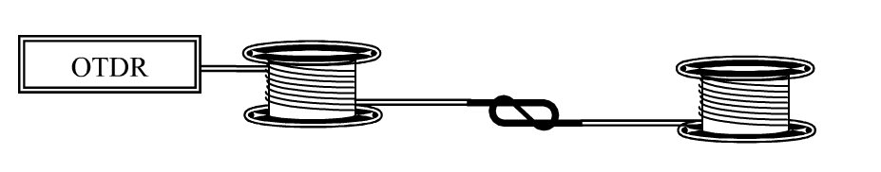
After OTDR with a sensing resolution of 1 meter, 10.00 ns wide pulse signal at 1500 nm wavelength the following reflected pulse is detected on OTDR monitor.
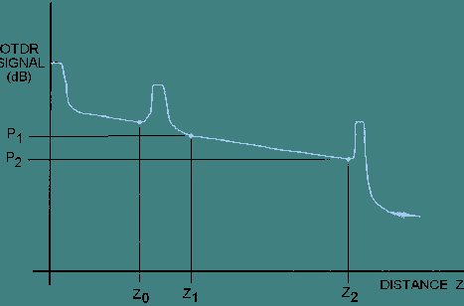 [41]

From above output attenuation is measured as
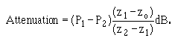[42]
Also I studied below non-linear effects
KERR EFFECT: The effect that causes the change in the refractive index of the material when electric field is applied
As per the standard definition
“The Kerr electro-optic effect, or DC Kerr effect, is the special case in which a slowly varying external electric field is applied by, for instance, a voltage on electrodes across the sample material. Under this influence, the sample becomes birefringent, with different indices of refraction for light polarized parallel to or perpendicular to the applied field. The difference in index of refraction, Δn, is given by”[43]
[43]
Brillouin scattering: Brillouin scattering is based on the concept that when medium is compressed index of refraction of the medium changes making light to necessarily bend when passing through.[44]
Brillouin scattering occurs when light in a medium interacts with time dependent optical density variations and changes its energy (frequency) and path. The density variations may be due to acoustic modes, such as photons, magnetic modes, such as magnons, or temperature gradients.[45]
Fluorescence is the emission of visible light by a substance that has absorbed light of a different wavelength.[46]
REFERENCES:
*All Images are referred from “Fiber optic sensors”, second edition, Shizuo Yun , Fransic Yu, CRC Press.2008, pages 1 -15 and extended beyond.
[1] Alexes Mendez, ‘overview of optical fiber sensors for NDT applications’, at iv NDT Pan-American conference Buenos Aries October 2007, paragraph 1- lines 1 to 4.
[2] Eric Udd , “fiber optic smart structure”, IEEE Journal vol 84 , No 1,1997, paragraph 1.
[3]E.Udd, Ed., “Fiber optic smart structures and skins”, in proc, SPIE , Boston, sept, 1988, vol 986
[4] R.O. Claus and R. S. Rogowski, Eds., “Fiber optic smart structures and skins V,” Proc. SPIE, Vol. 1798, sept. 1992.
[5] E. Udd, “ Embedded sensors make structures smart,” Laser Focus, P.138, May 1988.
[6] R.O. Claus, Eds., “ Fiber optic smart structure skins III,” in proc. SPIE, San Jose, CA, Sept. 1990, VOL.137c
[7] “Active materials and adaptive structures,” in proc ADPA/AIAA/ASME/SPIE conf, on active materials an Adaptive structures, IOP, Nov.1991. Proc SPIE Vol 1777 May 1988
[8] W. Maslach, Jr. and J. S. Sirkis, “Strain or stress component separation in surface mounted interferometeric optical fiber strain sensors,” proc.SPIE, vol. 1170, p.160, 1989.

[9] D.W. Jensen and J. Pascual, “Degradation of graphite/bismaleimide laminates with multiple embedded fiber optic sensors,” Proc, SPIE, vol. 1170, p.452, 1989.

[10]J.S. Sirkis and A.Dasgupta, “Optimal coatings for intelligent fiber optic sensors,” proc. SPIE, vol. 1370, p.129,1990.
[11] 2. J. Dakin and B. Culshaw, Optical Fiber Sensors: Principals and Components, Volume
1, Artech, Boston, 1988.
[12]. A. Méndez, T. F. Morse and F. Méndez, "Applications of Embedded Optical
Fiber Sensors in Reinforced Concrete Buildings and Structures", Proc. SPIE,
Vol. 1170, pp. 60-69. September 1989.

[13] R.MMeasures, “Smart structures in nerves of glass,” progress in Aerospace Sci., Vol. 26, P. 289, 1989.

[14] R.L. Wood, A. K. Tay, and D.A. Wilson, “Design and fabrication considerations for composite structures with embedded fiber optic sensors,” proc. SPIE, vol 1170, P. 160, 1989.

[15] B.Culshaw, P.T. Gardiner, and A.McDonach, Eds., “First European conference on smart structures and materials,”
[16] B. Culshaw and J. Dakin, Optical Fiber Sensors: Systems and Applications, Volume
2, Artech, Norwood, 1989.

[17]T. G. Giallorenzi, J. A. Bucaro, A. Dandridge, G. H. Sigel, Jr., J. H. Cole, S. C.
Rashleigh, and R. G. Priest, "Optical Fiber Sensor Technology", IEEE J. Quant. Elec.,
QE-18, p. 626, 1982.

[18] Farhad Ansari and Stein Sture, Nondestructive Testing of Concrete Elements
and Structures, American Society of Civil Engineers, 1992.

[19] Farhad Ansari, Applications of Fiber Optic Sensors in Engineering Mechanics,
American Society of Civil Engineers, 1993. ISBN 0-87262-895-7. 230 pp.

[20]. Farhad Ansari, Fiber Optic Sensors for Construction Materials and Bridges,
Technomic Publishing Co., 1998. ISBN 1-56676-671-0. 267 pp.

[21] D. A. Krohn, Fiber Optic Sensors: Fundamental and Applications, Instrument Society
of America, Research Triangle Park, North Carolina, 1988.

[22] E. Udd, editor, Fiber Optic Sensors, Proceedings of SPIE, CR-44, 1992.

[23] S. K. Yao and C. K. Asawa, Fiber Optical Intensity Sensors, IEEE J. of Sel. Areas in
Communication, SAC-1(3), 1983
[24] N. Lagokos, L. Litovitz, P. Macedo, and R. Mohr, Multimode Optical Fiber Displacement Sensor, Appl. Opt., Vol. 20, p. 167, 1981.

[25] E. Udd, Editor, Fly-by-Light, Proceedings of SPIE, Vol. 2295, 1994.

[26] Jose Miguel Lopez-Higuera, Handbook of Optical Fibre Sensing Technology,
John Wiley & Sons Inc., 2002. ISBN 0-47182-053-9. 828 pp.

[27] Raymond M. Measures, Structural Monitoring with Fiber Optic Technology,
Academic Press, 2001. ISBN 0-12-487430-4. 716 pp.

[28] Eric Udd, Fiber Optic Smart Structures, John Wiley & Sons Inc., 1995. ISBN 0-
471-55448-0 671 pp.

[29] Brain Culshaw, Smart Structures and Materials, Artech House, 1996. ISBN 0-
89006-681-7. 207 pp.

[30]K.A. Murphy et al. “ Sapphire fiber interferometer for microdisplacement measurements at high temperatures,”proc, SPIE, vol.1558, p, 117, 1991.

[31]K. a Murphy, A. M vengsarkar “ Fabry –Pirot sensors on full scale testing on F-15 fighter plane”
Proc frm SIPE vole 1588 pg 134

[32] C. E. Lee and H. F. Taylor, Interferometeric Optical Fiber Sensors Using Internal
Mirrors, Electronic Lett., Vol. 24, p. 193, 1988.

[33] C. E. Lee and H. F. Taylor, Interferometeric Fiber Optic Temperature Sensor Using a
Low Coherence Light Source, Proceedings of SPIE, Vol. 1370, p. 356, 1990.

[34] Private Communication, Elric Saaski, Research International, Woodinville,
Washington.

[35] H. Lefevre, The Fiber Optic Gyroscope, Artech, Norwood, 1993.

[36] W. K. Burns, Editor, Optical Fiber Rotation Sensing, Academic Press, San Diego,1994.

[37] R. B. Smith, Editor, Selected Papers on Fiber Optic Gyroscopes, SPIE Milestone
Series, Vol. MS 8, 1989.

[38] S. Ezekial and E. Udd, editors, Fiber Optic Gyros: 15th Anniversary Conference,
Proceedings of SPIE, Vol. 1585, 1991.

[39] R. J. Michal, E. Udd, and J. P. Theriault, Derivative Fiber-Optic Sensors Based on the
Phase-Nulling Optical Gyro, Proceedings of SPIE, Vol. 719, 1986.

[40]Berthold J.W 1995, Historical review of Micro Bend fiber optic sensor -1, Journal of light wave technology 7

[41]Author unknown, Optical Time-domain reflectometery, Integrated publishing, Electrical Engineering training series results from www.tpub.com

[42] Author unknown, Attenuation formula for dead zone, Optical Time-domain reflectometery, Integrated publishing, Electrical Engineering training series results from www.tpub.com

[43]Author unknown,” http://en.wikipedia.org/wiki/Kerr_effect” Wikipedia.com.Kereffect, 5 Mar.2006.Web 10 Dec 2009

[44] L.I. Mandelstam, Zh. Russ. Fiz-Khim., Ova. 58, 381 (1926).

[45] R.Y.Chiao, C.H.Townes and B.P.Stoicheff, “Stimulated Brillouin scattering and coherent generation of intense hypersonic waves,” Phys. Rev. Lett., 12, 592 (1964)

[46] Stokes, G. G. (1852). "On the Change of Refrangibility of Light". Philosophical Transactions of the Royal Society of London 142: 463-562.

PHYSICS 504- Fall 2009 Research Paper
(under the guidance of Dr. A. Hamad)
FIBER OPTICS SMART STRUCTURES FOR NON-DESTRUCTIVE APPLICATIONS
Presented by:
Harsha Raghuveer Are

