Introduction: Objective of the project is to study in close about different Ethernet frames and form an understanding of how Ethernet is organized by decoding a 10Mbps Ethernet frame both manually and logically which was sampled earlier in the lab. By arranging the bit pattern in fragments of different lengths as in standard frame format, each field is identified along with category to which Ethernet frame belongs.
ETHERNET: IEEE named Ethernet as the 802.3 standard in 1983; in general Ethernet is a standard local area network access method which can be used to connect computer to modem or a DSL modem as a cable to access internet. [1]
Ethernet involves
- Physical medium which carries signals between computers via Ethernet cable.
- Media access control protocol that follows set of rules are embedded in each Ethernet interface
that allows equal sharing of channel among multiple computers.
- Ethernet Frame that has standard frame format with set of bits which carry data over the system.
- Signaling components to set up communication between sender and receiver via Ethernet channel with use of electronic devices. [2]
IEEE has various supplements for the same Ethernet depending on the media varieties. For example 802.3a is supplement to 802.3 based on 10BASE2 thin Ethernet. Similarly 802.3i
is a 10BASE-T twisted-pair supplement for 802.3. Depending on the speed 100BASE-T Ethernet is classified which offers a speed increase ten times that of 10BaseT. But officially IEEE 802.3uf is the specified standard for 100BASE-T which preserves frame format, MAC mechanisms and MTU. [3]
ETHERNET FRAME:
DEC-Intel-Xerox (DIX) was the first to define the Ethernet frame. Briefly later IEEE 802.3 redefined it.
PREAMBLE: Preamble for both the DIX and IEEE 802.3 standards begins with alternating ones and zeros. Preamble for the DIX standard is total of 64 bits, where as for IEEE 802.3 it is 56 bits plus an 8 bits field of SFD (Start of Frame Delimiter). The general objective of the preamble is to synchronize Ethernet stations to signal’s frequency.
DESTINATION ADDRESS: Destination address for DIX standard is a 48 bit field. The first bit of the address
specifies whether the physical address is unicast (0) or multicast address (1). In IEEE 802.3 version of frame the second bit too holds the significance. If the bit is 0, then physical address is global address or if the bit is 1 then Ethernet is interfaced locally. The IEEE controls over the address assignments.IEEE issues 24 bit identifiers called "Organizationally Unique Identifiers" (OUIs). Organization then assigns 48-bit address with first 24 bits of the address as identifiers. This 48-bit address is then treated as physical address, hardware address, or MAC address. [4]
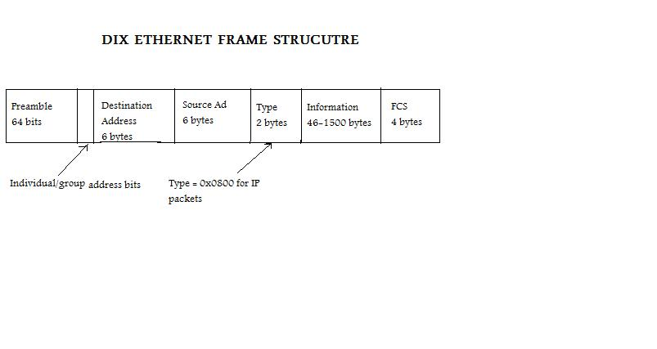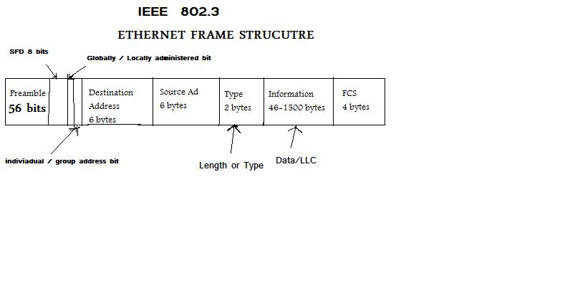
SOURCE ADDRESS: The source address field is a 48-bit (6 byte) field; it is unique and contains the address of the source or stations that transmitting packet. In general Ethernet uses its physical address as the source address in any frame it transmits.[5] Ethernet interface address can be changed by allowing the physical address to be variable.
LENGTH/TYPE: The 2-byte length field is equal to the number of bytes in the LLC field plus the number of bytes in the pad field. This field specifies the upper-layer protocol to receive the data after Ethernet processing is complete. If the LLC is less than 46 bytes, then the size of the pad field is 46 minus the size of the LLC. The LLC plus pad must be a minimum of 46 bytes, but no greater than 1500 bytes.[6] If the Type/Length value is greater than 0x05-DC (decimal 1500), then process the frame as Ethernet II. Any Type value greater than 0x05-DC (such as 0x0800 for IP or 0x81-37 for NetWare IPX/SPX) will be interpreted as an Ethernet II frame. [7]
DATA FIELD: Following the type/length field is the actual data contained in the frame. After physical-layer and link-layer processing is complete, this data will eventually be sent to an upper-layer protocol.
In the case of Ethernet, the upper-layer protocol is identified in the type field. In the case of IEEE 802.3, the upper-layer protocol must be defined within the data portion of the frame, if at all. If data in the frame is insufficient to fill the frame to its minimum 64-byte size, padding bytes are inserted to ensure at least a 64-byte frame. For example if the data is not a minimum of 43 bytes, the field is padded with undefined characters or groups of bytes. The pad is automatically stripped off by the LAN interface card. [6]
CRC: After the data field is a 32-bit error checking field called FCS field containing a cyclic redundancy check (CRC) value. The CRC is generated based on the destination address, source address, and type and data fields.
MANCHESTER CODING:
Manchester encoding is usually employed for frame transmission because this method allows receiver to synchronize easily with sender. Generally this technique is employed at physical level. In Manchester instead of sending a straight series of ones and zeroes bits are made to transition at the middle of signal rather than at the boundary. For logic 0 there is a transition from 0 to 1 at the middle of the bit. Similarly 1 is represented as 1 in the first half and zero in the second half. This coding comes under non return to zero coding.
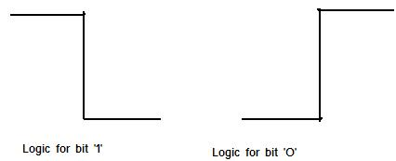
1 to 0 (downward transition at bit centre) 0 to 1 (upward transition at bit centre)
Example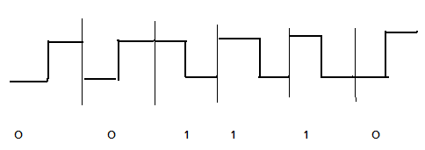
IMPLEMENTATION: Before decoding the frame provided enet.dat file is executed through the provided matlab function enetdisplay.m.
Now the signal generated by the matlab function is carefully analyzed on the waveform. As we can notice the waveform takes its transition for every 100ns. So a bit value of 1 is recorded if the transition of the bit is from high to low and 0 is recorded if the actual transition was from low to high. Each bit values are noted in binary form before decoding the signal.
After the waveforms for each field is printed out depending on modified mat lab file, bits are plotted for every pulse width of 100ns using Manchester encoding.
Plots are attached to the report.
IMPLEMENTING LOGICALLY USING C PROGRAM:
Before implanting the program size of the file is calculated using Vi terminal.
The given enet.dat file is fetched using fetch option in to the directory. Then using Vi editor set nu command is used to start from the beginning of the string and then: $ command is used to go to the end of the file from where the line count value is calculated.
To read the file as a string and record both time and voltage variables fscanf function is called. The reason for taking the input file as a string is there is an ‘,’ in between time and voltage readings that makes both voltage and time values to be come under string.
As each transition takes 100 ns of time and as each sample are sampled for every 0.5 ns there are 200 samples for every transition. So a for loop is described that runs its loop for every 200 samples at a time till the final row or EOF end of file is true.
Then a variable called level is assigned basing on the threshold value of the signal. To identify the switch from 1 to 0 and 0 to 1 an array called frame[134000] is declared to record frame values above and below the threshold voltage.
By comparing threshold value and the values of corresponding frame transition from low to high or high to low is judged for every 200 samples displaying the bits alternatively at the same time.
And again in parallel a variable c is taken which is initially assigned as zero and made to increment inside the loop as we decode the signal starting from row one to 134000th row. Now we have track of number of bits we produced inside the for loop.
After we decoded the signal to display the frame as per the standard Ethernet frame a variable r is defined which runs the loop with respect to size of the each individual field size.
After the end of every loop each binary bits are converted in to hexa-decimal by calling binary to hexa converter providing the size of the frame. If the size of the frame is 48 then function displays the values of source and destination address in its standard MAC notation. Note that the binary bits provided to the binary to hexa converter reversed octets of each field as Ethernet follows canonical format(LSB to MSB) in transmitting the bits of each field with the exception of FCS.
OUPUT file is taken screen shot and displayed for report.
Note: I tried to implement this algorithm to adapt the total number of samples by itself without externally mentioning the maximum frame size. But as I executed the loop using EOF (end of file function) and incrementing count for every increment of File pointer value, count is returning garbage value which can be overcome by typecasting the time and voltage values. But typecasting of variables again resulted in garbage value, for which I choose to mention the size of the frame manually.

Answers:
- Is this a DIX frame or an IEEE 802.3 frame?
Frame is of DIX standard. Any Type value greater than 0x05-DC (such as 0x0800 for IP or 0x81-37 for NetWare IPX/SPX) will be interpreted as a DIX or Ethernet II frame.
- What is the destination address, in standard MAC address form?
After decoding the destination address is found to be 00:04:76:b9:3f:ef
- Is the destination address a multicast or unicast address?
First bit of destination address is found to be 0. So the physical address is UNICAST.
- Is the destination address a globally unique address or a locally assigned address?
As the second bit of destination address is ZERO it is globally unique address.
- What is the source address, in standard MAC address form?
00:20: af: 0f:f2:32 is the source address in the standard MAC address form.
- Is the source address a globally unique address or a locally assigned address?
As the second bit of the source address is zero this is a globally unique address.
- If this is a DIX frame, what is the frame Type number? If it is an IEEE 802.3 frame, what is the Length or Type number?
Frame is DIX frame, as the frame type number is 2048 in decimal (0x0800 in hex)
- If it is an IEEE 802.3 frame do the 16 bits that follow the source address refer to the frame Length or the frame Type? How do you know?
If the frame is a IEEE 802.3 frame then the 16 bits following the source address could be type/length filed basing on the value of the field.
If the value is greater than or equal to 1536 decimal (0x600 hex) then the field is being used as a type field.
If the value is numerically less than or equal to 1500(decimal) then it is used as length field. The range of 1,501 to 1,535 was intentionally left undefined.
- If it is an IEEE 802.3 frame and the 16 bits that follow the source address refer to the frame Type, what is the type number and what does it tell you about the contents of the frame?
The type field indicates the type of the protocol data being carried in the data field of frame. They are maintained by XEROX Corporation. For example 0800 is DOD Internet Protocol (IP),
8046 is AT&T, 8147 is Vrije Universiteit (NL) and 86DD is IP version 6.
- How many bytes are in the body of the frame? (You do not need to make a plot of this.)
As per the decoded signal the body of the frame is of 456 bits or 57 bytes.
- Has the frame been padded to meet the minimum frame size or was the body long enough as to not require padding?
As the size of the body is 57 bytes which is more than the minimum required size of 46 bytes,
Frame has not been padded.
- What is the value of the Frame Check Sequence, in hex?
0x7790d870 is the value of frame check sequence.

REFERENCE:
1. From the article given in “http://encyclopedia2.thefreedictionary.com/Ethernet”.
2. Charles E spurgeon “Ethernet Guide” Text book page 24 lines 3 to 11.
3. From the article given in “ http://www.javvin.com/protocolFastE.html”
4. From the article given in “http://www.ethermanage.com/ethernet/10quickref/ch1qr_7.html”
5. Charles E spurgeon “Ethernet Guide” Page 43 under Source Address
6. With reference to “http://docs.hp.com/en/98194-90053/ch02s04.html.”
7. Extracted concept from “http://telecom.tbi.net/frmlan.html”

APPENDIX:

/* --------------------------------------------------------------------------
* ----| Etherdecode.c
* ----| Attempts to Decoding a 10Base2 Frame from a Voltage Signal

* ----|
* --------------------------------------------------------------------------
* ----| Compile with: visual studio
* --------------------------------------------------------------------------
* ----| Example usages: enet.dat file
* ----|
* ----|
* ----|
* ----|
* --------------------------------------------------------------------------
* ----| Harsha Are: Date:24,ict,2009
* --------------------------------------------------------------------------
*
*/

#include<stdio.h>
#include<math.h>

/* ----| Function to convert binary in to decimal value |---- */

int deconv(int sum, int dec[],int m)
{
int i;
for (i = 0;i < 4;i++)
{
sum = sum + (dec[m-i] << i);//left shift to convert 4 bit binary number to decimal number
}//end of for loop
return sum;
}//end of binary to decimal converter

/* ----| Function to convert decimal value in to Hexa Decimal value |---- */

dec2hex(int size, int dec[])
{
int r, sum = 0, m = 3;
for (r = 1;r <= (size / 4) ;r++)
{
sum=deconv(sum,dec,m);
printf("%x", sum); /* ----|To display final Hexa Decimal value on screen except for preamble|---- */
sum = 0;
m = m + 4;
if ((r % 2) == 0)
{
if (((r % 8) == 0) && (size == 456))
printf("\n"); /* ----|To print Buffer_data field in every new line given 8 values per row|---- */
else if ((r != 12) && (size == 48))
printf(":"); /* ----|To print Destination address: --:--:7-:b-:--:e-
Source address: --:--:a-:--:f-:-2
in the above given format|---- */
}//end of if loop
}//end of for loop
}//end of decimal to hexa convertor

main()
{
FILE *fp;
char c1[15],c2[18];
int frame[134000],i,j=0,r,initialaddress,in,fi,Finaddress,c=0,level =1,p[12700],read;
/* ----|In the above declaration array P is to carry the entire decoded frame,the size of the frame is taken
on the basis of maximum size the frame can be|---- */
int desAdd[48],desAdd_temp[48],finaladdress[48],address[48],Buffer_temp[456] ;

int dec = 0,lenORtyp[16],lenORtyp_temp[16],Buffer_data[456],FCseq[32],ch,count = 0;
double t, v, t0, T;
fp = fopen("C:\\Users\\hare\\Desktop\\enet.dat", "r");
if (fp == NULL)
{
printf("cannot open the file");
exit(0);
}

/* ----| To find the time period of each transition |---- */
while (!feof(fp))
{
fscanf(fp, "%[^,]%*c%s", &c1, &c2); /*---|reading the file as a string as there is ',' in each row|---*/
sscanf(c1, "%lf", &t);
/*----|The sscanf() function reads from the string t. Each function
reads bytes interprets them according to a format, and stores the results
in arguments c1|------*/
sscanf(c2, "%lf", &v);
/*----|if the voltage value is greater than the threshold value then it is considered to be a one or else zero|---*/
if (v > -1)
{
frame[j] = 1; //bit value is sent to frame
j = j + 1;
if (level == 0)
{
T = t - t0;
level = 2;
}
}
else
{
if ((level == 1)&&(v <-1))
{
t0 = t;
level = 0;
}
frame[j] = 0;
j = j + 1; //bit values are sent to frame
}
}

printf("\n \n The time taken for single transition is %le\n\n The decoded Signal is \n ", T);

/*---|As every transition takes 100 ns there are 200 samples in each transition|---*/

for (read = 0;read < 134000;read = read + 200) // where 134000 are no of lines found from vi editor
{
for (i = read ;i < read + 200;i++)
{
if (frame[i + 1] > frame[i]) // comparing frames serially
//recording transitions from 0->1 in every 200 values

{
p[c] = frame[i]; //compare frames and send minimum value to the array
c = c + 1;
printf("%d\0.05t",frame[i]);
//priniting Decoded frames for display from low to high
break;
}
else if (frame[i + 1] < frame[i])//Recording transition from 1->0 in every 200 values
{
p[c] = frame[i];
c = c + 1;
printf("%d\0.05t",frame[i]);
//printing Decoded frames for display from high to low
break;
}
}
}

printf("\n\n <----------------PREAMBLE OF THE FRAME--------------->\n");

for (r = 0;r <=56;r = r + 8) // Loop runnning for maximum length of 64 bits
{
for (i = r;i < r + 8;i++)
printf("%d ", p[i]); //Displaying 8 bits per row
printf("\n"); //New line after every Row
}

for (r = 0;r<48;r++)
{
desAdd_temp[r] = p[64 + r];
// printf("%d\t ",desAdd_temp[r]);
}
in = 0;
fi = 7;
for (r = 0;r < 6;r++) // each octet of the address is swapped
{
for (i = r * 8;i < 8*(r + 1);i++)
{
desAdd[i] = desAdd_temp[fi - in];
in = in + 1;
}
fi = fi + 8;
in = 0;
}
printf("\n<------------DESTINATION ADDRESS------------>\n");

dec2hex(48, desAdd);//swapped binary address is converted to hexa
//with size of 48 bits
for (r = 0;r < 48;r++)
{
address[r] = p[112 + r];
}
in = 0;
fi = 7;

for (r = 0;r < 6;r++) //each octet of the address is swapped
{
for (i = r*8;i<8*(r + 1);i++)
{
finaladdress[i] = address[fi - in];
in = in + 1;
}
fi = fi + 8;
in = 0;
}

printf("\n\n<---------------SOURCE ADDRESS------------->\n");

dec2hex(48, finaladdress);//swapped binary address is converted to hexa
//with size of 48 bits

printf("\n\n<-----------TYPE FIELD------------->\n");
in = 0;
fi = 7;
for (r = 0;r < 16;r++)
{
lenORtyp_temp[r] = p[160 + r];
}

for (r = 0;r < 2;r++) //reversing each octet of the type
{
for (i = r * 8;i < 8*(r + 1);i++)
{
lenORtyp[i] = lenORtyp_temp[fi - in];
in = in + 1;
}
fi = fi + 8;
in = 0;
}

dec2hex(16, lenORtyp);
printf("\n\n<---------------DATA FIELD-------------->\n");
for (r = 0;r < 459;r++)
Buffer_temp[r] = p[176 + r];
in = 0;
fi = 7;
for (r = 0;r < 57;r++) // each octet of the data field is swapped
{
for (i = r * 8;i < 8*(r + 1);i++)
{
Buffer_data[i] = Buffer_temp[fi - in];
in = in + 1;
}
fi = fi + 8;
in = 0;
}

dec2hex(456, Buffer_data); // calling dec2hex function

printf("\n\n<-----------------FRAME CHECK SEQUENCE-------------->\n");

for (r = 0;r < 32;r++)
{

FCseq[r] = p[632 + r];
}
dec2hex(32, FCseq);
fclose(fp);
getch();
exit(0);

}

RESULT:
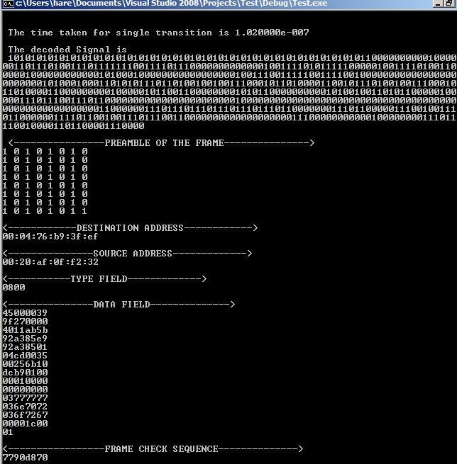
Note this is the output for etherdecode.c, which was earlier test.c file, the output path still shows test.c though it was renamed.

Ethernet Frame Decoding
ECE 477 –Fall 2009.
Submitted to Dr.Noble.

Harsha Raghuveer Are.

