Introduction: Aim of project is to study a traditional half-duplex coaxial Ethernet LAN while N multiple stations with individual frames are being transmitted in a single channel. Algorithm thus designed deals with the one of the possible way to analyze collision between frames, time delays for the frames to transmit and find possible ways to improve stations behavior towards the optimization of channel utilization and transmission.
Implementation: To implement the algorithm several assumptions are taken in to consideration.
- No other station will attempt to transmit a frame until all N stations have succeeded.
Basing on the above restriction I made assumption that no station should transmit a frame while the other station is transmitting through the channel. So each station should transmit in their individual time slots so that they never transmit at same time leading to collision inside a channel.
To implement this rule, an algorithm in C with the fallowing idea is chosen
- To have each channel a different time slot, I declared a variable called waiting[noofstations] where [noofstations]signify the total number of stations transmitted each time. And waiting[noofstations] signify waiting time for each channel.
- So to convince the assumption 1 each station should have their own waiting time which I mean diffferent time slots in order to stop collisions.
- Every time a collision is occurred a new waiting time is provided for the corresponding channel. To assign new waiting time after every collision a function named gen_rand(noofcollisions[i],i) is written which generates random values basing on number of collisions that are again exponentially backed off. In this random variable generator function each random variable is selected from random number
within the range of 0 to $2^{noofcollisions}-1$. So the new waiting time which is assumed to be multiple of T , where each T is a single time slot of value 51.2$μ$sec.
- So as the chance of collision for particular stations goes on increasing then the set of time slots from where random waiting time is chosen will be of wide range.

- Ignore interframe spacing, i.e.,assume the stations will attempt to transmit their frame immediately when they detect the line is free.
To implement this rule, again the variable waiting[noofstations] is chosen.
- When then waiting[noofstations] goes equal to 0 then the particular station is transmitted. When the waiting time is not zero then channel has to decrement its waiting time until it turns to zero eventually transmit through the channel.
- Average waiting time for both first successful transmission station and last successful transmission station is calculated for study.
- Rule 3 is fallowed while designed rule 1 and rule 2, that is retransmission of every collided station is done exactly after every multiple of T =51.2 $μ$sec.
- Each collision uses exactly one slot time. That is during when the waiting time equals to zero.
Results:
- Average delay before one station transmitts successfully for number of iterations 250
No of stations | Average Delay
5 | 5
10 | 7
20 | 10
40 | 18
60 | 25
80 | 31
100 | 36

No of stations vs Average Delay
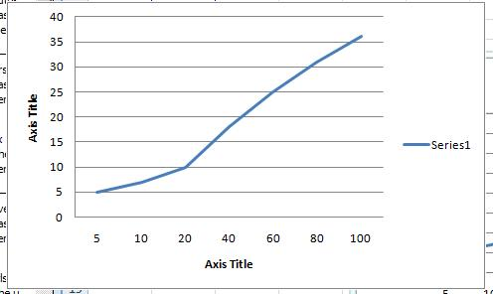

Plot for question 3.

- Average delay before last station transmitts successfully for number of iterations 250
No of stations | Average Delay
5 | 19
10 | 53
20 | 135
40 | 332
60 | 527
80 | 740
100 | 1009

No of stations Vs Average Delay
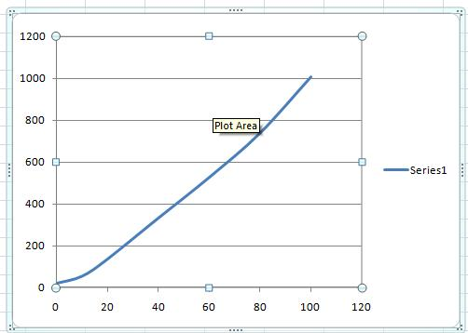
Plot for question 4

- From the plot 3 I observed that plot is varying exponentially because since we are providing the no of iterations for delay or waiting time exponentially back, the delay too is almost increasing exponentially.
- From the plot 3 I observed that plot is varying exponentially because since we are providing the no of iterations for delay or waiting time exponentially back, the delay too is almost increasing exponentially.
- The Number of trials to run the experiment is between 200 and 250 since the values obtained from both the trails are within the reference of${}_{-}^{+}{0.05\%}$. Which is obtained using
Standard deviation derivation inside confidence level.

Reference:
- Exponentially Back off problem , “http://en.wikipedia.org/wiki/Exponential_backoff”

APPENDIX:

/* --------------------------------------------------------------------------
* ----| network.c
* ----|
* ----| Computes Total number of Time slots required for stations to
* ----| transmit sucessfully through a channel
* --------------------------------------------------------------------------
* ----| Compile with:

* --------------------------------------------------------------------------
* ----| * ----| Printed with: private printer
* ----|
* --------------------------------------------------------------------------
* ----| Harsha Raghuveer Are - Fri Oct 11 2010
* --------------------------------------------------------------------------
*
*/

#include <stdio.h>
#include <stdlib.h>
#include <conio.h>
#define noofstations 5 /* ----| Number of stations to be transmitted declared globally |---- */
#include <time.h>
#include <math.h>

int FirstSucessTotalTime = 0 ; /* ----| Variable for representing MeanTime for first successfully Transmitted stations|---- */
int LastSucessTotalTime = 0 ; /* ----| Variable for representing MeanTime for last successfully Transmitted stations |---- */
int NoofIterations = 250; /* ----| Number of Iterations can vary from simulation to simulation(user choice) |---- */

/* ----| Function for random generator with exponential Backoff |---- */
/* ----| Any assumption of 0 in the code signifies that condition is false, if 1 its true|---- */

int gen_rand(int noofcollisions, int i)
{
int n ;
int x;
x = (pow(2,noofcollisions)-1);
n = rand() % x;
return(n);
/* ----| Returns a Random value for collided stations where they assign the random value for new waiting time |---- */
}

/* ----| Function for computing mean values for first successfully transmitted station and last successful station|---- */
int main_Function()

{

int noofcollisions[noofstations];/* ----|This variable tracks the number of collisions for each station|---- */
int FirstSucess = 1; /* ----|Variable choosen to trace First sucess time|---- */
int T = 0 ; /* ----|Here Timeslot T =0 represents very First time slot of the experiment|---- */
int Txend[noofstations]; /* ----|This variable keeps track of each sucessfully transmited stations|---- */
int waiting[noofstations]; /* ----|This variable keeps track of waiting time for each station, dec for every T|---- */
int Channel = 0; /* ----|Variable to classify Channel traffic|---- */
int i , FinalTsucess=0,InitialTsucess=0;
/*-----|Variables stores Final and Initial successful stations Time slots |---- */
int AllTxend = 0 ; /*-----|To signal Transmission of stations is complete when variable turns to 1 |---- */

for(i= 0 ; i<noofstations;i++)
{
noofcollisions[i] = 0; /*----| Initially we transmit every channel|---- */
Txend[i]= 0; /*----| No channel is succesfully transmited for T =1|---- */
waiting[i] = 0; /*----| Initially we transmit every channel|---- */

}

/*----|While loop Begins |---- */
while(AllTxend != 1)
{
FinalTsucess = T; /*----| Read Timeslot T value in to FinalTsucess|------- */
T = T + 1; /*----| End of present Time slot,So its time for new time slot too,increment T
to begin new time slot|-- */
for(i=0;i<noofstations;i++)
{
if(waiting[i] == 0 && Txend[i] != 1) /*----| If condition here checks the Number of stations about to transmit|----*/
{
waiting[i] = waiting[i] - 1;
Channel = Channel +1; /*----| If channel is transmiting one station then channel = 0 + 1|---- */
}
else if(Txend[i] != 1)
waiting[i] = waiting[i] - 1;
}//end of for loop
if(Channel >1) /*----| If channel is transmiting more than one station at a time|---- */
{
for( i=0;i<noofstations;i++)
/*----| "If condition" here checks the number of channels collided|---- */
if(waiting[i] == -1 && Txend[i] != 1)
{
noofcollisions[i] = noofcollisions[i] + 1;
/*----| Return the present value of collision occured for i station to random function generator
to generate new waiting times for the presently collided station |---- */
waiting[i] = gen_rand(noofcollisions[i],i);
}
}//end of if condition
else if(Channel == 1) /*----| This loop marks the succesfully transmited station with Txend =1|---- */
{
for( i=0;i<noofstations;i++)
if(waiting[i] == -1 && Txend[i] != 1)
{
Txend[i] = 1;

}
if (FirstSucess==1) /*----| As we enter loop FirstSucess becomes Increments there by
leaving behind Initial Time for the first station to succede
inside initialTsucess |---- */

{
FirstSucess++;
InitialTsucess = T;
}

}

AllTxend = 1; /*----| Let assume that All stations are transmitted successfully|---- */
for(i=0;i<noofstations;i++)
if(Txend[i] == 0)
AllTxend = 0; /*----| Atleast for one station failing to transmit Alltxend goes false|--- */

Channel = 0; /*----| Traffic free channel again, before we start new transmission ! |---- */

}//end of while loop

printf(" \n Final Station Sucess time: %d Initial Station Sucess Time: %d AllstationsTx = %d" , FinalTsucess,InitialTsucess,AllTxend);
LastSucessTotalTime += FinalTsucess; /*----| Total sum calculated for last station Sucess Time for all iterations |---- */
FirstSucessTotalTime += InitialTsucess; /*----| Total sum calculated for first station Sucess Time for all iterations |---- */

}//end of main_Function()

/*----| Below is the main program that runs the main_Function() for required Number of iterations |---- */
void main()
{
int i;
for(i=0;i<NoofIterations;i++)
{
main_Function(); /*----|Our earlier function that calculates the Initial and final success times of each station|---- */

}
/*----| Mean values for First and last successfully transmited stations |---- */
FirstSucessTotalTime = FirstSucessTotalTime / (NoofIterations);
printf("\n Mean for First station Sucess Time: %d " , FirstSucessTotalTime);

LastSucessTotalTime = LastSucessTotalTime / (NoofIterations);
printf("\n Mean for Last station Sucess Time: %d " , LastSucessTotalTime);

} //end of main()

