AIM: To regulate the force applied by the pantograph to the catenary to avoid loss of contact due to excessive transition motion. Settling time is reduced along with steady state error made to zero and eliminating high frequency oscillations by cascading a notch filter with the plant.
Given the Feedback block diagram of the system as shown below,

- Derive the closed loop transfer function.
After reducing the transfer function in to transfer function with unity feedback and individual gains of K for controller 1/1000 for actuator and
$0.7883(s+53.85)/\left(s^{2}+15.47s+9283\right)\left(s^{2}+8.119s+376.3\right)$ for pantograph dynamics and 82300 for spring along with the notch filter $G_{n }$(s) = $s^{2}+ 16s+9200/{\left(s+60\right)}^{2}$
The final open loop transfer function $G_{open}$(s) = G(s) * $G_{n }$(s).
G (s) =$\frac{0.6488 s + 34.94}{(s^4 + 23.59 s^3 + 9785 s^2 + 8.119e004 s + 3.493e006)}$.
$G_{n}$(s) = $\frac{s^{2}+ 16 s + 9200}{s^{2}+ 120 s + 3600}$

$G_{open}$(s) = $\frac{0.6488 s^{3}+ 45.32 s^{2}+ 6528 s + 3.214e005}{s^{6}+ 143.6 s^{5}+ 1.622e004 s^{4}+ 1.34e006 s^{3}+ 4.846e007 s^{2 }+ 7.115e008 s + 1.258e010}$

$G_{closed}$ (s) = ${\frac{C\left(s\right)}{R\left(s\right)}= G}_{open}$(s) / ${(G}_{open}$(s) +1)
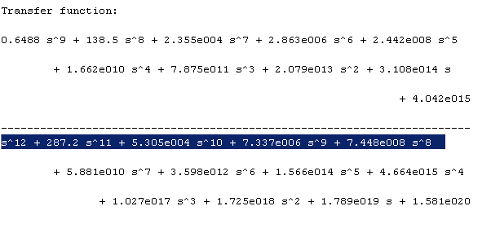
And K is assumed to be 1 here. Later it is derived while designing PD controller as per the specifications mentioned.
2. Design a PD controller to yield a settling time of approximately 0.3 second with no more than 60% of overshoot. Plot the step response to verify your design.
Given settling time of 0.3 seconds, we know for 2% criteria $t_{s}=4/εω_{n}$ = 0.3 sec
$ζω_{n}=\frac{4}{0.3}=13.33$3
And given overshoot of 60% then M $=e^{-\left(\frac{ζζ}{\sqrt{1-(ζ^{2})}}\right)π}=0.160$
Applying ln (natural log) on both sides we get $ζ^{2}$ > 0.160.
And $w_{n}$= 13.333 / 0.165 = 80.80606061, selecting $ζ^{}$ as 0.165
${subsituting s}^{2}+2sω_{n}ζ+ω_{n}^{2}$=0 we get ${ s}^{2}+26.666s+80.80606061$= 0
I obtained complex pole s = -13.333${}_{-}^{+}i 79.69849774$
Now assume a PD controller transfer function of $K_{p}$(s+Z) and assume it to be $G_{c1}$ (s)
Now to design the PD controller obtain the value of Z which is obtained from the angle condition of
$∠G_{open}\left(s\right)G_{c1}$ (s)$|_{s=s^{*}= -13.333{}_{-}^{+}i 79.69849774}= -{180}^{*}$ ------------------------------------ (1)
By root-Locus method
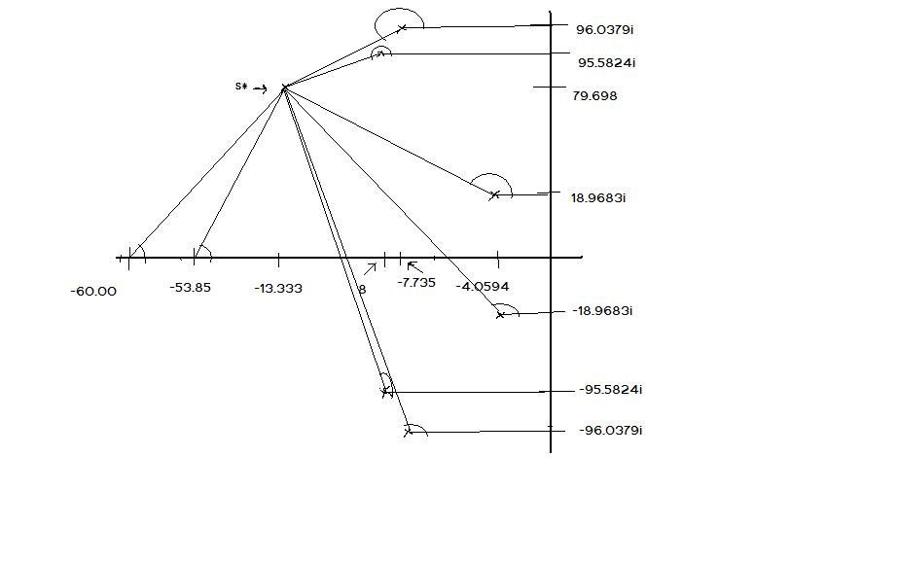
$Zeros and poles of G_{open}\left(s\right)$ are obtained to be -8.000+95.5824i , -8.000+95.5824i , -53.850 and
-7.7356+96.0379i , 7.7356-96.0379i , -60 , -60 , -4.0594+18.9683i , -4.0594-18.9683i.
Now plotting these points on root locus graph to obtain sum of the angles substituted by zeros and poles on the root locus graph with respect to s*we obtain the sum of the angles substituted by zeroes is (63.05205 at
-53.8500, 251.4411305 at -8.000+95.5824i, 91.90501 at , -8.000+95.5824i which gives )406.3981905
Similarly by poles 7.7356-96.0379i gives 91.824364711, -7.7356+96.0379i gives 92.8841 , -60 gives 59.64898 , -4.0594-18.9683i gives 98.67939511 results in 656.4129
Now substitute above results in 1 we get$θ-250.01480= -180$.
Which gives? $θ=70.0148.$ Now from the $θ$ ; Z = 42.31738.
Applying magnitude condition
|(s+z) $K_{p}$ *K * $G_{open}\left(s\right)|s=s* =1$ ---------------------------- 2
Where k is the gain of the controller. Which is obtained from root locus plot of open loop transfer function $G_{open}\left(s\right)|$
Root Locus plot of $G_{open}\left(s\right)|$ to find K value
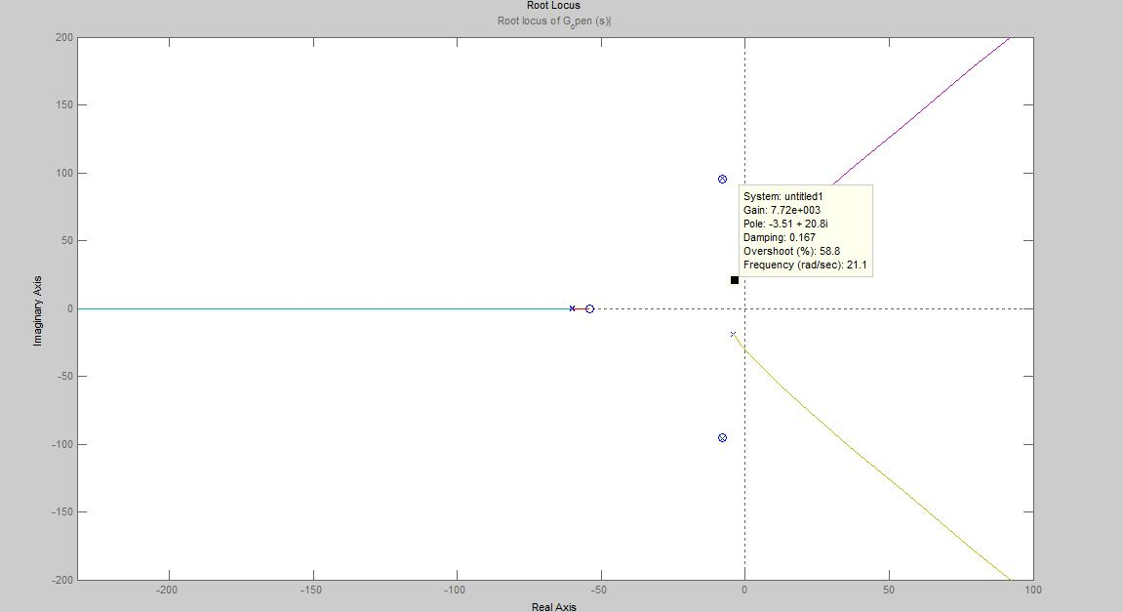
From the above root locus the controller K value is obtained to be 8.07 * 10^3 at an overshoot slightly less than 60.
Equation 2 can be written as $k_{\begin{aligned}p \\ \end{aligned}}\left| \left(s+42.31738\right).\frac{0.6487709\left(s+53.85\right)\left(s^{2}+16s+9200\right)}{\left(s^{2}+15.47s+9283\right)\left(s^{2}+8.119s+376.3\right)\left(s^{2}+3600+120s\right)}\right|=1$
At s = -13.333${}_{-}^{+}i 79.69849774$ gives $k_{\begin{aligned}p \\ \end{aligned}}$= (10910.90372/8.07 * 10^3) = 1.352
Now constructing the New transfer function ${(G}_{c}$new) that includes the PD controller gives the
${(G}_{c}$New) =
( G (s) =$\frac{0.6488 s + 34.94}{(s^4 + 23.59 s^3 + 9785 s^2 + 8.119e004 s + 3.493e006)}$. *
$G_{n}$(s) = $\frac{s^{2}+ 16 s + 9200}{s^{2}+ 120 s + 3600}$ * $G_{\begin{aligned}c1 \\ \end{aligned}}\left(s\right)=$1.352*(s+42.31738) * k controller = 8.07*10^3 )
$$=$$
7043 s^4 + 7.9e005 s^3 + 9.169e007 s^2 + 6.488e009 s + 1.477e011
----------------------------------------------------------------------------------------
s^6 + 143.6 s^5 + 1.622e004 s^4 + 1.34e006 s^3 + 4.846e007 s^2 + 7.115e008 s + 1.258e010
Closed loop of ${(G}_{c}$New) is given by = = ${\frac{C\left(s\right)}{R\left(s\right)}= G}_{\begin{aligned}c New \\ \end{aligned}}$/ (${(G}_{c}$New)+1)
= 7043 s^10 + 1.801e006 s^9 + 3.193e008 s^8 + 4.19e010 s^7 + 3.966e012 s^6 + 2.926e014 s^5
+ 1.618e016 s^4 + 5.875e017 s^3 + 1.293e019 s^2 + 1.867e020 s + 1.857e021
-----------------------------------------------------------------------------------------
s^12 + 287.2 s^11 + 6.009e004 s^10 + 9.139e006 s^9 + 1.064e009 s^8 + 1.007e011 s^7
+ 7.564e012 s^6 + 4.492e014 s^5 + 2.085e016 s^4 + 6.902e017 s^3 + 1.465e019 s^2
+ 2.045e020 s + 2.015e021
Step – Response
Matlab-File
% to find step response for PD controlled closed loop transfer function num= [ 7043 1.801e006 3.193e008 4.19e010 3.966e012 2.926e014 1.618e016 5.875e017 1.293e019 1.867e020 1.857e021];
den = [ 1 287.2 6.009e004 9.139e006 1.064e009 1.007e011 7.564e012 4.492e014 2.085e016 6.902e017 1.465e019 2.045e020 2.015e021];
step(num,den);
grid

Step Response
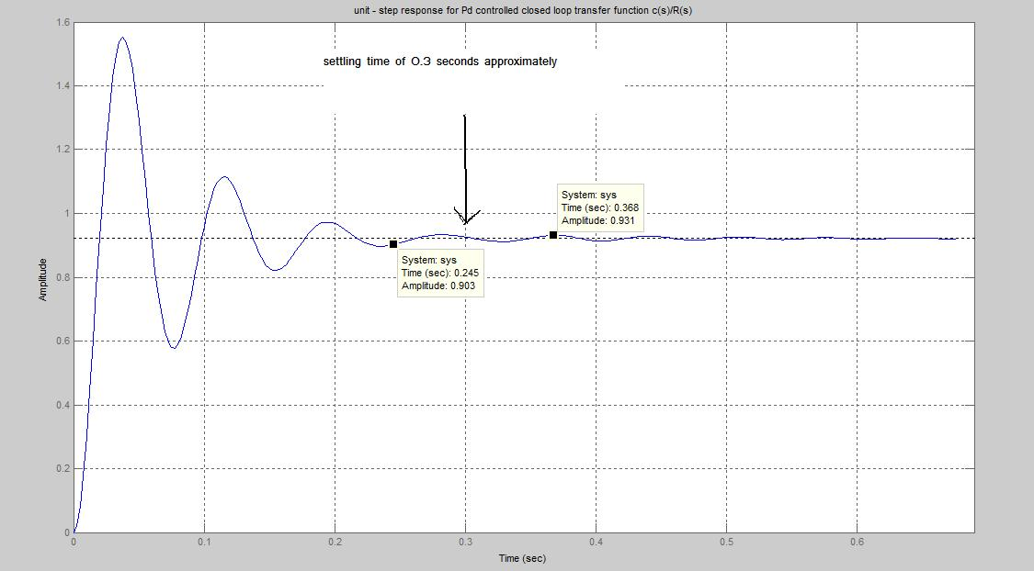
From above step response , the +/-2% FINAL STEADY STATE VALUE is within the tolerance band.
As Final steady state value is 0.921 we got tolerance band is within the 1.02*0.921 = 0.93942
and min value 0.98 *0.921 = 0.90258 we get settling time of approximately …… and overshoot of 55%.

3. Add a PI controller to yield a Zero steady -state error for step inputs. Plot the step response to verify your design.
Now assume a PI controller transfer function of $K_{p}$(s+Z)/s and assume it to be $G_{c2}$ (s).
Now again consider the root locus plot we used for solving PI parameters , since our new transfer function is $G_{c2}$ (s) * $G_{c1}$ (s)*$G_{open}\left(s\right)$.
Consider the angle condition from 1 again $∠G_{open}\left(s\right)G_{c1}$ (s)${G_{c2} (s) |}_{s=s^{*}= -13.333{}_{-}^{+}i 79.69849774}= -{180}^{*}$ ---------> 3
So by solving the above equation we can find the value of Z. To do that we add the angle made by 1/s to the equation 1 which we solved already.
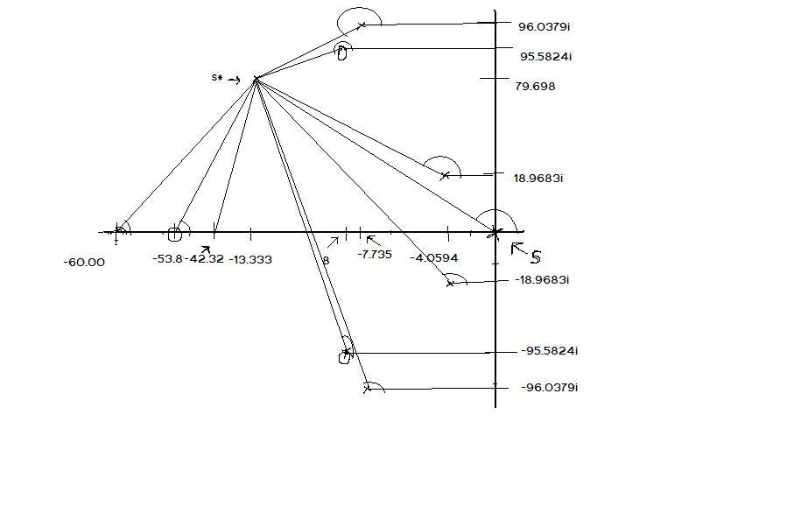
Now we add a value of 99.497234 to the sum of angles made by the poles earlier which is made by (s-0) at origin. These leads to $∠\left(s+z\right)$ to be -180 -(476.4095428-755.910134) = 279.5005912 – 180 = 99.5005912.
Therefore the value of pole z from equation 3 will be 13.33771664-13.333= - 0.04416643653
Now to find $K_{p}$ value we need to consider magnitude condition
|(s+z) $\frac{1}{s}K_{p}$ *K * $G_{open}\left(s\right)*G_{c1}$ (s)$|s=s* =1$ ------- (4)
We need to modify the equation 2 by multiplying the magnitude vectors from $G_{c1}$ (s)which is |s+42.32| * 1.32 and |s+z| of PI compensator which is |s+0.04416643653| and dividing by |s| which yields us
$$K_{p}=\frac{1}{0.9950*0.999}$$
$K_{p}=1.0051$
That gives $G_{c2}$ (s) = $1.0051*\frac{s+0.0441664}{s}$

Now $G_{c2}$ (s) * $G_{c1}$ (s)*$G_{open}\left(s\right)$ becomes ${(G}_{c}2$New) =
(1.005*$\frac{s+0.0441664}{s}*1.352*\left(s+42.31738\right)*\frac{0.6488 s + 34.94}{\left(s^{4}+ 23.59 s^{3}+ 9785 s^{2}+ 8.119e004 s + 3.493e006\right)}*8.07 * {10}^{3}$)
That gives the below equation ${(G}_{c}2$New) open loop
(7115 s^5 + 8.055e005 s^4 + 9.315e007 s^3 + 6.63e009 s^2 + 1.53e011 s + 6.743e009)
(s^7 + 143.6 s^6 + 1.622e004 s^5 + 1.34e006 s^4 + 4.846e007 s^3 + 7.115e008 s^2 + 1.258e010 s)
Step Response:
Consider closed loop transfer function = ${\frac{C\left(s\right)}{R\left(s\right)}= G}_{C2}$(s) / ${(G}_{c2}$(s) +1) which gives 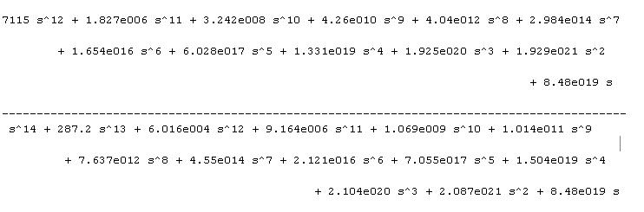
Step response of the above function from command step(C(s)/R(s)) in matlab command produce the fallowing wave form
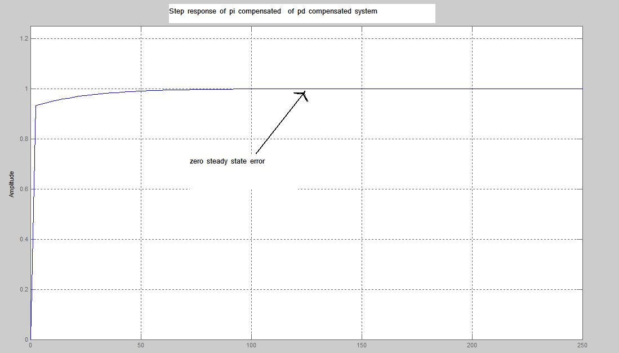
Thus we obtained zero steady state error for step inputs.
4. Plot the Bode diagram of the original open-loop transfer function with the notch filter and K =1.
Considering the open loop transfer function Transfer function with Notch filter:
$G_{open}$(s) = G(s) * $G_{n }$(s).
G (s) =$\frac{0.6488 s + 34.94}{(s^4 + 23.59 s^3 + 9785 s^2 + 8.119e004 s + 3.493e006)}$.
$G_{n}$(s) = $\frac{s^{2}+ 16 s + 9200}{s^{2}+ 120 s + 3600}$ - notch filter transfer function

$G_{open}$(s) = $\frac{0.6488 s^{3}+ 45.32 s^{2}+ 6528 s + 3.214e005}{s^{6}+ 143.6 s^{5}+ 1.622e004 s^{4}+ 1.34e006 s^{3}+ 4.846e007 s^{2 }+ 7.115e008 s + 1.258e010}$
With k = 1
In matlab we obtained fallowing function. Now applying Bode Plot to this original open-loop we obtain.
Transfer function:
0.6488 s^3 + 45.32 s^2 + 6528 s + 3.214e005
----------------------------------------------------------------------------------------
s^6 + 143.6 s^5 + 1.622e004 s^4 + 1.34e006 s^3 + 4.846e007 s^2 + 7.115e008 s + 1.258e010

Bode Plot is obtained as below:
Matlab code for open loop transfer function with k =1
num = [0.6488 45.32 6528 3.214e005];
den = [1 143.6 1.622e004 1.34e006 4.846e007 7.115e008 1.258e010 ];
bode(num,den);
grid
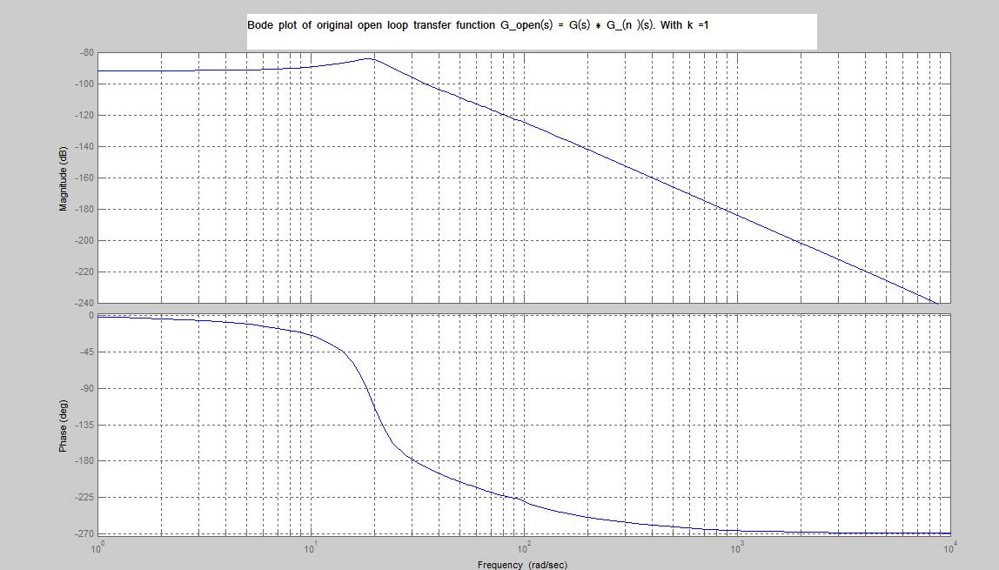

5. Design a lag-lead compensator using frequency response method to meet the following specifications: a) at least 35* phase margin b) maximum of 10% of steady state error for a step response. C) at least 35 rad/s bandwidth. Plot the compensated system’s Bode diagram and the step response to verify your design.
Given a steady state error for the step response of 10% or 0.1 that is $e_{ss}$ = 0.1
Therefore $1/(1+ k_{p }$) = 0.1 => $k_{p }of$ value equal to 9.
We know that for lag lead compensator using frequency response method $G_{c}\left(s\right)= k_{c}\frac{\left(s+\frac{1}{T1}\right)\left(s+\frac{1}{T2}\right)}{(s+\frac{β}{T1})(s+\frac{1}{βT2})}$

Step 1: Now to find the value of $k_{c};$ $k_{p }={Lt}_{s→0 }G_{c}\left(s\right)G_{}\left(s\right)$
That gives $k_{p }= k_{c}*53.85*0.7883*82300*\frac{9200}{9283*376.3*{10}^{5}*3600}$
$k_{c }=$ $k_{p }/2.5588$ = 3.5214*10^5 .
Step 2: Draw the bode plot of $k_{c}*G_{}\left(s\right)$ = $G_{1}\left(s\right)$
From the bode plot $w_{g}$ is obtained from the phase crossover frequency of$G_{1}\left(s\right)$ is 30.5.
Therefore zero of the lag portion is obtained to be 1/T2 = 0.1*30.5 = 3.05. ---- 1
Step3: Determine the value of $β$ from phase margin $∅$m which is given as 35*. But adding a additional phase margin of 12* gives $∅$ to be 47* which gives $β value of$10 from formula.
$β=(sin∅m-1)/(sin∅m+1)$ . Pole of lag portion is 1/$βT2$ = 3.5/10 = 0.305.
Step 4: To find the parameters of lead portion a 20 db scale of 1 frequancy band (10 to ${10}^{2}$) is taken.This is moved on the magnitude plot of $G_{1}\left(s\right)$ till it meets the –Gm value.
Matlab Code
% bode plot of k_c*G_ (s) = G_1 (s)
num = [ 2.285e005 1.596e007 2.299e009 1.132e011];
den = [1 143.6 1.622e004 1.34e006 4.846e007 7.115e008 1.258e010];
bode(num,den);
grid
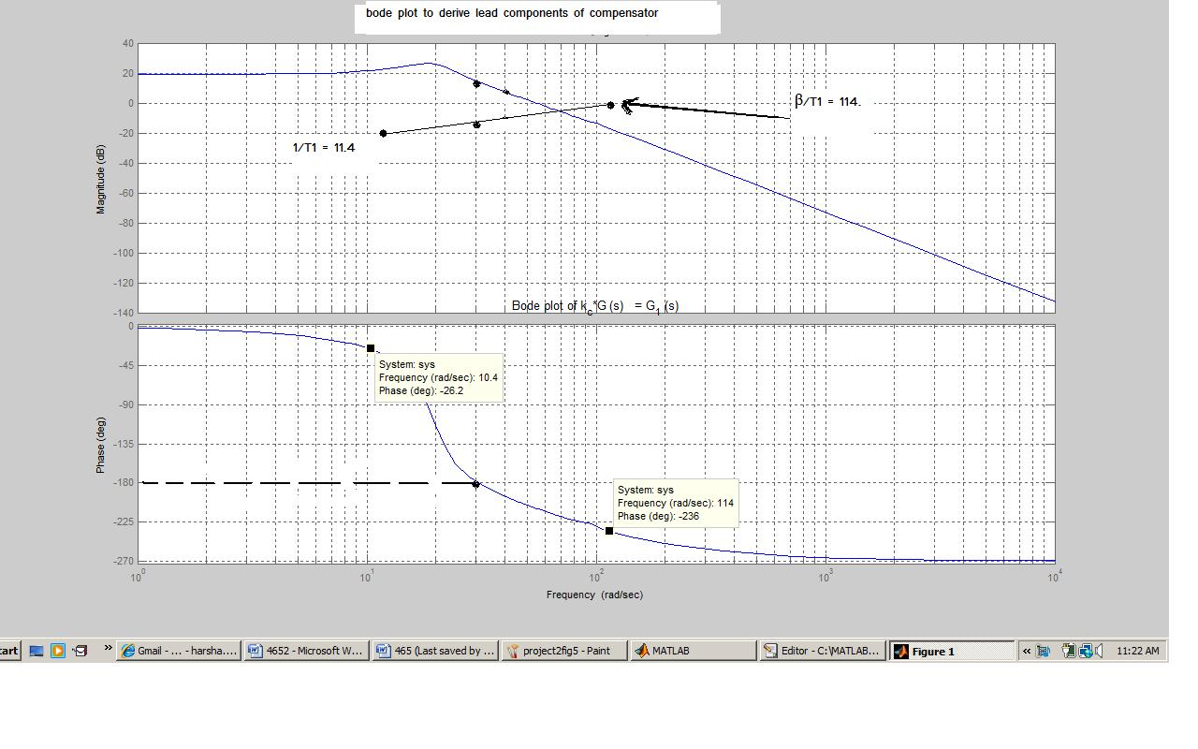That gives us the result of Lead portion. Where 1/T1 = 11.4 and from the right tip of scale $β/T1$ = 114.
So now we can construct the lead and lag portion of the compensator as
$G_{c}\left(s\right)= 3.5214*{10}^{5}$($(s+11.4)(s+3.05)/(s+114)(s+0.305))$

Now to plot the bode plot of compensated system and to verify the bandwidth and phase margin condition consider
$G_{c}\left(s\right) * G_{open}$(s) = $\frac{2.285e005 s^{5}+ 1.926e007 s^{4}+ 2.537e009 s^{3}+ 1.47e011 s^{2}+ 1.715e012 s+ 3.935e012}{ \left(s^{8}+ 257.9 s^{7}+ 3.266e004 s^{6}+ 3.199e006 s^{5}+ 2.022e008 s^{4}+ 6.297e009 s^{3}+ 9.558e010 s^{2}+ 1.462e012 s + 4.372e011\right)}$

MATLAB CODE:
% Bode plot of G_c (s) * G_open(s)
num = [2.285e005 1.926e007 2.537e009 1.47e011 1.715e012 3.935e012 ];
den = [1 257.9 3.266e004 3.199e006 2.022e008 6.297e009 9.558e010 1.462e012 4.372e011];
bode(num,den);
grid

From the bode plot thus obtained it is verified whether our system met the required specifications of
- Atleast 35% phase margin b)Maximum of 10% of steady state error.
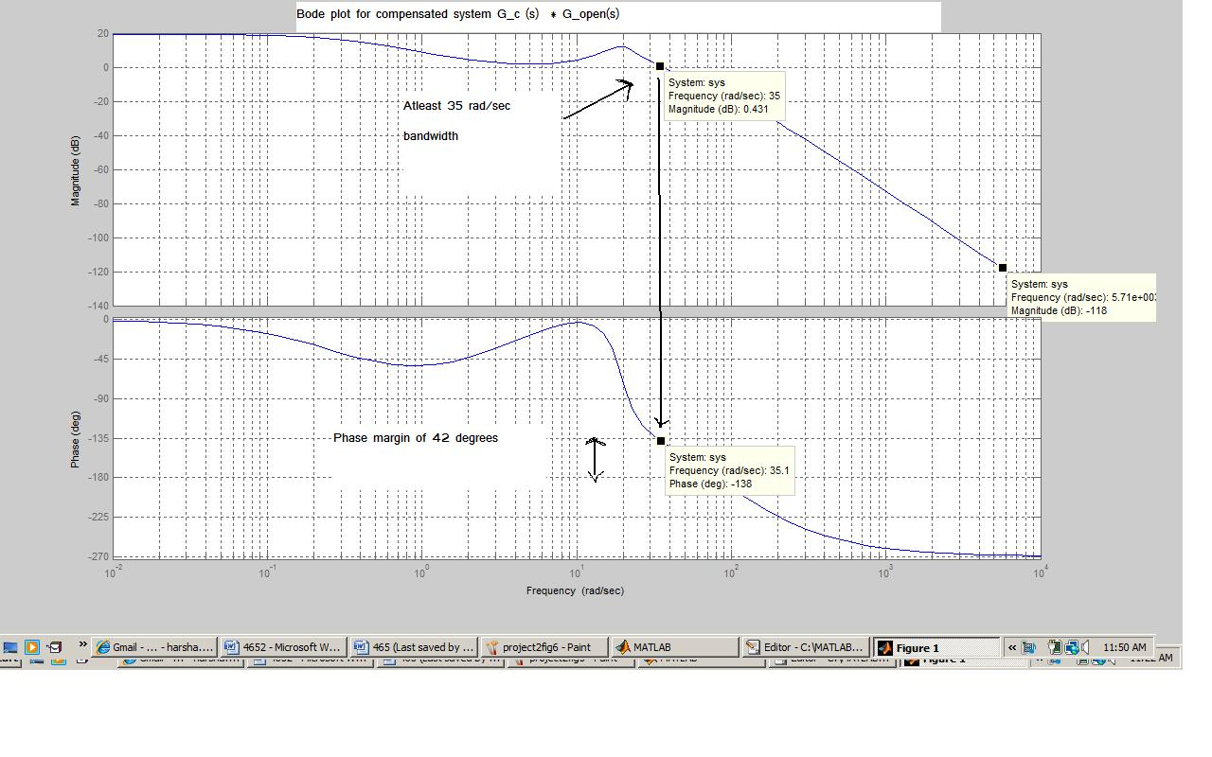

- Maximum of 10% of steady state error.
%step response for compensated system
num = [2.285e005 7.818e007 1.497e010 2.161e012 2.303e014 1.87e016 1.183e018 5.349e019 1.556e021 2.936e022 4.047e023 2.949e024 6.504e024 1.721e024];
den =[1 515.8 1.318e005 2.347e007 3.199e009 3.408e011 2.904e013 1.988e015 1.069e017 4.438e018 1.412e020 3.354e021 5.709e022 6.898e023 5.17e024 7.783e024 1.912e024 ];
step(num,den);
grid

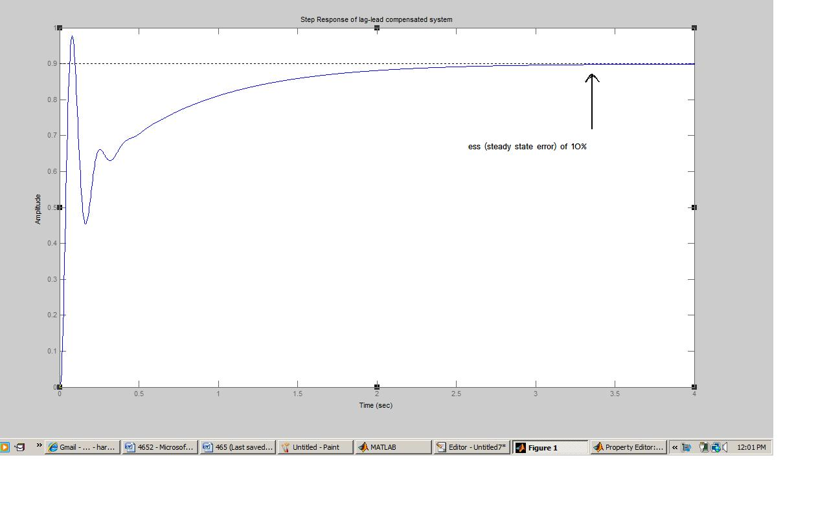
RESULT : A PID controller for a given system is designed and required parameters are verified.
A lag-lead compensator for the original system with k =1 is designed and required specifications are verified.

>> H

Transfer function:
s^2 + 16 s + 9200
------------------
s^2 + 120 s + 3600
G = (s*k)/(f*g)

Transfer function:
0.6488 s + 34.94
----------------------------------------------------
s^4 + 23.59 s^3 + 9785 s^2 + 8.119e004 s + 3.493e006

>> G_op = G*H

Transfer function:
0.6488 s^3 + 45.32 s^2 + 6528 s + 3.214e005
----------------------------------------------------------------------------------------
s^6 + 143.6 s^5 + 1.622e004 s^4 + 1.34e006 s^3 + 4.846e007 s^2 + 7.115e008 s + 1.258e010

G_op = G_op = G_op*8.03*10^3

Transfer function:
5210 s^3 + 3.639e005 s^2 + 5.242e007 s + 2.581e009
----------------------------------------------------------------------------------------
s^6 + 143.6 s^5 + 1.622e004 s^4 + 1.34e006 s^3 + 4.846e007 s^2 + 7.115e008 s + 1.258e010
>> d = [1,42.31738];
>> d = tf(d,1);
>> d = 1.352*d

>> GcNew = G_op*Pd

Transfer function:
7043 s^4 + 7.9e005 s^3 + 9.169e007 s^2 + 6.488e009 s + 1.477e011
----------------------------------------------------------------------------------------
s^6 + 143.6 s^5 + 1.622e004 s^4 + 1.34e006 s^3 + 4.846e007 s^2 + 7.115e008 s + 1.258e010

> ClosedGcNew = GcNew/ (GcNew +1)
7043 s^10 + 1.801e006 s^9 + 3.193e008 s^8 + 4.19e010 s^7 + 3.966e012 s^6 + 2.926e014 s^5

+ 1.618e016 s^4 + 5.875e017 s^3 + 1.293e019 s^2 + 1.867e020 s + 1.857e021

-----------------------------------------------------------------------------------------
s^12 + 287.2 s^11 + 6.009e004 s^10 + 9.139e006 s^9 + 1.064e009 s^8 + 1.007e011 s^7

+ 7.564e012 s^6 + 4.492e014 s^5 + 2.085e016 s^4 + 6.902e017 s^3 + 1.465e019 s^2

+ 2.045e020 s + 2.015e021
Tolerance band +/-2% FINAL STEADY STATE VALUE IS WITHIN THE TOLERANCE BAND ..
1.02*0.921 and min value 0.98 *0.921 ….
>> G_OPEN=T3 / (T4*T5)

Transfer function:
s + 53.85
----------------------------------------------------
s^4 + 23.59 s^3 + 9785 s^2 + 8.119e004 s + 3.493e006
>> G_OPEN= G_OPEN * GnS

Transfer function:
s^3 + 69.85 s^2 + 1.006e004 s + 495420
----------------------------------------------------------------------------------------
s^6 + 143.6 s^5 + 1.622e004 s^4 + 1.34e006 s^3 + 4.846e007 s^2 + 7.115e008 s + 1.258e010

>> G_OPEN = G_OPEN * 0.6488

Transfer function:
0.6488 s^3 + 45.32 s^2 + 6528 s + 3.214e005
----------------------------------------------------------------------------------------
s^6 + 143.6 s^5 + 1.622e004 s^4 + 1.34e006 s^3 + 4.846e007 s^2 + 7.115e008 s + 1.258e010

>> bode(G_OPEN)
>>

