AIM: To design an antenna control position system with the mentioned conditions and run the design using Matlab to verify whether the mentioned objectives are reached.
PROCEDURE:
Step 1: Given Block diagram is first analyzed and $θ_{i}$ is assumed to be as angular input, $θ_{0}$ as angular output. 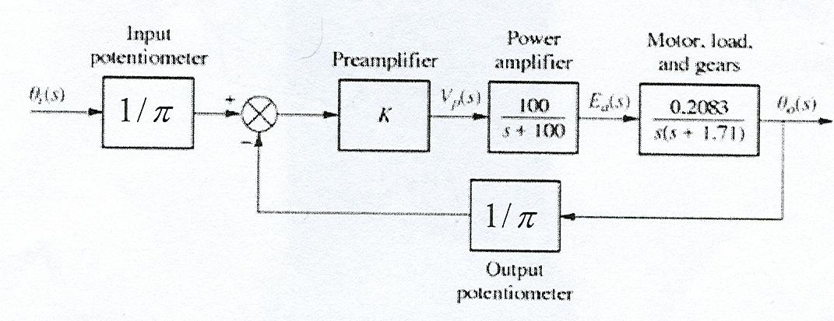
Equivalent diagram for the above block diagram is reduced as shown below and Error at the input is made equal to$E=1/π(θ_{i}-θ_{0})$.
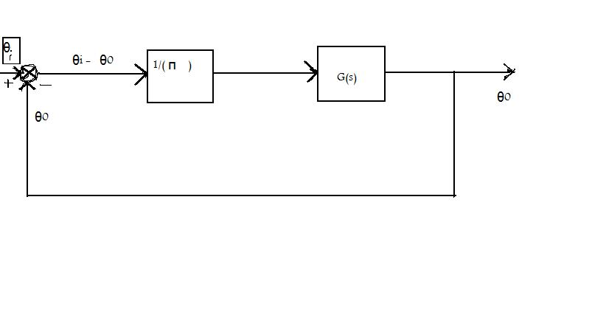Now thus after reducing the above transfer function G(s) is the product of gains of preamplifier power amplifier, motor load and gears.
Now new G(s) after considering the gain of the output potentiometer is given by
$$G\left(s\right)= \frac{20.83k}{\left(s^{3}+100s^{2}+1.71s^{2}+171s\right)}(\frac{1}{π})$$

Where k is the preamplifier constant
Or else
$G\left(s\right)=$ $6.6303k/(s^{3}+101.71s^{2}+171s)$ (a)
1. Derive the closed loop transfer function
Step 2:
Now consider the closed-loop transfer function for the uncompensated system
We get $G(s)/(1+G\left(s\right))$ =
$$\frac{C\left(s\right)}{R\left(s\right)} = \frac{6.630k}{s^{3}+100s^{2}+1.71s^{2}+171s+6.630k}$$
=$\frac{6.630k}{ s^{3}+101.71s^{2}+171s+6.630k}$ --> (b)
2. Sketch the root-locus plot of the original system
Step 3:
In order to derive root-locus for the transfer function, consider the original open-loop transfer function $G\left(s\right)=$ $6.6303k/(s^{3}+101.71s^{2}+171s)$.
From the transfer function the numerator and denominator values can be obtained as
num = [0 0 0 6.6303];
den = [1 101.71 171 0];
with varying preamplifier gain k
Matlab code for Root Locus plot of original system
% Root - Locus Plot for the open loop transfer function
% G(s) = 6.6303k/(s^3+101.71s^2+171s)
num = [0 0 0 6.6303];
den = [1 101.71 171 0];
k = 0:0.4:1000;
rlocus(num,den,k);
v = [-30 20 -25 25];
axis(v);
grid;
title('Root Locus for open loop transfer function G(s)= 6.6303k/(s^3+101.71s^2+171s)');
clear;

Root Locus plot generated for above code is :
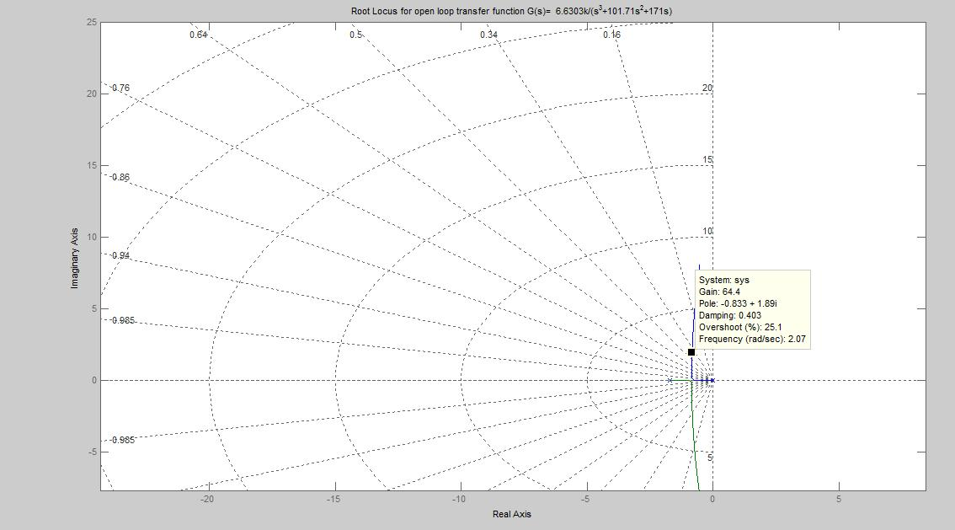
Fig : 1.1

3. Find a preamplifier gain to achieve 25% maximum overshoot. Describe detail derivations in your project report. Verify your design by the step response using Matlab.
Step 4: From the root locus in Fig 1.1 the preamplifier gain k is obtained to be approximately 64.6 at preamplifier gain of 25.1. Consider equation (b) as below and insert preamplifier k.
$$\frac{C\left(s\right)}{R\left(s\right)}=\frac{6.630k}{ s^{3}+101.71s^{2}+171s+6.630k}$$
So the above transfer function becomes
$$\frac{C\left(s\right)}{R\left(s\right)}=\frac{428.31738}{ s^{3}+101.71s^{2}+171s+428.31738}$$
To verify the design consider step response of the above system
For
num=[0 0 0 428.31738];
den=[1 101.71 171 428.31738];

%unit-step response for closed loop transfer function
%428.31738/(s^3+101.71s^2+171s+428.31738)
num=[0 0 0 428.31738];
den=[1 101.71 171 428.31738];
t=0:0.1:100;
c=step(num,den,t);
plot(t,c);
grid;
clear;
title('unit step response of C(s)/R(s)=428.31738/(s^3+101.71s^2+171s+428.31738)')

Step Response for closed loop transfer function C(s)/R(s) is as below
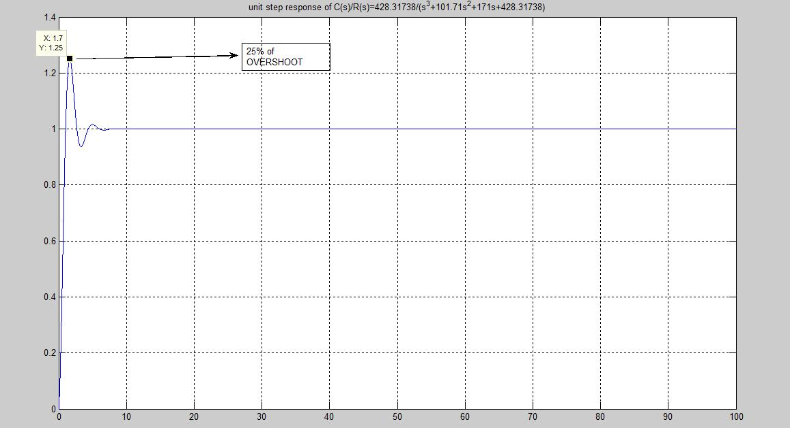
Fig 1.2

From the above step response you can verify the maximum overshoot of 25%.
4. Design a lead-lag compensator using root-locus method, such that closed-loop poles satisfy the fallowing conditions. A) 25% maximum overshoot. B) 2 sec settling time, C) static velocity error constant is 20. Verify your design by ramp and step response using Matlab

- It’s given maximum overshoot of 25%, therefore M = 25% (or) = 0.25
M $=e^{-\left(\frac{ζζ}{\sqrt{1-(ζ^{2})}}\right)π}=0.25$

Applying natural logarithm on both sides we get
$-\left(\frac{ζζ}{\sqrt{1-(ζ^{2})}}\right)=\ln{0.25}$
Or else $\left(ζ^{2}\right)=0.1946-0.1946 (ζ^{2})$

Or else $(ζ^{2})=\frac{0.1946}{1.946}$
$or else (ζ^{1})=0.403$ 4.1

Given settling time of 2 sec
At (5%) criteria $t_{ s=3/εω_{n }}$
Therefore $ω_{n}=3/ εt_{ s}$
Or else $ω_{n}=3.7228$
Now in order to design lag lead compensator
Step 1: I considered $γ ≠β$ case
For given performance specifications I determined the desired locations for the dominant closed-loop poles.

$s^{2}+2sω_{n}ζ+ω_{n}^{2}$=0
Or else $s^{2}+2\left(0.403\right)\left(3.722\right)s+{\left(3.722\right)}^{2}=0$
Or else $s^{2}+2.999s+13.853284=0$
And closed loop poles are obtained to be
$$s_{1}= -1.495+i 3.40609$$
$s_{2 }= -1.495-i3.40609$
$s$ at $s^{*}= -1.495-i3.40609$
Step 2: Using the uncompensated open-loop transfer function G(s), angle deficiency $ϕ_{m}$ is determined as below if the dominant closed loop poles are at desired location
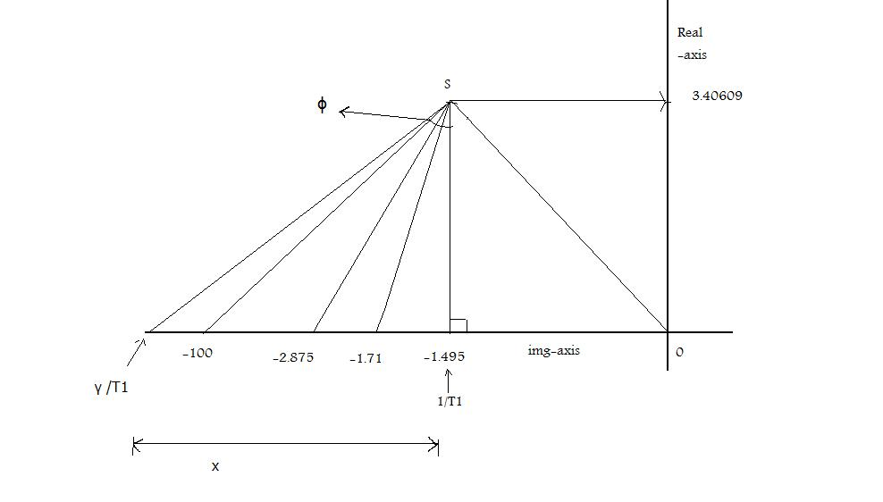
Fig 4.1
Angle of deficiency 180 $- angleG\left(s\right)|_{\begin{aligned}s=s^{*} \\ \end{aligned}}= ϕ_{m}$
$$ϕ_{m}= -180-(-113.6897-86.388-1.98037)$$
Or else $ϕ_{m}=22.05807$

Choosing -1.495 as – ($1/T_{1}$) --------------- (1)
We found $\tan\left(180-90-22.05807\right)=$ 2.46788
Therefore $x=(\frac{3.40609}{2.46788})$ = 1.380168404
Therefore extending $ϕ_{m}$ from complex pole to real axis we found ($γ/T_{1}$) = (1.380168+1.495) = 2.875168 -------------------- (2)
So satisfying the requirement angle of ${(s}_{1 }+ 1/T_{1})/(s_{1 }+ γ/T_{1})$ $T1 and γ$ are chosen.
And lead portion is found to be $k_{c}$ ${(s}_{1 }+ 1.495)/(s_{1 }+ 2.875168404)$
Then value of $k_{c}$ is determined from magnitude condition
|$k_{c}$ ${(s}_{1 }+ 1/T_{1})/(s_{1 }+ γ/T_{1})$ G($s_{1}$)| =1
Where $G\left(s_{1 }\right)= 428.33676/(s_{1 }\left(s_{1 }+100\right)\left(s_{1 }+1.71\right))$ .

Now substituting the length of the vectors individually we solve with
$\left(s+1.71\right) =\sqrt{{\left(0.125\right)}^{2}+11.6014}=3.4128$ ------------------------------- (3)
$\left(s+1.495\right) =3.40609$
$$\left(s+100\right) =\sqrt{(9703.25+11.60144)}$$
$=98.5639$ ----------------------------------------------- (4)
$s =3.7197411$
$\left(s+2.8751\right) =\sqrt{{\left(1.38\right)}^{2}+{\left(3.40609\right)}^{2}}$
$=3.6750304$ -------------------------------------------- (5)
From (1) , (2) , (3) , (4) and (5) we obtain
$k_{c}$ = 3.151924105
From the specified static velocity constant $k_{v }$ = 20 $\sec^{-1}$
$${ k}_{v }= {Lt}_{S→0} s . G_{c}\left(s\right)G\left(s\right)$$
Or else = ${Lt}_{S→0} sk_{c }$($β/γ) G(s)$
Solving we get $β$ = $\left(100\right)\left(20\right)\left(1.9231\right)(1.71)/(3.1519)(6.6303)(64.6)$
Or else $β=4.871$

Consider compensated transfer function $with β=4.871 and T_{2} =10$Where It satisfied Angle and magnitude condition.
$G_{c}$(s) = $\frac{3.1519(s+1.495)\left(s+\frac{1}{10}\right)}{\left(s+2.8751\right)(s+\frac{1}{48.71})}$ Answer for lead-lag compensator

or = $\left(3.1519s+4.712\right)\left(s+0.1\right)/(s+2.8751)(s+0.0205)$
or $=3.1519s^{2}+5.0271s+0.4712/(s^{2}+2.89565s+0.0589022$)
Consider original open loop transfer function $G\left(s\right)=6.6303(64.6)/(s^{2}+100s)(s+1.71)$
(from (a))
$G_{c}$(s) $G(s)$ Becomes new open loop transfer function of our system
Therefore $G(s)G_{c}$(s) = $\frac{428.33676}{s\left(s+100\right)\left(s+1.71\right)}$ x $\frac{3.1519(s+1.495)\left(s+\frac{1}{10}\right)}{\left(s+2.8751\right)(s+\frac{1}{48.71})}$
Solving numerator
=$\left(428.33676 \right)(3.1519)(s+1.495)\left(s+\frac{1}{10}\right)$
Or else =$428.31738(3.1519s^{2}+5.02171s+0.04712)$
Or else = 1350.01355$s^{2}+2153.194301s+201.83$
Solving Denominator
Or else = $\left(s+2.8751\right)(s+\frac{1}{48.71}) s\left(s+100\right)\left(s+1.71\right)$
Or else = $\left(s^{3}+101.71s^{2}+171s\right)(s^{2}+2.895625s+0.059022)$
Or else $=(s^{5}+104.6056s^{4}+465.5720s^{3}+501.15414s^{2}+10.0927s)$

$G_{c}$(s) $G\left(s\right)$ =
$$\frac{1350.01355s^{2}+2153.194301s+201.83}{s^{5}+104.6056s^{4}+465.5720s^{3}+501.15414s^{2}+10.0927s}$$
Now closed loop transfer function becomes = C(s)/R(s) = $\frac{Gc(s) G(s)}{1+Gc(s) G(s)}$
Solving numerator = 1350.01355$s^{2}+2153.194301s+201.83$
Solving denominator = $\left(s^{5}+104.6056s^{4}+465.5720s^{3}+501.15414s^{2}+10.0927s\right)+(1350.01355s^{2}+2153.194301s+201.83)$
Or else = $s^{5}+104.6056s^{4}+465.5720s^{3}+1851.16769s^{2}+2163.287001s+210.83$

$\frac{Gc(s) G(s)}{1+Gc(s) G(s)}$ = C(s)/R(s) =$\frac{(1350.01355s^{2}+2153.194301s+201.83)}{ ( s^{5}+104.6056s^{4}+465.5720s^{3}+1851.16769s^{2}+2163.287001s+210.83)}$

Verification:
To verify the step and ramp response of the system consider the numerator and denominators of the closed loop transfer functions
num = [1350.01355 2153.194301 201.83];
den = [ 1 104.6056 465.5720 1851.16769 2163.287001 201.83];
Now applying them in step and ramp response Matlab function we obtain
- rise_time = 0.3800 sec
- peak_time = 0.9400 sec
- max_overshoot = 0.2656 = 26.56%
- settling_time = 1.9200 sec

Matlab Code to find Ramp Response
% Unit Ramp response for closed loop transfer function
% C(s)/R(s) = ((1350.01355s^2+2153.194301s+201.83))/( (s^5+104.6056s^4+465.5720s^3+1851.16769s^2+2163.287001s+210.83))
num = [0 1350.01355 2153.194301 201.83];
den = [ 1 104.6056 465.5720 1851.16769 2163.287001 201.83 0];
t = 0:0.1:10;
c = step(num,den,t);
plot(t,c,'o',t,t,'-')
grid
title('unit - Ramp response for closed loop transfer function c(s)/R(s)')
xlabel('sec')
ylabel('input and outputs')

MATLAB code to find Step response , Overshoot and settling time
% C(s)/R(s) = ((1350.01355s^2+2153.194301s+201.83))/( ( s^5+104.6056s^4+465.5720s^3+1851.16769s^2+2163.287001s+210.83))
num = [1350.01355 2153.194301 201.83];
den = [ 1 104.6056 465.5720 1851.16769 2163.287001 201.83];
t = 0:0.02:20;
[y,x,t] = step(num,den,t);
plot(t,y)
grid
title('unit - step response for closed loop transfer function c(s)/R(s)')
xlabel('t(sec)')
ylabel('output y(t)')
r1 = 1; while y(r1) <0.1 , r1 = r1+1;end;
r2=1; while y(r2) <0.9, r2 = r2+1; end;
rise_time = (r2-r1)*0.02
[ymax,tp]=max(y);
peak_time = (tp-1)*0.02
max_overshoot = ymax-1
s = 1001;
while y(s) > 0.95 & y(s) < 1.05; %At (5%) criteria
s=s-1; end;
settling_time = (s-1)*0.02
clear;
% program ref to Modern Control Engineering "K Ogata" - Fourth Edition

Step Response:
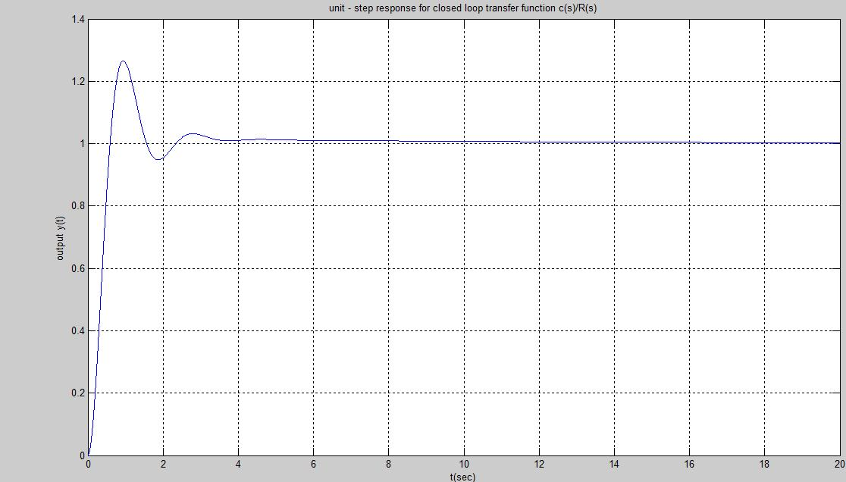
Fig 4.2
Ramp Response:
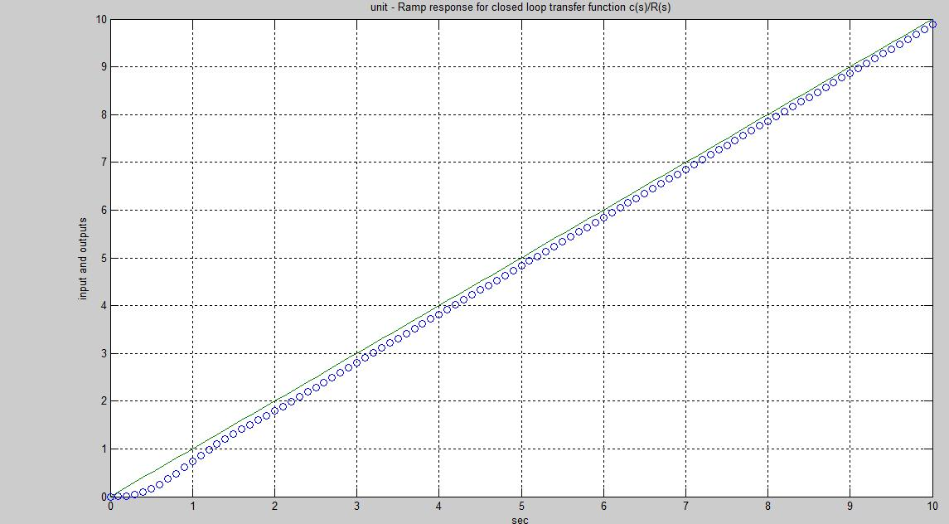
FIG 4.3
- A realization of lag-lead compensator is shown in below figure.
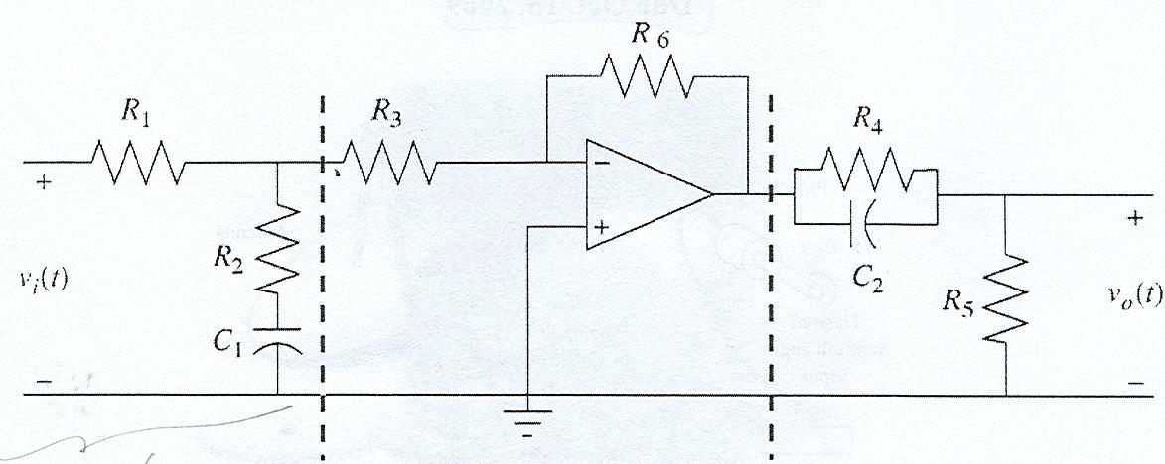
- $Derive the overall transfer function of the above circuit$.
- $Plug in appropriate values for resistors and capacitors, such that your lag-lead compensator in part 4 can be realized by op-amp circuit$

- $Calculating the transfer functions for lead , lag and middle portion with consant gain individually$
We obtain
Gain for the lead portion as = (($R_{4 }$||$C_{\begin{aligned}2 \\ \end{aligned}}$ )|| $R_{5}$ )
Or else = (1/${(R}_{5}$ + ($R_{4}||\left(\frac{1}{jωc_{2}}\right)$)$)$

Since middle portion is an inverting amplifier
Gain for the middle portion = (-$R_{6}$ $/R_{3}$)
Gain for the lag portion is = (${(C}_{\begin{aligned}1 \\ \end{aligned}}+ R_{2})/(R_{\begin{aligned}1 \\ \\ \end{aligned}}+ R_{\begin{aligned}2 \\ \end{aligned} }+C_{\begin{aligned}1 \\ \end{aligned}} )$)

Over all transfer function = $V_{0 }$(t) / $V_{i}$ (t)

= (1/${(R}_{5}$ + ($R_{4}||\left(\frac{1}{jωc_{2}}\right)$)$)$ (${(C}_{\begin{aligned}1 \\ \end{aligned}}+ R_{2})/(R_{\begin{aligned}1 \\ \\ \end{aligned}}+ R_{\begin{aligned}2 \\ \end{aligned} }+C_{\begin{aligned}1 \\ \end{aligned}} )$)
(-$R_{6}$ $/R_{3}$)

Now to solve for $R_{1}C_{\begin{aligned}1 \\ \end{aligned}}R_{2}$ consider lead – circuit
Compare the gain for lag portion with answer obtained for lead lag compensator,
$G_{c}$(s) = $\frac{3.1519(s+1.495)\left(s+\frac{1}{10}\right)}{\left(s+2.8751\right)(s+\frac{1}{48.71})}$ Answer for lead-lag compensator

We obtain
(1/$R_{\begin{aligned}2 \\ \end{aligned} }C_{\begin{aligned}1 \\ \end{aligned}} )=0.1$ and (1/${(R}_{1 }{+ R_{\begin{aligned}2 \\ \end{aligned} }) C}_{\begin{aligned}1 \\ \end{aligned}}$) = 0.02502.
Or else on solving the equations on both sides I ended up with

$R_{1 }/R_{2 }$= 3.87

Now I assumed $R_{1 }$ = 2K, so I ended up with $R_{2}$ of 0.5167K.

So $C_{\begin{aligned}1 \\ \end{aligned}}$ = 0.01935 F

Considering gain for the lead portion

(1/$R_{\begin{aligned}4 \\ \end{aligned} }C_{\begin{aligned}2 \\ \end{aligned}} )=2.8751$ ${(R}_{4 }{+ R_{\begin{aligned}5 \\ \end{aligned} })/({(R}_{4 }{ R_{\begin{aligned}5 \\ \end{aligned} }) C}_{\begin{aligned}2 \\ \\ \end{aligned}}}_{})$ = 1.495
By solving above equations I obtained ${(R}_{\begin{aligned}4 \\ \end{aligned} }$ / $R_{\begin{aligned}5 \\ \end{aligned} }$ ) = 1.403
I assumed $R_{\begin{aligned}4 \\ \end{aligned} }$ = 2K , then $R_{\begin{aligned}5 \\ \end{aligned} }$ = 1.425K
And $C_{\begin{aligned}2 \\ \end{aligned}}= 0.012 F$
Now considering
Constant gain (1 + $\frac{R_{1 }}{R2}$) ($R_{\begin{aligned} \\ 3\end{aligned} }/R_{\begin{aligned} \\ 6 \end{aligned} }$ ) = 0.167

On solving I obtained $R_{\begin{aligned} \\ 6 \end{aligned} }$ = $\frac{R_{\begin{aligned} \\ 3\end{aligned} }}{0.034}$
On assuming $R_{\begin{aligned} \\ 3\end{aligned} }$ = 1 k I obtained $R_{\begin{aligned} \\ 6 \end{aligned} }= 29.4117K$

ANS : $C_{\begin{aligned}1 \\ \end{aligned}}$ = 0.01935 F , $C_{\begin{aligned}2 \\ \end{aligned}}= 0.012 F{, R}_{\begin{aligned} \\ 3\end{aligned} }$ = 1 k ,$R_{\begin{aligned} \\ 6 \end{aligned} }= 29.4117K$ , $R_{\begin{aligned}4 \\ \end{aligned} }$ = 2K
$R_{\begin{aligned}5 \\ \end{aligned} }$ = 1.425K, $R_{1 }$ = 2K and $R_{2}$ of 0.5167K.

