- Title: CCC (Civilian Conservation Corps) workers, Prince George's County, MD
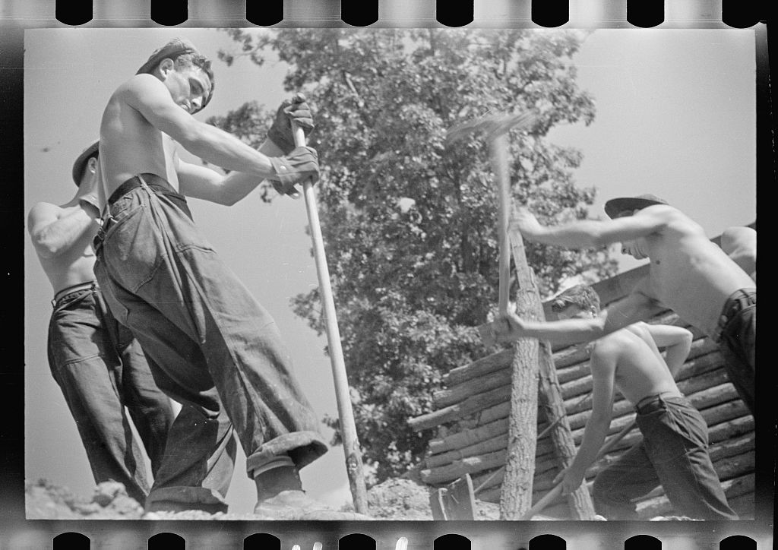

United States Resettlement Administration, Mydans, C., photographer. (1935) CCC Civilian Conservation Corps workers, Prince George's County, Maryland. Nov. [Image] Retrieved from the Library of Congress, https://www.loc.gov/item/fsa1997000061/PP/.

Excerpt: Out of the Dust Hesse, K. (1997). Out of the dust.
Hope Smothered-p. 181
…Mrs. Love is taking applications  for boys to do CCC work.  Any boy between eighteen and twenty-eight can join.  I’m too young | and the wrong sex  but what I wouldn’t give to be  working for the CCC  somewhere far from here,  out of the dust.
- Title: Plains farms need trees Trees prevent wind erosion, save moisture ... protect crops, contribute to human comfort and happiness
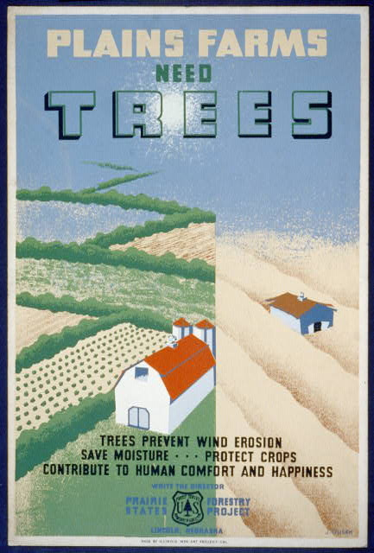 | Du  Dusek, J. & Federal Art Project, S. Plains farms need trees Trees prevent wind erosion, save moisture ... protect crops, contribute to human comfort and happiness / / J. Dusek. [Chicago: illinois wpa art project, between 1936 and 1940] [Image] Retrieved from the Library of Congress, 5. http://www.loc.gov/pictures/item/98517930/

Excerpt: Out of the Dust Hesse, K. (1997). Out of the dust.
Roots-p.75

President Roosevelt tells us to
plant trees. Trees will
break the wind. He says,
trees
will end the drought,
the animals can take shelter there,
children can take shelter.
Trees have roots, he says.
They hold on to the land.
That’s good advice, but
I’m not sure he understands the problem.
Trees have never been at home here.
They’re just not meant to be here.
Maybe none of us are meant to be here,
only the prairie grass
and the hawks.

Title: Four families, three of them related with fifteen children, from the Dust Bowl in Texas in an overnight roadside camp near Calipatria, California
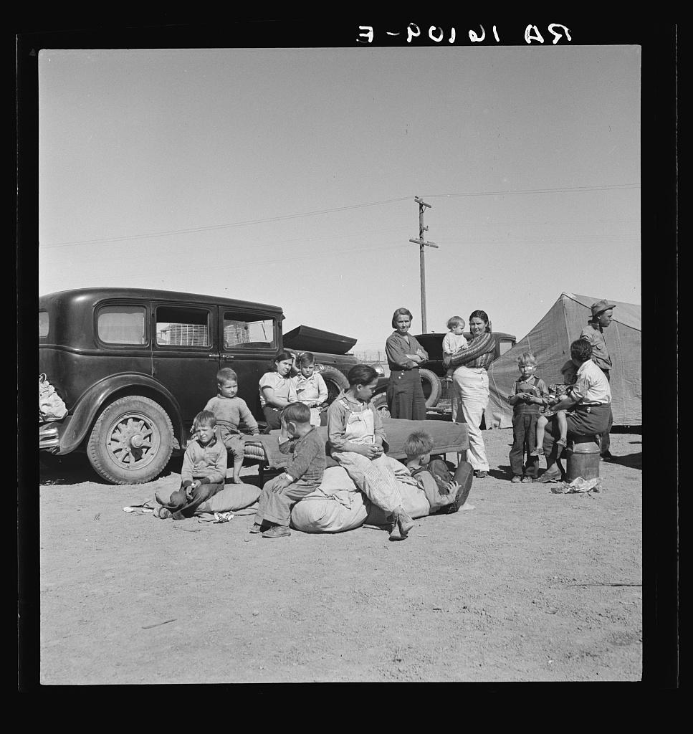 | Lange, D., photographer. (1937) Four families, three of them related with fifteen children, from the Dust Bowl in Texas in an overnight roadside camp near Calipatria, California. Mar. [Image] Retrieved from the Library of Congress, https://www.loc.gov/item/fsa2000000789/PP/.

Excerpt: Out of the Dust Hesse, K. (1997). Out of the dust.
Migrants-p. 160

We’ll be back when the rain comes,
they say,
pulling away with all they own,
straining the springs of their motor cars.
Don’t forget us.

And so they go,
fleeing the blowing dust,
fleeing the fields of brown-tipped wheat
barely ankle high,
and sparse as the hair on a dog’s belly.

We’ll be back, they say,
pulling away toward Texas,
Arkansas,
where they can rent a farm,
pull in enough cash,
maybe start again.

- Title: Years of dust Resettlement Administration rescues victims,
restores land to proper use
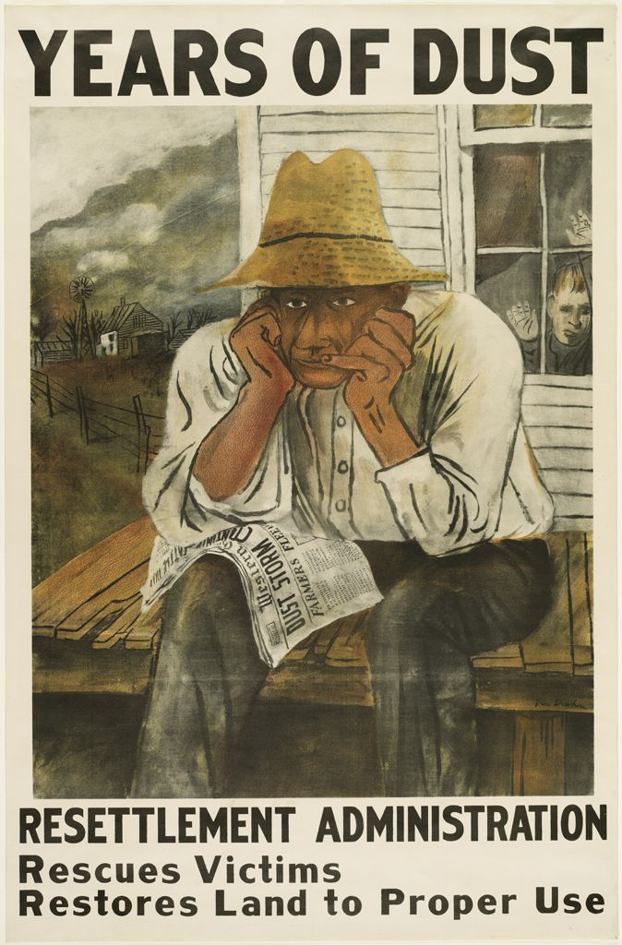 | Sh Shahn, B. & United States Resettlement Administration, P. (1936) Years of dust Resettlement Administration rescues victims, restores land to proper use / / Ben Shahn. [Washington, D.C.: Resettlement Administration, Government Printing Office] [Image] Retrieved from the Library of Congress, https://www.loc.gov/item/88706324/.

Excerpt: Out of the Dust Hesse, K. (1997). Out of the dust.
Debts: p. 26

Daddy is thinking  of taking a loan from Mr. Roosevelt and his men,  to get some new wheat planted  where the winter crop has spindled out and died.  Mr. Roosevelt promises  Daddy won’t have to pay a dime  till the crop comes in. | Daddy says,  “I can turn the fields over,  start again.  It’s sure to rain soon.  Wheat’s sure to grow.”

- Title: Arid land. Weld County, Colorado
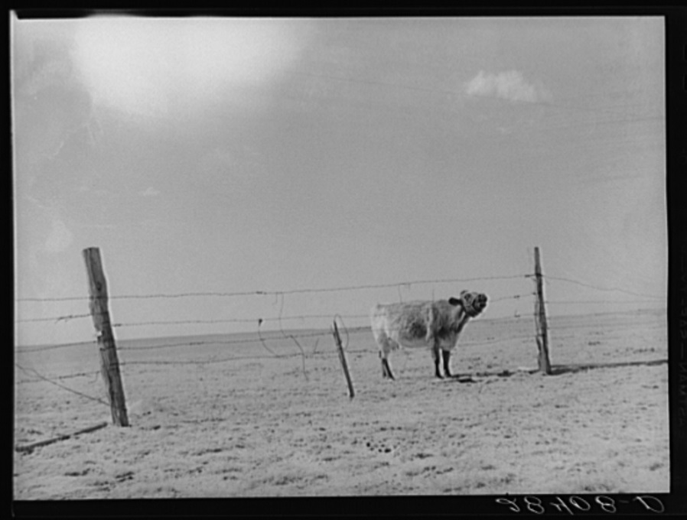

Rothstein, A., photographer. (1939) Arid land. Weld County, Colorado. Oct. [Image] Retrieved from the Library of Congress, https://www.loc.gov/item/fsa2000009787/PP/

Excerpt: Out of the Dust Hesse, K. (1997). Out of the dust.
Driving the Cows-p. 102

Dust  piles up like snow  across the prairie,  dunes leaning against fences,  mountains of dust pushing over barns.  Joe De La Flor can’t afford to feed his cows,  can’t afford to sell them.  County Agent Dewey comes,  takes the cows behind the barn,  and shoots them.  Too hard to | watch their lungs clog with dust,  like our chickens, suffocated.  Better to let the government take them,  than suffer the sight of their bony hides  sinking down  into the earth.

- Title: Approaching dust storm in middle west

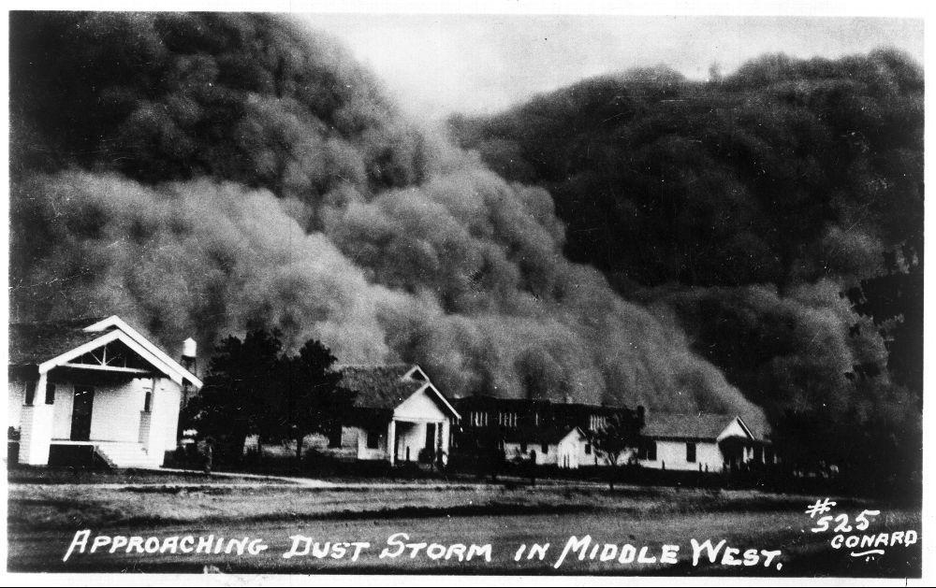
(ca. 1930) Approaching Dust Storm in
Middle West. [between and Ca. 1940]
[Image] Retrieved from the Library of Congress, https://www.loc.gov/item/2013646367

Excerpt: Out of the Dust Hesse, K. (1997). Out of the dust.
Blankets of Black--p. 163

…Six miles out of town the air turned cold,  birds beat their wings  everywhere you looked,  whole flocks  dropping out of the sky,  crowding on fence posts.  I was sulking in the truck beside my father  when  heaven’s shadow crept across the plains,  a black cloud  big and silent as Montana,  boiling on the horizon and  barreling toward us. | More birds tumbled from the sky  frantically keeping ahead of the dust.  We watched as the storm swallowed the light.  The sky turned from blue  to black,  night descended in an instant  and the dust was on us.  The wind screamed.  The blowing dirt ran

