Getting Started with Student Job Finder:
Contact our office at 618-650-2563 to obtain a username and password.
Begin by going to our Student Employment homepage. (www.siue.edu/studentemployment)

Click the “Employer Login” link on the left side of the screen and enter your username and password provided to you. Your account is initially set up to have your password be the same as your username. Your home screen will look like this:

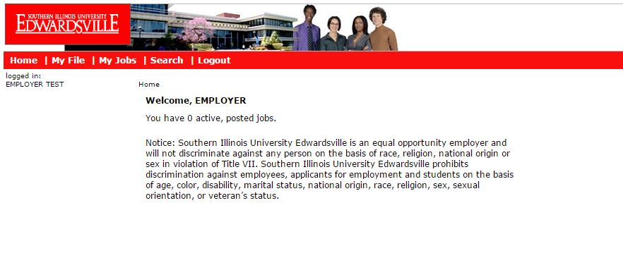

Once you are logged in, you may change your password or contact information by clicking the “My File” tab, and clicking the “Edit” button next to the fields you wish to change.

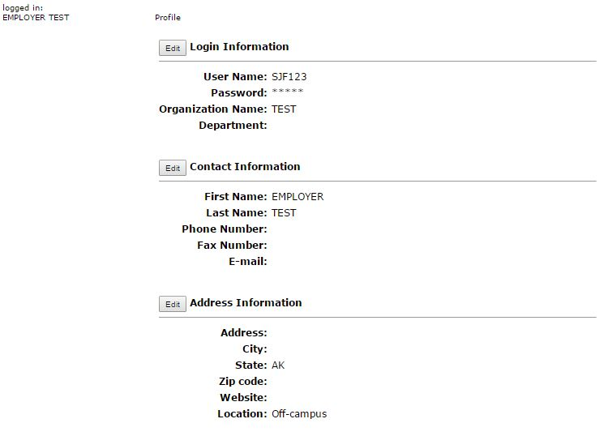
To add a new position:

Click the “My Jobs” tab, followed by the “Add New Job” link.

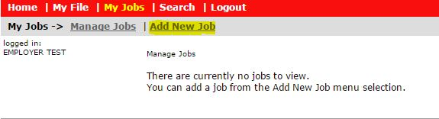

Fill in the information on each screen. There are three screens of information.

Screen 1
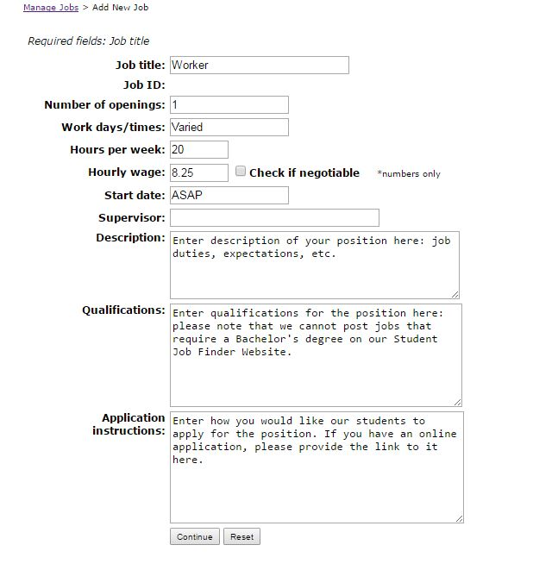

Screen 2
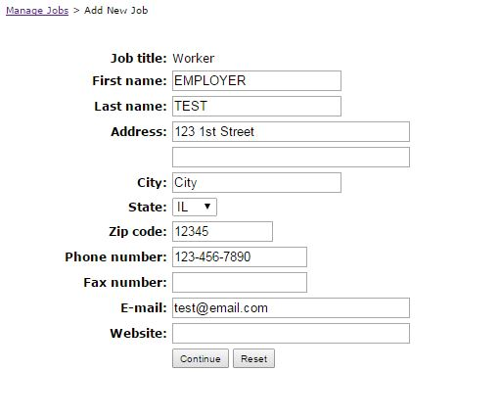

Screen 3*
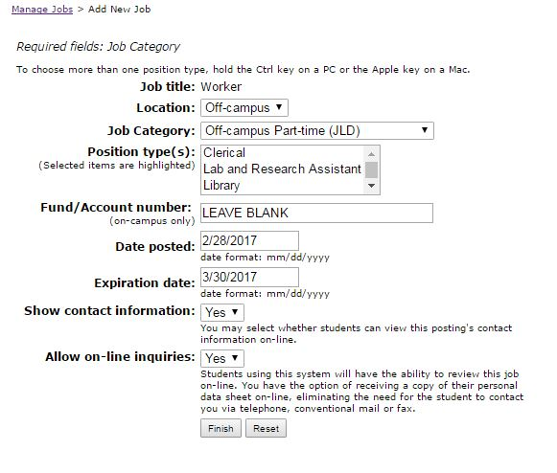

Please select “Off-campus” for the Location and “Off-campus Part-time (JLD)” for the job category. You may leave the Fund/Account number field blank, as that is only used for on-campus positions.

Please provide when you would like to have the position posted as well as the expiration date. Jobs may only be posted for a maximum of three months.

*If you would prefer to keep your contact information private, select “No” for the Show contact information field. If you opt to hide your contact information, please ensure your Application Instructions (from screen 1) are clear.

*Our website allows the option of on-line inquiries where students will be able to send their information to you through the website. If you would like to utilize this function, please select “Yes” to Allow on-line inquiries and edit your Application Instructions (screen 1) to inform students that you will accept online inquiries. If you would not like to utilize this function, please select “No.”

When you have completed, click the “Finish” button. You will see this message when your post has been successfully submitted:

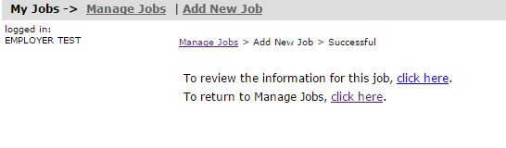

To Repost or Edit a Previous Position:
Log into Student Job Finder and click “My Jobs.” Then click the title of the job you wish to edit or repost.
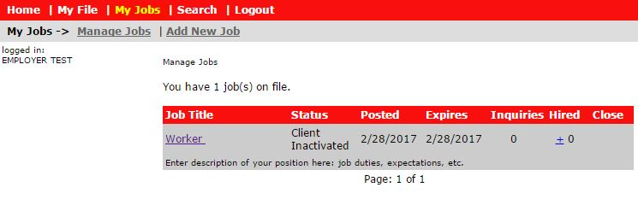Select the “Edit” button next to the fields you wish to change.
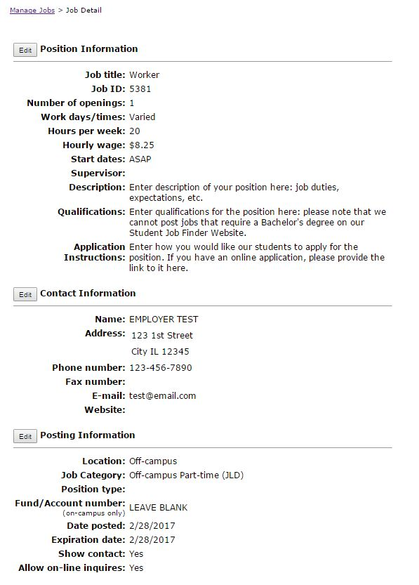
Once you have made your changes, click “Save.” The position’s status will switch to “Pending,” and our office will review the changes before making the position active.

Closing your jobs
Select “My Jobs” and find the job you wish to close.
Click the “Close” button next to the job.
Requirements for Using Student Job Finder:

Please be aware that we cannot post positions that require a Bachelor’s degree, as our students utilize the Student Job Finder website to find jobs while they are attending classes. If your position requires a Bachelor’s degree or higher, please contact SIUE’s Career Development Center to post the position with their office.

SIUE Career Development Center
www.siue.edu/careerdevelopmentcenter
Student Success Center
Room 0281
(618) 650-3708
careerdevelopment@siue.edu
Fax: (618) 650-3656

Each position can be on our website for a maximum of three months. After your post’s expiration, we will send a one-page certification form requesting information for any students you have hired. Our program is funded through a federal grant, and in order to stay in compliance we must keep accurate records on all hires made through the program. The form must be completed even if you did not hire an SIUE student. Once we have received a completed form, we can reactivate the position for another 3 months, if you wish.

If we do not receive a completed form after three attempts, your account risks deactivation. If your account is deactivated, we will not post any new positions until all outstanding Certification Forms have been received.

Thank you for helping provide our students with local employment opportunities! Please contact us if you have any questions. Our office is open 8:00am – 4:30pm, Monday through Friday.

SIUE Student Employment
Southern Illinois University Edwardsville
stuemp@siue.edu
P: 618-650-2563
F: 618-650-2566
SIUe

