Overview
When registering for your Spring 2026 classes, you may be prompted to accept the SIUE Financial Agreement before you are allowed to proceed. This agreement is a promise to pay the tuition and fees associated with your enrollment at SIUE. Once you accept the agreement, you should not be prompted to view it again until next semester.
Process
From the CougarNet landing page, select Class Registration under Student to get started.
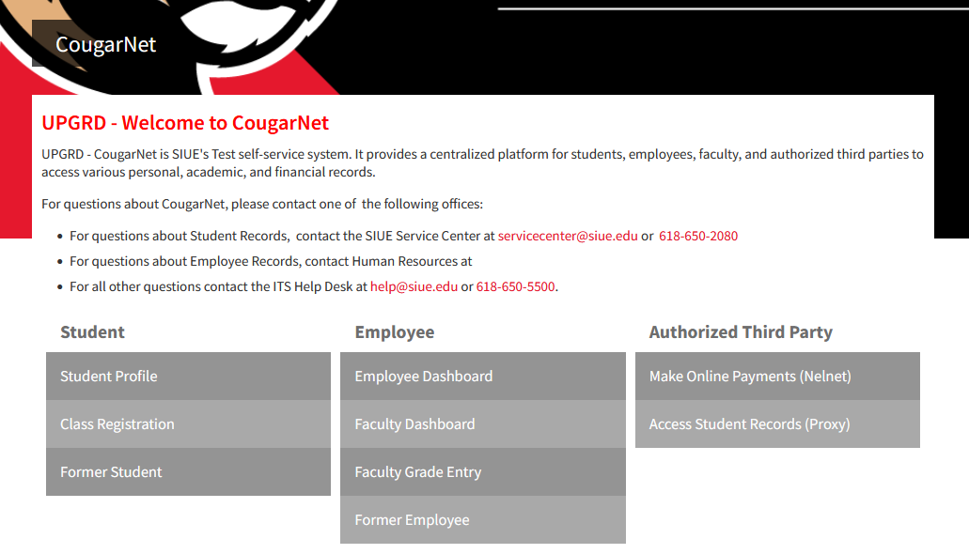

This will take you to the Registration menu. Click “Register for Classes” in the top row of links.
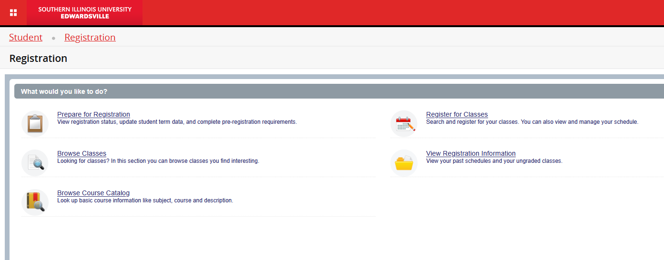

If you have not already accepted the Financial Agreement you will get a pop-up titled “Action Item Processing.” Select “continue” from the bottom of the pop-up.
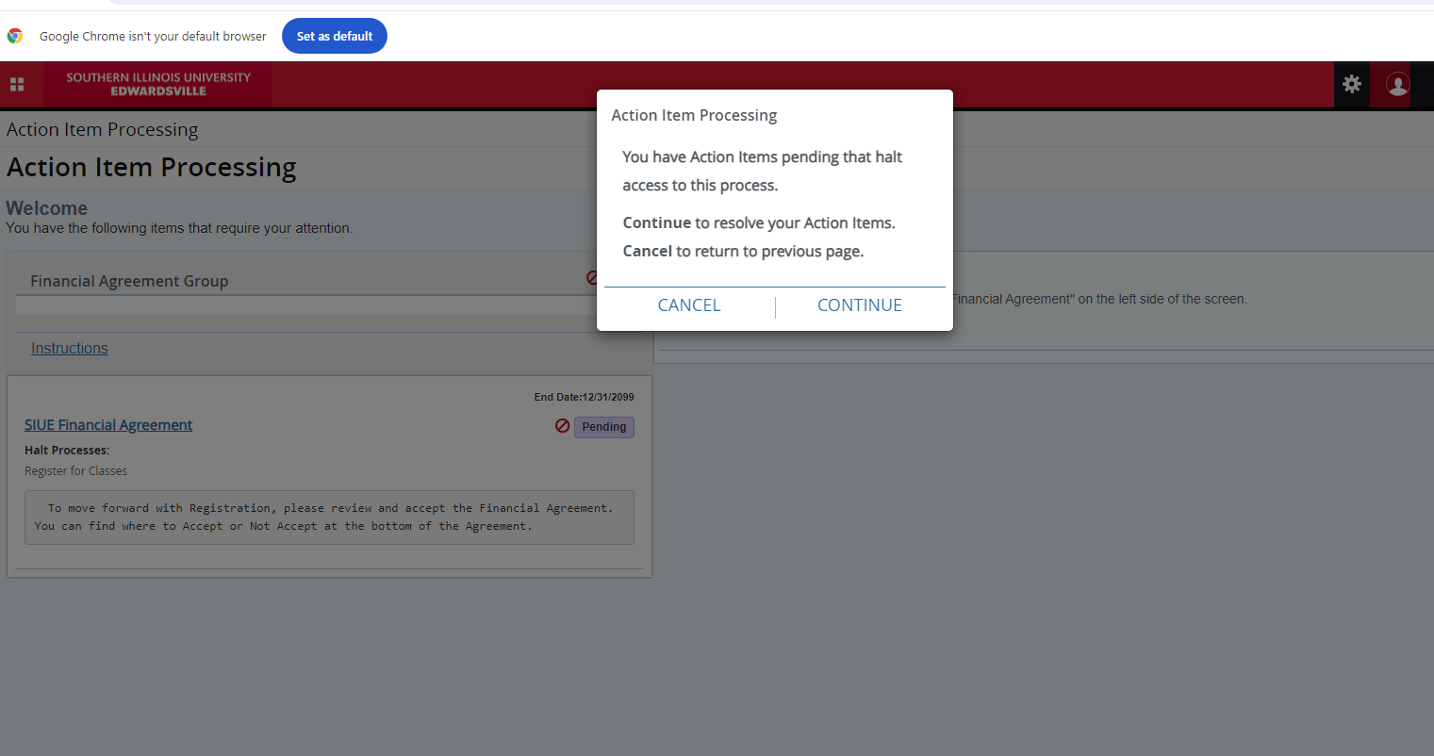
This will take you to a new menu called Action item Processing. There will be a box titled “Financial Agreement Group”. Click the link that says “SIUE Financial Agreement.” There should be a “Pending” flag next to it.
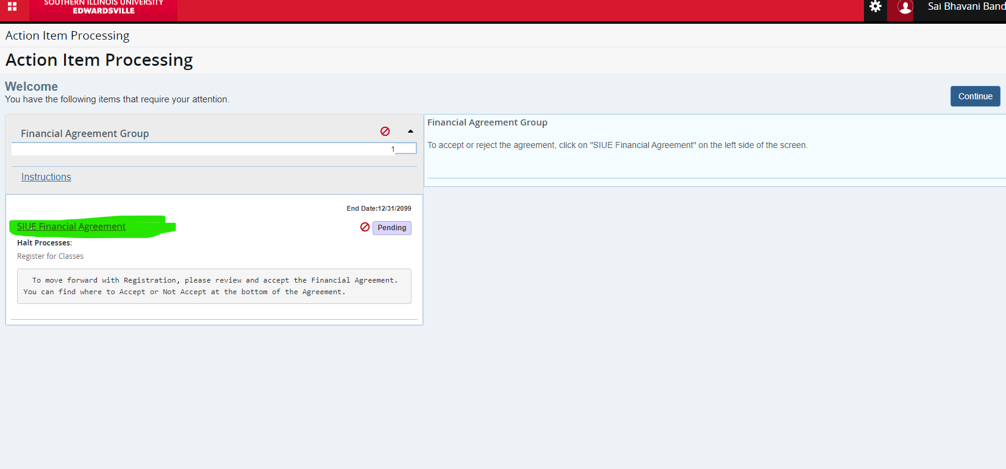
The full text of the agreement will open on the right side of the screen. Read the agreement carefully and scroll down to the end.
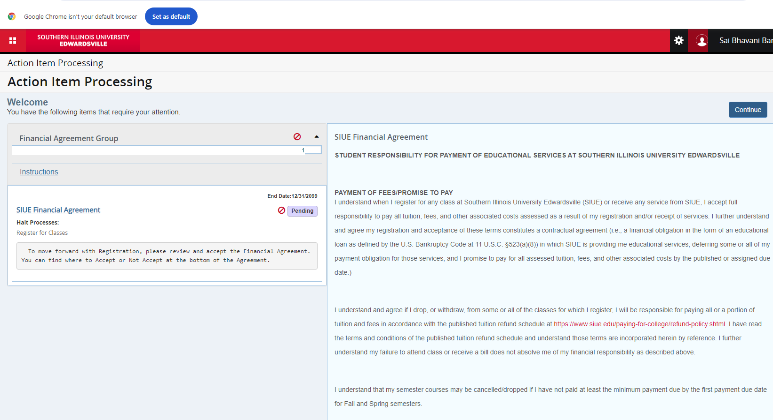

At the end of the agreement, there are two radio buttons. Select “I ACCEPT AND AGREE” if you agree to the terms of the agreement. If you select “I DO NOT ACCEPT” you will not be allowed to register for Spring 2026 classes.
Click Save to save your selection.

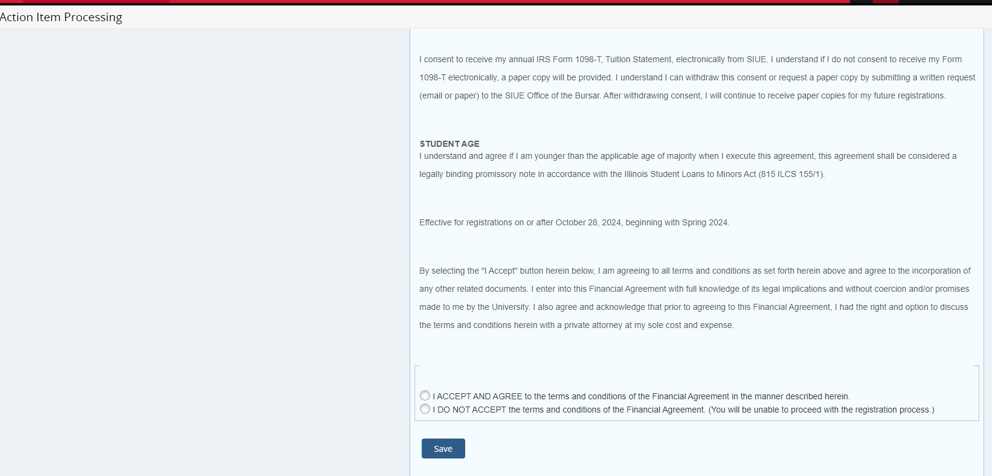

The flag on the left side of the page should now be green and say Completed.
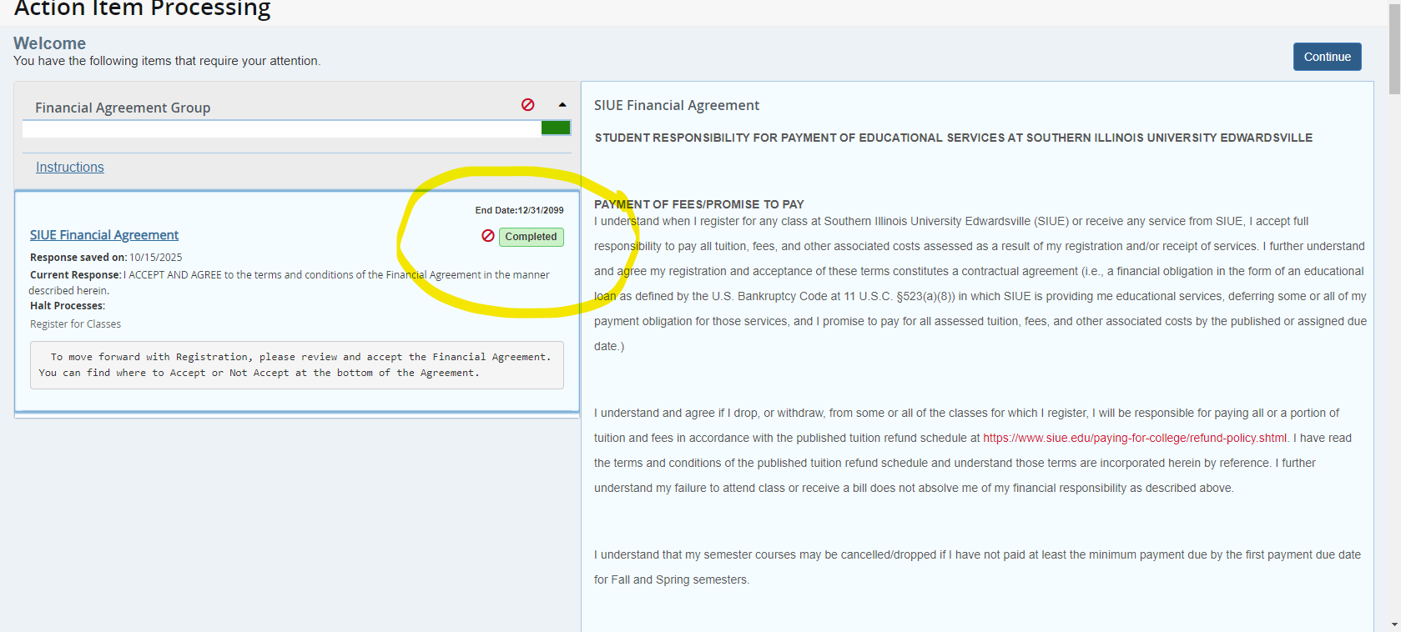

Click on the blue Continue button on the upper right, and you should now go to the registration menu.

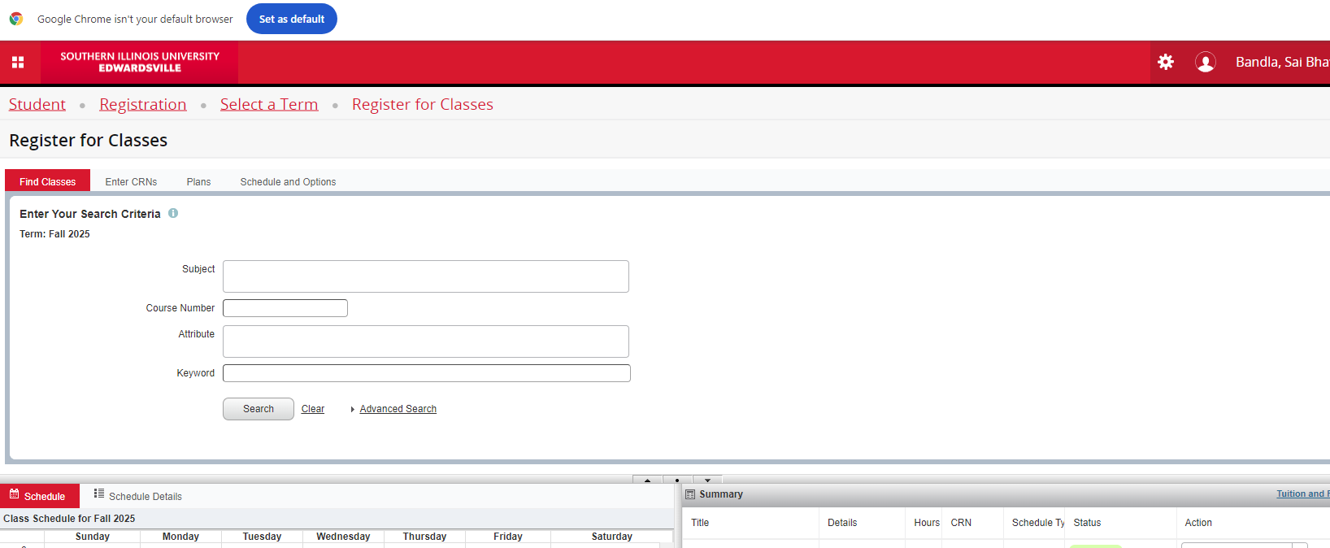

- If you do not receive the Action Item Processing pop-up, but instead go directly to registration, it means you have already accepted the financial agreement. You do not need to do anything else at this time.
- If you have other holds that prevent you from registering, you may not receive the Action Item Processing pop-up. Resolve these other holds first, then return to CougarNet to complete the Financial Agreement.
- If you are unable to register but are not being prompted with an Action Item, please contact the Office of the Registrar (servicecenter@siue.edu or via phone (618)650-2080) or the Bursar Office (bursar@siue.edu or via phone (618)650-3123) in Rendleman Hall.

