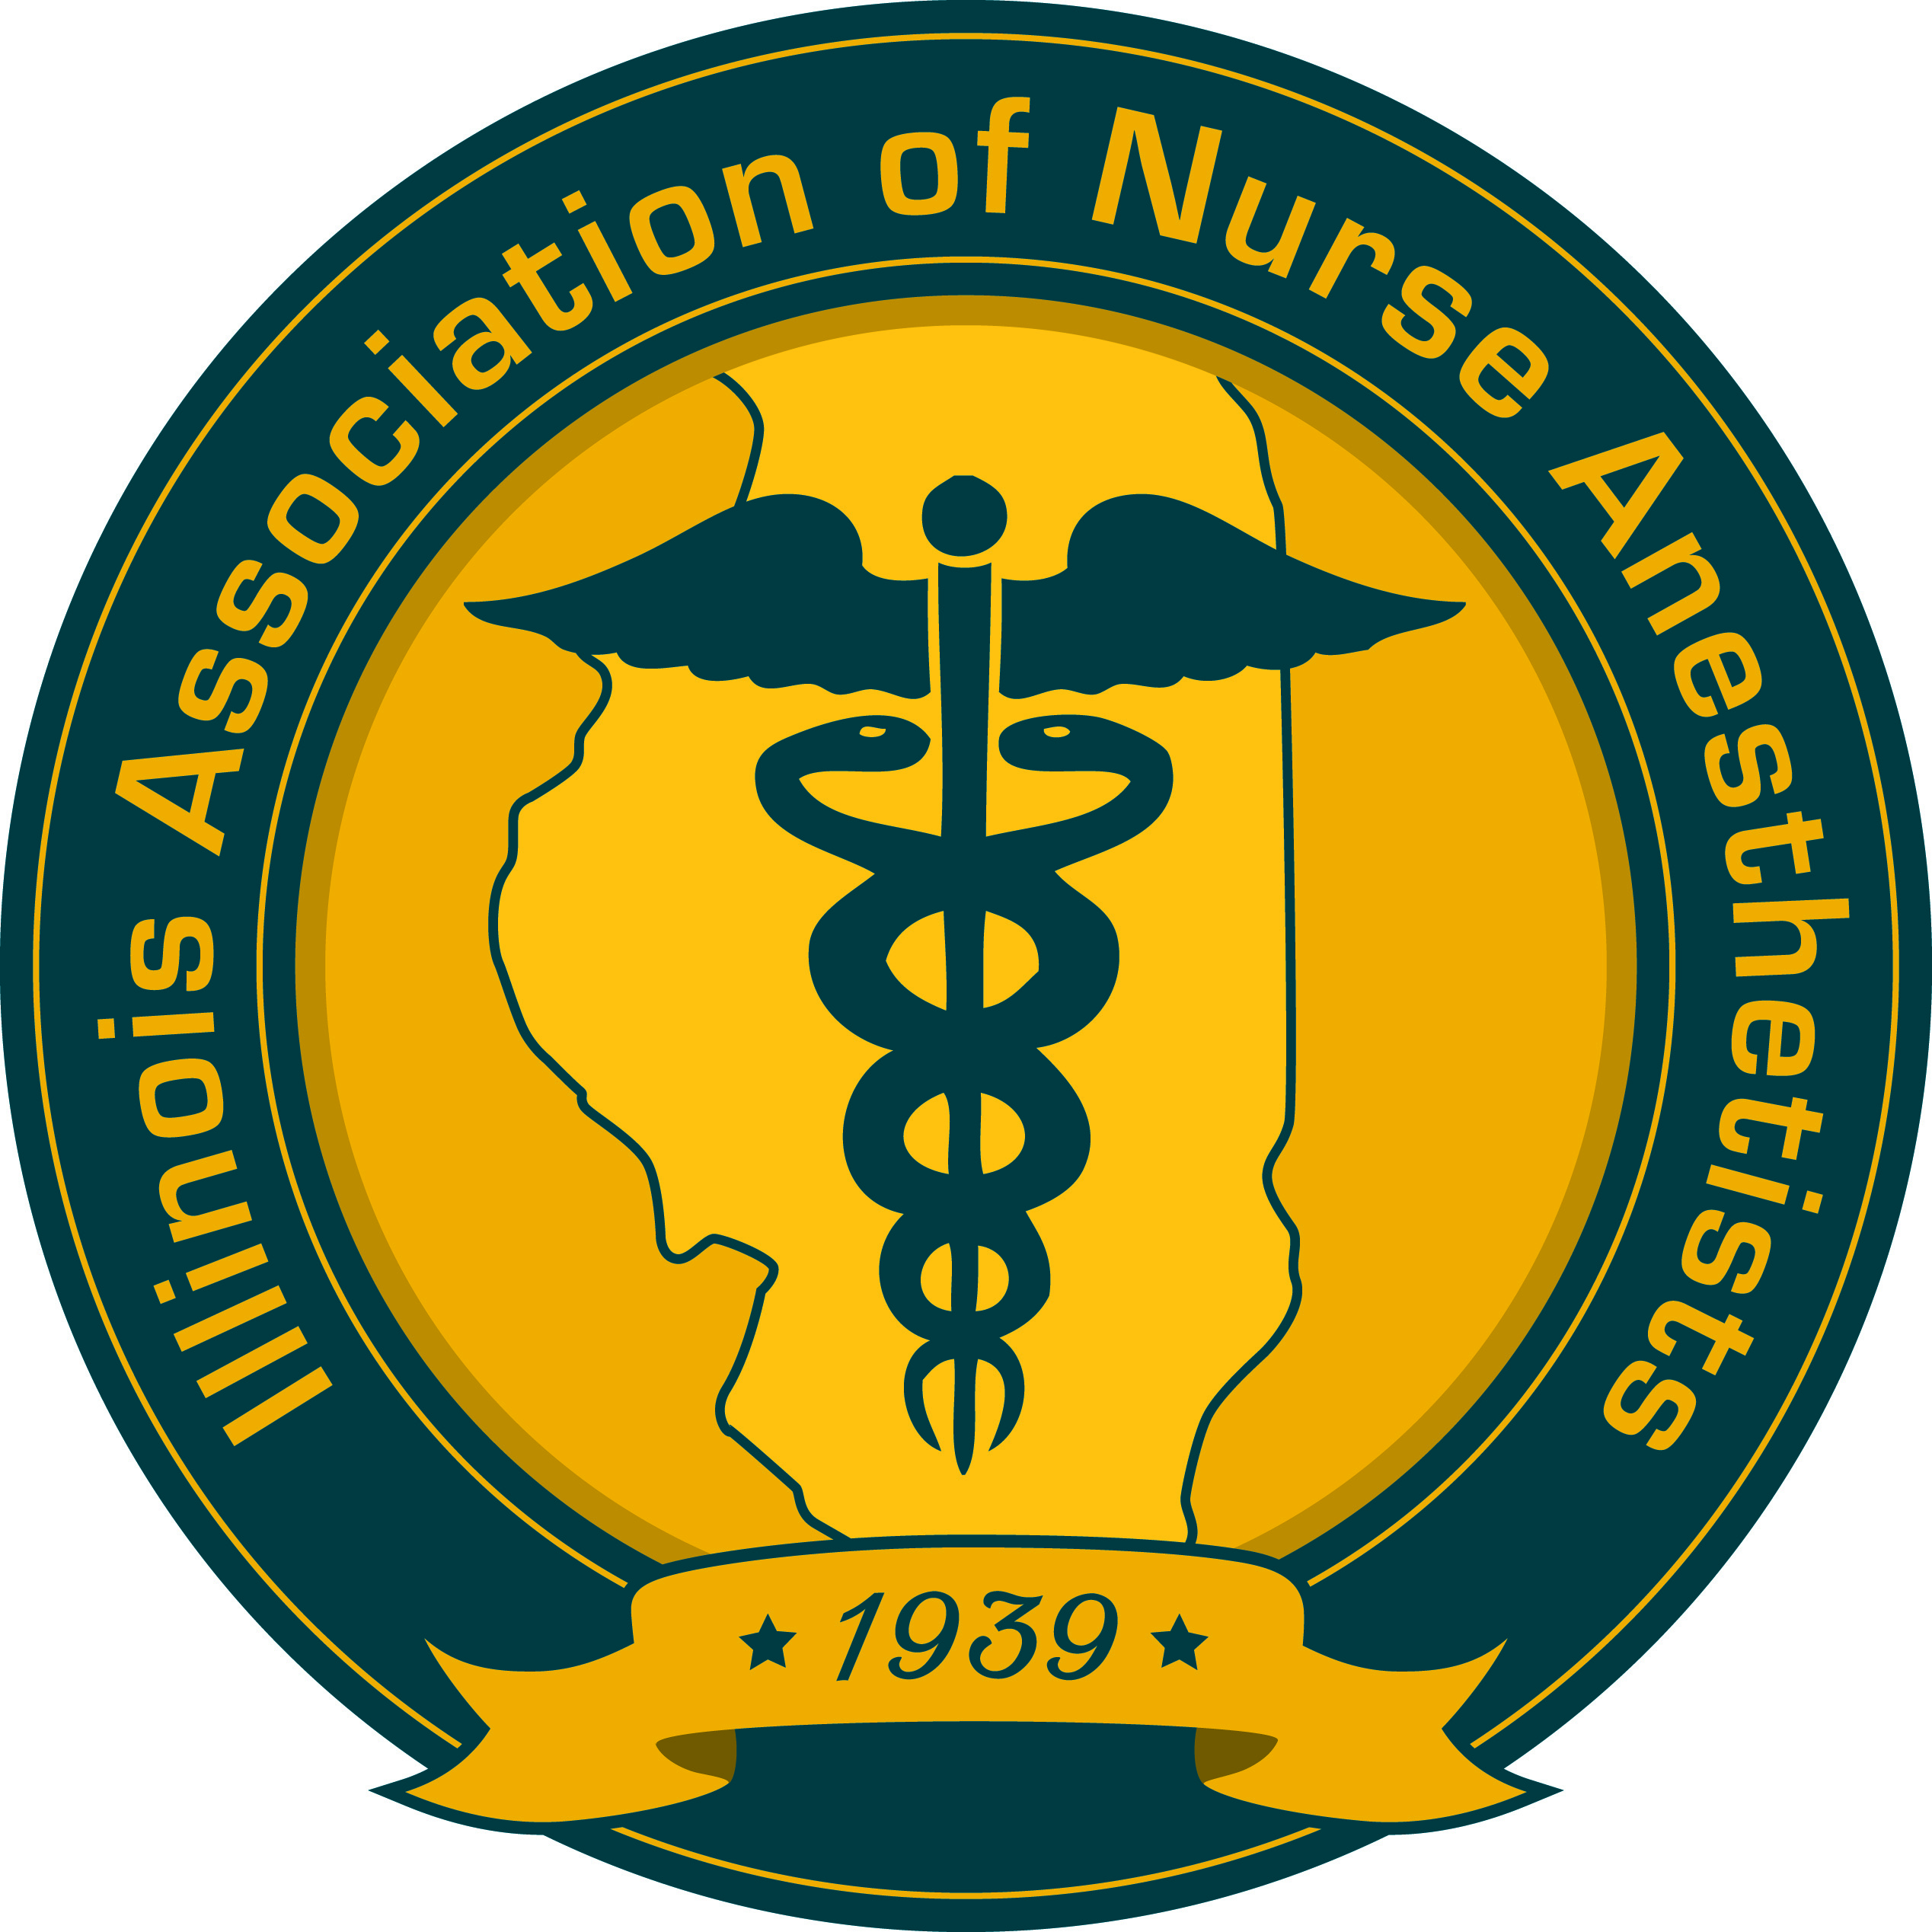
ANNUAL WINTER ACLS/BLS/PALS RECERTIFICATION COURSE
SOUTHERN ILLINOIS UNIVERSITY EDWARDSVILLE
Alumni Hall, 2nd Floor
January 29, 2022 AND January 30, 2022

ACLS/BLS/PALS – Please note this is no longer a one day event, but is a **TWO DAY EVENT.

Saturday, January 29, 2022
08:00-08:30 Registration and Continental Breakfast, Alumni Hall, 2nd Floor

08:30-08:45 Welcome and Course Orientation

08:45-09:15 (0.5 CE Credit) 1-Rescuer Adult BLS with AED

09:15-09:45 (0.5 CE Credit) 2-Rescuer Child BLS with AED

09:45-10:15 (0.5 CE Credit) Team Dynamics & High-Performance Teams Activity

10:15-10:30 Break

10:30-11:30 (1 CE Credit) Infant BLS with AED & Relief of Choking

11:30-12:00 (0.5 CE Credit) BLS for Healthcare Provider Written Exam

12:00-12:30 Working Lunch/ACLS Course Overview & Organization/
The Science of Resuscitation

12:30-14:30 (2 CE Credit) High-Quality BLS Testing Station & Airway Management Testing Station

14:30-14:45 (0.25 CE Credit) Technology Review

14:45-16:45 (2 CE Credit) Team Dynamics & Megacode Practice Station

16:45-18:00 (1.25 CE Credit) Megacode Test

18:00 (0.5 CE Credit) ACLS Test/Remediation/Adjourn

Sunday, January 30, 2022
08:00-08:30 Registration and Continental Breakfast, Alumni Hall, 2nd Floor

08:30-09:00 (0.25 CE Credit) Course Orientation & Science of Pediatric Resuscitation

09:00-10:00 (1 CE Credit) Learning/Testing Stations: Child & Infant High Quality BLS

10:00-10:30 (0.5 CE Credit) Overview of Systematic Approach Model & Team Dynamics

10:30-10:45 Break

10:45-11:45 (1 CE Credit) Case Scenario Practice with Simulations

11:45-12:15 (0.25 CE Credit) Management of Post-Cardiac Arrest Care

12:15-12:45 (0.5 CE Credit) Case Scenario Practice with Simulations

12:45-14:45 (2 CE Credit) Case Scenario Testing

14:45 (0.5 CE Credit) PALS Test /Remediation/Adjourn

ANNUAL WINTER ACLS/BLS/PALS RECERTIFICATION COURSE
SOUTHERN ILLINOIS UNIVERSITY EDWARDSVILLE
January 29, 2022 AND
January 30, 2022

Registration Form
**In order to be eligible to receive new cards, all Participants MUST bring:
- A photocopy of their current American Heart Association cards.
- The printed results of the ACLS and/or PALS pretests with a score greater than 84% on each. The only exception is if they have a printed Certificate of Completion from either the ACLS or PALS AHA Heartcode Part 1 Course instead of a current AHA Card.
Name: ________
Address: ________
City, State, Zip: _________
Telephone: Email:
AANA #:
***Payments will be processed through the SIUE Foundation as received.***
Please note this make take up to two weeks.

Select One Provider Category and the Recertification Courses Requested:
BLS ACLS PALS TOTAL
_______SIUE Student**_____$50.00 _______ $95.00 _______ $95.00 _______
_______Megacode Only***_____$35.00 _______ $95.00 _______ $95.00 _______

**Megacode Only** Initial or Expired ACLS/BLS/PALS eSimulation documentation is required; see webpage below.

Total Payment for Recertification Courses Requested: _______
Checks Payable to: SIUE Foundation.
Credit Card Payments and Registration Forms may be emailed:

Name of cardholder as it appears on the credit card
Card Type: _____MC _____Visa _____AM EX _____Discover

Credit Card # Expiration Date: CVV#
Mail Completed ACLS/BLS/PALS Registration Form with checks to:
Southern Illinois University Edwardsville
School of Nursing
Attn: Kris Heather
Campus Box 1066, Alumni Hall
Edwardsville, IL 62026
For registration information contact: Kris Heather at 618-650-2551 or kheathe@siue.edu

For Up-To-Date information please go to:
http://www.siue.edu/nursing/academic-programs/graduate/acls-bls-pals%20recertification/acls-bls-pals%20recertification.shtml
General information, course materials, requirements for Initial & Expired ACLS/BLS/PALS Certification, SIUE maps, and other course information are available online.
Program Coordinator: Leah Baecht, DNP, CRNA, APRN, SIUE Nurse Anesthesia Assistant Program Director

