Cascade Overview
Cascade Server by Hannon Hill is SIUE’s web content management system 8.14 and it is completely web based and all updates and changes to your sites and pages will be made using your web browser.

- For tutorials, tips, videos and more, visit our Web Management site: www.siue.edu/its/web/

** Cascade can be accessed from any browser or smartphone. And VPN (websafe) access is no longer required for using Cascade when not on campus.

Log into Cascade
- Open ANY browser
- Key in URL: https://cascade.siue.edu
- Press Enter
- Enter Username/Password (same as email)
- Click Login or click Enter

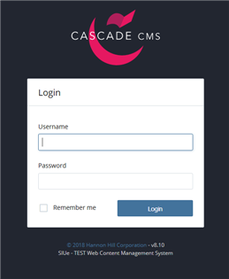

Main Window – Dashboard

You will see your Dashboard, Add Widget, My Upcoming Tasks, and My Content.
- Dashboard - your own personalized overview of your messages, tasks, content, and more.
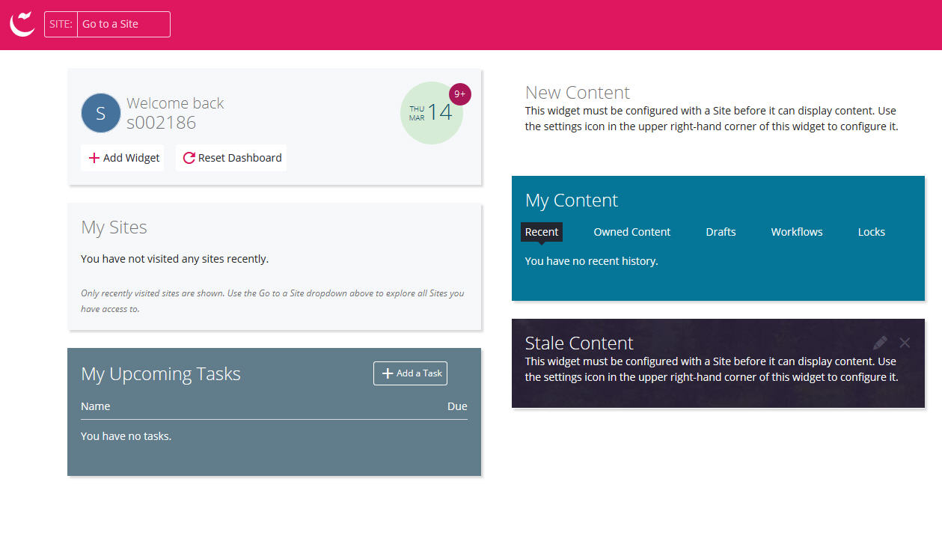
- Click Go to a Site drop down (located top left of the page) and select ‘Southern Illinois University – Edwardsville’
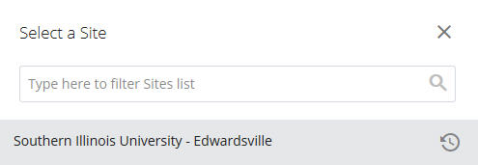

Note: Add Widgets - Allows you to grab any objective throughout the entire site and add it onto your dashboard.

- My Upcoming Tasks - Tasks shows your upcoming jobs and marked to-do items.
- New Content – The creation and modification of new content.
- Notifications – A message that informs you of any forthcoming action.
Folder Tree – This is where all of the assets are located and allows for easier expanding/collapsing of folders
- Folders
- Pages
- Files
- Blocks

Note: Click on the folder to expand (open) to view the contents of the folder.
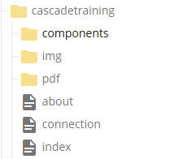

Creating a Page

- Select the folder where the page is to be located.

- Click Add Content
  - Choose from the following options:
  - Page – 1 Column
  - Page – 1 Column Minimal (with left OR right column only)
  - Page – 2 or 3 Column (with both left and right columns)
  - Page – Blank

- Enter text in the following fields (Note: All fields with a red (*) are required fields):

  - Page Name: Name that will appear in Folder Tree
  - Placement Folder: Location for new page
  - Title: Name appears in the title bar (tab) of the browser window (
    - Note: Can be seen in the title bar of the browser
  - Content: Enter content for the body of the page using the WYSIWYG (toolbar) editor
  - Click Save & Preview
  - Click Submit
  - Click Submit

Page Name: Name that will appear in URL address for Live page
- Naming convention rules:
  - Uppercase / Lowercase letters
  - Spaces allowed (instead of use an underscore or dash)
  - No special characters

Note: Display Columns: three options for displaying navigation columns on the page.
  - For a 3 column (with both left and right columns) layout, select both.
  - For a 2 column (with left column OR right column only) layout, select left or right.

** WYSIWYG allows users to easily add, edit, and format content in the body of a page.

For video on how to use the WYSIWYG features, visit http://ww.siue.edu/its/web/wysiwyg.shtml

Note: After page is created, you can check the content for errors by selecting ‘Check Content & Submit’

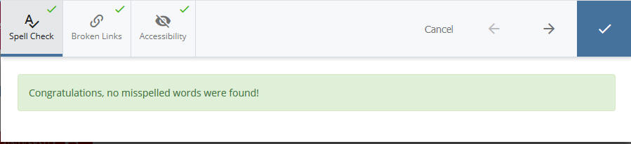

Viewing a Page
- Browse the Folder Tree and select the page to view
- Three ways to view a page by tab: Layout, Preview, or Live
  - Layout: standard view of the page
  - Preview: view of how the page will look when published
  - Live: Click the URL to open the live page in a new browser tab

Creating a link:  - Type name of link  - Highlight text for link  - Click on insert/edit link  - Choose Internal or External for link  - Click ‘Choose File, Page, or Link’  - Select File or Page  - Click Choose  - Click Target (new window)  - Click OK  - Click Preview Draft  - Click Submit  - Click Submit | 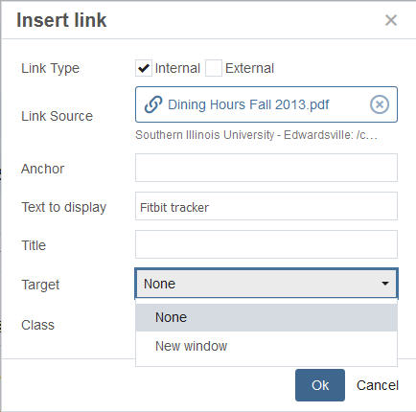

Importing a file:  (image, pdf, word, excel, video file, etc.)  - Select the folder  - Click ‘Add Content’  - Click Default  - Click File  - Click ‘Drop files here  or choose some from your computer’  - Search for file location and click on file to import  - Modify size of file (if necessary)  - Click Save & Preview  - Click Submit; Submit  - Click Publish | 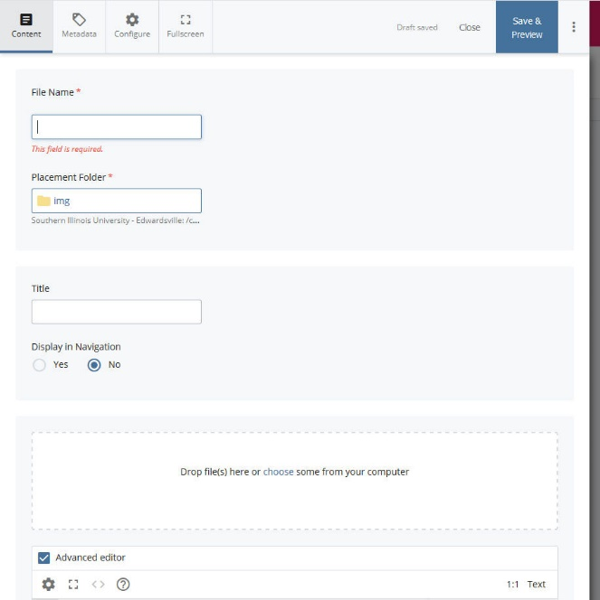

- **IMPORTANT:
  - When importing an image, make sure to resize/resample image BEFORE importing into Cascade.
  - Max width for an image in the body of a 2-column page is 700px wide.
  - Max width for an image in the body of a 3-column page is 525px wide.
  - Page Name field: Do NOT enter anything in this field (Cascade will automatically use the name of the file for the system name)

Editing a page
- Select the asset (page, image, pdf)
- Right-click on page name (within Folder Tree)
- Click edit
- Make any necessary changes within the WYSIWYG editor.
- Click Preview Draft
- Click Submit
- Click Submit
- Edit page (2) ways by:
  - Click the Edit tab OR
  - Right-click on page name then select edit.
  - Click Save & Preview
  - Click Submit
  - Click Submit

** WYSIWYG allows users to easily add, edit, and format content in the body of a page.
Note: To edit the HTML code, click the Source Code icon in the WYSIWYG editor.

Inserting an image:
- Click on insert/edit image
- Click Choose File
- Select File
- Click Choose
- Input Image Description
- Click OK

Editing a block (optional):  - Select the site folder.  - Select the components folder  - Select a block to edit (left navigation or right navigation column)  - Click edit  - Edit the content of the block.  - Click Ok  - Click Preview Draft  - Click Submit  - Click Submit | 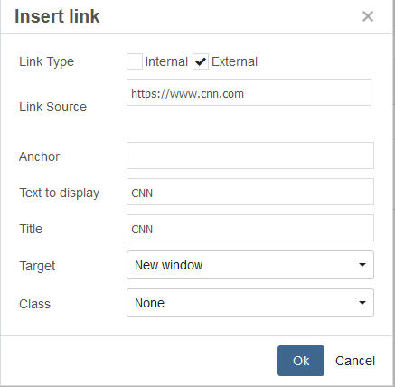

Copy an asset:  - Select the asset (page, image, pdf)  - Right-click on the asset (page, image, pdf)  - Select copy  - Enter new name in the New Page Name field  - Click copy | 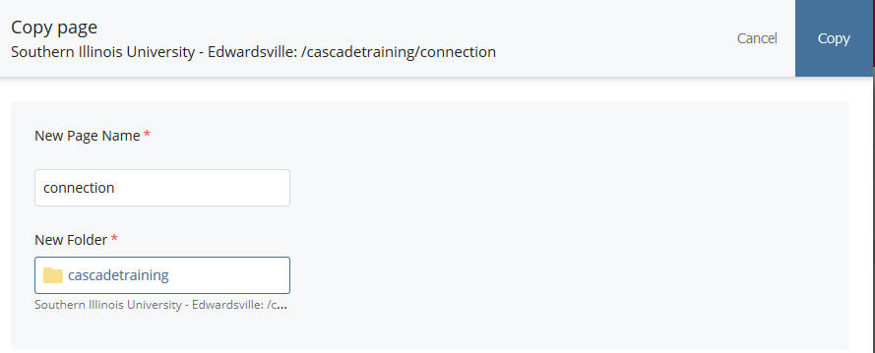

Rename an asset:
- Select the asset (page, image, pdf).
- Right-click on the asset (page, image, pdf)
- Select Rename
  - Enter a new name in the ‘New Page Name’ field and click Rename

Move an asset:
- Select the asset (page, image, pdf).
- Right-click on the asset (page, image, pdf)
- Leave the name in the Page Name field as is (OR enter a new name)
- Select New Folder for destination folder
- Click Choose
- Click Move
- OR click on file, hold, and drag to proper folder
- Click Move

Delete an asset:
- Select the asset (page, image, pdf)
- Right-click on the asset (page, image, pdf)
- Click Delete
- Click Delete

Retrieve an asset (page or file):
- Click on Trash (top left side – within Folder Tree)
- Select the file(s)
- Click 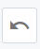 Restore

Edit a component:
(Note: Cascade users whose website is Responsive will not have access to any component folders).

Publish a page:
- Select the asset (page, image, pdf).
- Right-click on the asset (page, image, pdf)
- Click Publish
- Click Publish

Unpublish a page:  - Select the page to unpublish  - Click ‘More’ (drop-down) tab.  - Click Unpublish  - Click Submit | 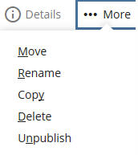

Log out of Cascade  - Click Sign Out | 