HireTouch – Access Process  Complete SARF  - Access System Access Request Form (SARF) ITS page. siue.edu/its/forms/index.shtml  - Complete form requesting the addition of HireTouch access  - Supervisor and Fiscal Officer or Unit Head must sign the form  - Send to Information Technology Services, Attn: IAM Team, Campus Box 1068, or fax to 650-3055.  ITS Process  - ITS logs request  - ITS forwards request to the HireTouch System Admin  HireTouch System Admin Process  - The System Admin will contact the requestor’s direct supervisor to confirm what role(s) are needed in the system  - The System Admin will arrange and conduct training  - The access is then completed  - Notification is sent to the Requestor and to ITS that the access has been granted and completed  New Admin User Accesses HireTouch  - The new Admin user can access HireTouch at https://siue.hiretouch.com/admin  - They are redirected to the Central Authentication Service (CAS) login page  - Login credentials are the Network login & password | 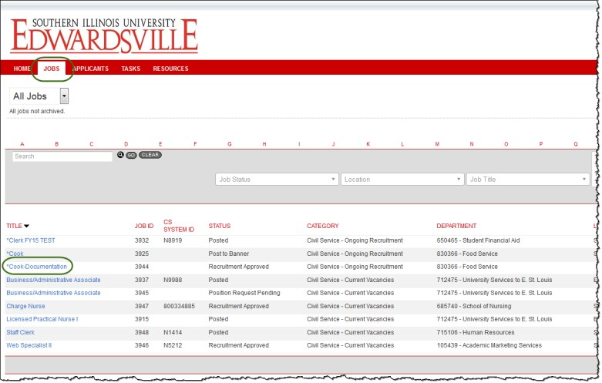  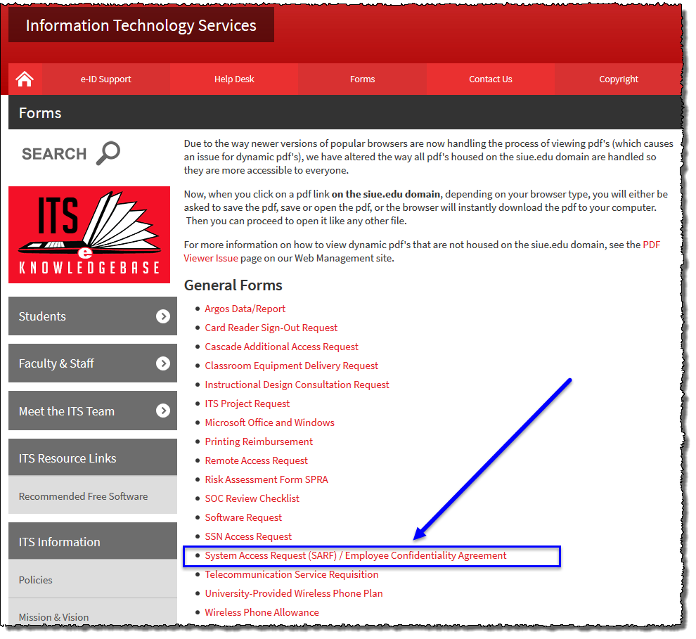  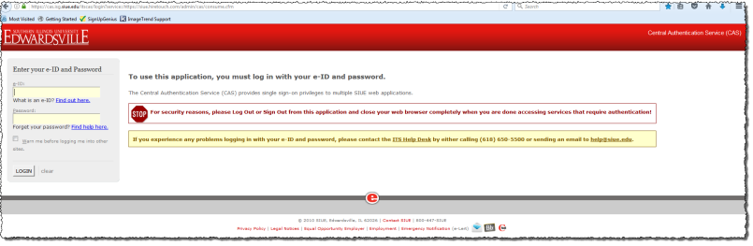

Additional Resources

Phone Numbers
- Human Resources: (618)650-2190
- ITS Help Desk: (618)650-5500
Web Sites
- Human Resources Employment: http://www.siue.edu/employment
- Human Resources: http://www.siue.edu/human-resources
- ITS: http://www.siue.edu/its
Email Addresses
- ITS Help Desk: help@siue.edu
- Human Resources Systems Group: systemsHR@siue.edu

