Proposal Processing Timeline Tool
ORP offers a tool to help faculty sketch out a timeline for their development of a proposal to ensure that all proposal elements are completed and uploaded into Kuali Research by the required 10-day window. This tool generates a series of deadlines for the proposal to be prepared, reviewed, and approved. To access this tool, visit http://www.siue.edu/funding/external-funding/pre-award/timeline.shtml.
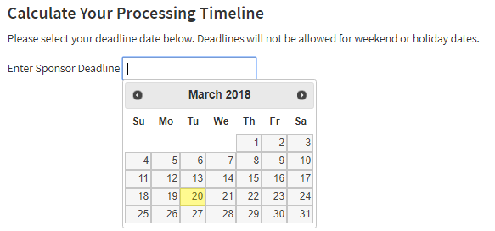
Here are some tips to troubleshoot any errors preventing the tool from generating deadline dates:
- Ensure that you select a business day for your proposal due date. If you select a weekend day, you will receive this error:
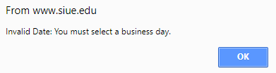
- If your deadline falls on the weekend, consult your solicitation guidelines or program officer for clarification. Typically for National Institutes of Health and National Science Foundation funded projects, proposals are due on the business day following the solicitation’s listed due date.
- If the calendar does not open when you click in the box next to Enter Sponsor Deadline, ensure that your browser is up-to-date, make sure JavaScript is enabled, and try disabling your ad-blocker.
- If you need to change the date that you selected on the calendar, and the tool will not update the corresponding deadline dates after selecting a new date, try refreshing your browser or deleting the date in the box manually and try to select the correct date again.

