Susan M. Morgan, Ph.D., P.E.

Title: Associate Dean for Research, ORP; Professor of Civil Engineering
Institution: Southern Illinois University Edwardsville
Email: smorgan@siue.edu
Phone: 618-650-2171
Web: none

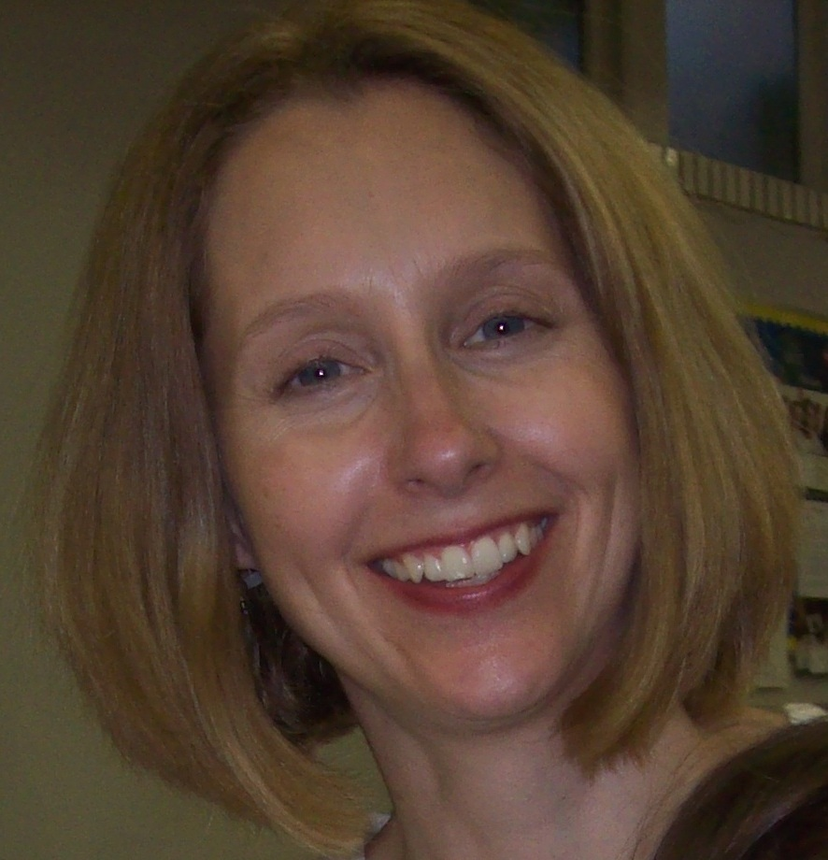

- What are your current 3 main areas of research?
- Stormwater management, including bioretention and green roofs/walls
- Environmental engineering outreach
- Waste management

- What are the top 3 areas of expertise/tools you are looking for in a research collaborator?
- Pre-K – 12 education and/or educational outreach expertise
- Hydrologic analysis and/or modeling expertise
- Chemistry of nutrients and/or metals expertise

- What 3 skills/tools that you have access to are you willing to share with a potential research collaborator?
- Collaboration experience with the local environmental engineering community, including MSD
- Writing and editing skills for proposals and journal articles
- Environmental engineering laboratory, including field sampling equipment

