Table of Contents
PILOT PROJECT REQUIREMENTS 1
POSTGRADUATE RESIDENT RESEARCH PROJECT REQUIREMENTS 3
ADVANCED INVESTIGATION AWARD REQUIREMENTS 4
DEAN’S STUDENT RESEARCH FELLOWSHIP (DSRF) PROGRAM 6
A. Requirements 6
B. DSRF Application Procedures: 7
C. Specific Requirements for the DSRF: 9
Format for ALL SDM Proposals 10
A. Cover Sheet 10
B. Abstract: 10
C. Introduction and Background 11
i. Statement of the problem or question 11
ii. Hypothesis: 11
iii. Specific objectives 11
iv. Significance 11
v. Literature review 12
vi. Innovation (if applicable 12
D. Approach (Materials and Methods) 13
i. Methodology 13
ii. Description of research space and equipment 14
i. Justification for each item in budget 18
iv. Personnel 19
F. Appendices 19
iv. FOR DSRF STUDENTS 19
FOR DSRF STUDENTS 20

PILOT PROJECT REQUIREMENTS
Full-time SDM faculty members interested in developing a research program are encouraged to apply for SDM Pilot Project funding. Faculty members who are relatively inexperienced in developing and/or conducting research programs are strongly advised to seek mentorship from faculty members with established research experience. Submission may be a maximum of three double-spaced, typed pages excluding bibliography, curriculum vitae, and appendices).
Only full-time faculty members are eligible to serve as a Principal Investigator (PI) on a Pilot Project. Part-time faculty may serve as co-investigators.

If a student worker is a Research Assistant on the project, they will be required to complete online and classroom training in the responsible and ethical conduct of research for undergraduate students, graduate students, and postdoctoral researchers. Requests for Responsible Conduct in Research (RCR) Training should be directed to the Office of Research.

Not more than two funded pilot projects per year will be awarded to any PI. After receipt of the second Pilot Project award (second year of funding), the minimum requirement for being considered for subsequent SDM research funding is either the acceptance of an abstract (by the PI) for presentation at a state, national, or international symposium or a refereed publication. No further research applications will be reviewed until this minimum criterion is met.

If the PI is unable to fulfill the above requirement, the Research Committee reserves the option to seek recommendation from the PI’s department chair so that a research mentor may be assigned for the design and preparation of subsequent research proposals.
A progress or final report for the funded project(s) must be submitted to the SDM Research Committee upon completion of the project. The PI will be held responsible for submitting this report when it is due. If the PI is unable to complete the final report, the Co-Investigator is responsible for finishing the project or submitting a final report explaining why the project cannot be completed. This report can be prepared in any of the following formats:
1) copy of a published abstract (journal or meeting)
2) draft of a submitted manuscript
3) reprint of a published manuscript
4) copy of a submitted external grant application
5) a detailed outline (1-3 pages) of the research performed. This format should include a detailed description of any methodologies that were not included in the original proposal. Figures and figure legends are required.

POSTGRADUATE RESIDENT RESEARCH PROJECT REQUIREMENTS
It is required for Postgraduate Residents interested in developing a research project to submit the application to the Research committee for approval before starting their project. It is applicable for projects that require and do not require funding.

The application documentation should include the completed cover sheet and a project proposal following the format provided by the SIU SDM Office of research. Submission may be a maximum of five double-spaced, typed pages (excluding bibliography, curriculum vitae, and appendices).

Only full-time faculty members are eligible to serve as the Principal Investigator (PI) on the Postgraduate Research Projects. Residents and other Faculty members participating in the project will serve as co-investigators.

For clinical projects, it is requested that a clinical faculty member of the postgraduate program participate as a faculty mentor or co-investigator. The faculty mentor must communicate with the clinic and/or the business office and follow the appropriate protocol if incentives will be given or clinical procedures will be performed on patients.

Projects that involve human subjects will need to be submitted to the SIUE Institutional Review Board in addition to the SDM Research Committee. All investigators may be required to complete Responsible Conduct in Research Training. Please contact the SDM Research Office with any questions.

A progress or final report for the funded project(s) must be submitted to the SDM Research Committee upon completion of the project. The resident will be held responsible for submitting this report when it is due. If the resident is unable to complete the final report, the PI and Co-Investigator are responsible for finishing the project or submitting a final report explaining why the project cannot be completed. This report can be prepared in any of the following formats:
1) copy of a published abstract (journal or meeting)
2) draft of a submitted manuscript
3) reprint of a published manuscript
4) A detailed outline (1-3 pages) of the research performed. This format should include a detailed description of any methodologies that were not included in the original proposal. Figures and figure legends are required.

ADVANCED INVESTIGATION AWARD REQUIREMENTS
The Advanced Investigation award mechanism is designed to provide funding to full-time SDM faculty to support and extend established research programs.

Only full-time faculty members can serve as a Principal Investigator on a project. Part-time faculty may be assigned as co-investigators. Submission may be a maximum of ten double-spaced, typed pages (excluding bibliography, curriculum vitae, and appendices).

All undergraduate and graduate students paid by internal or external research grants will be required to complete training in the responsible and ethical conduct of research for undergraduate students, graduate students, and postdoctoral researchers.

Any given PI may receive a maximum of two concurrent Advanced Investigation awards. To be considered for a second Advanced Investigation Award (either for the same project or a new one), the PI must have either

- submitted an abstract to IADR/AADOCR or an equivalent national or international meeting, or
- published the data generated because of the Advanced Investigation Award(s) in a peer-reviewed journal.

After receipt of a second Advanced Investigation Award, subsequent Advanced Investigation awards may be given providing that the PI has fulfilled at least one of the following:
- obtained external funding to support his/her research, and/or
- published the data generated because of the Advanced Investigation award(s) in a peer-reviewed journal and/or
- presented a poster at a national conference or Research Day

If the faculty member has not been able to generate sufficient data, a discussion with the research committee and the Assistant Dean for Research to determine a solution will be scheduled and a plan of action will be generated.

A progress or final report for the funded project(s) must be submitted to the SDM Research Committee upon completion of the project. The PI will be held responsible for submitting this report when it is due. If the PI is unable to complete the final report, the Co-Investigator is responsible for finishing the project or submitting a final report explaining why the project cannot be completed. This report can be prepared in any of the following formats:
- draft of a submitted manuscript
- reprint of a published manuscript
- copy of a submitted external grant application
- Poster presentation at a conference or at Research Day
- a detailed outline (1-3 pages) of the research performed. This format should include an in-depth description of any methodologies that were not included in the original proposal. Figures and figure legends are required.

DEAN’S STUDENT RESEARCH FELLOWSHIP (DSRF) PROGRAM
- Requirements
Applications are invited from students who wish to participate in research sponsored by SDM faculty. The DSR fellowships will be awarded on a competitive basis as determined by the merit of each research proposal. This program is designed to introduce students to research with SDM faculty mentors. Details of the research program and how to apply are given below.

Eligible Students: All year I, II, and III students who are in good academic standing are eligible.

Term of Award: May 19 through November 22, 2025 (break from July 15 to August 14)

Travel: Students who have abstracts accepted to the 2025 combined meeting of the American Association for Dental Research and International Association for Dental Research can apply for travel funds through the SDM Office of Research.

Stipend: $3,000.00* per accepted project (Fellows will be paid in bi weekly installments)
*Max of 6 full stipends.

DSRF Application Procedures:
- Each applicant must have a full-time faculty sponsor who will supervise the project. It is expected that the faculty sponsor would have a good research record or show promise of research productivity as exemplified by past research performance. The student or the faculty sponsor may be the source of the research idea. For those students who plan to utilize clinic materials or patients, a clinical faculty member must be at least one of your sponsors. You may have two sponsors in that case: a biomedical faculty member and a clinical faculty member.
- A brief prospectus (2-3 sentences) of the project must be submitted to Michelle Shatto (mshatto@siue.edu / Bldg. 279) on the attached Prospectus form by December 20, 2024. This will provide the Research Committee with information on the number of students applying and the types of projects being proposed. The Research Committee will review each prospectus to ensure that the project, student's academic standing, etc., conform to the principles and guidelines of the program. The Committee may offer suggestions, if appropriate, before the full proposal is prepared.
- The full Research Proposal must be submitted to Michelle Shatto (mshatto@siue.edu / Bldg. 279) by 4:30 p.m. on February 7, 2025, for distribution to Research Committee members. The format and information concerning proposal preparation, along with appropriate Cover Sheet and Budget Form, are included with this handout. NOTE: The Research Proposal (section #2 – Specific Aims and Research Strategy) may only be a maximum of three single-spaced, typed pages Upon submission, the proposal must be in final, TYPED form. There will be no exceptions or extensions.
- Submission of the Prospectus and Research Proposal MUST BE a joint effort by the student and faculty member. Student experience in grantsmanship is considered part of the research experience. A written statement should be included in the proposal stating what contribution the faculty member and the student will make to the project. The detailed submission format to be used for the application is provided below.
- Criteria for evaluating each full proposal are outlined in the following table:
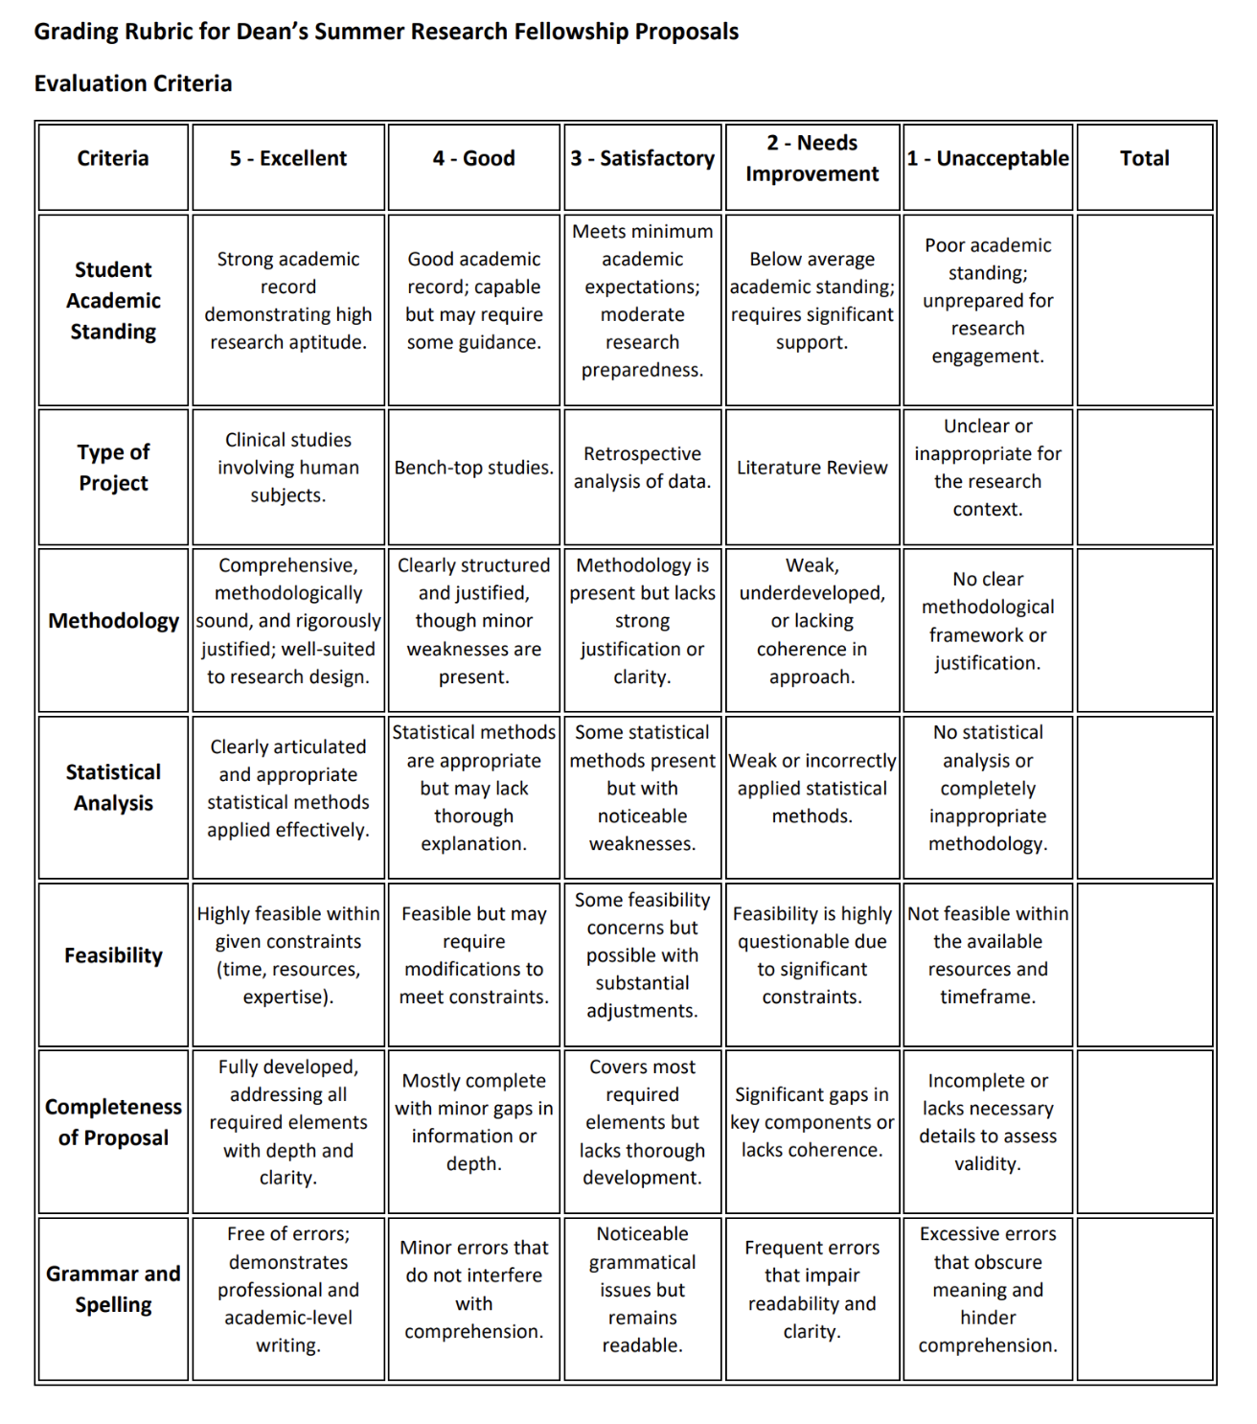

Specific Requirements for the DSRF:

- The student must be in good academic standing.
- All full-time faculty members are eligible to sponsor Dean's Student Research Fellows. Part-time faculty may be eligible to sponsor a Dean’s Student Research Fellow if approved by the Research Committee.
- The research project must be designed (sufficiently limited in scope) to be completed in a 10-month period.
- The student must present a progress report at a meeting of all Fellows, sponsors, students, and faculty to be held during September 2025. The exact date will be determined after participants are selected. A 10-minute oral presentation along with a written progress report will be required of each DSR Fellow at that time.
- The student must present a poster describing the project and its results at Research Day on April 14, 2026. The final written report will be due at this time. This report will be a printed copy of the poster that is suitable for publication in a brochure. If no final report is submitted, both student and sponsor(s) will be ineligible for further participation in all SDM research projects until such a report is on file.

Format for ALL SDM Proposals
  - Cover Sheet: The cover sheet includes a brief yet explicit title for the research project. Use appropriate cover sheet for each type of proposal (Pilot project, AIA, Resident Research, DSRF). Acquire signatures of all listed personnel. Note: P.I. must be a full-time faculty member. Part-time faculty members may be included as co-investigators. For resident research projects, list the resident as the Co-P.I.
  - Abstract: The abstract should be a self-contained description of the project. It should contain information about the significance, broad objectives, hypotheses, specific aims, and methods to be employed. The abstract should use lay language as much as possible. Assume that all reviewers, not just those assigned to your application, will read the abstract. if the grant is funded. Do not include graphs or images in the abstract. Most abstracts state: (1) the general purpose, (2) specific goals, (3) research design, (4) methods, and (5) significance (contribution and rationale). Be as explicit as possible in your abstract.
  - Introduction and Background: The introduction should cover the key elements of your proposal, including a statement of the problem, the purpose of research, research goals or objectives, and significance of the research.
    - Statement of the problem or question: The statement of problem should provide a background and rationale for the project and establish the need and relevance of the research. How is your project different from previous research on the same topic? Will you be using new methodologies or covering new theoretical territory?
    - Hypothesis: A strong proposal is driven by a strong hypothesis(es) that leads to clear research objectives. Clearly state your hypothesis.
    - Specific objectives:
      - The research goals or objectives should identify the anticipated outcomes of the research and should match up to the needs identified in the statement of problem. List only the principal goal(s) or objective(s) of your research and save sub-objectives for the project narrative.
      - Do your objectives address the problem or question? Did you state your hypotheses and link them appropriately to your objectives? Are the objectives clearly related to each other? Do the objectives represent an achievable amount of work?
    - Significance:
      - Using no more than two or three sentences, describe the relevance of this research to public health.
      - In this section, be succinct and use plain language that can be understood by a general, lay audience. In this section, state the research problem, current state of knowledge, and potential contributions of the research to the field. Explain the importance of the problem or critical barrier to progress in the field that the proposed project addresses. Explain how the proposed project will improve scientific knowledge, technical capability, and/or clinical practice in one or more broad fields. Describe how the concepts, methods, technologies, treatments, services, or preventative interventions that drive this field will be changed if the proposed aims are achieved. Consider the following questions. Does this study address an important problem? Will it resolve an important controversy in the field? If the aims of the application are achieved, how will scientific knowledge or clinical practice be advanced? What will be the effect of these studies on the concepts, methods, technologies, treatments, services, or preventive measures that drive this field
    - Literature review:
      - Readers want to know whether you've done the necessary preliminary research to undertake your project. Readers want to see your evaluation of pertinent works.
      - Literature reviews should be selective and critical, not exhaustive. It should contain an evaluation of the literature and identify the gap that this project will fill. The literature review should provide only that information that directly pertains to the scientific need for your project and should reflect up-to-date knowledge of the field.
    - Innovation (if applicable):
      - Consider the following questions. Is the project original and innovative? For example, does the project challenge existing paradigms or clinical practice? Does it address an innovative hypothesis or critical barrier to progress in the field? Does the project develop or employ novel concepts, approaches, methodologies, tools, or technologies for this area?

D. Approach (Materials and Methods)

i. Methodology
- Justification for each method:
        - This section is critical for demonstrating that you have developed a clear, organized, and thoughtful study design that tests the central hypothesis.
        - The methodology should supply all the details of the project, including a detailed statement of problem, research objectives or goals, hypotheses, methods, procedures, outcomes or deliverables, and evaluation and dissemination of the research. For this section, pre-empt and/or answer all the reviewers' questions. Don't leave them wondering about anything. For example, if you propose to conduct unstructured interviews with open-ended questions, be sure you've explained why this methodology is best suited to the specific research questions in your proposal. Or, if you're using item response theory rather than classical test theory to verify the validity of your survey instrument, explain the advantages of this innovative methodology. Or, if you need to travel to Valdez, Alaska to access historical archives at the Valdez Museum, make it clear what documents you hope to find and why they are relevant to your historical novel on the '98ers in the Alaskan Gold Rush.
        - Clearly and explicitly state the connections between your research objectives, research questions, hypotheses, methodologies, and objectives.

ii. Description of research space and equipment
1. Human subjects or Vertebrate animals (if applicable)
        - If you answer "yes" to human subjects' involvement, you will need to have an IRB approval letter before the proposal is funded. Go to this link for SIUE’s IRB guidelines: https://www.siue.edu/compliance/human-subjects/pdf/IRBProtocolGuidance.pdf
        - There is one scenario regarding human subjects’ involvement in which it is not always clear whether to answer "yes" to human subjects involvement. If you plan to study biological specimens or data received from living individuals, and the data were originally collected for another purpose, and you do not have access to the identities of these individuals, then the answer to the "human subjects research" question is more complicated. In this scenario, your project will fall into one of the following categories: a) NOT human research orb) "yes" to human subjects research but exempt under exemption #4. Exemption #4 is research involving the collection or study of existing data or specimens if recorded by the investigator in a way that subjects cannot be identified. If your study fits this description because you are using de-identified data or specimens, then you are required to consult the SIUE Institutional Review Board to make the proper determination on the category of your research. This does not mean you need the IRB approval before you submit your proposal. It means that the IRB will guid you to reporting the correct category for your project. Once you know the correct category, you can proceed to do the relevant human subjects write-ups for the proposal. Below is information on the required written sections.
        - If you are doing Human Subjects Research (no exemptions): In this case you must write three sections in your proposal, as follows:
          - Proposed Use of Human Subjects: Provide information in 6 issues: (1) the characteristics of the subjects; (2) the sources of research materials; (3) recruitment plans and consent procedures; (4) potential risks; (5) procedures for protecting against or minimizing potential risks; and (6) potential benefits to subjects and to humans.
          - Inclusion of Women and Minorities: Discuss the demographics of the minority populations in the area and the criteria and rationale for selection of sex and racial/ethnic group, as well as your plan for recruiting/including women and minorities in the research.
          - Inclusion of Children: Discuss the participation of children and explain the rationale if children are to be included.
        - If your Human Subjects Research is Exempt under Exemption 4: In this case, you need only describe the human subjects work you will do involving specimens or data, where and how you will collect the data, and clearly justify the exemption.
        - If your project is not considered Human Subjects but you’re using human specimens or data: In this case, you must justify why the project is not considered human subjects even though you are studying data or specimens from living beings. This determination will have been made by the IRB, which can help you with the justification.
        - Vertebrate Animals: If vertebrate animals are involved, you will need to submit an IACUC proposal approval. In addition, address each of the five points below. Be succinct.
          - Provide a detailed description of the proposed use of the animals in the work outlined in the Research Strategy section. Identify the species, strains, ages, sex, and numbers of any animals to be used in the proposed work.
          - Justify the use of animals, the choice of species, and the numbers to be used. If animals are in short supply, costly, or to be used in large numbers, provide an additional rationale for their selection and numbers.
          - Provide information on the veterinary care of the animals involved.
          - Describe the procedures for ensuring that discomfort, distress, pain, and injury will be limited to that which is unavoidable in the conduct of scientifically sound research. Describe the use of analgesic, anesthetic, and tranquilizing drugs and/or comfortable restraining devices, where appropriate, to minimize discomfort, distress, pain, and injury.
          - Describe any method of euthanasia to be used and the reasons for its selection. State whether this method is consistent with the recommendations of the American Veterinary Medical Association (AVMA) Guidelines on Euthanasia. If not, include a scientific justification for not following the recommendations.
- Statistical analysis: State how the data will be collected, analyzed, and interpreted. Describe statistical techniques that will be used. For the DSRF: A detailed description of the statistical analyses to be used. All students must consult with a statistician and provide detailed description of the statistical analyses that will be performed. The SDM Office of Research recommends that the expertise of Dr. Robb VanPutte (rdvanput@mckendree.edu) be used to complete the appropriate statistical methodologies

- Timeline of project
a. Include a proposed timeline for completing the work. Discuss potential problems, alternative strategies, and benchmarks for success anticipated to achieve the aims.
b. When will you begin and complete each step? It may be helpful to reviewers if you present a visual version of your timeline. For less complicated research, a table summarizing the timeline for the project will help reviewers understand and evaluate the planning and feasibility.
E. Budget: The budget spells out project costs and usually consists of a spreadsheet or table with the budget detailed as line items and a budget narrative (also known as a budget justification) that explains the various expenses. The amount of money requested should reflect the scope of the science proposed.

i. Justification for each item in budget
- A specific budget justification must be provided for all equipment requests exceeding $500
- Provide an explanation for use of each item in the budget
- For Pilot Projects the limit is approximately $2,500 which can be used for: Commodities, Contractual Services, or Equipment (up to $500)
- FOR AIA the limit is approximately $5,000 which can be used for: Commodities, Contractual Services, or Equipment (up to $500*)
* In special circumstances, an investigator may request an equipment budget up to $1,000 (total budget limit for AIA shall not exceed $5,000). A budget justification must be provided for all equipment requests exceeding $500. Following review by the Research Committee, recommendations for equipment funding will be forwarded to the Dean for final approval.
4. For Resident the limit is approximately $1,250 which can be used for: Commodities, Contractual Services, Student Wages, or Equipment (up to $500).
5. For DSRF A maximum of $1,500.00 may be available to each student researcher for the purchase of supplies to support their project, Student investigators are limited to COMMODITY items (e.g., lab supplies) and CONTRACTUAL SERVICES (e.g., payment for services). Equipment cannot be purchased. Equipment is defined as an item which is not expendable, cannot be used up, and costs more than $100.

iv. Personnel
List the duties of everyone involved in the project

F. Appendices
i. Complete Bibliography
- Two-page (abbreviated) curriculum vitae for P.I. and each co-investigator (if not already on file with the Office of Research; provide updated CV if significantly different from the one on file)
- Additional relevant information including photos, charts, graphs, etc. (Optional)
- FOR DSRF STUDENTS: Training
  - If radioactive compounds, animal care or human subjects will be required in your project, additional online training will need to be done before starting your project. The training will provide a certificate that should be forwarded to the SDM Office of Research (Building 279, Room 1108). All DSRF Fellows will be required to complete an online training course in chemical safety and an online training in the responsible and ethical conduct of research.
      - In addition, for human research, your proposal must be approved by the Institutional Review Board (IRB) at SIUE. For all vertebrate animal research, your proposal must be approved (or fall within an already approved proposal) by the SIUE Institutional Animal Care and Use Committee (IACUC).
FOR DSRF STUDENTS Sponsor Statement (to be included with signature and date)

"I certify that I have read the proposal and concur with the student that this work has not been done previously. I agree to act as a faculty advisor for this project. I will provide or arrange for the necessary space and facilities to conduct this project. In addition, I will ensure that the student submits a printed copy of the poster suitable for publication in a brochure and presents a table clinic based on the results of this project."
Signature Date

NOTE: If grants are co-sponsored by more than one faculty member, all faculty sponsors must sign the above statement. Failure to meet the outlined requirements will jeopardize future proposals submitted by the faculty member.

FOR DSRF STUDENTS Student Statement (to be included with signature and date)

"I agree to abide by the rules of the contract I will sign as an employee of the University. I agree to submit a printed copy of the poster suitable for publication in a brochure and present a table clinic based on the results of this project."
Signature Date

FOR ALL PROPOSALS utilizing Axium IT Statement (to be included with signature and date

“I have consulted with ______________ (student) and ________________ (faculty sponsor) and have determined that the patient data in question is available for analysis and able to be deidentified.”
Signature_________________________________ Date_________________

