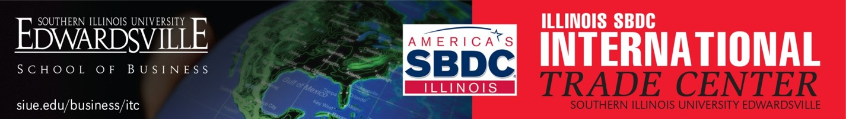

EXPORT NOW 2022

COMPANY NAME:
ADDRESS:
CITY: | STATE: | ZIP:
TELEPHONE: | FAX:
PARTICIPANT’S NAME: | TITLE:
E-MAIL: | WEBSITE:
INDUSTRY- PRODUCT DESCRIPTION:

Product Information
- Your Dun & Bradstreet Number if known. Dun & Bradstreet Number can be found at www.dnb.com.

- Your NAICS Code
This is the North American Industries Classification Systems (NAICS) number that describes what your company does. If you do not know your NAICS code, please 1) Check your Dun&Bradstreet listing; and/or 2) Search for the applicable code at https://www.census.gov/eos/www/naics/
- Your Harmonized Code/Schedule B number, if known:

This is a 10-digit number describing your product. It is an internationally standardized product classification code system. Often called the Harmonized System or HS Code. You can often find yours on current shipping documents you are submitting. More info at: https://www.trade.gov/harmonized-system-hs-codes

Company Information

- Briefly describe your market/customers:

- Your Export Revenue Goal

- Current Export International Revenue

- Current International % of Total Revenue

- Briefly describe your past export experience:

- Are you currently receiving international sales inquiries? From Where?

- What countries do you currently sell to?

- Any specific Target Countries of interest?

- What do you see as your company’s key challenges in exporting/international sales?

- Approximate budget available to invest in developing / expanding your company’s export strategy? Consider time, $ budget.

- What do you hope to achieve through your participation in EXPORT NOW?

Please send this form to: International-Trade-Center@siue.edu
Thank you for your interest in participating in Export NOW 2022!

