Trip to China - An Unforgettable Experience!
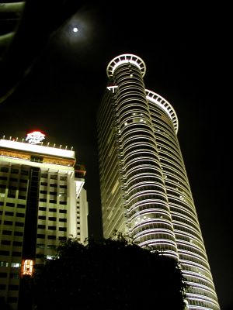
Xiamen is such a beautiful city! No wonder it is described as the “Garden on the sea.” The climate is just perfect. The buildings are so elegant and the skyscrapers are so beautiful. “The first thing you would notice,” according to Katie Miller and Jeff Rule, two students who participated in the May 2006 travel study course to Xiamen and Shanghai, China, “is the clean and tidy environment - so neat you would wonder if the streets were ever littered.” Jeff said that he made some wonderful friends that he would never forget, yet it all ended too soon. As far as Katie is concerned, “The trip to China was a trip of a lifetime, and if I got the opportunity, I would do it again in a heartbeat!”
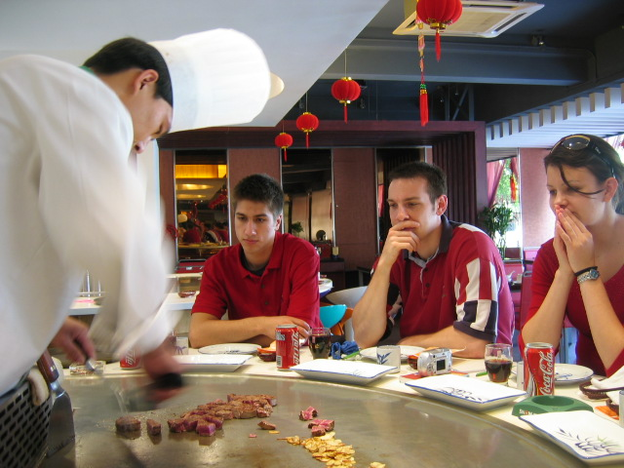
These are just some of the impressions SIUE students had about Xiamen, China when they participated in the Office of International Programs’ fourteen-day travel study program to Xiamen and Shanghai earlier this year. Of course it was not a relaxing vacation. There was much to learn, and the students kept busy, but Katie and Jeff said that the environment was so welcoming that learning was fun. The students also visited Suzhou University. They said that even though it was a short visit, they were able to interact with the students there. Suzhou University is located in the ancient city of Suzhou that is famous for its classical gardens and is known as the “Paradise on Earth.”
Upon returning to America, the students recommended the program, saying that it was a great learning experience, very beneficial, and eye opening. They also found the experience to be of excellent value and a wonderful opportunity to learn about other people’s cultures. Their perception of the environment was especially changed. They were surprised to learn that it was someone’s job to scrape off gum that was stuck to the streets, which explains why the city was so clean. It is understandable that the “National Sanitary City” award went to no other city than Xiamen.
At Xiamen University, Katie and Jeff said that the Chinese students were friendly and warm. Since the Chinese students spoke English, integrating and studying with them was easy and very interesting. Katie and Jeff said that they found it intriguing that the Chinese students thought it was such a blessing to hear visiting American students talk about their siblings. Apparently, the rule in China that it is unlawful for a family to have more than one child is very much in effect. Another interesting observation students made was that the people of China have a unique culture that shows great respect for seniors, to people in general, and for visitors, which is very noticeable the moment you set your feet on Chinese ground.
Katie mentioned how business oriented the Chinese people are, and that it was interesting to watch them bargain. The students reported that being in Shanghai, China’s capital of commerce, industry and finance, was a great experience. The business environment seemed to be very rich. In Shanghai, the students learned about how business is conducted in China.
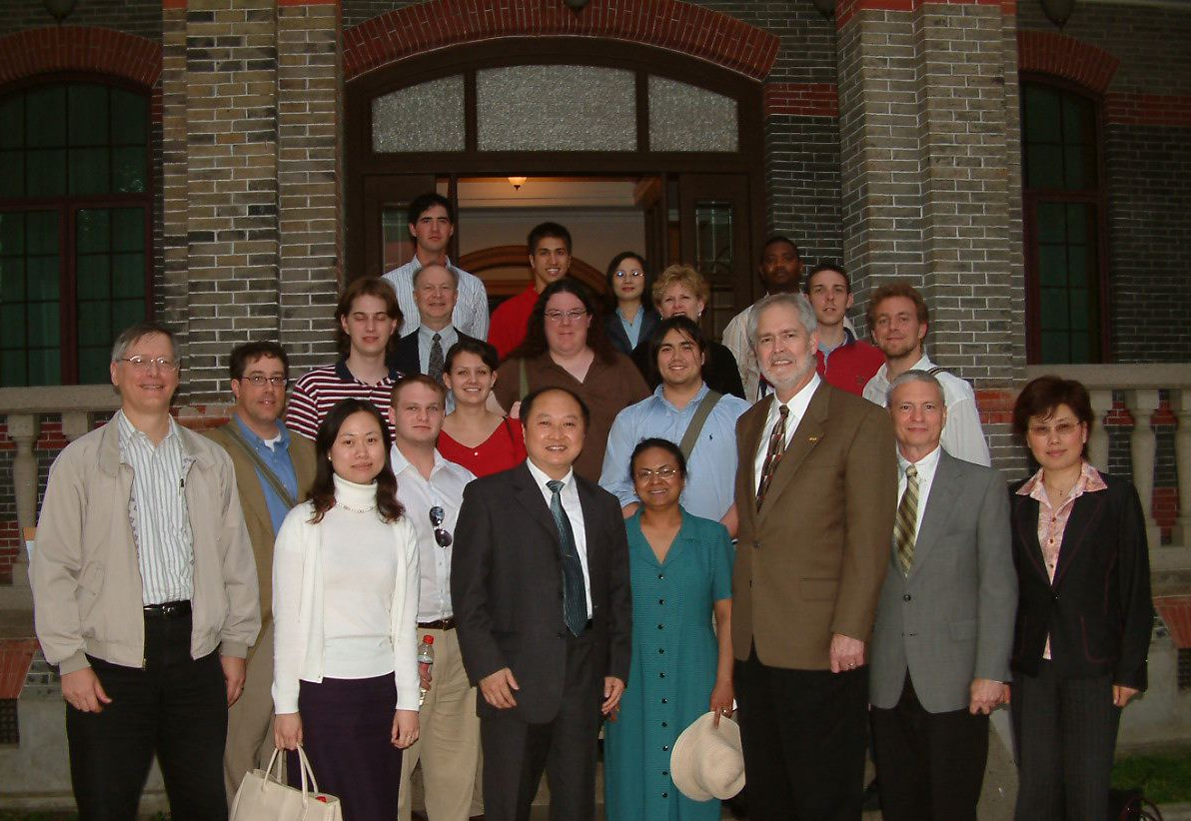
The students also appreciated SIUE faculty’s assistance on the trip. Katie and Jeff said they never found themselves wanting in any way. As highly populated as China is, the students said they never felt lost. Both accompanying staff from SIUE and the host universities in China ensured that they were doing well. Moreover, no matter which part of the city they found themselves, any taxi would take them back to the university or hotel without problems. Special guests on the trip were the School of Business Dean, Gary Giamartino, and College of Arts and Sciences Dean, Kent Neely.
Who would have thought that a simple decision to study abroad for just a couple of weeks could leave students with such an unforgettable memory and add so many dimensions to their lives? Well, you may want to ask the students who took the trip to China about it. You might find yourself on the next travel study or study abroad trip.

