Log into ImageNow  Click on located on System Tray  - Or: Click Start, All Programs, ImageNow 6  Enter User Name and Password  - Will use e-id and e-id password  - Password will be updated in ImageNow whenever you change your e-id password  Click |  | ImageNow Log In
Search for Documents
Without Banner Open
On ImageNow toolbar, select Documents
Select the document view from left side of menu
From Quick Search
- Where to search, select from drop down list
- From Banner View, ID or Name
- From All Document, Folder is the same as ID and Tab is the same as Name
- How to search, leave at ‘starts with’
- Enter search criteria in blank field
- If searching using name, enter last name then ‘, ‘ and part of first name (last name comma space first name)
Click
Search results are displayed
ImageNow Toolbar

ImageNow Search
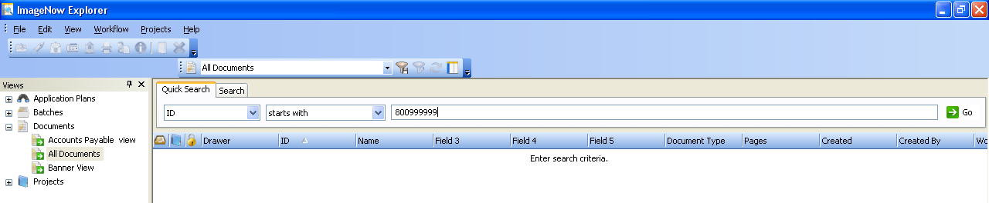
Where to Search
Search Criteria
How to Search
View Selection

Search from Banner
Find person in Banner (i.e.; SPAIDEN)
On ImageNow toolbar, select Applications
Search results are displayed
ImageNow Toolbar
Open Document
From the search results, double click on document type to view

Search Results Window
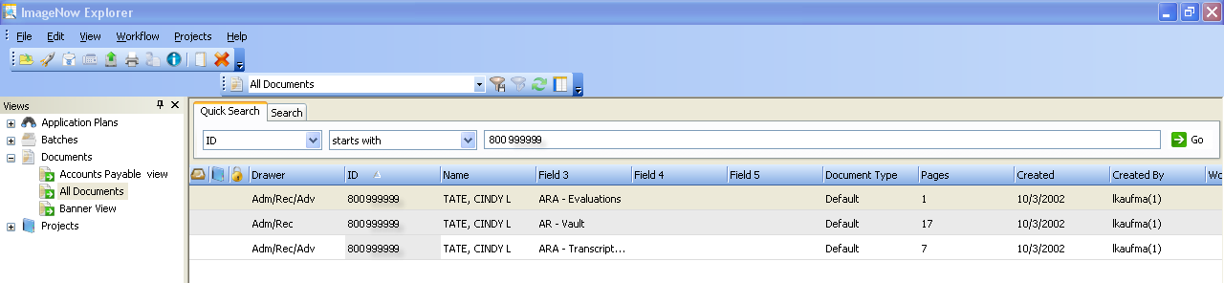

View Document
Note: Screen size and resolution can affect how the document is viewed. If blank, reduce size of WebNow Viewer.

ImageNow Viewer
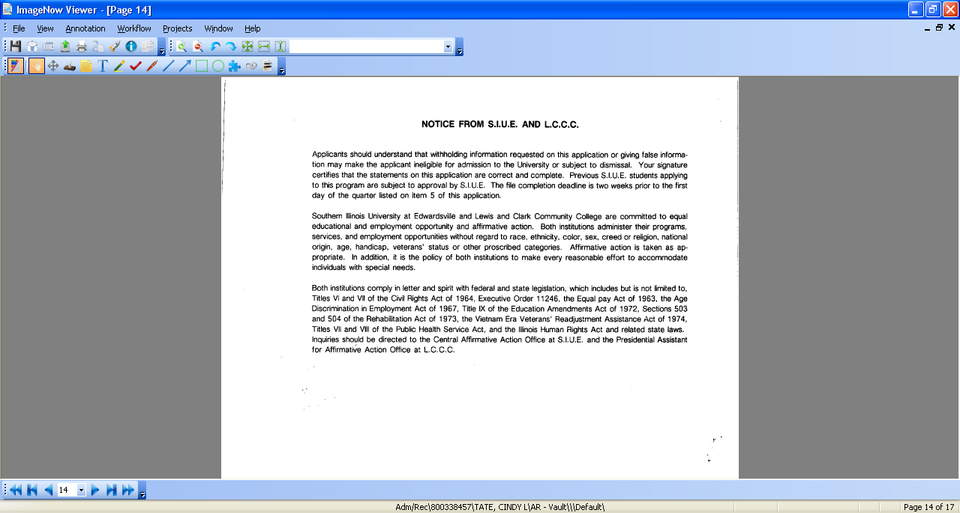

Use the navigation buttons at the bottom of the screen to move from one page to the next.

Navigation Buttons

Moves to the previous/next document type on Search Results | Moves to the first/last page for selected document type |  | Moves one page forward/backward for the selected document type
Use the toolbar buttons to manipulate the view

Toolbar

Zoom in and out buttons to increase/decrease size of document | Rotate left and right buttons to rotate document view 90º |  | Select how to view document: fit to window (4 arrows) default view to see entire document, fit to width (landscape) and fit to height (portrait)
Documents may include annotations, items not original to the document but added, such as highlighting, text
- Click to toggle between showing and not showing the annotations

Close ImageNow Viewer
Click in the upper right-hand corner to close document view and return to search screen

ImageNow Viewer

Select new document type to view
OR Enter new search criteria to view document types for another person
OR Exit ImageNow

