Log into ImageNow  Click on located on System Tray  - Or: Click Start, All Programs, ImageNow 6  Enter User Name and Password  - Will use e-id and e-id password  - Password will be updated in ImageNow whenever you change your e-id password  Click | ImageNow Log In
Performing QA on Documents  Note: This document covers the basics of quality assurance for a document. Every department has its own procedures for QA. The department will inform the user on what those procedures are.  From drop down list for Batches on the Tool Bar Button Options, select batch type to open  - Ready for QA (to shorten list)  - Sort by Batch number or by Created by  Double click on batch to open | ImageNow Tool Bar Button Options  Batch Results  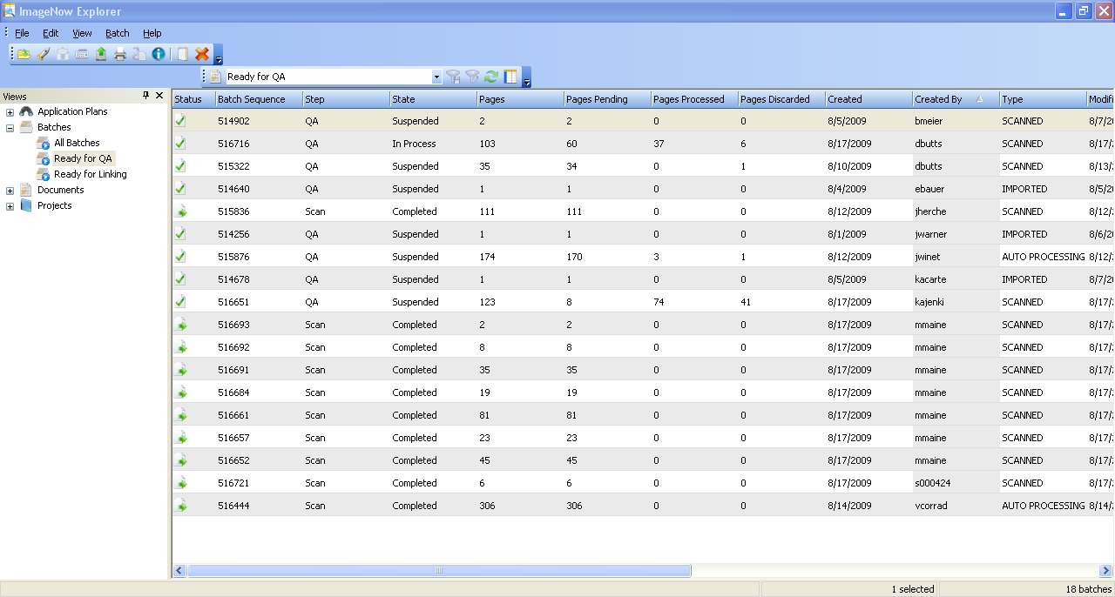
Options for page/batch  - Mark pages as OK  - Rescan this page  - Commit this batch (used if not performing QA at this point)  Note: Not all departments perform QA as a separate step. QA is done at the same time as linking.  - Suspend this batch  - Delete this page | QA Options  Same
When all QA’d (either OK or deleted) or batch is committed or suspended, will be returned to the batch results
If no more batches to QA, proceed to the next step in the imaging process (i.e.; linking) or exit ImageNow
Or repeat QA process for next batch

