Log into ImageNow  Click on located on System Tray  - Or: Click Start, All Programs, ImageNow 6  Enter User Name and Password  - Will use e-id and e-id password  - Password will be updated in ImageNow whenever you change your e-id password  Click | ImageNow Log In
Linking Documents  Note: This document covers the basics of linking a document to Banner. Every department has its own procedures for linking. The department will inform the user on what those procedures are.  From drop down list for Batches on the Tool Bar Button Options, select batch type to open  - Ready for Linking (to shorten list)  - Sort by Batch number or by Created by  Double click on batch to open  Log in to Banner  - Open applicable form  - Enter person that is to be linked to the document | ImageNow Tool Bar Button Options  Batch Results  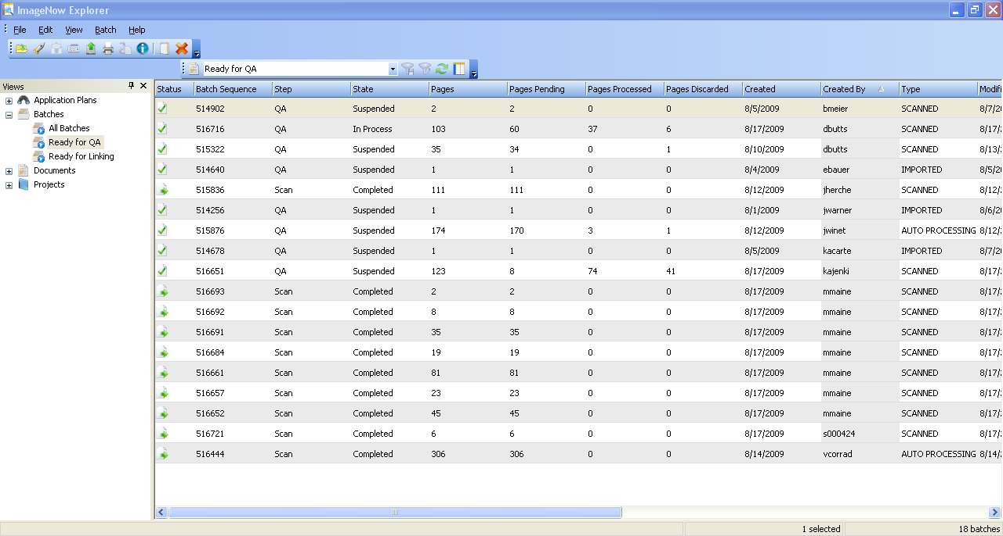
Options for page/batch  - Link this page  - Hold this page  - Suspend this batch  - Delete this page  Click Link this page  Select application plan  Verify that name/info is correct as shown in Document Keys  Click Save Batch Page | Link Options
When linking complete or batch is suspended, will be returned to the batch results
If no more batches to link exit ImageNow
Or repeat linking process for next batch

