The Instrument Panel for Spaceship Earth consists of three Excel spreadsheets. The first sheet you see pictured on the front. The second sheet contains the data that populates the first sheet when the “Captain” selects a country from the dropdown list next to “Pick a Country.”
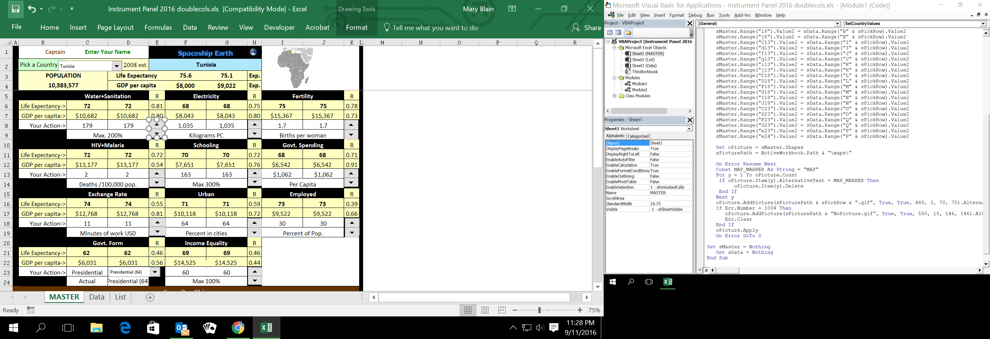
Tunisia’s 2008 population was 10,383,577.
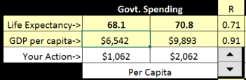
Life expectancy was 75.6 years and Gross Domestic Product per capita was equivalent to $8,000 US.
The 75.1 and $9,022 are “expected” values, estimates based on the 11 variables in the rest of the panel. They are close to actual life expectancy and GDP/pc, so the 11 variables represent well the main factors affecting life in Tunisia in 2008.
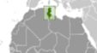
The map on the far right shows Tunisia’s location on the northern coast of Africa.
Two equations operate behind 10 of the 11 instruments, one for life expectancy and one for GDP/pc. These equations fit the data for the 220 countries best as evidenced by correlation coefficients, shown under R. Water+Sanitation correlated best with life expectancy, R = .81. Government spending correlated best with GDP per capita, R = .91.
The sum of their correlations put government spending first on the panel (.71 + .91 = 1.62) and Water+Sanitation second (.81 + .80 = 1.61).
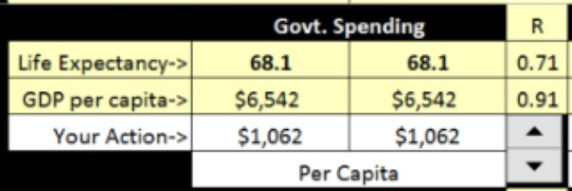
If government spending were the only factor operating in Tunisia, the equations show that its $1,062 per capita government spending would produce 68.1 years life expectancy and $6,542 GDP per capita.
Here is where the Captain gets to explore policy options to improve life in Tunisia by clicking the up and down arrows in the lower right corner of each instrument. Clicking up once raises government spending $1,000 per capita, showing it would add more than two years to life expectancy and more than $3,000 to GDP/pc. So increasing government spending would be a good policy option.
Water+Sanitation, being next on the panel, suggests that increased spending would best go there. Adding 100 kilograms per capita of Electricity shows that it alone would add .4 of a year to life expectancy (.1 to expected value 75.1), so it also would be a good place to invest more.
The exception to equations is Government Form. Its values are taken from a table at the bottom of the spreadsheet of average life expectancy and GDP/pc for six forms of government.
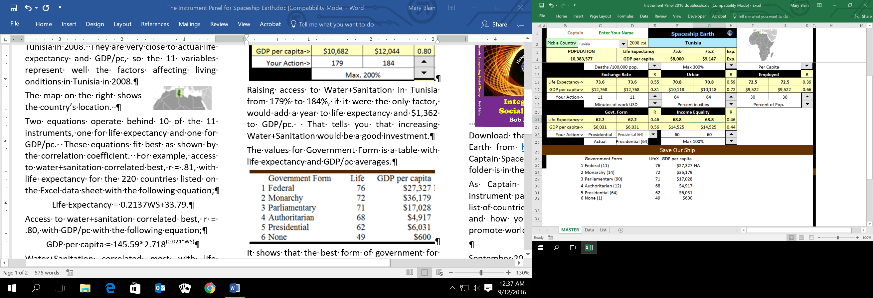
Inspired by R. Buckminster Fuller (1895-1983), the first Instrument Panel for Spaceship Earth was constructed with data for 1986. This one used 2008 data. I am 77, so it is time to pass the work of updating to a younger generation, which could mean you.
The history, theory, and research that produced the Instrument Panel are all presented in detail in the 369 page Weaving Golden Threads and summarized in the 43 page Promoting World Peace with Sociology, both available from http://www.iedpress.com/
You can download the zipped file of the Instrument Panel, maps, and this instruction sheet. It’s free. http://www.siue.edu/~rblain/ Be sure to keep the maps folder in the same folder as the Excel spreadsheet because that is where the program looks for them.
I hope you take advantage of this opportunity to explore options that sociology, the science of societies, shows would improve life and promote peace in countries around the world. Use the list of countries to record the ones you visit and what changes you find would improve life there.
If you decide to change anything, be sure to make a copy of the original and store it in a safe place.

September 2016
Bob Blain, Ph.D. Emeritus Professor of Sociology Southern Illinois University Edwardsville USA
rblain@siue.edu 1-618-656-5706

