EXPERIMENT 6: ALTERNATOR CHARACTERISTICS

OBJECT :

- To determine the voltage regulation characteristics of the alternator with resistive, capacitive and inductive loading.
- To observe the effect of unbalanced loads on the output voltage.

DISCUSSION :

The output voltage of an alternator depends essentially upon the total flux in the air gap. At no load, this flux is established and determined exclusively by the dc field excitation.
Under load, however, the air gap flux is determined by the ampere-turns of the rotor and the ampere-turns of the stator. The latter may aid or oppose the MMF (magneto motive force) of the rotor depending upon the power factor of the load. Leading power factors assist the rotor, and lagging power factors oppose it.

Because the stator MMF has such an important effect upon the magnetic flux, the voltage regulation of alternators is quite poor, and the dc field current must continuously be adjusted to keep the voltage constant under variable load conditions.
If one phase of a three-phase alternator is heavily loaded, its voltage will decrease due to the IR and IX_{L} drops in the stator winding. This voltage drop cannot be compensated by modifying the dc field current because the voltages of the other two phases will also be changed. Therefore, it is essential that three-phase alternators do not have loads that are badly unbalanced.

INSTRUMENTS AND COMPONENTS :

Synchronous Motor/Generator Module EMS 8241

DC Motor/Generator Module EMS 8211

Resistance Module EMS 8311
Capacitance Module EMS 8331
Inductance Module EMS 8321

Power Supply Module (0-120/ 120 Vdc) EMS 8821
AC Metering Module (250/250/250 V) EMS 8426
AC Metering Module (2.5A) EMS 8425
DC Metering Module (2.5A) EMS 8412
Hand Tachometer EMS 8920
Connection Leads EMS 8941
Timing Belt EMS 8942

PROCEDURE :

Caution: High voltages are present in this Laboratory Experiment! Do not make any connections with the power on! The power should be turned off after completing each individual measurement!

- a) Using your EMS Synchronous Motor/Generator, DC Motor/Generator, Resistance, Power Supply and Metering Modules, connect the circuit shown in Fig.11-1. Note that the balanced resistive load is wye connected to the three-phase output of the alternator. The alternator rotor is connected to the variable 0-120 Vdc output of the power supply, terminals 7 and N. the dc shunt motor winding is connected to the fixed 120 Vdc output of the power supply, terminals 8 and N.

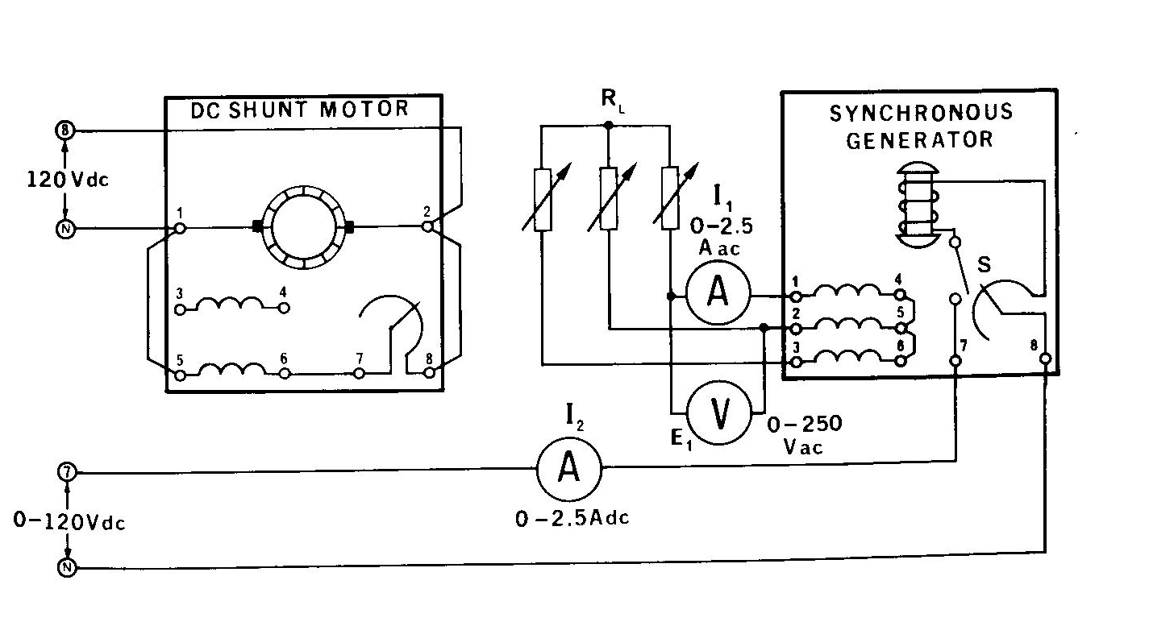 Fig. 11-1.

- a) Couple the dc motor to the alternator with the timing belt.
b) Set the dc motor field rheostat at its full ccw position (for minimum resistance).
c) Set the alternator field rheostat at its full ccw position for maximum resistance.
d) Adjust each resistance section for a resistance of 300 Ω.

- a) Turn on the power supply and, using your hand tachometer, adjust the dc motor rheostat for a motor speed of 1800 r/min.
Note: This speed must be kept constant for the remainder of this Laboratory Experiment.
b) If the synchronous motor has switch S, close it at this time.
c) Adjust the dc excitation of the alternator until the output voltage E₁ = 208 Vac. Measure and record the full load I ₁ ,I _{2.}
d) Open the three resistance load switches for no load on the alternator and measure and record the no load E₁ and I ₂. Remember to check the motor speed and readjust to 1800 r/min if required.
e) Return the voltage zero and turn off the power supply.
f) Calculate the alternator regulation with resistive loading.

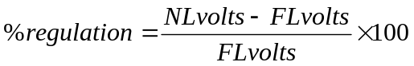
- a) Using your EMS Inductance Module, replace the resistive load with an inductive load.
b) Adjust each inductance section for a reactance X_{L} of 300Ω
c) Repeat procedure 3 and record the full load values of I ₁ , I₂
d) Measure and record the no load values of E ₁ , and I₂
e) Return the voltage zero and turn off the power supply.
f) Calculate the alternator regulation with inductive loading.
- With an inductive load, does the stator MMF aid or oppose the rotor MMF?

- a) Using your EMS Capacitance Module, replace the inductive load with a capacitive load.
b) Adjust each Capacitance section for a reactance X_{C} of 300Ω
c) Repeat procedure 3 and record the full load values of I _{1,} I₂
d) Measure and record the no load values of E _{1,} and I₂
e) Return the voltage zero and turn off the power supply.
f) Calculate the alternator regulation with Capacitive loading.
g) With a Capacitive load, does the stator MMF aid or oppose the rotor MMF

- a) With a capacitive reactance load of 1200 Ω per phase, turn on the power suply and adjust for a motor speed of 1800 r/min.
b) Adjust the excitation of the alternator until the output voltage E₁ = 208 Vac
c) Increase the capacitive loading by placing an additional reactance of 600 Ω in parallel with
each of the 1200 Ω sections and observe what happens
d) Increase the capacitive loading further by placing an additional reactance of 300Ω across
each section and observe what happens.
e) Return the voltage zero and turn off the power supply.
f) Explain, if you can, the phenomenon you have just observed.

- a) Connect the circuit shown Fig 11-2. Note that only one of the alternator phases has a load.

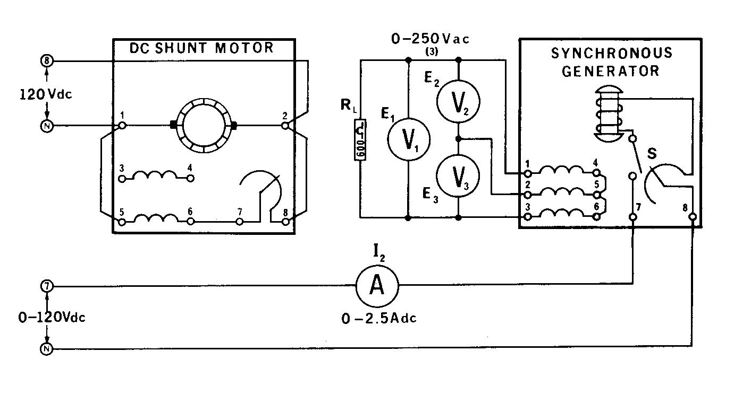

Fig 11-2.
b) Turn on the power supply and adjust the dc motor rheostat for a motor speed of 1800 r/min.
c) Adjust the dc excitation of the alternator until the voltage across the 600Ω load E₁ = 208
Vac. Measure and record the two other phase voltages E₂ and E₃
d) Turn off the power supply without touching any of the variable controls.
e) Reconnect the three ac voltmeters so they will measure the voltages across each of the
three stator windings.
f) Turn on the power supply. Measure and record the voltages across each of the alternator
windings.
E_{1 to 4} = ………………..Vac E_{3 to 6} = ………………..Vac
E_{2 to 5} = ………………..Vac
g) Return the voltage zero and turn off the power supply.
e) Did the single-phase load produce a large unbalance?

TEST YOUR KNOWLEDGE :

1. Explain why the alternator output voltage increases with capacitance loading.

2. Could it be dangerous to connect an alternator to a long transmission line, if the line looks like a capacitor?………….Explain.

- The rotor of an alternator, at rated power, dissipates more heat at a low power factor (lagging) load than at a high power factor load. Explain.

4. If an industrial customer of an electrical power company connects a large single-phase load to a three-phase power line, then every other user on that power line will have unbalanced three-phase power, even if their loads are balanced. Explain.

