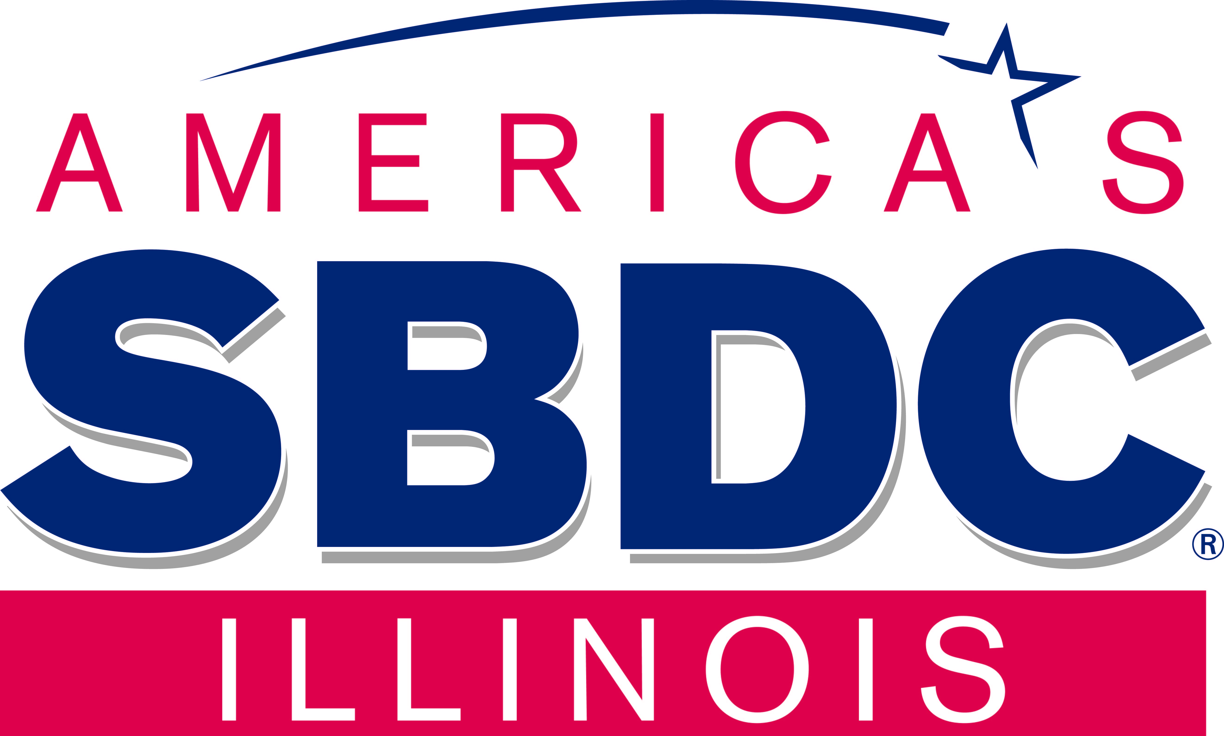 | Request for Consultation  Illinois Small Business Development Center  Local Center Information Here |   Funded in part through a cooperative agreement with SBA
*1. Type of Contact: Face to Face Online Telephone *2. Primary Counselor:

PART I: Client Intake:
*3. Client Name (last, First, MI): (Name of the person completing the form/representative of the business) |  | *4. Email:
*5. Client Work Phone:  Primary: Secondary: |  |  |  | *6. Client Fax Number:
*7. Street Address/PO Box (Give business address if currently in business) | *8. City: |  | *9. State: |  | *10. Zip: | +4

PART II: Client Intake: (To be completed by all Clents)
*11. Client Federal Representative District Number: |  |  |  |  |  |  |  |  |  | *12. Client State Representative District Number: |  |  |  |  |  |  |  |  |  |  |  | *13. Client State Senate District Number:
*14. Race (Mark one or more):  Native American or Alaskan Native  Native Hawaiian or other Pacific Islander  Asian |  |  |  |  |  | White  Black or African American |  |  |  |  |  |  | *15. Client Ethnicity:  Hispanic Origin  Not of Hispanic Origin |  |  |  |  |  |  |  |  | *16. Gender:  Male  Female |  |  |  | *17. Do you consider yourself a person with a disability?  No Yes
*18. Veteran Status: Non-Veteran |  |  |  | Service-Disabled Veteran  Veteran |  |  |  |  |  |  |  | *18a. Military Status: |  |  |  |  |  |  |  |  | Member of Reserve or National Guard  On Active Duty
*19. Referred by? (Mark all that apply):
SBA District Office  Lender  Business Owner  SBA Web site |  | SBDC  USEAC  SCORE  WBC |  |  | Other Client  Educational Institution  Local Economic Development Official  Chamber of Commerce |  |  |  |  |  |  |  |  |  |  | Magazine/Newspaper Other (Specify)  Word of Mouth _______________________________  Television/Radio  Internet (Please indicate site) ________________________________
*20a. Are you currently in Business? Yes No (if no Skip to 30)
*20b. I yes, are you currently exporting Yes No
If yes to 20b, please go to appendix A on page 3 to indicate the markets to which your company currently exports (mark all the apply)
*21. Name of business:
*22. Type of Business: (Choose Primary Categories) |  |  |  |  |  |  |  |  |  |  |  |  |  | Professional, Scientific & Technical Services
Mining  Utilities  Information  Construction  Retail Dealer | Manufacturing  Finance & Insurance  Wholesale Trade  Public Administration  Educational Services |  |  |  |  | Real Estate & Rental & Leasing  Health Care & Social Assistance  Accommodation & Food Services  Arts, Entertainment & Recreation  Transportation & Warehousing |  |  |  |  |  |  |  | Management of Companies & Enterprises  Agriculture, Forestry, Fishing & Hunting  Administrative & Support  Waste Management & Remediation Services  Other Services (except Public Administration)
*23. Business Ownership: What percentage of your business is male or female owned?  ________% Male ________% Female |  |  |  |  |  |  |  |  | *24. Date Business Started:  (MM/YYYY) |  |  |  |  |  | *25. Do you conduct  business online?  Yes No |  |  |  |  |  |  | *26. Are you a home based Business?  Yes No  *27. Are you 8(a) certified? Yes No
*27a. Total No. of Employees:  (full and PT)_____  *27b. Of total employees, how many are  engaged in the exporting aspect of your  business? (full and PT)_____ |  |  |  |  |  |  | *28a. For your most recent full year, what  were your: Gross revenues/Sales $____________  +Profits/-Losses $_______________  *28b. Amount of your Gross Revenues/Sales  Related to exporting? $__________________ |  |  |  |  |  |  |  |  |  |  |  |  | *29. What is the legal entity of your Business?  Sole Proprietorship Corporation LLC  S-Corporation Partnership  Other (specify) ____________________________

*30. What is the nature of the nature of the assistance you are seeking? (choose a primary category)
Start-up assistance (How do I start a small bus.)  Business Plan  Financing/Capital (such as applying for a loan,  building equity capital)  Managing a Business |  |  |  |  |  |  |  | Human Resources/Managing  Employees  Customer Relations  Business Accounting/Budget  Cash Flow Management  Tax Planning |  |  |  |  |  |  | Marketing/Sales (promotion,  Market research, Pricing, etc)  Government Contracting  (including certifications)  Franchising  Buy/Sell Business |  |  |  |  |  |  |  |  | Technology/Computers  eCommerce (using the Internet  to do business)  Legal Issues (such as, should I  incorporate?)  International Trade

Describe specific assistance requested in the space provided_____________________________________________________________________________________
*31. Business Size:  Disadvantaged Small ( Not Certified Certified SDB SBA 8(a) Certified ) Minority-Owned Small Large Other Small |  |  |  |  |  |  |  |  |  |  | *32. Company FEIN: |  |  |  |  |  |  | *33. Company Cage  Code If Applicable: |  |  |  |  |  |  | *34. Company DUNS #:
*35. Is Business in a HUBZone:  No Located in HUBZone Only Certified HUBZone? Date Certified __________ |  |  |  |  |  |  |  |  | *36 Is Business Located in Distressed Area:  No Yes |  |  |  |  |  |  |  |  |  | *37 Keywords
*38. Product Service Codes (PSCs): |  |  | *39 Standard Industrial Classification SICs: |  |  |  |  |  |  |  |  |  |  |  |  |  | *40 North American Industrial Classification (NAICs):
*41. Product or service description:
________________________________________________________________________________________________________________________
________________________________________________________________________________________________________________________
________________________________________________________________________________________________________________________
________________________________________________________________________________________________________________________

ANY CHANGES TO THIS FORM OR THE USE OF ANY OTHER INTAKE FORMS MUST HAVE PRIOR WRITTEN APPROVAL OF THE SMALL BUSINESS DEVELOPMENT CENTER STATE DIRECTOR Updated 09/13/2011
 |  |  |  |  | CLIENT RIGHTS AND RESPONSIBILITIES |  |  |  |  |  |  |  |  |  |  |  |  |  |  |  |  |  | Funded in part through a cooperative agreement with SBA

As a new client of the Illinois Small Business Development Center (SBDC), we'd like to advise you of certain rights and responsibilities you have as one of our clients:

You have a right to expect:
- Prompt, courteous, and professional counseling services and to be advised if the Illinois SBDC is unable to provide service within the time frame required. Be aware that due to the demand for our services, cases must often be prioritized by need and training may be recommended before counseling is provided.
- All information shared with the Illinois SBDC and any of its resources (staff, faculty, volunteers, and consultants) will be held in strictest confidence. No information provided by you will be used to the commercial advantage of any staff member, consultant, or other resource of the Illinois SBDC or to the benefit of any third party.
- That your client status with the Illinois SBDC will remain confidential. No public use of your name, address, or business identity will be made without your prior approval. Please note, however, that the Illinois SBDC is funded in part by the U.S. Small Business Administration, Department of Commerce and Economic Opportunity and the local host so, limited information with respect to your client status is provided to those entities.

Our role is to counsel and assist small business owners and those planning to go into business. We will not make business decisions or judgments for you, though we will make recommendations and suggestions as appropriate. These will be based upon our best efforts to apply the experience and resources available to us to assist you in making your own business decisions.

The Illinois SBDC may charge reasonable fees for training programs, special services, and publications. However, you have a right to feel secure that no fee will be charged by the ISBDC or its resources for normal counseling services provided to you. Also, no recommendations will be made as to the purchase of goods or services from any individual or firm with whom any ISBDC staff or its resources have any financial, familial or personal interest.

The counseling services provided to you are a part of the effort of the Illinois SBDC and its sponsors to respond to the growing needs of the small business community and to positively affect the economy of Illinois. They are not intended to compete with, replace, or be a substitute for services available from the private sector. Clients whose needs can be fully met by private sector practitioners or firms in an affordable manner will be encouraged to use those resources.

In consideration of the Illinois SBDC furnishing you with management and technical assistance, you agree to waive all claims against the ISBDC and its constituent institutions, its staff, or any other resources employed by or used in connection with these services. You will also be expected to cooperate with the ISBDC in its efforts to assure the quality and effectiveness of the counseling services it provides.

In this respect, the Illinois SBDC will ask all clients who receive counseling assistance to complete a written evaluation of the services provided. In addition, all clients will be asked to complete an Economic Impact Verification form that documents the assistance provided by the Illinois SBDC. Finally, clients may receive direct inquires from this office, the State Director's office or the U.S. Small Business Administration with respect to the services provided to you. Your response to all of these inquiries will be greatly appreciated.

REQUEST FOR CONSULTATION

SBDC Agreement:
I request business counsultation service from the Illinois SBDC, a Resource Partner of the Small Business Administration (SBA). I agree to cooperate should I be selected to participate in surveys designed to evaluate SBA services. I permit the Illinois SBDC the use of my name and address for surveys and information mailings regarding products and services ( Yes No). I understand that any information disclosed will be held in strict confidence. The SBDC will not provide your personal information to commercial entities.) I authorize the Illinois SBDC to furnish relevant information to the assigned management counselor(s). I further understand that the counselor(s) agrees not to: 1) recommend goods or services from sources in which he/she has an interest, and 2) accept fees or commissions developing from this counseling relationship. In consideration of the counselor(s) furnishing management or technical assistance, I waive all claims against SBDC personnel, and that of its Resource Partners and host organizations, arising from this assistance.

*_______________________________________________ *__________________________________
Client Signature Date
_______________________________________________
Counselor Signature

We welcome you as a client and encourage you to call on us if you have any questions or comments with regard to your rights and responsibilities or services you receive. You can do so by calling your local Illinois SBDC counselor or the Illinois SBDC State Office at (800) 252-2923.
ANY CHANGES TO THIS FORM OR THE USE OF ANY OTHER INTAKE FORMS MUST HAVE PRIOR WRITTEN APPROVAL OF THE SMALL BUSINESS DEVELOPMENT CENTER STATE DIRECTOR Updated 09/13/11

Please note: The estimated burden for completing this form is 18 minutes. You are not required to respond to any collection information unless it displays a currently valid OMB approval number. Comments on the burden should be sent to: U.S. Small Business Administration, 409 3rd Street, SW, Washington, DC 20416, and to: Desk Officer SBA, Office of Management and Budget, New Executive Office Building, Room 10202, Washington, D.C., 20503. OMB Approval (3245-0324). PLEASE DO NOT SEND FORMS TO OMB.

 | Request for Consultation  Illinois Small Business Development Center  Local Center Information Here | Funded in part through a cooperative agreement with SBA

Appendix A to Questions 20b. & 39b.
If your company is currently exporting, please indicate the countries to which your company exports: (Mark all that apply)
Asia | Africa | Caribbean | Central America | North America
Afghanistan  Bahrain  Bangladesh  Belarus  Bhutan  Brunei  Burma  Cambodia  China  East Timor  Georgia  Hong Kong  India  Indonesia  Iran  Iraq  Israel  Japan  Jordan  Kazakhstan  Korea, North  Korea, South  Kuwait  Kyrgyzstan  Laos  Lebanon  Macau  Malaysia  Maldives  Micronesia  Mongolia  Nepal  Oman  Pakistan  Philippines  Qatar  Russia  Saudi Arabia  Singapore  Sri Lanka  Syria  Tajikistan  Taiwan  Thailand  Turkey  Turkmenistan  United Arab Emirates  Uzbekistan  Vietnam  Yemen | Algeria  Angola  Benin  Botswana  Burkina Faso  Burundi  Cameroon  Cape Verde  Central African Republic  Chad  Comoros  Congo  Democratic Republic of Congo  Cote d'Ivoire  Djibouti  Egypt  Equatorial Guinea  Eritrea  Ethiopia  Gabon  Gambia  Ghana  Guinea  Guinea-Bissau  Kenya  Lesotho  Liberia  Libya  Madagascar  Malawi  Mali  Mauritania  Mauritius  Morocco  Mozambique  Namibia  Niger  Nigeria  Rwanda  Sao Tome and Principe  Senegal  Seychelles  Sierra Leone  Somalia  South Africa  Sudan  Swaziland  Tanzania  Togo  Tunisia  Uganda  Zambia  Zimbabwe | Anguilla  Antigua & Barbuda  Aruba  Bahamas  Barbados  Virgin Islands (British)  Cayman Islands  Cuba  Dominica  Dominican Republic  Grenada  Haiti  Jamaica  Montserrat  Netherlands Antilles  St. Kitts and Nevis  St. Lucia  St. Vincent and Grenadines  Trinidad and Tobago | Belize  Costa Rica  El Salvador  Guatemala  Honduras  Nicaragua  Panama  Europe  Austria  Azerbaijan  Albania  Armenia  Belgium  Bosnia-Herzegovina  Bulgaria  Croatia  Cyprus  Czech Republic  Denmark  Estonia  Finland  France  Germany  Greece  Hungary  Iceland  Ireland  Italy  Latvia  Liechtenstein  Lithuania  Luxembourg  Macedonia  Malta  Moldova  Monaco  Montenegro  Netherlands  Norway  Poland  Portugal  Romania  Serbia  Slovak Republic  Slovenia  Spain  Sweden  Switzerland  Turkey  Ukraine  United Kingdom  Vatican City | Bermuda  Mexico  Canada  South America  Argentina  Bolivia  Brazil  Chile  Colombia  Ecuador  Guyana  Paraguay  Peru  Suriname  Uruguay  Venezuela  Oceania  Australia  New Zealand  Cook Islands  Fiji  Kiribati  Marshall Islands  Nauru  Palau  Papua New Guinea  Samoa  Solomon Islands  Tonga  Tuvalu  Vanuatu  Other  Subcontractor for  Exporter  Sell to fill-freight
ANY CHANGES TO THIS FORM OR THE USE OF ANY OTHER INTAKE FORMS MUST HAVE PRIOR WRITTEN APPROVAL OF THE SMALL BUSINESS DEVELOPMENT CENTER STATE DIRECTOR Updated 09/13/11

