SIUE students broaden perspectives in Mexico
~ Article by student participant Josh Smucker ~
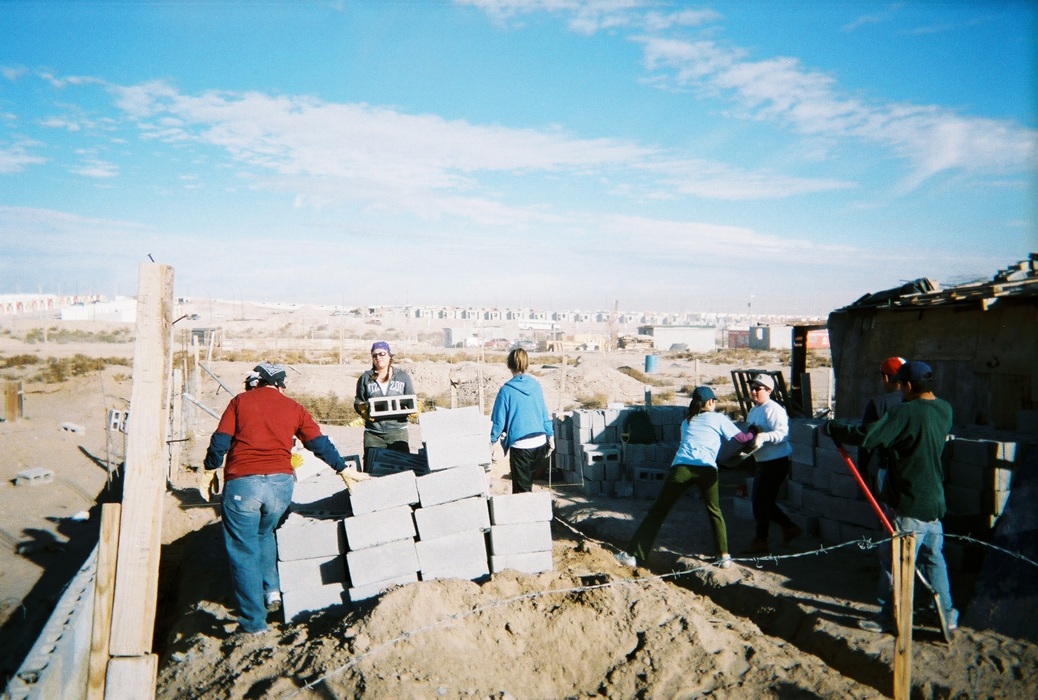
Students and professors from various areas of study teamed up from January 2 – 8 for a one-week service-learning course that proved to be a rewarding and life-shaping experience. The three-credit offering led the group of Business, Language, History, and Education students and © Photo by Josh Smucker
faculty to Ciudad Juárez, Mexico, where they built a new home for a family in poverty, toured a Johnson Controls plant, and had first-hand experiences with the local culture.
The first three days of the trip were used building the new home. Materials and local experts (maestros) awaited the group, who dug into the project. The cinder blocks were quickly organized and the team began mixing the cement and mortar by hand. As the participants formed the walls, some of the Spanish-speaking students took the opportunity to converse with the curiously observing family and local children. The group helped pour the cement floor and assemble a solid roof, replacing a wooden pallet and cardboard structure with one of cinder block for the family to live in.

Midway through the week, the group had the opportunity to visit a manufacturing facility of the type in which one of the family members worked. The trip to the maquiladora of Johnson Controls, an international company that offers interior design services and temperature control devices, among other products and services, included a round table discussion with the Human Resources Director, a tour of the facility, and some Q & A time with the Director of Operations. This was a great opportunity for everyone to gain first-hand experience with seeing the factory conditions, learn about the government’s environmental regulations, and the conditions of the border economy.
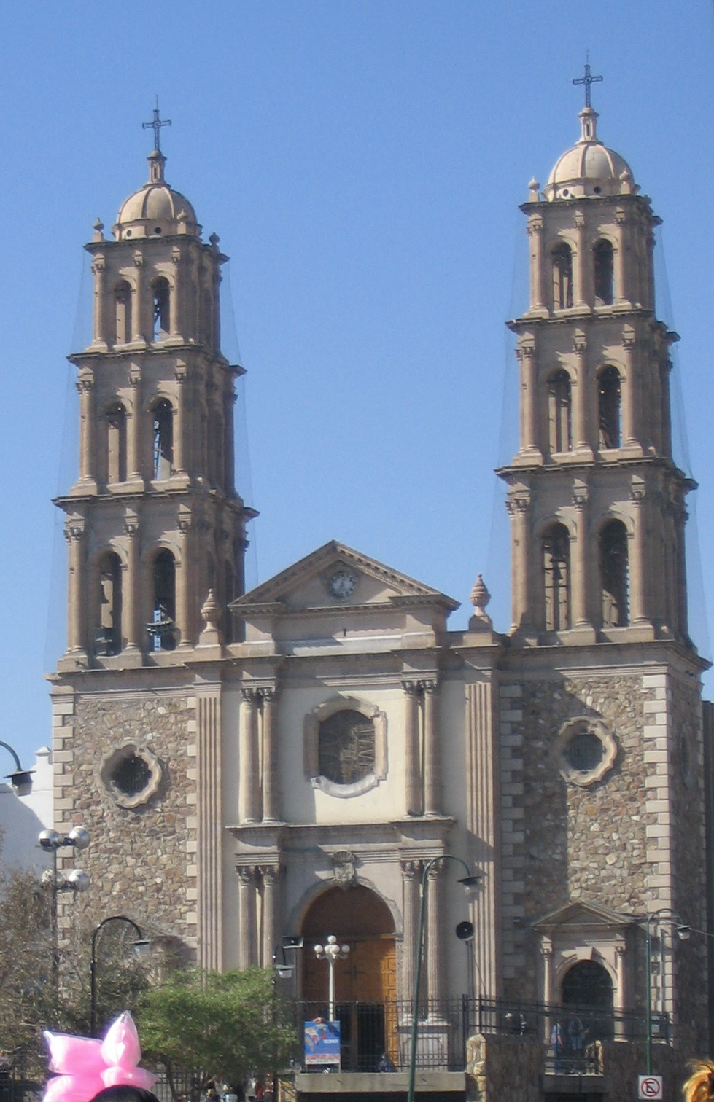
After experiences building the home and exploring the border economy, the group took a day trip to downtown Juárez for a taste of the local culture. A local museum provided an exhibit of information and artifacts from the Spanish Revolution, which started in 1936. The downtown also held a cathedral, many shops and street vendors, and outdoor eateries. The air was filled with the sounds of a large band, the smells of the local fare, and bustling energy. The group trekked
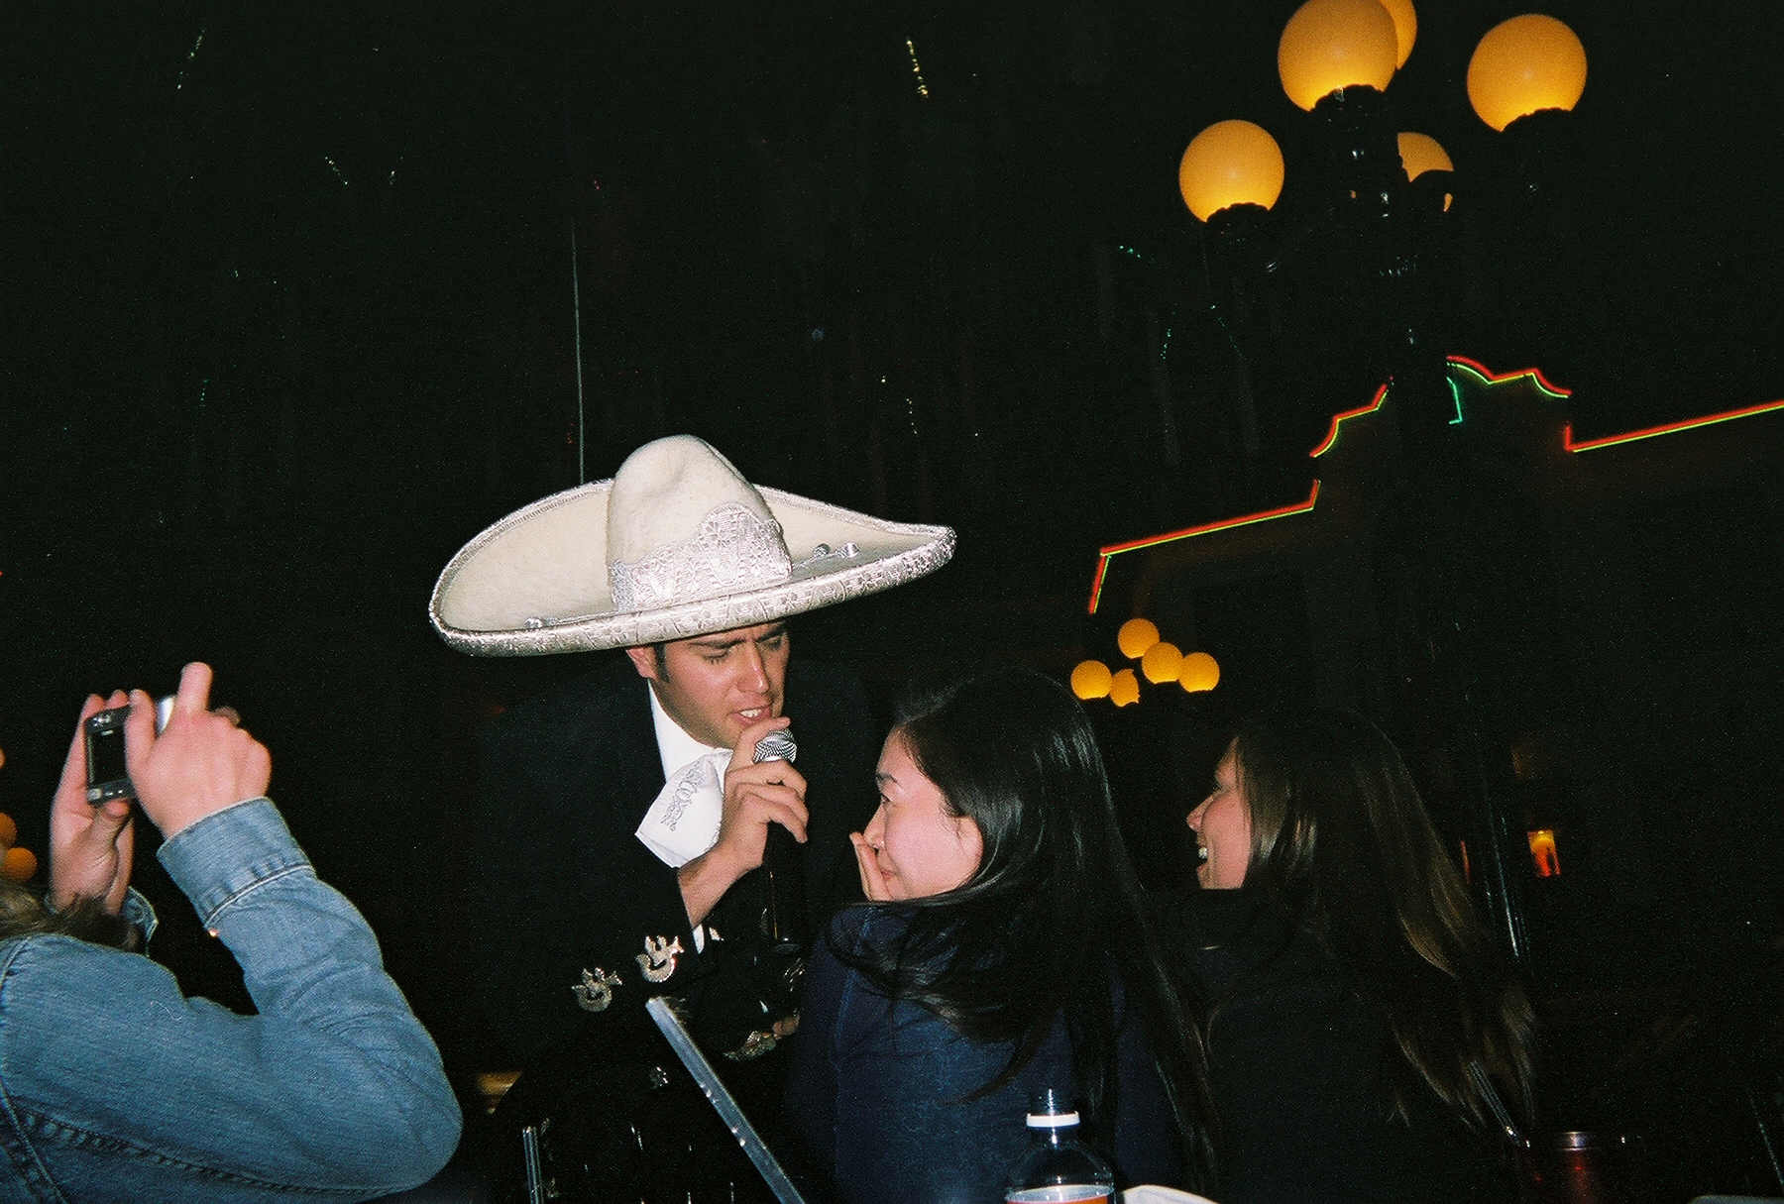
© Photo by Cindy Holesko throughout the town and ended up at an indoor market, where they bartered for gifts and souvenirs. Their final dinner together was at Viva Mexico, a restaurant that provided music, a simulated cockfight, cultural dances, and a very lively and interactive atmosphere.
One student participant, Petra Flores, commented on her experience, “I absolutely gained a great deal of perspective on the trip…I think most of us expected poverty and sadness, to a certain extent, but we didn't really find that. People were happy; they © Photo by Josh Smucker
were thankful for what they have, not mournful for what they lack.” When asked if she would recommend the trip to other students, she replied, “I would wholeheartedly recommend a study abroad trip to anyone considering it. You not only learn about the world and its people, you learn about yourself and your abilities. It made me realize not just how lucky I am for what I have, but that I need to use what I have been given to make changes in the world, and I am capable of doing so.” The group recently met at La Fonda restaurant in Edwardsville for a reunion to share new-found perspectives, pictures, new friendships, and to relive the stories of their adventure.

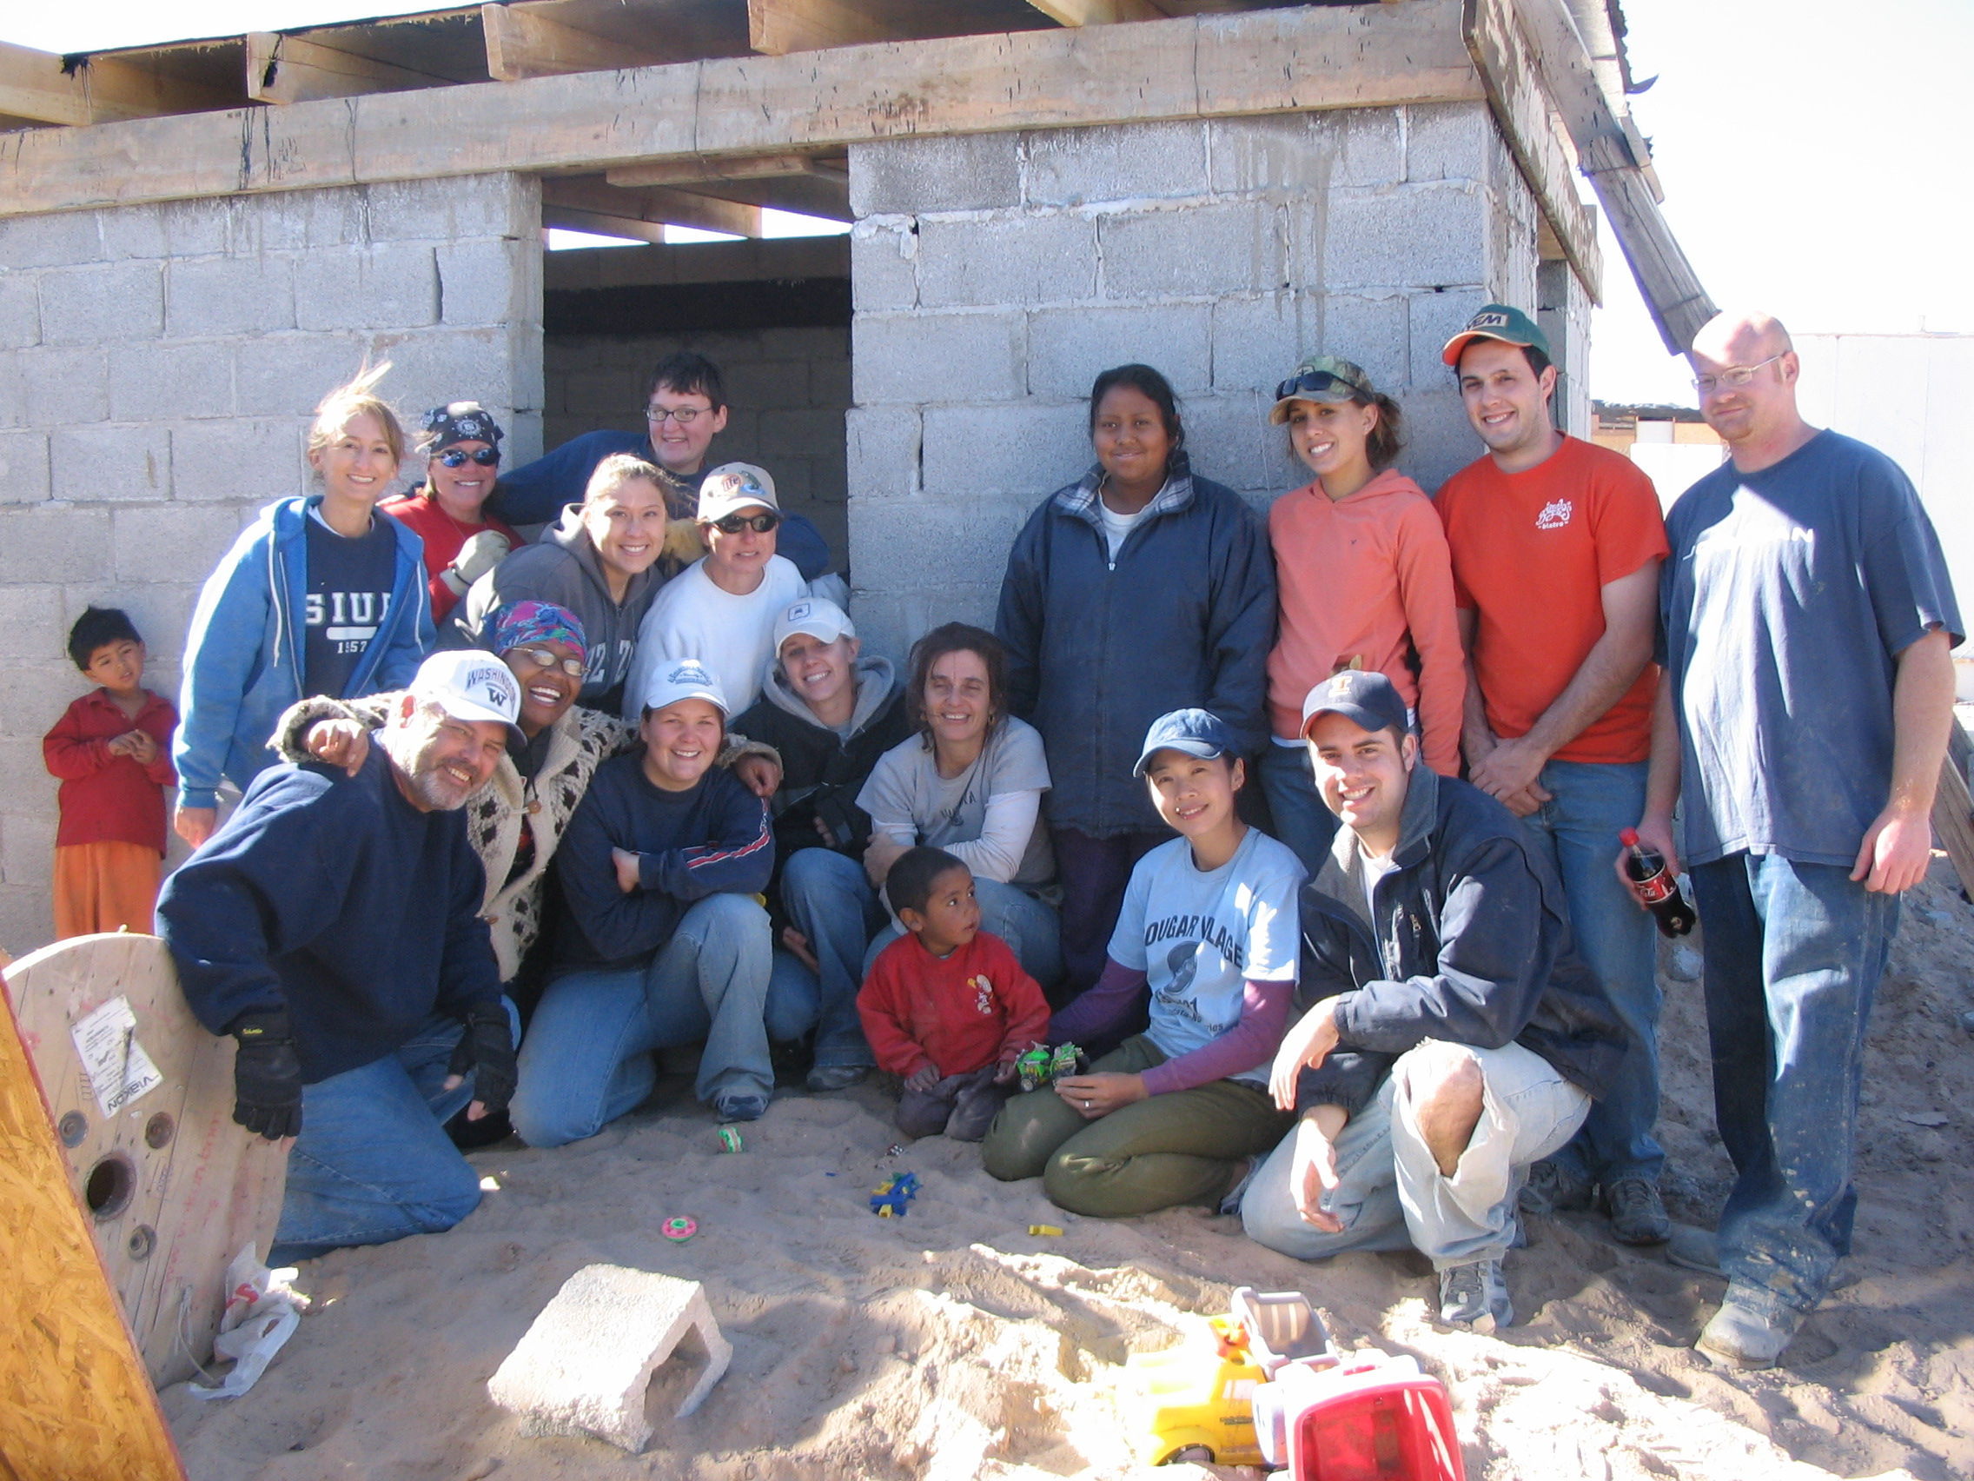
© Photo contributed by Cindy Holesko

