Application
Business Study Tour to Germany
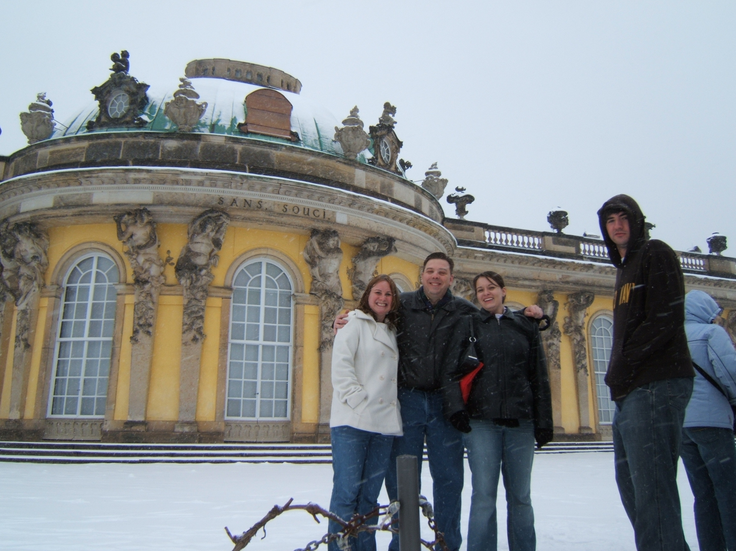
March 2-11, 2007
Name: ______________________________
Social Security Number: ________________
Address: ____________________________
____________________________________
Email: _______________________________
Day Phone: ____________________
Evening Phone: __________________
Sans Souci Castle
Travel Study in Germany 2006
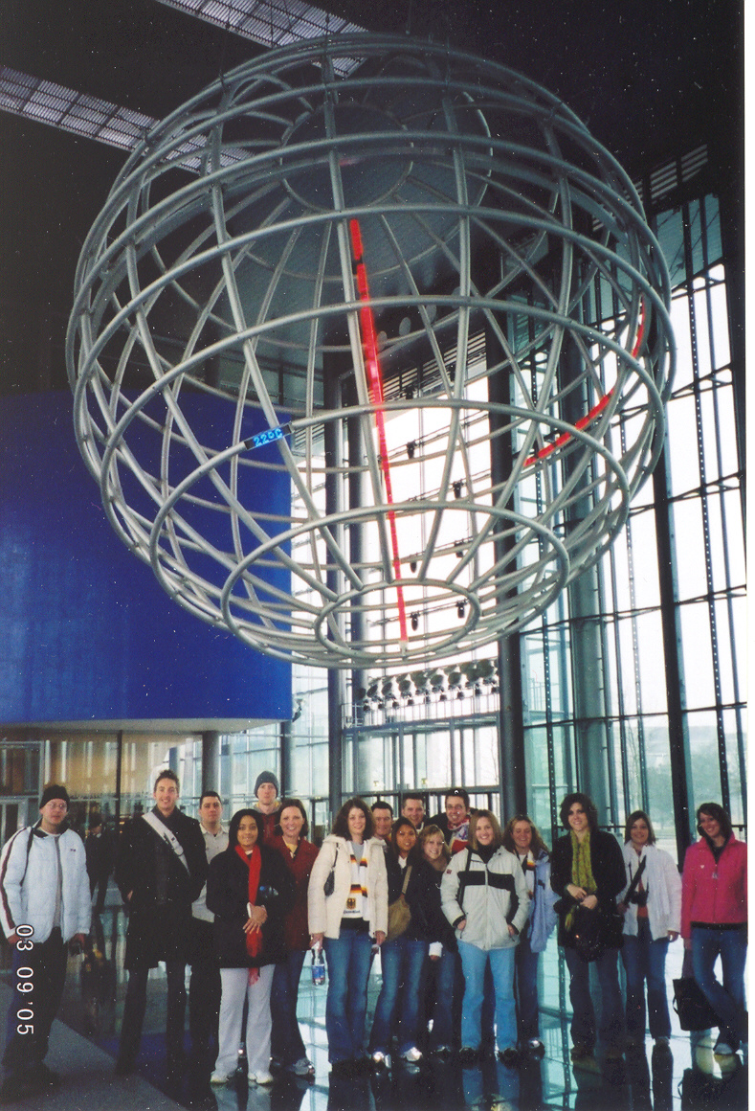

Are you a US citizen? Yes ___ No ___
Do you have a current passport? Yes ___ No ___
Major: __________________ GPA: ______________
Please attach a one-page, single-space essay explaining
  - Your reasons for participating in this experience
  - What you hope to learn from this experience
Volkswagen tour Travel Study 2005

Please also provide the name and contact info of a faculty member who can serve as a reference.

CORPORATE TUITION ASSISTANCE
Many companies that provide tuition assistance may be willing to provide extra assistance for participation in this course. If you plan to request assistance from your employer, please let us know if a letter or phone call from the Office of International Programs of the School of Business is needed.

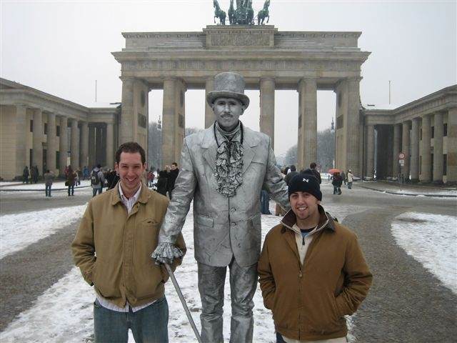
Submit this application by Mon., Oct 16, 2006, to:
Dr. John Navin
AH 3143
618-650-3423
jnavin@siue.edu
Applications submitted after Oct. 16 will be reviewed on a space-available basis. In case there are more applicants than can be accommodated, applicants may be invited for a selection interview.

Brandenburg Gate
Travel Study in Germany 2006

