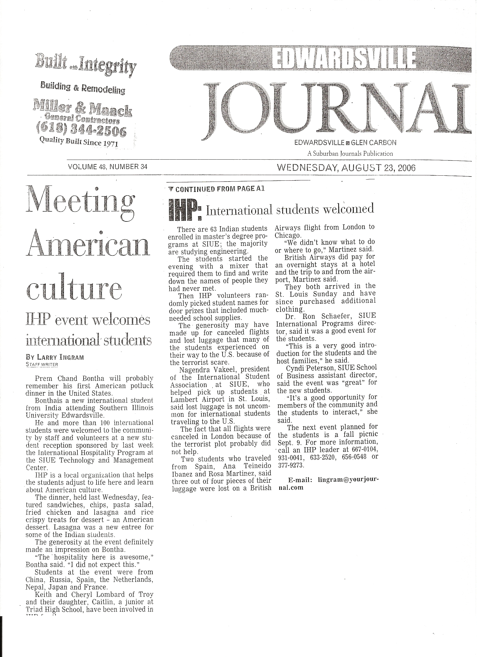
Edwardsville Journal
August 23, 2006

