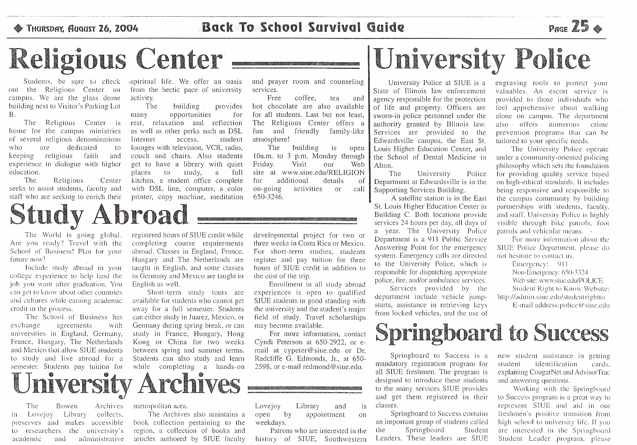
The Alestle
August 26, 2004

