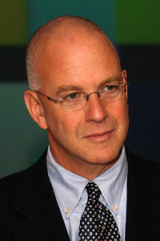

Amos N. Guiora is professor of law at The S. J. Quinney College of Law, University of Utah, where he teaches Criminal Law, Criminal Procedure, International Law, Global Perspectives on Counter-terrorism, and Religion and Terrorism.

He will speak at SIUE on August 30th as a guest in the Department of Public Administration & Policy. The plan is to have him speak from 12-2:00 p.m. at a campus location to be determined. He will also will speak to a combined PAPA class from 6-8 p.m. later that same evening.

Watch your e-mail for more details.

Visit http://www.law.utah.edu/faculty/faculty-profile/?id=amos-guiora to read more about Professor Guiora and this work.

