2012 College of Arts and Sciences Colloquium

Dr. Lani Van Eck presents
THE MASSACRE AT
WOUNDED KNEE CREEK
a two-hour multimedia event

Wednesday 28 March, 2012 at 6:00pm
Morris University Center, Maple/Dogwood room

Hear the untold story that examines the cultural, political, and economic factors leading up to this incident, including new information uncovered by the speaker. This comprehensive overview of the last major military action of the U.S. against the Native peoples of this country is based on meticulous research of historical records, personal papers, and oral histories of the descendants of survivors of the massacre. A balanced perspective that considers both sides of the story is presented along with a vivid description of the event itself.
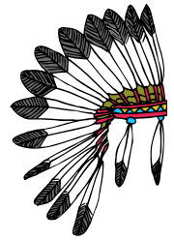

An analysis of the continuing importance of Wounded Knee for present-day Native peoples is offered. The presentation promotes intercultural dialogue by providing a common knowledge base for both cultures, filling knowledge gaps for non-Natives. Over 50 rare archival photographs and hand-drawn maps from the 19th century are presented.

The event is FREE and open to the public

