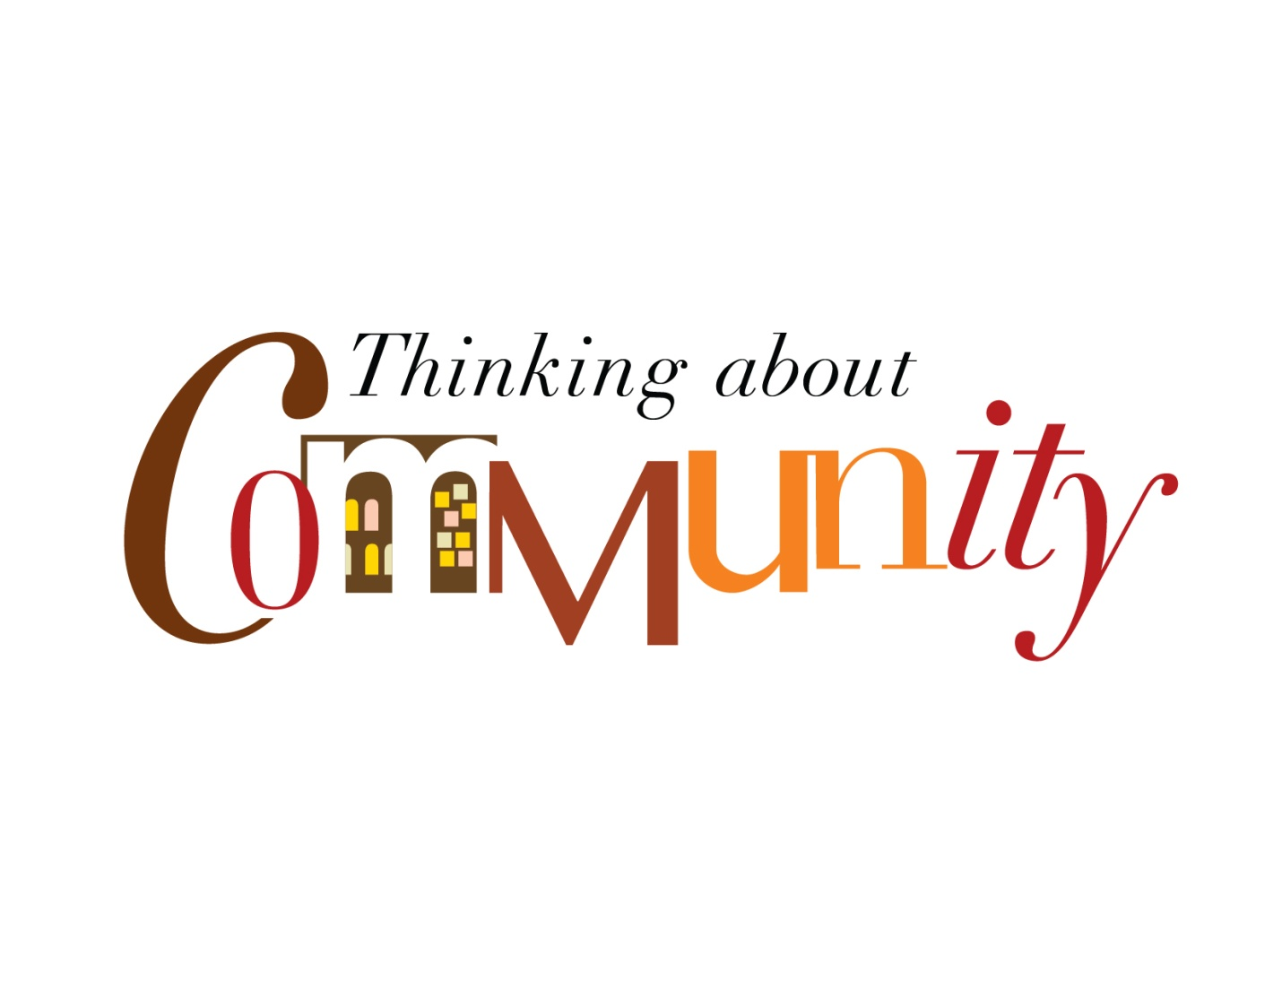
The College of Arts and Sciences
11th Annual Colloquium
October 1, 2015
Morris University Center

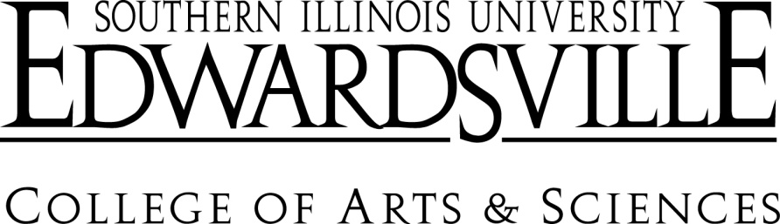

The College of Arts and Sciences
2015 Colloquium
Thursday- October 1, 2015
10:00-10:30am
Location: Maple-Dogwood
Participant: Larry LaFond
Rediscovering Academic Community
Modern university communities frequently have evolved into a “caste” system in which distinct social stratification occurs. The roles played in these communities range from strong power brokers in a hierarchical model of superiors and subordinates, to middle managers, to faculty, to non-tenured instructors, lecturers, professional staff, and civil servants. This session invites participants into an open discussion of how our vision of “academic community” affects our living together at SIUE.

11:00-12:15
Location: Maple-Dogwood
Participants: Lora Smallman, Sarah Park, Steve Kerber
Community and Immigration in the 19th Century Madison County, Illinois: Digitization of Naturalization Records and Creation of a Data Set
Library & Information Services (LIS) Faculty members Lora Smallman, Sarah Park, and Stephen Kerber have received a grant from the Illinois State Library in support of their proposal “Madison County, Illinois Naturalization Records: A Digital Collection of Social and Family History.” With the support of this grant, LIS will digitize and make accessible online a unique collection of Madison County, Illinois, naturalization records from the nineteenth-and early-twentieth centuries preserved in the Bowen Archives. Smallman and Kerber will discuss definitions of community and the controversial issue of immigration with respect to Madison County during the years documented by these records.

12:15-1:30
Location: Hickory-Hackberry
Participants: Shelly Goebl-Parker, Kathryn Bentley, Judy McGrath, Roseann Weiss
With Not For – A Community Art Exhibition
This panel will share and discuss an exhibition presented at the St. Louis Regional Arts Commission (RAC) Galleries. RAC is an arts funding organization that has cross-trained artists and community change workers since 1997 to develop the work being done by artists and arts organizations in the community. Best practices will be illustrated for working in a collaborative stance that values work done "with not for" the communities we seek to engage.

12:30-1:00pm
Location: Maple-Dogwood
Participants: J. Debbie Mann and Chance Goodwin
Uniquely Québec: Linguistic and Cultural Coexistence in the Novels of Louise Penny
This paper explores the concept of “communities” in the context of Anglophone and Francophone populations of the province of Québec. The linguistic and cultural “cohabitation” of these two groups is portrayed by the Anglophone Canadian writer Louise Penny in her series of detective novels featuring Chief Inspector Gamache. The paper examines how Québec (history, geography, culture) functions as a character in the novels and the ways the linguistic duality of the province is presented.

2:00-3:15pm
Location: Maple-Dogwood
Participants: Jessica DeSpain, Sharon Locke, Georgia Bracey, Matthew Johnson, Liza Cummings, and Howard Rambsy
The Digital East St. Louis Project: An Interdisciplinary Outreach Project Focuses on the Digital Humanities and Place-Based Education

2:00-2:45pm
Location: Hickory-Hackberry
Participants: Kathryn Bentley, Kenneth Coleman, Quincy Gordon, & Avalon Palmer
Black Theatre Touring Ensemble – Performance “A Beautiful Day in the Neighborhood”
SIUE’s Black Theatre Workshop Touring Ensemble (BTWTE) uses theater and spoken word to bring awareness of social injustices in order to enlighten and educate the community. This 30 minute performance piece focuses on issues of race relations and students’ reactions to recent events in St. Louis and throughout the country. The presentation will be followed by a question/answer discussion with the students and the faculty artistic director.

3:30-4:45pm
Location: Maple-Dogwood
Participants: Cory Willmott, Julie Holt, Suzanne Kutterer-Sibert
The Mounds-America’s First Cities Project
The capital city of a large intertribal civilization (900 to 1300 AD) is almost in the backyard of the SIUE campus. Today, the Mounds – America’s First Cities project works towards having the large Mississippian Mounds Centers in the Illinois Metro East and Greater St. Louis area converted into an inter-connected National Historic Site. This panel will discuss the collaborative work of American Indians, scholars, activists, politicians, and realtors to realize this far reaching community goal.

3:30-4:30pm
Location: Hickory-Hackberry
Participant: Dr. Jeff Skoblow
Poetry and Community
Jeff Skoblow is interested in making an informal presentation on the poetry program for high-school students he led at the Edwardsville Public Library for many years. He will talk about poetry and the formation of community.

5:00-7:00pm
Location: Maple Dogwood
Participant: Introduced by Dr. Mariana Solares
Aqui y Alla [Here and There] Special Film Screening
Winner of the top prize at the Critics’ Week section of the Cannes Film Festival, Antonio Méndez Esparza’s directorial debut radiantly captures the complex homecoming of a loving father. In an unexpected take on the traditional immigrant story, Pedro returns home to a small mountain village in Guerrero, Mexico, after years of working in New York. He finds his daughters older and more distant than he imagined; his wife still has the same smile.

7:30-8:30pm
Location: Maple-Dogwood
Participant: Amy Hunter, Director, Racial Justice, YWCA Metropolitan St. Louis
Keynote Address on Communities

