Please correspond with:
Jaehyung Yu
Department of Geosciences
Texas A&M University – Kingsville
Kingsville, TX 78363
Phone: 361-593-3586
Fax: 361- 593 – 2184
e-mail: jaehyung.yu@tamuk.edu

Potential Climatic Deterioration in Semiarid Subtropical South Texas
Jaehyung Yu*, Jim Norwine*, Ralph Bingham**, and Claudia Tebaldi***
*Department of Geosciences, Texas A&M University-Kingsville
MSC175, 700 University Blvd. Kingsville, TX 78363,
**Department of Mathmatics/CKWRI, Texas A&M University-Kingsville
MSC218, 700 University Blvd. Kingsville, TX 78363, and
***National Center for Atmospheric Research
P.O. Box 3000 Boulder, CO 80307

Abstract: The existing subhumid to semiarid subtropical climate of South Texas has been characterized in a variety of published reports as “problematic” due to a combination of limited precipitation, high evapotranspiration, and exaggerated inter-annual variability of rainfall. Temperature and rainfall means calculated for the twentieth century indicated no shift away from these properties, although it was found that annual temperature averages were rising nearly every year at the century’s end. Climate models were used at the National Center for Atmospheric Research in Boulder, CO, to simulate how the regional climate might change during the present century, i.e., to indicate changes possibly related to global warming. The climate of South Texas was found to be likely to be even more problematic in the years 2025, 2050 and 2100 than it is at present, due to projected annual rainfall averages near those of the present coupled with mean annual temperatures higher by ~4 ºC.

The climate of South Texas (Fig. 1) has been variously described in the literature as a “problem” climate (Le Houerou and Norwine 1987; Norwine et. al. 1978; Trewartha 1968; Norwine and Bingham 1986; Powley and Norwine 1992; Norwine et. al. 1995; Norwine et. al. 2005). This owes to a distinctive geography: the region lies close to the intersection of two of Earth’s three first-order climate divides, a very rare, and defining, circumstance: the interface between the “winterless” tropical regimes to the south and the seasonal, temperate or middle-latitude regimes to the north, and the division between the arid west and the moisture-surplus east, a north-south divide which extends right through South Texas. The result is that this region is at once “subtropical”and “semi-arid.” More specifically, South Texas has a regional climate which is dominated by three main aspects: it is (a) neotropical or megathermal, with high summer and annual temperatures (21.5-23.5 ºC compared with 26.5 ºC at the Equator), and mild winters with occasional severe or killing freezes (historically ~one such per decade); (b) both wet and dry: near the surface the prevailing southeasterly winds bring copious quantities of moisture from the Gulf of Mexico, causing South Texas to experience higher atmospheric moisture contents (humidity levels) than any other part of the continental United States except southern Florida; however, due to the sinking action associated with the nearby subtropical Bermuda and Pacific Highs, South Texas is climatically subhumid to semiarid, i.e., uniformly moisture-deficient because of limited annual rainfall (500-750 mm) combined with high evapotranspiration rates (mean yearly potential evapotranspiration ranges from double to quadruple average annual precipitation); and, (c) it is marginal or vulnerable (e.g., agriculturally and ecologically) in that most years are either significantly wetter or drier than the long-term average. Curiously, in other words, rather than average annual rainfall being “normal” it would be more accurate to consider it as “abnormal” because the precipitation of most years is either well above or below the mean. Such unusually large interannual variabilities of precipitation − 30% in eastern South Texas and 40% in the west near Laredo − represent rainfall variability values more typically associated with many of the world’s semi-desert regions (Norwine et. al.1978; Norwine and Bingham 1986; LeHouerou and Norwine 1987).
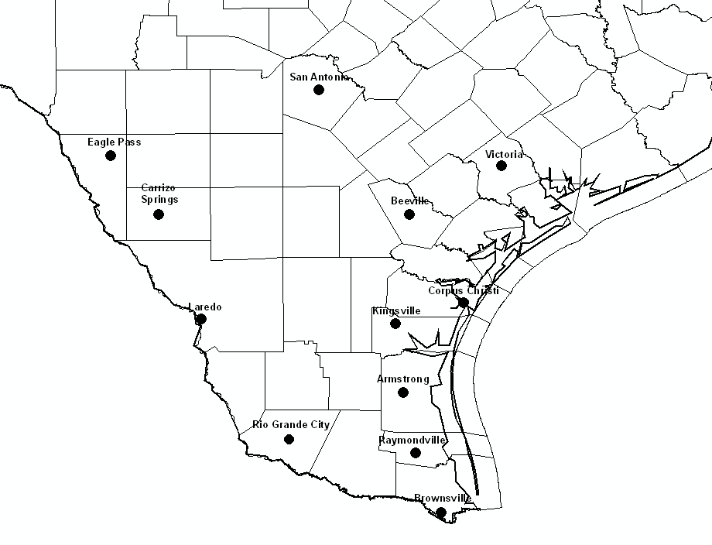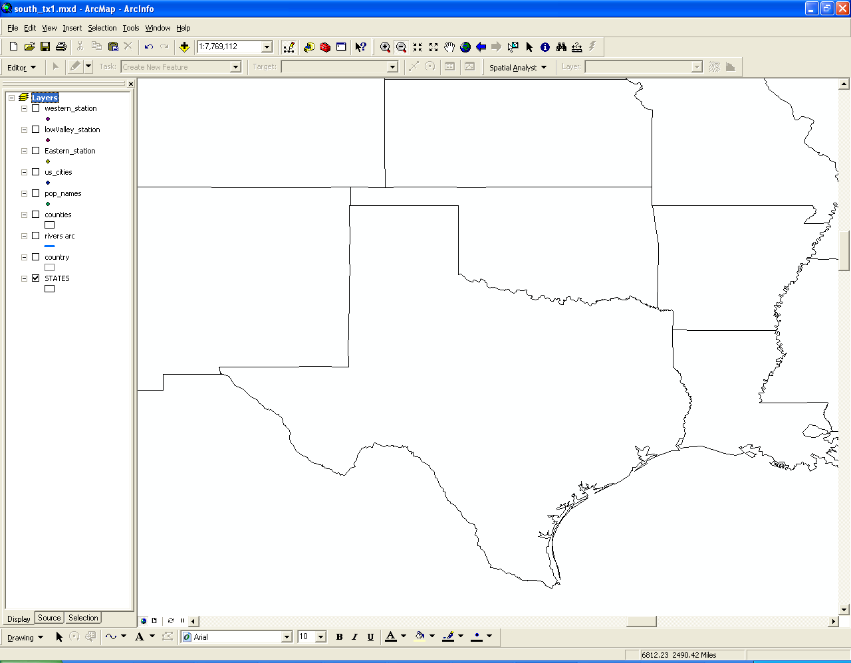
0
50 mile
Figure 1. Location map of South Texas.
While the region is classified according to Thornthwaite’s water-balance system (Thornthwaite 1948; Fig. 2) as subtropical subhumid in the east (e.g., near Corpus Christi) and subtropical semiarid in the west (e.g., near Laredo), because mean annual potential evapotranspiration exceeds precipitation by 2-5 times, it is on average uniformly moisture-deficient. Consequently, it seems reasonable to conclude that from the standpoints of both natural and human ecologies and economies, this is a regime which should be thought of as having relatively little margin of error. In particular, any combination of future climate changes that would tend to exaggerate existing moisture deficiencies would be likely to have mainly negative implications for people and at least some biophysical/environmental aspects.
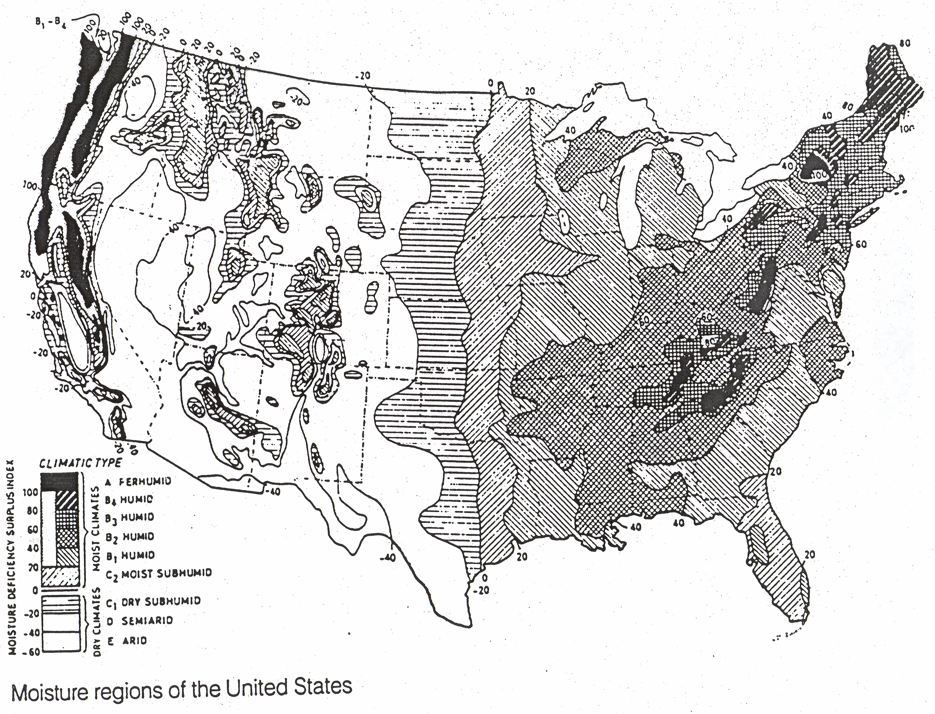
Figure 2. Moisture Regions of the U.S. (Thornthwaite, 1931/1933/1948).
The Climate of South Texas: The Twentieth Century
Temperatures 1900-2000: Mean Annual, Maximum and Minimum (Fig. 3). The median mean annual temperature for the period of 1900-2000 of (a group of 21 stations across) South Texas was 22 ºC. The median mean daily minimum temperature for the 21-station South Texas region during the 20th century was 15.9 ºC. The 20th century median daily maximum temperature for the region was 28.2 ºC. In some cases data was limited prior to 1930, in which instances the means are more heavily influenced by data from those stations with the longest periods of record, i.e., Corpus Christi and San Antonio.
Examination of a plot of annual temperatures for the century reveals three interesting features: values generally trended upward through the first one-half of the 20th century, then trended downward for 20 years between approximately 1955 and 1975, and have since climbed markedly (Fig. 3).
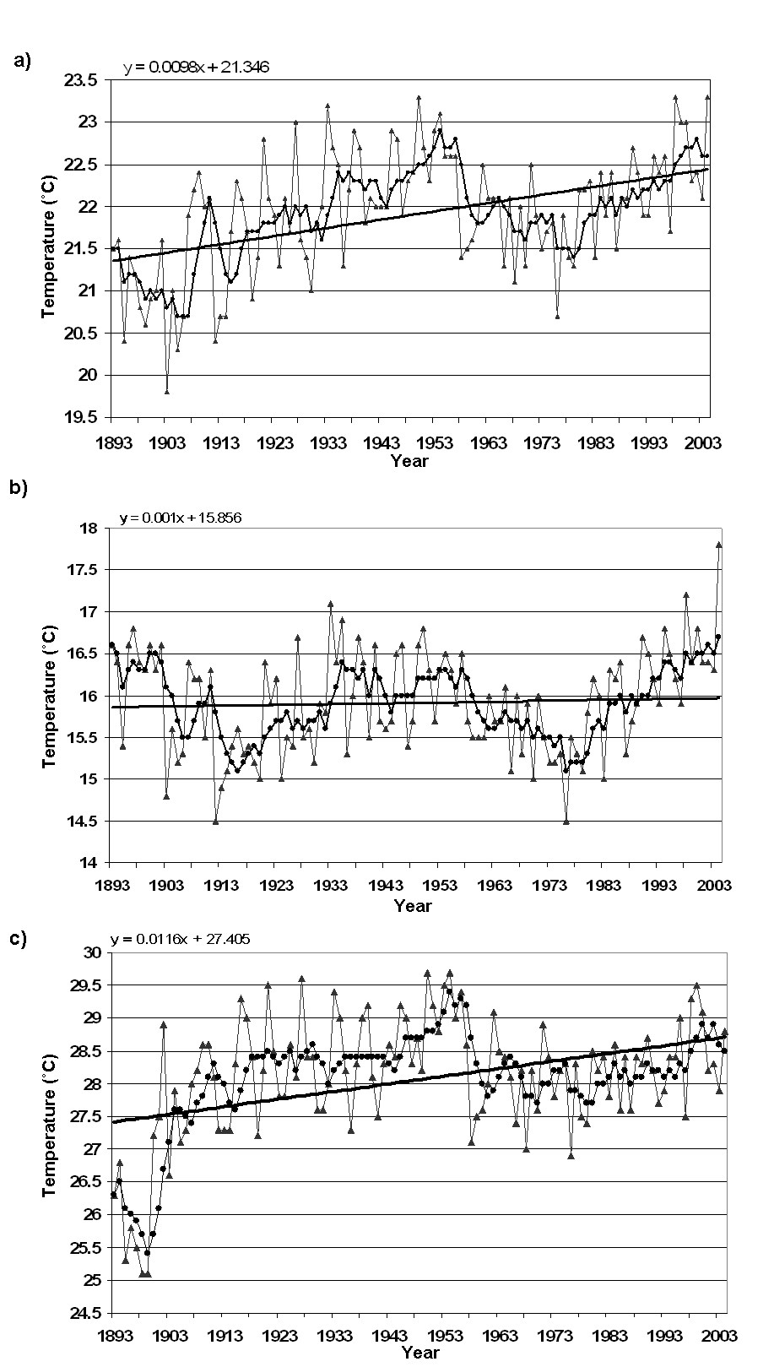
Yearly Average
5 year running Average
Trend line
Year
Figure 3. Mean annual temperature (a), mean annual minimum temperature (b), and man annual maximum temperature (c) of South Texas* during 1900 – 2000.
*21 Stations: Eastern: Alice, Beeville, Corpus Christi, Falfurrias, Goliad, Kingsville, and Victoria, Western: Brackettville, Carrizo Springs, Dilley, Eagle Pass, Encinal, San Antonio, and Uvalde, Lower Valley: Brownsville, Harlingen, McAllen, Port Isabel, Raymondville, Rio Grande City, and Weslaco.
Table 1. Mean annual temperature, mean annual minimum temperature, and mean annual maximum temperature of South Texas during 1900 – 2000.

 | Mean annual maximum  temperature (˚C) |  | Mean annual  temperature (˚C) |  | Mean annual minimum temperature (˚C)
Year | Yearly average | 5-year running average | Yearly  average | 5-year running average | Yearly  average | 5-year running average
1900 | 27.2 | 26.7 | 20.9 | 21 | 16.6 | 16.4
1905 | 27.1 | 27.4 | 20.3 | 20.7 | 15.2 | 15.5
1910 | 28.6 | 28.1 | 22 | 21.8 | 15.5 | 15.8
1915 | 28.3 | 28.2 | 21.7 | 21.5 | 15.4 | 15.2
1920 | 28.2 | 28.4 | 21.4 | 21.8 | 15.0 | 15.6
1925 | 28.6 | 28.4 | 22.1 | 22.0 | 15.5 | 15.7
1930 | 27.6 | 28.0 | 21.0 | 21.6 | 15.2 | 15.6
1935 | 28.2 | 28.4 | 22.5 | 22.4 | 16.9 | 16.3
1940 | 28.1 | 28.4 | 21.8 | 22.3 | 15.5 | 16.2
1945 | 29.2 | 28.7 | 22.9 | 22.3 | 16.5 | 16.0
1950 | 29.7 | 28.9 | 23.3 | 22.6 | 16.8 | 16.2
1955 | 29.0 | 29.2 | 22.6 | 22.8 | 16.3 | 16.3
1960 | 27.6 | 27.9 | 21.6 | 21.8 | 15.5 | 15.6
1965 | 28.1 | 28.1 | 22.1 | 21.9 | 16.1 | 15.7
1970 | 27.6 | 28.0 | 21.3 | 21.8 | 15.0 | 15.5
1975 | 28.3 | 27.9 | 21.8 | 21.5 | 15.3 | 15.2
1980 | 28.5 | 28.0 | 22.2 | 21.9 | 15.8 | 15.7
1985 | 27.6 | 28.0 | 21.9 | 22.0 | 16.2 | 15.8
1990 | 28.7 | 28.2 | 22.7 | 22.2 | 16.7 | 16.2
1995 | 28.4 | 28.2 | 22.4 | 22.2 | 16.5 | 16.2
2000 | 29.1 | 28.9 | 23.0 | 22.7 | 16.8 | 16.6
100 year median | 28.2 | 28.2 | 22.0 | 21.9 | 15.9 | 15.9

The linear least square regression analysis (Fig. 3) of 100 years of mean, minimum, and maximum temperatures shows that South Texas has experienced a warming trend. The general 100-year trends reveal that mean, minimum, and maximum temperatures increased by 0.0098 ºC/year, 0.001 ºC/year, and 0.0116 ºC/year respectively. Importantly, the maximum temperature trend was more pronounced than that of mean and minimum temperature over the last 100 years.
We may respond to these observations with several comments. First, the overall temperature increase corresponds to numerous studies which have reported increasing planetary surface temperatures during the past century or so; i.e., “global warming” (Hansen et. al. 2001; Rayner et. al. 2003). Second, the Northern Hemisphere cooled by roughly one-half of one degree Fahrenheit during the so-called Little Ice Age of ~1300-1900, the impact of which may have lingered into the 1890s in South Texas. (Many of the record cold temperatures in the region set during that period were not shattered until brutally cold snaps on or around the Christmas days of 1983 and 1989.) Third, various studies have reported that global mean temperatures decreased for about 25 years between the late 1940s and 1970 or so. At the time this decrease was widely attributed to the so-called “human volcano,” i.e., aerosols of anthropogenic origin, but most climate scientists now believe that it was in fact an expression of natural variability (Johannessen et al. 2004; Tourpali 2005). Fourth, overall temperatures trended upward for the century as a whole and sharply upward approximately the last 15 years of the century. During this period temperatures trended higher “across the board”—average annual, average minima and average maxima.
Precipitation 1900-2000: Mean Annual. The median of mean annual precipitation, 1900-2000, for the entire 21-station South Texas region was 660.7 mm (Fig. 4 and Table. 2). In general, over the last 100 years, the linear least square regression analysis reveals that the precipitation has increased at the rate of 0.879 mm/year (Fig 4 a). As reported earlier, the year-to-year pattern is one dominated by variability, with many “wet” years/periods and at least as many “dry” ones. Particularly noteworthy among the latter was the infamous drought of 1950-1956, a climatic phenomenon not experienced in the region since around the time of the Civil War according to dendroclimatological studies (Stahle and Cleaveland 1988). During the 1950 - 1956 drought the mean annual region-wide precipitation fell to 477.5 mm (and only 350 mm in 1956), an event which caused widespread hardship still bitterly recalled throughout South Texas. Also notable, and following close on the heels of the 1950s drought, was that of 1961-1964, when the average yearly rainfall for that 4-year period was only 500 mm. By contrast, during the 12-year period of 1965-1976, the mean annual region-wide precipitation was 777 mm and not a single year with significantly below-mean rainfall occurred. It would probably not be exaggerating to speculate that this prolonged relatively benign wet period lulled citizens and policy-makers into some degree of complacency vis-à-vis what constitutes “normal” rainfall in a semiarid region like South Texas.
Precipitation 1900-2000: Mean Summer. A majority of annual precipitation recorded across South Texas comes during the “high sun” period although, as earlier noted, this is somewhat deceiving: because it is so hot, the mean potential evapotranspiration or moisture loss values of these months far exceeds the moisture “income” in the form of rains. In other words, the rainy season is actually the dry season, i.e., the period of the year experiencing the largest average moisture deficiencies. The median of average annual summer (April-September) rainfall for the region was 397.55 mm. The general trend (Fig. 4 b) increased at the rate of 0.612 mm/year.
Examination of the century-long plot reveals that summer rainfall was if anything even more prone to exaggerated variability than was annual precipitation. This is not particularly surprising, as the six-month “summer” includes the month of September, during which the region sometimes experiences heavy rains associated with hurricanes and other tropical disturbances.
Precipitation 1900-2000: Winter. Winters in South Texas are relatively dry. The median of average winter (October-March) precipitation for the century was 239.8 mm, less than 40 % of the yearly mean. (However, as earlier noted this figure is misleading. Because of the severe heat load and evaporation loss of South Texas long hot summers, our “dry” (i.e., limited rainfall) winters are when average moisture deficiencies are actually the smallest.). Compared to that of mean total precipitation and summer precipitation, the winter precipitation increase relatively minimal upward trend of 0.429 mm/year (Fig. 4 c).
Precipitation 1900-2000: Summary. Overall, mean yearly precipitation remained approximately--and typically for this region--variable during the twentieth century and in this sense remains as described in our earlier reports (e.g., Norwine et. al. 1995). The regional mean annual precipitation for 1900-2000 was at 660.4 mm in line with previous studies (e.g., Norwine et. al. 1978). However, precipitation did increase slightly during the period.

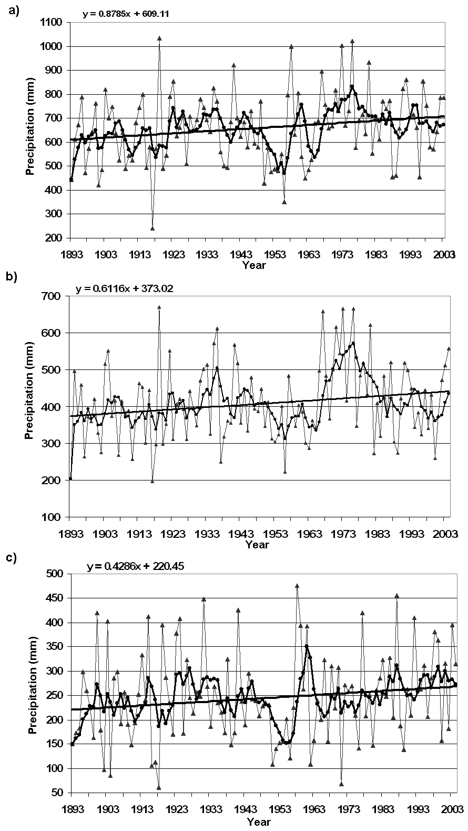
Yearly Average
5 year running Average
Trend line
Figure 4. Mean annual total precipitation (a), mean annual summer* precipitation (b), and mean annual winter* precipitation (c) of South Texas during 1900 – 2000.
*Summer includes precipitation from April to September, and winter indicates October to March.
Table 2. Mean annual total precipitation, mean annual summer precipitation, and mean annual winter precipitation of South Texas during 1900 – 2000.

 | Mean annual  Total precipitation (mm) |  | Mean annual  Summer precipitation (mm) |  | Mean annual  Winter precipitation (mm)
Year | Yearly average | 5-year running average | Yearly  average | 5-year running average | Yearly  average | 5-year running average
1900 | 761.6 | 576.1 | 421.2 | 351.1 | 418.8 | 217.3
1905 | 746 | 684.8 | 374.3 | 425.3 | 286 | 252.9
1910 | 543.1 | 576 | 389.2 | 360.4 | 148.8 | 208.7
1915 | 491.4 | 570.5 | 301.2 | 371.6 | 411.7 | 241.1
1920 | 490.6 | 686.2 | 297.5 | 433.7 | 287.8 | 229.8
1925 | 660.7 | 671 | 420.2 | 368 | 172.8 | 305.5
1930 | 691.2 | 713.9 | 348.5 | 431.7 | 247.7 | 287
1935 | 825.9 | 697.6 | 572.2 | 454.4 | 235.9 | 215.8
1940 | 682.2 | 659.2 | 354.4 | 423.4 | 173.4 | 262.1
1945 | 579.5 | 641.5 | 333.5 | 401.8 | 243.1 | 235.1
1950 | 429.3 | 566 | 346.3 | 381.1 | 231.1 | 188.7
1955 | 549.4 | 532.9 | 400.3 | 346.8 | 201.7 | 171.7
1960 | 805.7 | 684.8 | 403.1 | 369.9 | 263.3 | 327
1965 | 676.1 | 654.1 | 342.7 | 429.6 | 201.1 | 215.8
1970 | 667 | 725.4 | 501.1 | 502.6 | 307.8 | 236.5
1975 | 729.8 | 800 | 565.1 | 532 | 209.4 | 259.8
1980 | 633.1 | 705 | 434.1 | 466.5 | 147.5 | 230.8
1985 | 769.8 | 719.5 | 483.5 | 421.5 | 327.5 | 311.8
1990 | 658.3 | 651.7 | 422.6 | 403.8 | 262.1 | 241.9
1995 | 660.4 | 677.4 | 384.3 | 389 | 311.4 | 266.1
2000 | 570.6 | 665.7 | 259.7 | 376.1 | 157.9 | 279.9
100 year median | 660.7 | 659.5 | 397.55 | 400.1 | 239.8 | 243.15

Simulating the Climate of the Twenty-First Century
How might this regional climate change during the current century? A statistical model (Tebaldi et. al. 2004, 2005) synthesizes the information contained in an ensemble of 21 state-of-the-art Global Climate Models, run under historical conditions and the same, relatively conservative, future scenario of greenhouse gas emissions. This model uses a Bayesian approach to determining probability distribution functions (PDFs) of temperature change at regional scales, from the output of a multi-model ensemble, run under the same scenario of future anthropogenic emissions. This model combines the General Circulation Models (AOGCMs) of the ensemble in a way that accounts for their performance with respect to current climate and a measure of each model's agreement with the majority of the ensemble. This model emphasizes differences in the PDFs of precipitation change derived in regions where models find easy agreement, and perform well in simulating present day precipitation, compared to regions where models have large biases, and/or their future projections disagree. Based on the model we get the results in Probability Distribution Functions (PDFs) of monthly temperature and precipitation change for three future periods, as regional averages, the region encompassing southern Texas and Northern Mexico.
The statistical assumptions are formulated so that two criteria of model reliability are going to determine the way the 21 members of the ensemble are "weighted" in, i.e. contribute to shape, the PDF of climate change. Historical observed data are used to assess model reliability in representing current climate, so that models with large biases are discounted. How well each model's future projection agrees with the ensemble consensus is also taken into account, rewarding the central tendencies and slightly discounting more extreme projections.
Temperature and Precipitation in 2100: Simulated Changes. The range of uncertainty quantified in these PDFs is dependent on, and limited by, the specific emission scenario assumed and the set of GCMs used, which are thought of representing a fairly conservative set. Nonetheless, the climate models project a consistent warming (on average) from the present through 2025 and 2050 to a mean annual temperature increase on the order of 3-4 ºC in the year 2100 (Fig. 5). It is perhaps worth observing in passing that the total worldwide warming during the 10,000 years of the Holocene period (i.e., since the end of the last Ice Age) was only slightly greater at approximately 4.5 ºC. With respect to moisture conditions, this analysis of 21 climate models indicated that the most likely projection for future precipitation is centered around the current average with equal probabilities for more/less precipitation (Fig. 6 and 7).
Toward 2100: Summary. It was found that precipitation increased slightly and temperatures increased markedly in South Texas during the 20th century. Simulations of the 21st century climate of South Texas were made using Global Climate Models (GCM). These simulations suggested that temperature will continue to increase significantly while the precipitation likely remains approximately at current levels. The most logical interpretation of this analysis of the future regional climate of South Texas using GCMs supports the conclusion that the most likely scenario for the late-21st century climate of South Texas is that of an increasing reduction in water supply (i.e., higher temperatures + constant precipitation = greater moisture deficiencies), with the least likely scenario being increased water supplies, as well as longer dry spells and more high-intensity precipitation events. If correct, this scenario is unlikely to render the climate of South Texas any less problematic than at present. For example, it suggests the possibility, perhaps even probability, that the existing regional climatic divides (Fig. 2) will by century’s end move eastward, with eastern South Texas shifting from subhumid to semiarid and western South Texas shifting from semiarid to semidesert. The implications of these findings, which tend to support other indications of planetary warming (IPCC, 2001), suggest significant future challenges to the natural and human economies and ecologies of South Texas.

a)
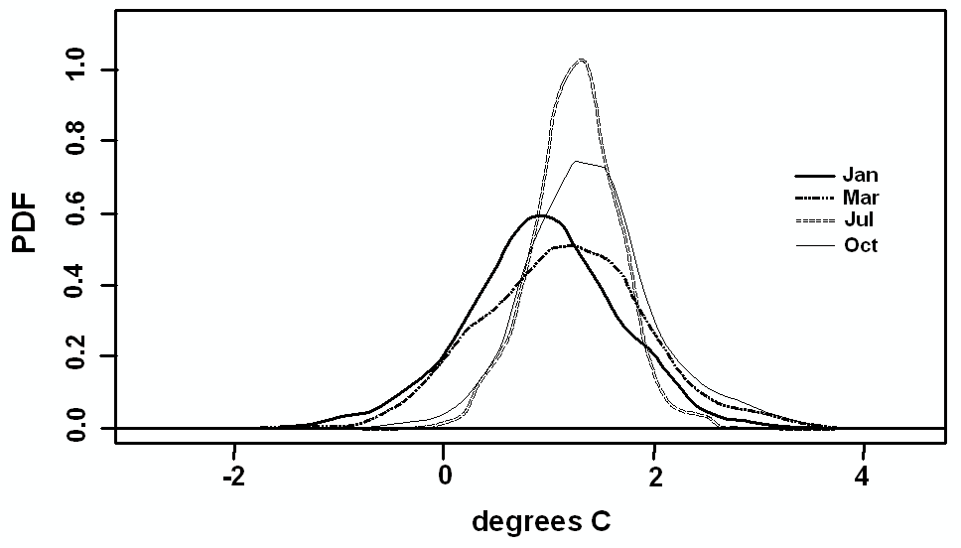
b)
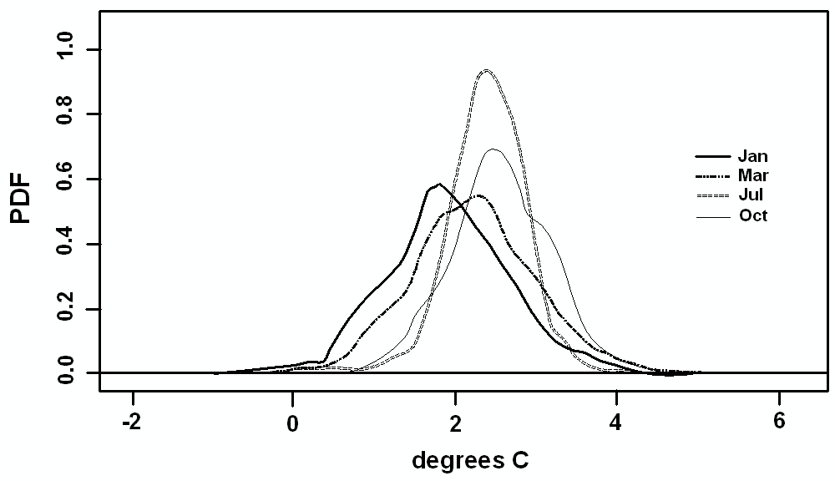
c)
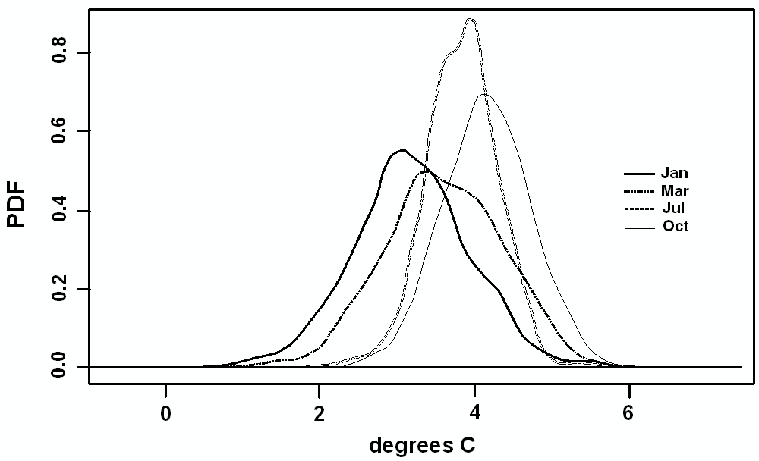
Figure 5. South Texas future climate: temperature change over the year 2025 (a), 2050 (b), and 2100 (c).
Calculations by C. Tebaldi, NCAR, 20006.
a)
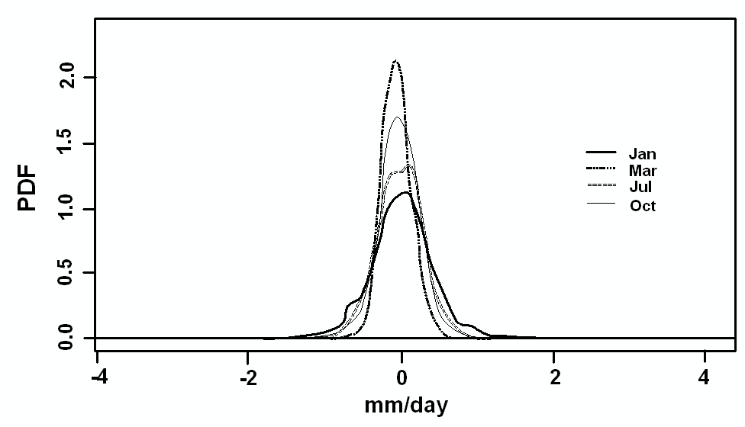
b)
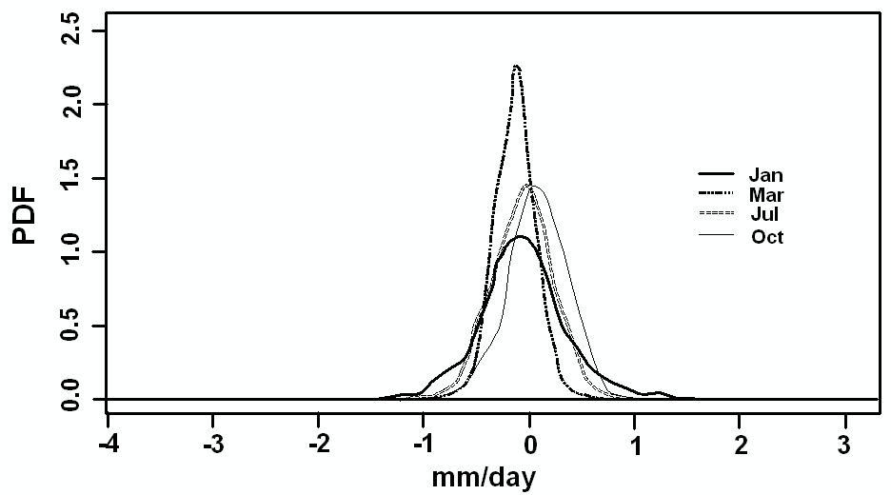
c)
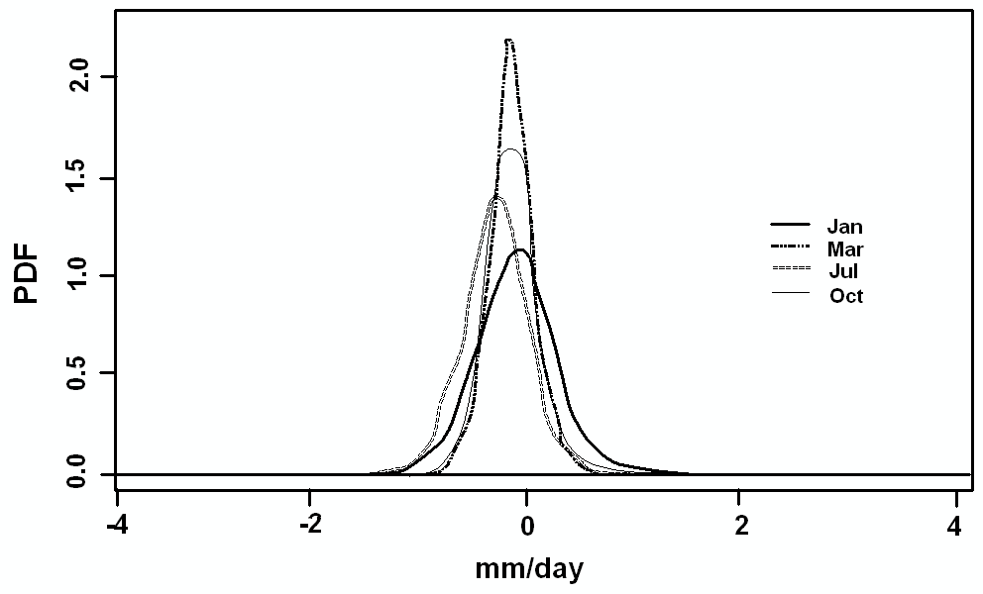
Figure 6. South Texas future climate: precipitation change (mm) over the year 2025 (a), 2050 (b), and 2100 (c). Calculations by C. Tebaldi, NCAR, 20006.

a)
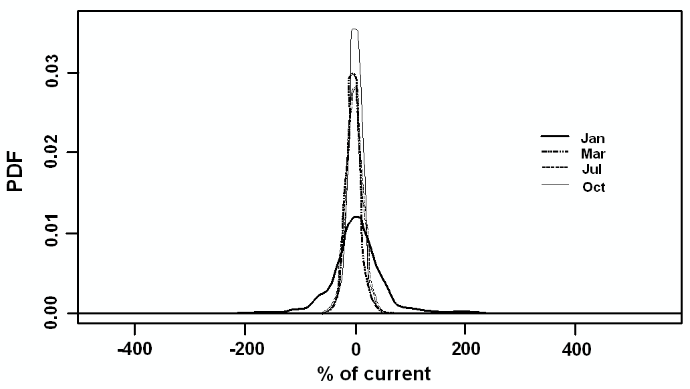
b)
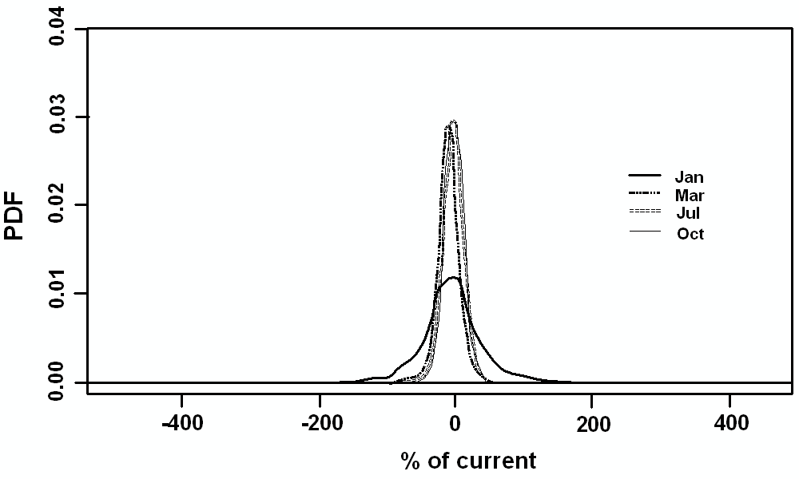
c)
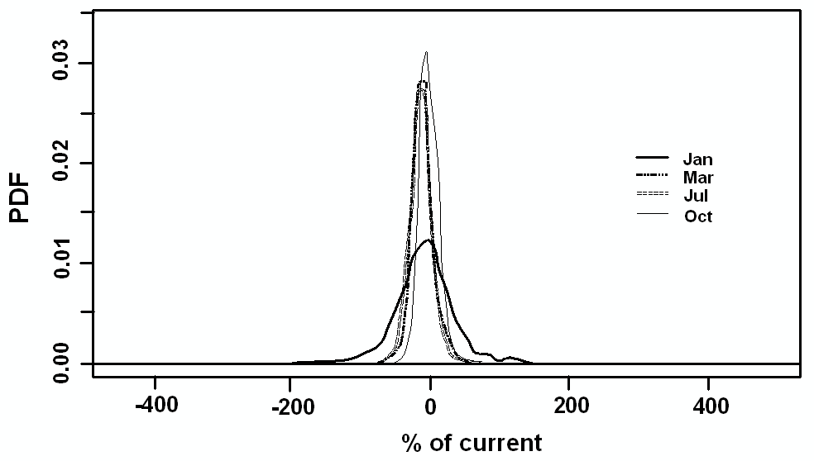
Figure 7. South Texas future climate: precipitation change (%) over the year 2025 (a), 2050 (b), and 2100 (c).
Calculations by C. Tebaldi, NCAR, 20006.
REFERENCES
Hansen, J. 2001. “Earth’s Becoming a Greener Greenhouse,” Top Story: Goddard Space Flight Center, Sept. 4, 2001.
www.gsfc.nasa.gov/topstory/20010904greenhouse.html/
Intergovernmental Panel on Climate Change 2001. Summary for Policy Makers, Climate Change 2001. www.ipcc.ch. (At the same website see also the IPCC reports for 1995 and 2005.)
Johannessen, O.M., L. Bengtsson, M.W., Miles, S.I., Kuzmina, V.A., Semenov, G., Alekseev, V.F., Zakharov, A.P., K. Hasselmann, L.P. Bobylev, L.H. Pettersson and H. Cattle. 2004. “Arctic Climate Change—Observed and Modeled Temperature and Sea Ice.” Tellus, 56A (4) 328-341.
Le Houerou, H. and Jim Norwine 1987, “The Ecoclimatology of South Texas,” in Arid Lands: Today and Tomorrow, E. Whitehead et al, eds. Boulder, CO: Westview Press, 417-443.
Norwine, J., Giardino, J.R., and Krishnamurthy, S., eds. 2005. Water for Texas, College Station, TX: Texas A&M University Press
Norwine, Jim and Ralph Bingham 1986. “Frequency and Severity of Droughts in South Texas: 1900-1983,” Livestock and Wildfire Management During Drought, 1986, R. Braun, ed. (Kingsville, TX: Caesar Kleberg Wildlife Research Institute, Texas A&I University).
Norwine, Jim, John R. Giardino, Gerald R. North, and Juan B. Veldes 1995. The Changing Climate of Texas: Predictability and Implications for the Future. (College Station, TX: Cartographics, Texas A&M University), 138-154.
Norwine, Jim, Ralph Bingham and Rosalia Vidal Zepeda 1978. “Twentieth Century Semiarid Climates and Climatic Fluctuations in Texas and Northeastern Mexico,” J. Arid Environ., 1978, 1:313-325;
Powley, Jane and Jim Norwine 1992. “Effects of Carbon Dioxide-Induced Global Warming on Water Budget in Southern Texas,”Managing Water Resources During Global Change, American Water Resources Association, November, 1992, 203-209;
Rayner, N.A., D.E. Parker, E.B. Horton, C.K. Folland, L.V. Alexander, D.P. Rowell, E.C. Kent, and A. Kaplan. 2003. “Global analyses of sea surface temperature, sea ice, and night marine air temperature since the late nineteenth century.” J. Geophys. Res. 108, 4407, doi:10.1029/2002JD002670.
Stahle, David and Malcolm Cleaveland. 1988. “Texas Drought History Reconstructed and Analyzed from 1698 to 1980.” J. Climate 1(1): 59-74.
Tebaldi, C., L.O. Mearns, D. Nychka and R. L. Smith (2004) Regional probabilities of precipitation change: A Bayesian analysis of multimodel simulations. Geophys. Res. Lett., v. 31.
Tebaldi, C., R. L. Smith, D. Nychka and L.O. Mearns (2005) Quantifying uncertainty in Projections of Regional Climate Change: a Bayesian Approach to the Analysis of Multimodel Ensembles. Journal of Climate, vol. 18, no. 10, pp. 1524-1540.
Thornthwaite, C. W. 1931. “The Climates of North America According to a New Classification. Geogr. Rev., 21: 633-655. With separate map at 1:20,000,000.
Thornthwaite, C. W. 1933. “The Climates of the Earth.” Geogr. Rev., 23: 433-440. With separate map at 1:77,000,000.
Thornthwaite, C.W. 1948. “An Approach Toward a Rational Classification of Climate,” Geogr. Rev., 38: 55-94.
Tourpali, K, C. J. E. Schuurmans, R. van Dorland, B. Steil, C. Brühl, and E. Manzini. 2005. “Solar cycle modulation of the Arctic Oscillation in a chemistry-climate model.” Geophys. Res. Lett., 32, L17803, doi:10.1029/2005GL023509, September 3, 2005
Trewartha, Glenn T., 1968, An Introduction to Climate. (New York: McGraw-Hill).

