Power Clean Assessment
Assessing your new found knowledge on how to properly perform a power clean, you will be required to complete this assessment. Reflecting whether the information attained was learned, and whether your acquired knowledge can be used outside of instruction, you will self-assess your score. Answers will be provided at the end of the assessment.

- List the 10 materials used or worn when power cleaning.

____________________________________________________________________________________________________________________________________________________________________________________________________________________________________________________________________________________________________________

- Given below are the five key materials used when power cleaning. Next to each material, state the importance of that material.

Gym Shoes:________________________________________________________________________
_________________________________________________________________________________

Weight Lifting Gloves: _______________________________________________________________
_________________________________________________________________________________

Wrist Wraps:_______________________________________________________________________
__________________________________________________________________________________

Weight Belt:________________________________________________________________________
__________________________________________________________________________________

Knee Sleeve/brace:_________________________________________________________________
_________________________________________________________________________________

3. Viewing the illustrations below, circle whether the item in the picture is in good or poor condition.
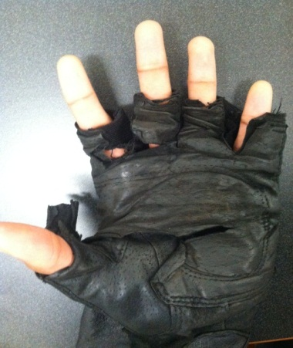 Good or poor

4. Viewing the illustrations below, circle whether the item in the picture is in good or poor condition.
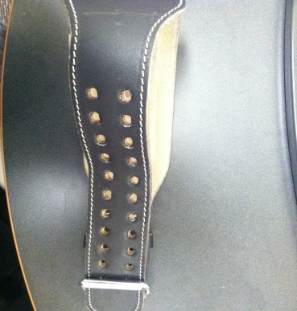 Good or Poor

5. Viewing the illustrations below, circle whether the item in the picture is in good or poor condition.
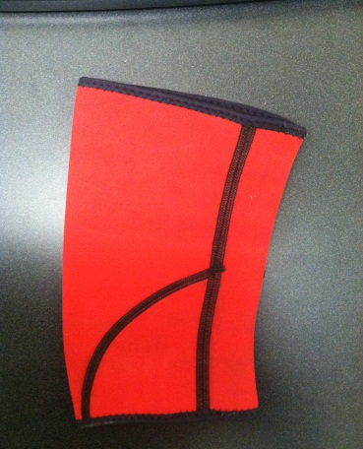 Good or Poor

6. Viewing the illustrations below, circle whether the item in the picture is in good or poor condition.
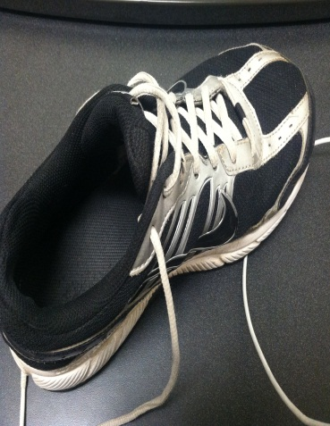 Good or Poor

7. Viewing the illustrations below, circle whether the item in the picture is in good or poor condition.
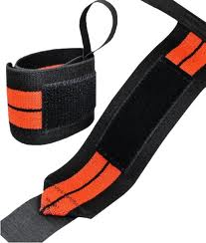 Good or Poor

8. Within the image displayed, what type of grip is the lifter using?
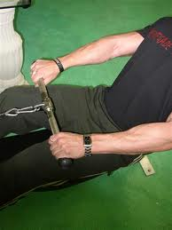
- Pronated
- Supinated
- Mixed

9. Name and list, in order, the exercises involved in the progressive movements of a power clean.
1. _______________________
2. _______________________
3. _______________________
4. _______________________
5. _______________________

10. Looking at the images below, arrange the pictures in order, portraying a power clean. Mark each box, numbering 1 to 5, 1 being the beginning, and 5 being the end.
___ 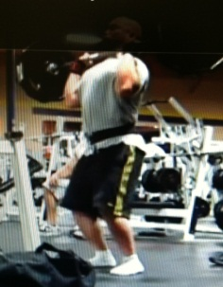 ___ 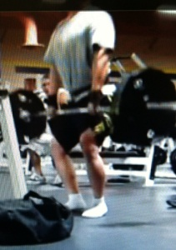
___ 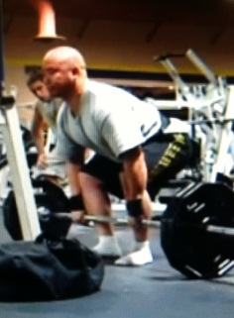 ___ 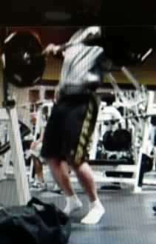
___ 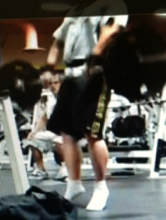

11. Pertaining to the image below, did any mistakes occur during the clean?
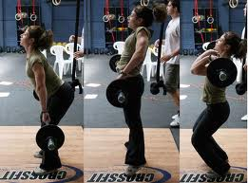 Yes or No

12. When performing a deadlift, the learner does all of the following except?
A. Use supinated grip when gripping bar.
B. Inhale deeply before starting lift.
C. Make sure posture is correct.
D. Keep back straight throughout lift.

TURN PAGE TO REVIEW ANSWERS
ANSWER KEY

1. List the 10 materials used or worn when power cleaning.
1. Gym shoes
2. Shorts
3. Sweats
4. Shirt (short sleeve or long)
5. Socks
6. Weight lifting gloves
7. Wrist wraps
8. Back support slimmer belt
9. Weight belt
10. Knee sleeves or brace

- 2. Given below are the five key materials used when power cleaning. Next to each material, state the importance of that material.

Gym Shoes:_Wrong shoes can result in shin splicts, and aching heels. People with flat feet will need motion controlled shoes. Need a running shoe or cross-trainer when power cleaning.____________

Weight Lifting Gloves: _Helps prevent calluses, improves gripping ability, reduces chances of bar slipping out of hand. They are padded, reducing pressure on hands.________________________

Wrist Wraps:__Offer additional support to wrists, limits range of unintended motion. Wraps are usually used when lifting heavy.______________________________________________________

Weight Belt:__Keep back aligned, maintains pressure or lower back and abdomen. Reduces probability of spinal shrinkage, self-corrects form by limiting sideways motion.____________

Knee Sleeve/brace:__Keeps knee supported, does not restrict knee it offers flexibility. Reduces irritation and pressure on knees.____________________________________________________

3. Viewing the illustrations below, circle whether the item in the picture is in good or poor condition.

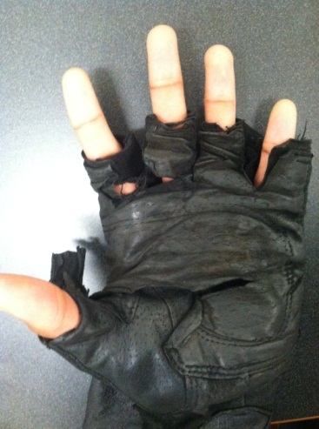 Good or Poor

4. Viewing the illustrations below, circle whether the item in the picture is in good or poor condition.
Good or Poor

5. Viewing the illustrations below, circle whether the item in the picture is in good or poor condition.
Good or Poor

6. Viewing the illustrations below, circle whether the item in the picture is in good or poor condition.
Good or Poor

7. Viewing the illustrations below, circle whether the item in the picture is in good or poor condition.
Good or Poor

8. Within the image displayed, what type of grip is the lifter using?
- Pronated
- Supinated
- Mixed

9. Name and list, in order, the exercises involved in the progressive movements of a power clean.
1. Deadlift
2. Jump
3. Shoulder shrug
4. Upright row
5. Front squat

10. Looking at the images below, arrange the pictures in order, portraying a power clean. Mark each box, numbering 1 to 5, 1 being the beginning, and 5 being the end.
_5__ _2__
_1__ _4__
__3_

11. Pertaining to the image below, did any mistakes occur during the clean?
Yes or No

12. When performing a deadlift, the learner does all of the following except?
A. Use supinated grip when gripping bar.
B. Inhale deeply before starting lift.
C. Make sure posture is correct.
D. Keep back straight throughout lift.

If you missed more than 7 problems (including fill in the blanks/arrangements), reread material and try test again.
CHECKLISTS WITHIN INSTRUCTION
Material Checklist #1
Check to see if you have everything you might need for power cleaning.
Materials | I Have This | I Need This
Gym Shoes
Shorts
Sweats
Shirts
Socks
Weight Lifting Gloves
Wrist Wraps
Weight Belt
Knee Sleeve or Brace
MPP3 Arm Band

Material Checklist #
After reading the importance of the five key materials used when power cleaning, check whether or not you possess these materials.
___ ___
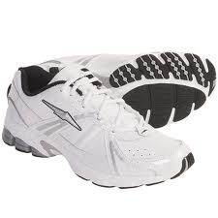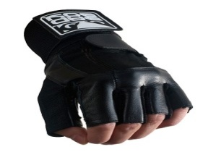
___ ___
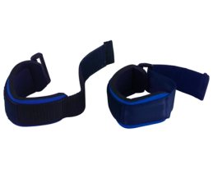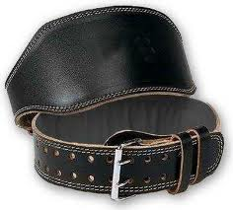
___

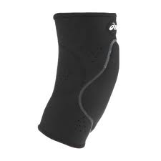
Knowledge Checkpoint #1
Can you arrange the following exercises in rank order?

______B____________ A. Upright Row
______D____________ B. Deadlift
______E____________ C. Front Squat
______A____________ D. Jump
______C____________ E. Shoulder Shrug K

Knowledge Checklist #2
Being able to pinpoint flaws within another’s power clean can be beneficial not only for the person needing correction, but for you as well. Recognizing other’s mistakes helps you critique/analyze yourself more thoroughly. Given the image below, can you determine what mistake(s) occurred?
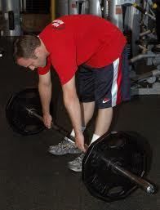
_____________________________________________________________________________________________________________________________________________________________________________________________________________________________________________________________________________________________________________

Performance Checklist #1 GRIP
Did you remember to… | YES | NO
Start with a pronated grip?
Were hands spread-out past shoulder’s width?
Were thumbs clenched by pointer and middle fingers?

Performance Checklist #2 PROGRESSION MOVEMENTS
Movements |  |  | Yes | No
Make sure you are exemplifying the correct posture, placement, and grip.
Before starting lift, make sure you inhale deeply before lifting bar.
Keeps arms locked out while lifting bar, imitating a deadlift.
Once your legs have reached a one o’clock position, you will jump powerfully, shifting weight from heels to toes.
At the peak of the jump, when body is hyper extended, you will powerfully shrug shoulders back.
6Bending arms, you will raise bar, performing an upright row.
While bar is still traveling upward, you will drop below bar, and receive the bar, transitioning into a front squat.
Knees will be bended; weight will be across your shoulders, you will drive through heels till standing erect.

Performance Checklist #3 POWER CLEAN
Did you remember to…. | Yes | No
Position feet correctly?
Position shins close to bar?
Grip the bar correctly?
Lock out arms?
Is back straight?
Look forward before lifting bar?
Exhale while lifting the bar?
Keep back straight throughout movement?
Rest in hyper extended position?

Performance Checklist #4 JUMP to RECEIVING BAR
Are you….. | Yes | No
Starting with legs slightly bent?
Driving your hips forward as if jumping?
Shrugging shoulders back forcefully?
Keeping the bar close to body while upright rowing?
Receiving bar correctly?

Performance Checklist #5 POWER CLEAN
Are you…… | Yes | No
Using correct posture/placement?
Exhaling before lifting bar?
Locking out arms?
Performing deadlift correctly?
Thrusting hips forward?
Shoulder shrugging after thrusting hips?
Performing an upright row?
Receiving bar correctly?
Dropping into a front squat when receiving bar?
Standing erect to show weight is controlled?

