Part Three: Working On Mechanics
Being able to grip the bar correctly, you are now ready to learn what all is involved within a power clean. Throughout the fluid motion of a power clean, several exercises are being conducted, whether conscious or not. When performing a power clean, you will perform five basic exercises, a deadlift, jump, shoulder shrug, an upright row, and a front squat.

Deadlift
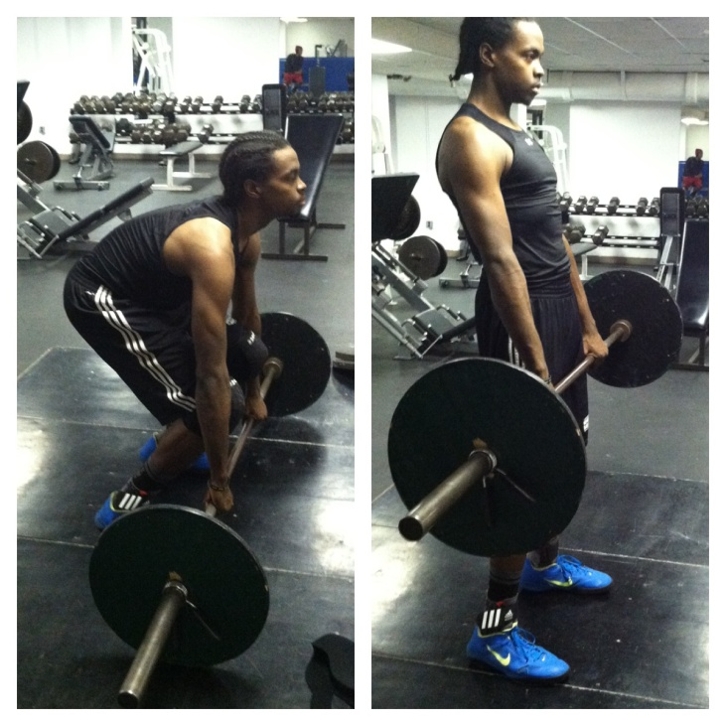
The deadlift is a power lifting exercise, simple in nature. Similar in placement and posture, replicating the positioning of a power clean, a deadlift begins the power clean. Traveling from point A to B, you will place your shins close to bar about shoulder’s width apart, placing your hands slightly further than shoulder’s width apart. Grabbing the bar, you may use either a pronated or mixed grip. When power cleaning though, your grip will be a pronated hook grip. Once your feet and hands are placed, you will correct your posture by bending your knees, allowing your butt to drop to about 110 degrees or 2 o’clock. Then, you will make sure that your arms are directly over the bar, and locked out (straight, no bend in arm). Next, you will straighten your back by sticking out your chest, and tensing your abdomen, while lifting up your head to look straight forward. After exemplifying the correct form, you can then stand straight up with the weight, keeping your back straight throughout the lift until your back is slightly hyper extended. Figure 11

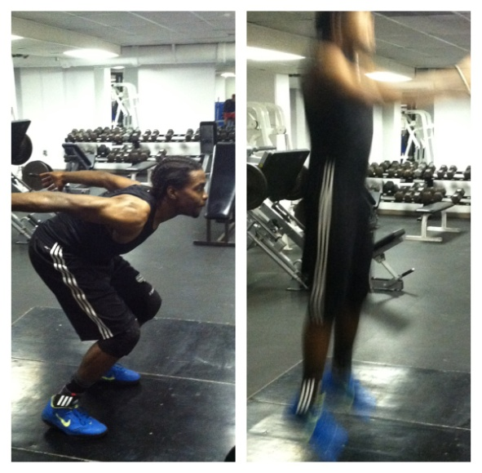
Jump
Succeeding the deadlift, a jump is incorporated. When jumping, with the bar in your hand, you will approach the jump like a standard jump. You will gather yourself once your legs are at one-o’clock. Fiercely driving through the heels of your feet, powerfully popping/thrusting your hips forward, you will then shift your weight from heels to toes, you will become slightly hyper extended and become vertical. Not appearing too difficult, your jump can ultimately determine whether or not you will successfully complete a power clean. Throughout this process, your arms should remain locked out. Figure 12

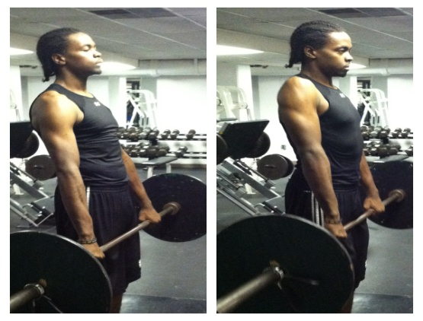
Shoulder Shrug
The rotation of your shoulders in an upward and back motion, through the use of a pronated grip, is known as a shoulder shrug. Within a power clean, this exercise is conducted almost simultaneously with the jump. Before you become vertical, or when your weight has shifted and you are on your toes, you will then powerfully shrug your shoulders. Figure 13

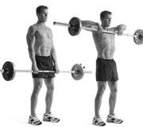
Upright Row
Varying in preferred placement, an upright row can be performed with a grip wider than shoulder’s width apart, or a close grip, being within shoulder’s width. Starting with your arms in a locked out position, you will bend your arms and point your elbows outward. You will raise the bar to your collar bone or throat, keeping the bar close to your body throughout the pull. This portion of the power clean occurs after the shoulder shrug. Figure 14
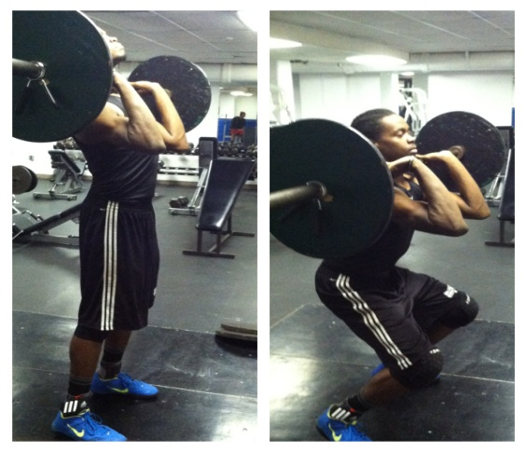
Front Squat
Awkward for most beginners, a front squat is another variation of a squat, where the weight rests across your shoulders in front of your collar bone. Differing from your basic back squat, when performing a front squat, you will receive the bar on your shoulders, crease at hips, and squat. Squatting until your body has surpassed 90 degrees or 3 o’clock, you will then drive up through heels until you are standing erect. The front squat is the concluding exercise in a power clean.
Figure 15

Recapping Over Exercises
So, before you attempt a power clean, you might want to perform these five exercises, making sure that you are able to perform each exercise. Remember, the power clean consists of a deadlift, jump, shoulder shrug, an upright row, and a front squat.

Knowledge Checkpoint #1
Can you arrange the following exercises in rank order?

___________________ A. Upright Row
___________________ B. Deadlift
___________________ C. Front Squat
___________________ D. Jump
___________________ E. Shoulder Shrug

Referencing to the titled exercises within this segment, or recapping over exercises, you can compare your answers with how the exercises were listed in either of the suggested.

Steps within a Power Clean
Now aware of the exercises occurring within a power clean, you can see how the exercises transition. When performing a power clean, eight steps should be applied. Not all steps consist of movement, some steps are more cue focused. So, let’s look at these progressive movements.
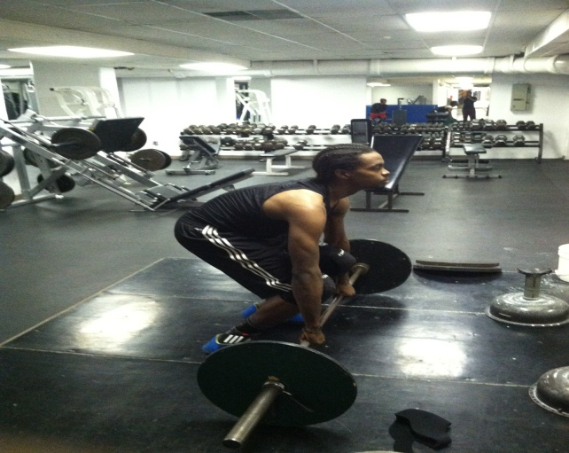

Figure 16
- Make sure you are exemplifying the correct posture, placement, and grip.
- Before starting lift, make sure you inhale deeply before lifting bar.
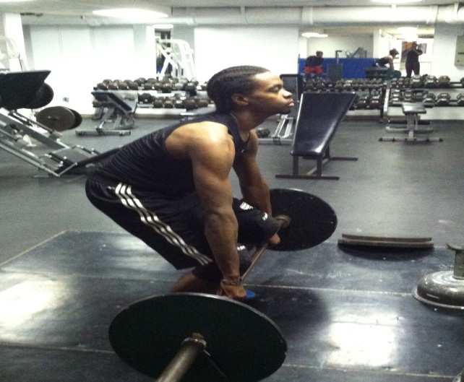

Figure 17
- Keeps arms locked out while lifting bar, imitating a deadlift.

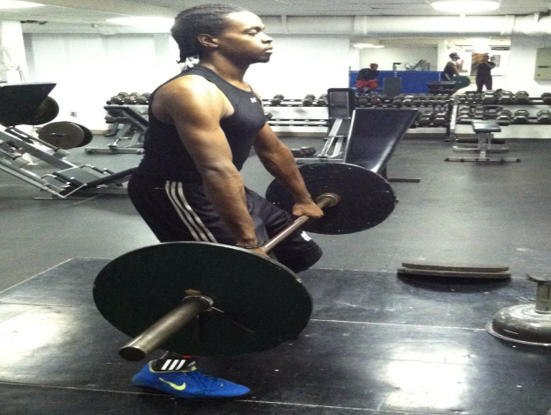

Figure 18
- Once your legs have reached a one o’clock position, you will jump powerfully, shifting weight from heels to toes.

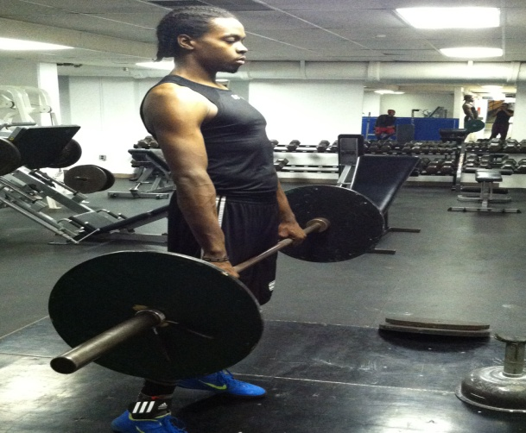

Figure 19
- At the peak of the jump, when body is hyper extended, you will powerfully shrug shoulders back.

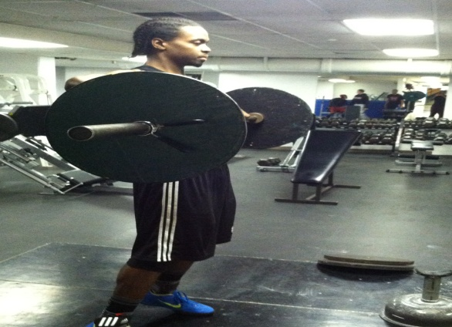

Figure 20

- Bending arms, you will raise bar, performing an upright row.

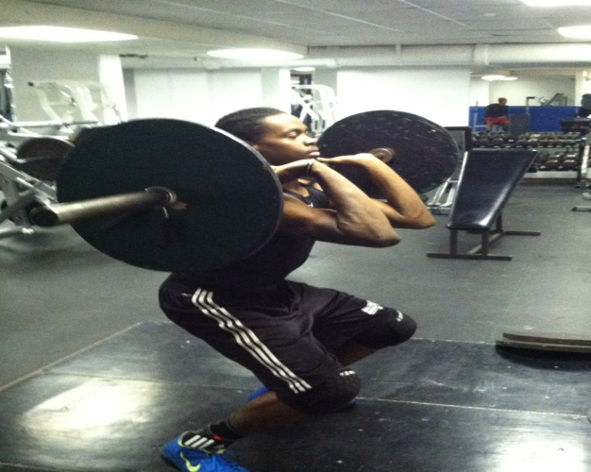

Figure 21
- While bar is still traveling upward, you will drop below bar, and receive the bar, transitioning into a front squat.
- Knees will be bended; weight will be across your shoulders, you will drive through heels till standing erect.

Recapping Over Steps
Looking at the progressive movements within a power clean, you must:
- Make sure you are exemplifying the correct posture, placement, and grip.
- Before starting lift, make sure you inhale deeply before lifting bar.
- Keeps arms locked out while lifting bar, imitating a deadlift.
- Once your legs have reached a one o’clock position, you will jump powerfully, shifting weight from heels to toes.
- At the peak of the jump, when body is hyper extended, you will powerfully shrug shoulders back.
- Bending arms, you will raise bar, performing an upright row.
- While bar is still traveling upward, you will drop below bar, and receive the bar, transitioning into a front squat.
- Knees will be bended, weight will be across your shoulders, and you will drive through heels till standing erect.

Performance Checklist #2
Given the progressive movements occurring within a power clean, which of the following do you suppose will give you complications?

Movements |  |  | Yes | No
Make sure you are exemplifying the correct posture, placement, and grip.
Before starting lift, make sure you inhale deeply before lifting bar.
Keeps arms locked out while lifting bar, imitating a deadlift.
Once your legs have reached a one o’clock position, you will jump powerfully, shifting weight from heels to toes.
At the peak of the jump, when body is hyper extended, you will powerfully shrug shoulders back.
6Bending arms, you will raise bar, performing an upright row.
While bar is still traveling upward, you will drop below bar, and receive the bar, transitioning into a front squat.
Knees will be bended; weight will be across your shoulders, you will drive through heels till standing erect...

Are you envisioning yourself power cleaning? Does it look like this figure?

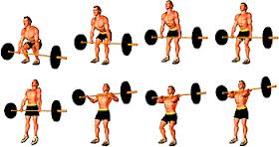

Do’s and Don’ts
Now that you are aware of the movements occurring within the power clean, you can now acknowledge what to do and not to do when cleaning. Pay close attention to the images presented below. The slightest variation of placement or pulling to early can result in a less effective lift, unnecessary dispersal of energy, and possible injuries.

Incorrect Correct
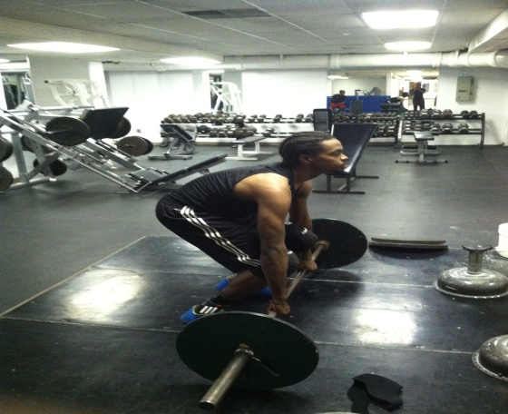
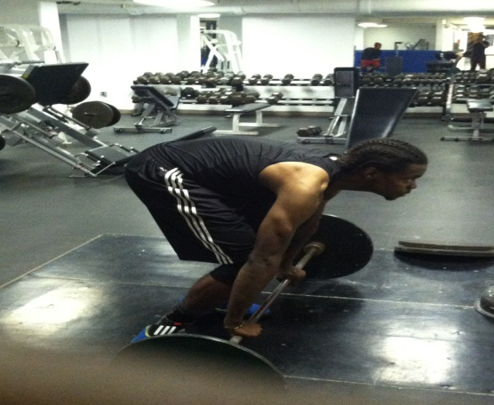

Figure 23 Figure 24
Lifter’s arms are not aligned directly over bar. Lifter’s arms are aligned over bar. Lifter is
displaying correct posture and placement.

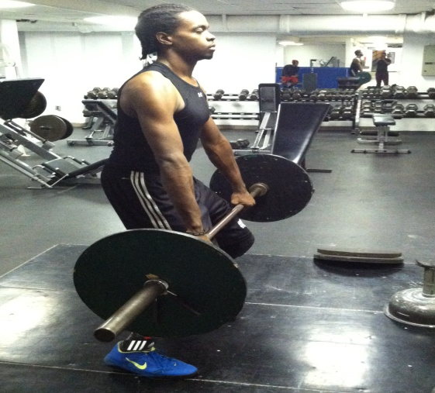
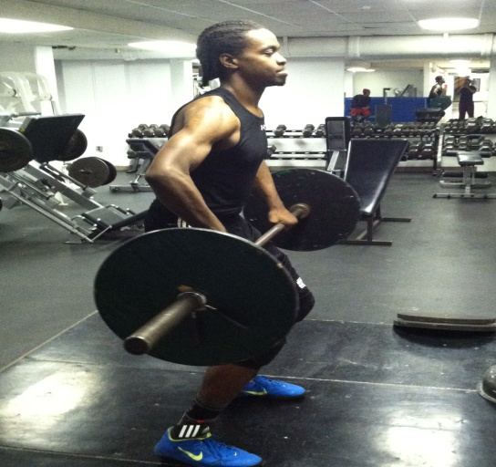
Incorrect Correct

Figure 25 Figure 26
Lifter’s arms are already beginning to bend. Arms are still locked out. Bar is close to
Placing access strain on shoulders. body. Lifter is ready to begin jump.

Incorrect Correct
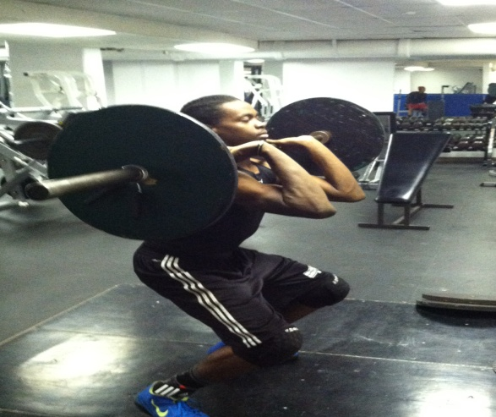
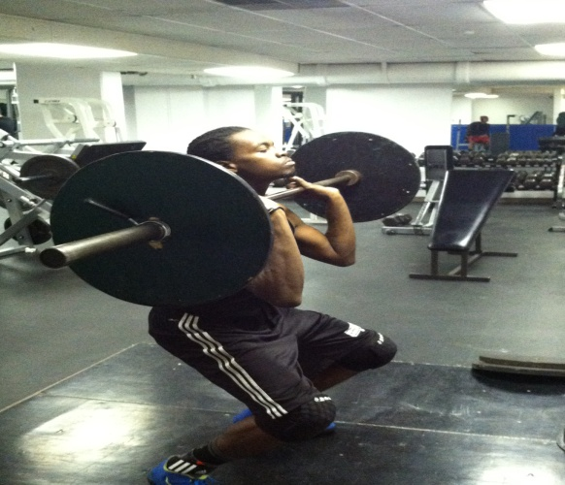

Figure 27 Figure 28
Bar was not received properly. Elbows Bar is received correctly. Elbows are
are not parallel from floor. Again placing parallel from floor. Bar is resting across
additional strain on shoulders. Weight is shoulders. Wrist is bent back.
Not resting across shoulders.

Knowledge Checklist #2
Being able to pinpoint flaws within another’s power clean can be beneficial not only for the person needing correction, but for you as well. Recognizing other’s mistakes helps you critique/analyze yourself more thoroughly. Given the image below, can you determine what mistake(s) occurred?
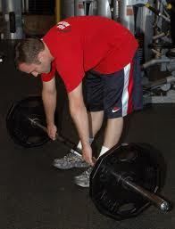

________________________________________________________________________________________________________________________________________________________________________________________________________________________________________________________________________________________________________________________________________________

Once you have answered the checklist, look at the first correct figure. Compare and contrast the two figures (checklist and first correct image) and note whether or not your answer pointed out all of the obvious flaws. If so, continue onto the next part; but if not, review section again.

