Problem Information Statement
The Power clean is a technical lift, generally performed by athletes. The clean is typically favored among explosive movements and lifts. The level of complexity in performing this lift enabled the lift to be considered an Olympic lift. Regardless of the label placed upon the clean though, numerous people are unaware and lacking knowledge in the progressions and technique needed to optimally execute the lift. Ignorance about this lift can result in multiple injuries, ranging from something as simple as unnecessary muscle fatigue, to tears and strains in shoulders and wrists.
A goal analysis will be used, providing information needed for creating instruction for performing a power clean. Identifying critical learning goals, as well as objectives, an instructional manual will teach and aid in the development of knowledge and skills associated with power cleaning. The instruction will briefly discuss materials used when power cleaning; yet the primary focus will emphasize proper form/posture, and ability to transition through various exercises within the power clean movement.
Subject Matter Expert (SME)
In creating the instruction on, the proper way to power clean, I met with Gabi Kropid. Ms. Kropid is a certified personal trainer, currently employed at the YMCA. Gabi has worked with several clients, each client varying in levels of fitness and capabilities. Having a thorough understanding of the human anatomy, and a plethora of exercises isolating desired muscles, Gabi was easy to converse with on this matter. Coaching individuals through several power clean demonstrations, Gabi was able to simplify the steps occurring within the movement. While addressing which exercises were being implemented within this single lift. Visual aids, such as video recordings and photographs, were suggested and utilized. I asked Ms. Kropid many questions, which in return offered me an even more concise explanation for what was happening, and what was going to proceed afterwards. We were able to meet several times; and after completing a draft, she was able to review my material for accuracy.
Goal Analysis
Set Goals
Know the muscle being used (SME says this will be stated in progression explanation)
Prevent injuries. (SME said that the correct posture prevents injuries, they are
Correct the lifters posture almost one in the same)
Know proper form/technique.
Demonstrate the correct grip (I assumed that before you can lift, you prepare by gripping bar)
Prepare for lift
Know what materials to use
Incorporate exercises into routine (I decided that this is not a goal but rather a preference)
Understand how to perform a clean
Know the progressions of movements (SME and I agree that this could be separate objectives
Know the exercises used in clean in the same goal since they are complimentary)
Know how to properly receive the bar
Refine Goals
Understand how to perform a clean
Demonstrate the proper grip
Know what materials to use
Know proper form/technique
Know the progression of movements
Know how to properly receive the bar
Appreciate the lifts complexity
Prevent injuries
Rank Goals
Know what materials to use
Demonstrate the proper grip
Prevent injuries (Should be blatantly/indirectly stated throughout instruction,
Know proper form/technique SME suggests dropping the two)
Know the progression of movements
Know how to properly receive the bar (SME says these go hand in hand)
Understand how to perform a clean
Appreciate the lifts complexity (SME felt learner will appreciate difficulty through practice)
Second Refinement
Know what materials can be used or worn, while performing a power clean.
Understand how to properly grip or hold the straight bar before attempting to power clean.
Know the proper mechanics to power cleaning, to prevent injuries.
Appreciate the level of difficulty involved within a power clean.

Learner Analysis
General Characteristics
Recommended to ages 14 to 65
Specific Characteristics
Must be able to lift forty-five pounds.
Must be able to use muscles required for lift.
Doctor’s clearance advised for previously injured or age 45 and above.
Must be able to read and comprehend at an eight-grade level or higher.
Environmental Analysis
A few factors that might prevent the learner from meeting their objective are preferred accessories, scheduling appointments, and eating thoughtfully. The majority of lifters prefer to wear gloves (protects hands from rough equipment that might pinch hands, causing calluses), weight belts (supports lower back, reduces chances of lower back strain), and cushioned/fairly new shoes (old or worn shoes can be hazardous for lifter). Scheduling an appointment with a trainer or instructor can be hectic when times conflict. This in return can prolong the lifters progress, and possibly lose the lifters interest in being coached. The instruction must incorporate schedule flexibility. Lastly, the lifter needs to be aware of their meal in-take. Gorging or not consuming enough or the proper foods can result in blackouts, dizziness, sluggishness, or regurgitation. Learners must be cautions of their diet and eat properly/thoughtfully before lifting.

Contextual Analysis
Orienting Context
The purpose of this instruction is to educate individuals attempting and inaccurately performing, the power clean. The instruction will guide the lifter step by step, from start to finish, in aim of reducing excess strain.
Instructional Context
This instruction is self-paced, using accessible equipment, found within any local gym and several fitness stores. The location of the instruction will be within a gym. The learner will need to meet several times, each session with duration of thirty minutes.
Transfer Context
Completing the course, the learner will be able to transfer the instruction to performance, and execute a proper power clean.

Task Analysis
- Materials lifters can use
- Gym shoes
- Comfortable athletic shoes
- Gym clothing
- Shorts
- Sweats
- Shirt (short sleeve or long)
- Socks
- Weight lifting gloves
H Wrist wraps
I. Waist belt
J. Knee sleeves or brace
K. MP3 Arm Band
- Exercises within movement
- Deadlift
      - Utilizes calves, hamstrings, gluteus maximus, and lower back.
      - Incorporates forearms, shoulders, chest, and abdomen
      - Lower back exercise
      - Uses similar posture as power clean
A. Differing from power clean, a mixed grip can be used
      - Lift is completed when lifter stands slightly hyper extended.
      - Power lifting movement
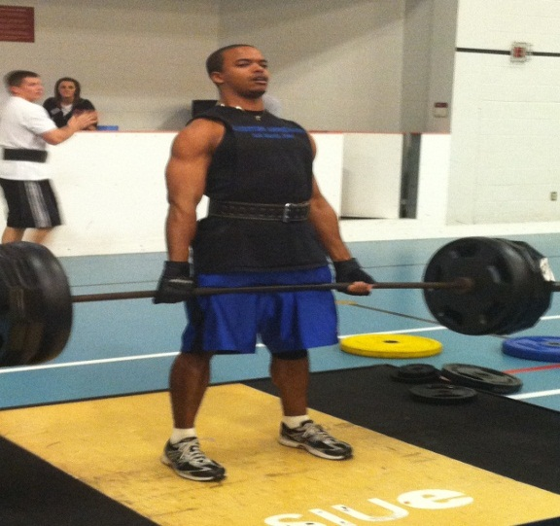
- Jump
- Feet are shoulder’s width apart
- Requires a slight bend in knees (1 o’clock)
- Heel to toe movement
- Explode/drive from thighs
- Shoulder Shrug
- Place heels into ground
- Feet shoulder’s width apart
- Contract abdomen
- Individual may either stand or sit
- Can use a bar or dumbbell
- Arms remain straight
- Shoulder’s rotate in an upward then back motion
- Upright Row
- Place heels into ground
- Feet shoulder’s width apart
- Contract Abdomen
- Hands spread shoulder’s width apart
- Bar or dumbbell is held close to body
- Shoulders are pointed or pulled back
- Bar or dumbbell should travel up and near the body
- Bar or dumbbell is raided slightly beneath chin
- Front Squat
- Individual stands erect
- Place heels into ground
- Feet shoulders width apart
- Contract abdomen
- Bar is grabbed slightly wider than shoulders width
- Bar is held in a pronated grip
- Bar is brought towards throat, resting on shoulders
- Bar rests on shoulders as elbows are raised
- Bar then is held by fingers instead of palm
- After positioned the individual bends at hips
- Hips come down in a straight line while squatting
- At the bottom of squat, drive up through heels
- Placement of lifter
- Footing
- Center self with bar
- Feet shoulder’s width apart
- Shins close to bar
- Feet pointed forward
- Grip
  - Hand spread slightly past shoulder’s width
  - Use a pronated grip
A. The palms of both hands are facing towards the lifter
  - Clench thumb with pointer and middle finger around bar
- Thumbs should be held tight enough to relinquish the bar from sliding or rubbing against hand.
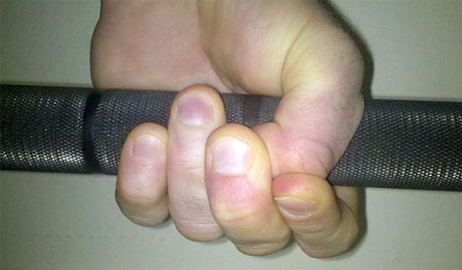

- Posture
- Legs should be bent about 110 degrees (2 o’clock)
- Arms aligned directly over bar
A. Arms must be straight (no bend)
- Back is straight3ened
- Face looking directly ahead
- Poke out chest
- Contract abdomen
4. Performing the lift
- Make sure placement of lifter is correct
- Inhale deeply before commencing lift
  - Provides oxygen to muscles
  - As soon as lift commences, exhale
- Bar is lifted, imitating a deadlift movement
      - Arms are in a locked out position
      - Tension is present in quadriceps, abdomen, pectorals, biceps, shoulders, and back
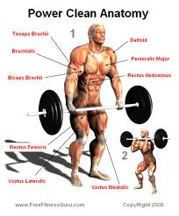
- Prior to fully extending legs and erecting the body, individual drives through legs as if jumping.
- Lifter shifts weight from heel to toe
- Hips are pushed forward powerfully.
- Body becomes slightly hyper extended (beyond erect)
- Arms are still in locked position
- Once hyper extended, shoulders are powerfully shrugged back
- Once shoulders shrug back, arms bend
- Bar travels fluidly with aid from jump and powerful shrug
- An upright row is performed, bringing the bar closer to throat
- Lifter drops into a front squat
- Lifter receives bar
- Weight rests on fingertips
- Elbows are pointed upwards
- Bar rests on shoulders crossing the collar bone
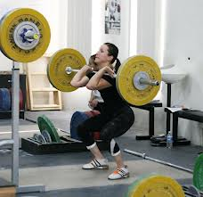

- Lifter drives up through heels
- Tension is placed on lifters quadriceps, abdomen, oblique, back, gluteus maximums, and calves.
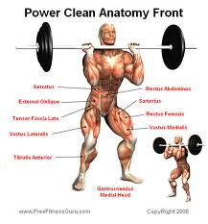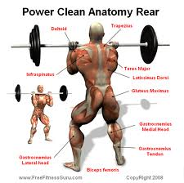
- Lifter stands erect with weight on shoulders

Goals and Objectives
Goal 1: Know what materials can be used or worn, while performing a power cling.
Objective 1.1
Reviewing which 10 materials are used when performing a power clean, the learner will list the materials on paper, with 80% accuracy.
(Fact-recall) (Task Analysis 1.A-K)
Initial Presentation 1.1
(Materials used when power cleaning)
The instruction will show a list of materials used when performing a power clean. Instruction will give a brief synopsis over the importance of each material, shown within the list. After covering synopsis, the list, labeling all materials will be reshown.
Generative Strategy 1.1
(Recall)
Learner will read materials off of a list, and recap over the materials once again, reinforcing the learner to memorize the materials. Learner will be given feedback in the form of a checklist (found in assessment – material checklist #1).
Test Item 1.1
(Objective- Short Answer- Item 1- In Assessment)
Objective 1.2
Given an overview, explaining the importance of the 5 key materials used when power cleaning, the learner will explain the importance of each material, with less than 2 mistakes.
(Concept-Recall) (Task Analysis 1.A, 1.G-J)
Initial Presentation 1.2
(Importance and benefits of each material)
Instruction will give a thorough overview pertaining to five key materials used when power cleaning. Instruction will explain the importance of each material. Instruction will provide illustrations enhancing the importance of each material.
Generative Strategy 1.2
(Review)
Learner will review information, reciprocating the importance of concepts (different materials) learned throughout this objective. Learner will acknowledge the importance of the 5 key materials. Receive feedback in checklist (found in assessment under material checklist #2).
Test Item 1.2
(Objective- Matching- Item 2)
Given below are the five key materials used when power cleaning. Next to each material, state the importance of that material.
- Gym shoes
- Weight training gloves
- Wrist wraps
- Weight belt
- Knee Sleeves or brace
Objective 1.3
Given 5 images of good and poor conditioned materials, the learner will identify the good conditioned materials at 80% accuracy.
(Concept-Application) (Task Analysis 1.A, 1.G-J)
Initial Presentation 1.3
((Give an example and explain why it's an example))
The instruction will show a picture of "good materials." Along with the picture, there will be an explanation of why that is an example of "good" materials. For contrast, the instruction will show a picture of poor materials. The instruction will explain why the materials are poor.

Generative Strategy 1.3
(Integrative)
Instructional packet will instruct the learners to distinguish the condition of the material (example) depicted in the selected image.
(Organization)
Learner will make a decision, relating their current materials to the images within the figure (good or poor). Learner will be given feedback at the end of bad condition section.
Test Item 1.3
(Objective- Multiple Choice – Item 3-7)
Viewing the illustrations below, circle whether the item in the picture is in “good” or “poor” condition.
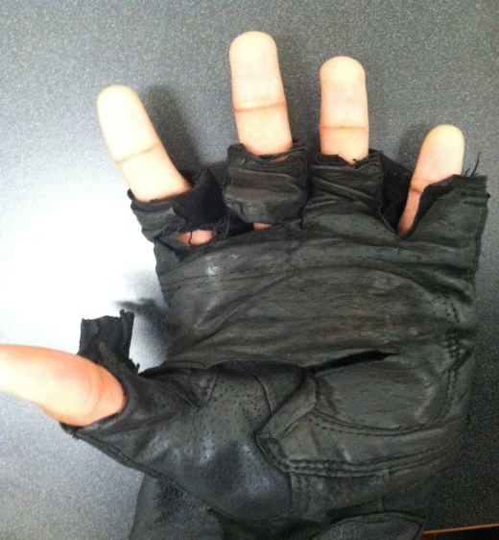 Good or poor?

Goal 2: Understand how to properly grip or hold the straight bar before attempting to power cling.
Objective 2.1
Given an overview, describing different grips for holding a straight bar, the learner will identify which grip is used for power cleaning, with 100% accuracy.
(Concept-Application) (Task Analysis 3.B)
Initial Presentation 2.1
(Give an example and explain why it's an example).
The instruction will show a picture of a proper power cleaning grip. Along with the picture, there will be an explanation as to how to correctly grip the bar and why this is an example of a correct grip. For contrast, the instruction will give an example of incorrect grips. The instruction will explain why these grips are incorrect.
Generative Strategy 2.1
(Integrative)
Learner will be knowledgeable on multiple grips. Learner will be able to identify correct grip. Learner will be given feedback after the incorrect grip segment.
(Organization)
Learner will analyze picture, relating the image to concepts learned, correlating the logic as to why a certain grip is used over another, shown in the image.
Test Analysis 2.1
(Objective- Multiple Choice- Item 8)
Within the image displayed, what type of grip is the lifter using?
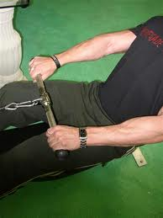
- Pronated
- Supinated
- Mixed group

Objective 2.2
After reviewing pictures explaining the correct grip used when power cleaning, the learner will demonstrate while holding a straight bar, the required grip, with 100% accuracy.
(Procedure-Application) (Task Analysis 3.B)
Initial Presentation
(Model correct grip)
Instruction will show proper power cleaning grip through step by step imaging, accompanied by physical descriptions underneath image. Instruction will allocate learner to participate in this process of gripping the bar, asking learner to replicate the steps seen within the pictures.
Generative Strategy
(Practice)
Using the equipment, straight bar, learner will practice gripping the bar or making a fist, replicating the grip displayed within the instruction.
(Elaboration)
Learner will envision themself, before touching the bar, gripping the straight bar correctly. After performing desired task, the instruction will offer feedback after describing the last image.
Test Item 2.2
(Objective- Checklist 1 )
Did you remember to… | YES | NO
Start with a pronated grip?
Were hands spread-out past shoulder’s width?
Were thumbs clenched by pointer and middle fingers?

Goal 3: Know the proper mechanics to power cleaning, to prevent injuries.
Objective 3.1
Given an overview, explaining the five primary exercise movements comprising a power clean, the learner will list the exercises in sequential order for a power clean, with 100% accuracy.
(Concept-Recall) (Task Analysis 2.A, 2.B, 2.C, 2.D, 2.E)
Initial Presentation
(Explain exercises involved in power clean)
Instruction will list, define, and describe each exercise involved within a power clean, in sequential order. Providing illustrations, portraying each exercise before and after, will be presented. After explaining each exercise, a list stating each exercise involved within a power clean will be reshown in sequential order.
Generative Strategy
(Review)
Learner will review concepts, distinguishing between several exercises, arranging the exercises logically within movement (power clean). Feedback will be given to learner at the bottom of the page.
Test Item 3.1
(Objective- Short Answer- Item 9)
Name and list, in order, the exercises involved in the progressive movements of a power clean.
- Deadlift
- Jump
- Shoulder shrug
- Upright row
- Front squat

Objective 3.2
After reviewing the progression movements within a power clean, the learner will recognize the steps occurring within the clean, with 100% accuracy.
(Procedure-Recall) (Task Analysis 3.A-C, 4.A-H)
Initial Presentation
(Steps involved within power clean)
The instruction will give an overview, in a step by step breakdown of a power clean. Listed in sequential order, figures will be used within illustrations, displaying each progressive movement, each step labeled below the image. The instruction will show the steps once again, in order after the illustration segment.
Generative Strategy
(Review)
Learner will review information, logically applying prior and current material, reshown in sequential order, the steps illustrated within the instruction will be presented to the learner. Learner will identify which steps may be problematic within a checklist.
Test Item 3.2
(Objective- Checklist 2)
Movements | Yes | No
Make sure you are exemplifying the correct posture, placement, and grip.
Before starting lift, make sure you inhale deeply before lifting bar.
Keeps arms locked out while lifting bar, imitating a deadlift.
Once your legs have reached a one o’clock position, you will jump powerfully, shifting weight from heels to toes.
At the peak of the jump, when body is hyper extended, you will powerfully shrug shoulders back.
6Bending arms, you will raise bar, performing an upright row.
While bar is still traveling upward, you will drop below bar, and receive the bar, transitioning into a front squat.
Knees will be bended; weight will be across your shoulders, you will drive through heels till standing erect.

Objective 3.3
Given a series of 5 pictures, identify and arrange the pictures in how a power clean would be performed, with less than two mistakes.
(Procedure-Recall) (Task Analysis 3.A-C, 4.A-H)
Initial Presentation
(Recognize Steps involved within power clean)
Instruction will illustrate the steps and progressive movements within a power clean
Generative Strategy
(Memory)
Learner will analyze images, conceptually recalling the sequential order stated within the review, and further engrained through visual stimuli (progressive illustration). Learner will be given feedback at the bottom of the illustration.
Test Item 3.3
(Objective- Matching- Item 10 in assessment)
Objective 3.4
Given images demonstrating correct form when power cleaning, the learner will identify if the lift was correct, with 100% accuracy.
(Concept-Application) (Task Analysis 3.A-C, 4.C-H)
Initial Presentation
(Give an example and explain why it's an example)
The instruction will show incorrect and correct form when power cleaning through several images. The images, incorrect and correct will be placed next to each other, streaming down the page. An explanation describing what was correct or incorrect will be captioned underneath each image.
Generative Strategy
(Integration)
Learner will view images displaying correct form, understanding certain aspects that made the form correct. Learner will also be given an example of an incorrect power clean, explaining why it is incorrect.
(Organization)
Learner will analyze the images, comparing the two forms (correct and incorrect), remembering aspects (concepts) stated by instruction, enhancing characteristics of the correct form. Feedback will be given to learner on the “next” slide.
Test Item 3.4
(Objective- Short Answer- Item 11)
Pertaining to the image below, did any mistakes occur during the clean?
Goal 4: Appreciate the level of difficulty involved within a power clean.
Objective 4.1
Given a straight bar, the learner will demonstrate the correct form prior to lifting the bar to perform the power clean, with less than 3 mistakes.
(Procedure-Application) (Task Analysis 3.A-C, 4.A)
Initial Presentation
(Model starting placement/posture within power clean)
The instruction will explain the importance of posture and placement, prior to power cleaning. The instruction will then show a picture illustrating the correct posture before power cleaning. The steps taken, in order to get in the correct posture, will be listed alongside of the illustration.
Generative Strategy
(Practice)
Learner will practice correct grip prior to touching straight bar. Learner will receive feedback by comparing their demonstrations to the steps and illustrations in the instruction.
(Elaboration)
Learner will envision themselves performing a correct grip prior to touching bar, mimicking the form on the picture, within the instruction.
Test Item4.1
(Objective- Performance Checklist 3)
Objective 4.2
Reviewing the first exercise used within the power clean movement, the learner will demonstrate a deadlift, with 100% accuracy.
(Procedure-Application) (Task Analysis 2.A, 3.A, 3.B.1, 3.C, 4.A, 4.B)
Initial Presentation
(Model Procedure)
The instruction will explain the importance of deadlifting correctly, as well as what can occur when deadlifting incorrectly. The instruction will list the steps used when deadlifting correctly. Alongside of the steps, an image displaying the middle and after movement of the exercise will be shown.
Generative Strategy
(Practice)
Learner will be given a straight bar, replicating the motion seen within the instruction, used for deadlifting. Learner will receive feedback, correcting any mistakes pertaining to form.
(Elaboration)
Learner will be encouraged to mentally envision performing a deadlift, prior to touching bar. Learner will also be encouraged to remember the form displayed within the instruction. Learner will be given feedback after steps are mentioned.
Test Item 4.2
(Objective- Multiple Choice – Item 12 in assessment)
Objective 4.3
After reviewing the required steps before “receiving” the straight bar, the lifter will jump, enabling hips to thrust forward powerfully, perform a shoulder shrug into an upright row, and end in a front squat, the learner will demonstrate these 4 movements, receiving the bar with less than two mistakes.
(Procedure-Application) (Task Analysis 2.B-E, 3.A-C, 4.D-G)
Initial Presentation
(Model Procedure)
The instruction will give an overview, explaining the steps occurring after the deadlift. The instruction will entail the powerful hip thrust occurring from the jump, followed by a shoulder shrug into an upright row, receiving the bar, ending in a front squat. Explaining the steps, in sequential order, the instruction will provide several images, each image showing a step.
Generative Strategy
(Practice)
Learner will review concepts. Learner will practice with the bar, repetitively performing the instructed movement, enabling the lift to be fluid. Learner will receive feedback at the end of checklist.

(Elaboration)
Learner will envision the movement, mentally imagining their self- completing the lift. Learner will also envision the instructions images when performing the lift, aiding as a guidance tool.
Test Item 4.3
(Objective- Performance Checklist 4)
Are you….. | Yes | No
Starting with legs slightly bent?
Driving your hips forward as if jumping?
Shrugging shoulders back forcefully?
Keeping the bar close to body while upright rowing?
Receiving bar correctly?

Objective 4.4
After reviewing how to perform a power clean, the learner will demonstrate a power clean with a straight bar, with less than 3 mistakes.
(Principle-Application) (Task Analysis 2.A-E, 3.A-C, 4.A-H)
Initial Presentation
(Model Procedure)
The instruction will give an illustration, displaying all of the movements occurring within a power clean. Pertaining to each movement occurring, in the image, the instruction will state the significance of each step. The instruction will reshow the illustration displaying the movements involved within the power clean.
Generative Strategy
(Practice)
Learner will practice power cleaning with a straight bar, remembering concepts, and illustration viewed within the instruction. Feedback will be given to learner at the end of the checkpoint.
(Elaboration)
Learner will mentally imagine power cleaning the bar correctly. Envisioning the movements within the clean, in a step by step “breakdown.”
Test Item 4.4
(Objective- Performance Checklist 5)

Preinstructional Strategy
The preinstructional strategy selected was an overview. An objective strategy would be exempted because it could cause difficulty for the learner, not enabling the learner to remember objectives and content (Morrison, 177). A pretest strategy may have issues with learner familiarity on the subject of power cleaning; which in return could render the learner from answering pretest questions (Morrison, 178). The overview will describe how learning to power clean will aid in the enhancement of a learner’s physical fitness (Morrison, 179). Introducing the subject of power cleaning, an overview will prepare the learner for the task to come. Not to mention, majority of the objectives developed for performing a power clean are concepts and facts, matching the task attributes of the overview strategy.
Assessment Strategy
Assessing the learner’s comprehension towards the instruction, a paper-pen based test will be administered. Upon completion of test, the learner will be able to self-check or evaluate themselves, observing the answers at the end of the packet. If the ideal number of questions were answered incorrectly, the learner is encouraged to retry the test, after recapping over the material.
Sequencing Strategy
The sequencing strategies selected were depicted from Posner and Strike’s learning related sequencing, infiltrating a prerequisite structure, a logical concept-related sequencing strategy, as well as world related sequencing, encompassing temporal order. Requiring a basic knowledge of skills prior to performing a task, the learning related sequencing, prerequisite structure was used to teach the progressive movements of a power cling (Morrison, 137). For instance, before attempting to “receive” the bar, the learner will be taught how to deadlift properly. The logical concept-related sequencing was chosen to facilitate the concept/knowledge portion of the instruction pertaining to materials worn/used (Morrison, 140). The world related sequencing utilizing temporal order, was selected because there was a procedure reflecting the sequencing of content, outlined within the instruction (Morrison, 139). In essence, task expertise sequencing was used, increasing psychomotor difficulty from easy to hard, beginning with objectives 2.2, 4.1, 4.2, and 4.3, ending in 4.4. Given the two strategies, the objectives comprised will be taught in the order presented within this documentation: 1.1/1.2/1.3/2.1/2.2/3.1/3.2/3.3/3.4/4.1/4.2/4.3/4.4.
Formative Evaluation
SME Review: Compiling the information presented within the documentation, the SME had reviewed the material throughout several stages, within multiple Microsoft Office documents. The SME had reviewed the learner analysis prior to the task analysis, each being delivered to the SME at different encounters. Allocating whether or not tasks were defined correctly and thorough in detail, if cues were used correctly, and if deficiencies occurred, the SME indicated when revisions needed to be made. Creating the instruction, the SME was provided with each of the four goals, reviewing each goal upon completion, the SME did confer whether changes were needed or if the information presented for each goal was correct. And last, the SME was presented the assessment, and offered feedback concerning whether the objectives were attainable through the test items asked.
Pilot Test: Nearing the end of the development, a paper-based instruction packet was given to a small group of individuals with some kind of athletic background. Members within the group had met at a local gym, gathering in the weight room. The group was asked to find a seat against a wall. Once seated, instructions were given to small group, and all individuals were asked to complete the instruction packet. Keeping record of the time range amongst member’s completion of the instruction, as well as the assessment (test), the members were then given a survey. All members were given the survey (assessing specifics of the instruction, targeting areas of improvement, acknowledging strengths and weaknesses). Concluding the meeting, the small group was debriefed and thanked.
Survey questions for small group
        - Do you think that the instruction covered the materials you might need?
If no, what else could be added or changed to improve this section?
        - Given the instruction, were you able to perform the correct grip?
        - Given the instruction, were you able to display the proper posture prior to lift?
If no, what else could be added or changed to improve this section?
        - Do you think that the instruction thoroughly explained the exercises used in power cleaning?
        - Do you feel that from this instruction you could determine the flaws in an incorrect power clean??
        - Were you able to perform a power clean correctly?
        - Do you have any suggestions for improving this instruction?

