Performing A Power Clean

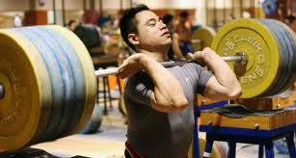

Instruction

Micah Day
IT 510

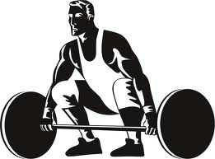

Overview
Welcome aspiring lifters! The instruction presented before you will teach and enable you to perform, coach, and improve your power clean. What is so important about this particular lift though? Why should I consider implementing this into my workout routine? Well, this dynamically explosive full body movement is not only an excellent exercise used for building strength, seed, and endurance, but this exercise is a high calorie burner. Incorporating every major and several minor muscle groups, the power clean is known for enhancing physical abilities, as well as appearance. Nontraditional to most lifters, the majority of lifters tend to feverishly rely on isolating specific muscle group for improving their physiques; however, have you ever questioned what could transpire from utilizing multiple muscle groups at once instead of one? The answer is quick and impressive results. Now, let’s begin achieving your goal.

What Is A Power Clean?
The power clean can be best thought of as an exercise consisting of a jump with a bar in hand, followed immediately by an upright row, finished by racking the weight on one’s shoulders. Teaching explosion, this quickly performed exercise cannot be completed slowly. Emphasizing on its finish, where the maximum hip, knee, and ankle extension occur, a power clean rapidly exerts force. Knowing what a power clean is now, what materials are needed or entailed with this exercise?
Part One: Getting Materials
The first thing you need to do is get the appropriate materials needed to help you maximize your performance for power cleaning. Like most weight lifting exercises, certain materials are used. Attained for two primary reasons, most materials are purchased for an individual’s level of comfort, or safety. The majority of the materials needed for power cleaning can be purchased at any sports store or athletic department. So what should you consider purchasing?
Gym Shoes
Varying from person to person, the style and type of shoe will differ. The type of shoe selected will be dependent on your current physical state.
- For individuals with weak ankles, low tops are ill-advised.
- For individuals with knee issues, shoes with a thicker sole are recommended for relieving additional tension.
- For individuals with strong ankles and knees, shoes with little to no sole will be fine, as well as not wearing shoes.
Shorts
Athletic shorts are strongly advised. This will allow the lifter to fully utilize their legs.
- Eliminates unnecessary friction.
- Does not limit one’s range of motion.
- Denim and cargo shorts are not ideal, not only with power cleaning, but working out in general.
Sweats
Sweats or any other kind of long legging material allocating flexibility, is acceptable.
- Yoga pants, sweat/wind suits, or elastic pants
- Keeps leg muscles warm and loose
- Sweats are a primary choice when lifting in cool environments/facilities.

Shirts
Various in styles, comfort, and material, selecting the proper shirt is important. Generally, it is suggested that an individual wears a shirt that allows convection to occur. Or in other words, a shirt that is breathable.
- This can be found in most shirts not comprised of cotton.
- Different styles of shirts can range from tank-tops, under armor, basic shirts, and long sleeve shirts.
Socks
Socks are one of the most essential clothing items, varying in styles and texture. Giving the lifter comfort and preventing the lifter from excessive rubbing, socks aid in cushioning the lifters feet.
Weight Lifting Gloves
Gloves are commonly used within gyms. Protecting one’s hands from grasping rough materials or metals, gloves offer the lifter a certain level of comfort.
Wrist Wraps
Wraps are used within weight rooms, not as commonly as gloves.
- For individuals with weak or non-flexible wrists, wrist wraps are ideal for power lifting.
- This item is a great for supporting one’s wrist.
Weight Belt
Differing from your standard belt, but similar in concept, a weight belt keeps your back aligned, just as a belt keeps your pants above your hips. A weight belt serves many purposes, however its main contribution is reducing back injuries such as strains, tears, and pulls.
Knee Sleeve or Brace
Knee issues are quite common for individuals, whether the issue is contingent on being active in sports for several years, lacking flexibility in knees, or attaining some type of trauma or injury.
- Sleeves, as well as brace, keeps knee supported.
- Relieves excess tension.

MP3 Arm Band
Not necessarily a must, but most definitely a want, an MP3 arm band can help refocus and boost your drive to complete your task at hand. Being able to listen to your music without having to be concerned about damaging your music device, can be an important concern. An MP3 arm band can rectify this problem. The arm band is comfortable and easy to adjust, allowing you to finish your workout while listening to music.
Recap Over Materials
So, before you begin thinking about practicing the power clean, decide on which materials will best suit you, and invest in those items. Now, will you be acquiring new gym shoes, shorts, sweats, shirts, socks, weight lifting gloves, wrist wraps, weight belt, knee sleeve or brace, MP3 arm band, or a mixture of materials presented on this list?
Material Checklist #1
Check to see if you have everything you might need for power cleaning.
Materials | I Have This | I Need This
Gym Shoes
Shorts
Sweats
Shirts
Socks
Weight Lifting Gloves
Wrist Wraps
Weight Belt
Knee Sleeve or Brace
MPP3 Arm Band

The Key 5 Materials to Consider
Now that you know what materials are used when power cleaning, you can take a step further in knowing the five key materials that not only provide comfort, but are the greatest preventers for possible injuries.
Gym Shoes
- Earlier stated, the type of shoe selected will be dependent on your physical state. Factors such as weak ankles and knee issues should be strongly considered, however, many people rely on their perception of shoes attractiveness and if it so called “feels right.” There is a lot more that should be considered though.
- Selecting the wrong shoes can result in shin-splints and aching heels.
- Know whether your foot is arched or flat. If flat, be sure to purchase a shoe with motion control feature and maximum support.
- Most experts suggest that if you are going to be using a pair of shoes to lift in, do not make those shoes multi-purposed. Use them solely for working out in.
- Ideally, a good running or cross training shoe would be recommended for power cleaning. These shoes provide cushion, shock absorption, flexibility and control in one’s heals.
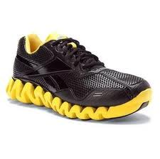 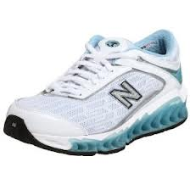 Figure 1 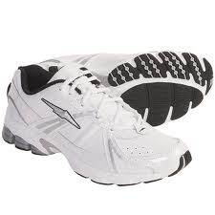

Weight Training Gloves
- Besides protecting one’s hands from rough materials, weight lifting gloves help prevent calluses.
- Improves your ability to grip, and prevents your hands from slipping while exercising.
- Some gloves have elasticated wrist straps. This gives additional support to the lifter’s wrist. Usually used if wrists are weak or the lifter is lifting heavy.
- Also, the majority of weight lifting gloves are padded, reducing pressure on hands.

Figure 2 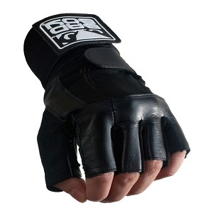

Wrist Wraps
- Stated previously, wrist wraps are ideal for power lifting, or lifting heavy.
- Wrist wraps offer additional support to your wrist, limiting the range of unintended motion.
- Wraps are not advised to be left on hands for too long. Wraps are usually applied tightly, cutting off circulation to the hands.
- Varying in sizes, typically 24” to 36” the smaller of the two is recommended. The larger of the two wraps are typically used when the lifter is dealing with outrageously heavy weight.
Figure 3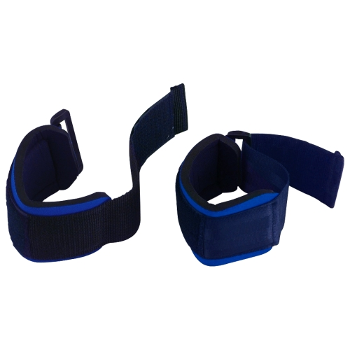
Weight Belt
- Previously mentioned, weight belts aid in keeping your back aligned.
- Back injuries are fairly common within lifting. This typically originates from lifting incorrectly. However, maintaining pressure within your abdomen and lower back, weight belts help in the prevention of lower back injuries.
- Weight belts are great to use when lifting heavy. Is not effective in light weight workouts.
- Reduces the probability of spinal shrinkage.
- Self-corrects form by preventing sideways bending and twisting, as well as exaggerated hyper extensions.
- Weight belts should not be worn for long periods of time. Research has shown that this can increase blood pressure. Therefore, after lift is completed, or sets are completed in a reasonable amount of time, the belt should be removed.

Figure 4 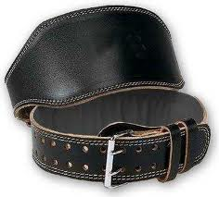

Knee Sleeve or Brace
- Main purpose is to keep knee supported through alignment and compression.
- Does not restrict knee by much, sleeves offer flexibility.
- Sleeves and braces vary in styles; however, each style offers comfort during flexion.
- Knee sleeves and braces relieve the lifter of irritation and pressure on knees.

Figure 5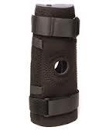 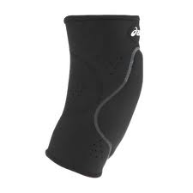
Material Checklist #
After reading the importance of the five key materials used when power cleaning, check whether or not you possess these materials.

___ ___

___ ___
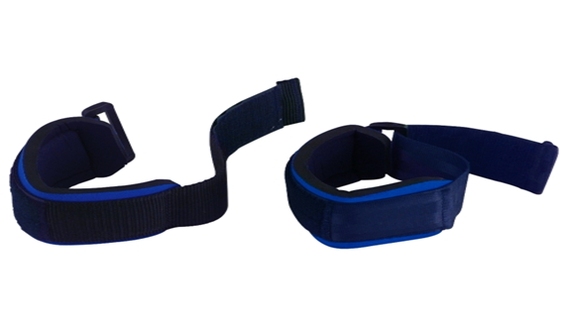
___

Condition of Materials
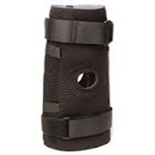
Now that you know the five key materials used when power cleaning, reassess any materials you own, and determine the condition of those materials. If some of your materials are weathered and damaged due to excessive usage, then it may be time for you to upgrade.
Good Condition
Shown within the picture to your right, is an image of a material (knee brace) in good condition. Despite being able to visibly concur that the item is good, there are other attributes that contribute to the concept of “good” condition. However, focusing on physical appearance, rather than haptics, we will discuss what visibly makes an item good.
- Visibly, a good item is lacking rips or tears
- Visibly, a good item is well cushioned/padded.
- Visibly, a good item’s supports or straps are intact.
Figure 6
Poor Condition
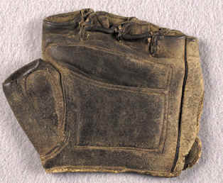
Differing from the image above, the image on the left is displaying a material (weight lifting glove) in “poor” condition. Materials in this state should be discarded. Sure, the materials may feel comfortable, and you may not want to repurchase a similar item to the one which you previously own; however, worn materials can decrease performance.
- Visibly, poor items have grooves or worn markings.
- Visibly, poor items have rips and tears, exposing once sealed areas.
- Visibly, poor item’s supports or straps are no longer hinged.
Figure 7

Do any of your materials favor the knee sleeve? Compare your items to figure 6.

Part Two: Begin- Gripping Bar
Now that we know what materials to use and the condition they should be in, let’s go on to the next step. Before you can start lifting a straight bar, attempting to power clean, you must start with the very basics of this exercise. Beginning with knowing the proper grip, the correct grip will prevent the likelihood of the bar slipping out of your hands. Varying from exercise to exercise, different grips are applied, each allowing the lifter to have the optimal level of control needed to execute that exercise. So what grip do you use to increase your level of control when power cleaning?
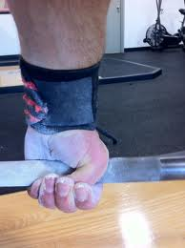
Correct Grip
When performing a power clean, a pronated hook grip is used. Placing your hands slightly wider than shoulder’s width apart, you will place your hands upon the bar. Consisting of two grips in one, you will first apply a pronated grip. A pronated grip is a grip in which the palms of both hands are facing towards the lifters body. You will then apply a hook grip. The hook grip adds an additional step to an ordinary pronated grip, the hook grip infers for you to clench your thumb with your pointer and middle finger, around the bar. The hook grip reinforces your grip, reducing the likelihood of the bar slipping out of your hand when lifting.
Figure 8
Incorrect Grip
Used within other exercises, you may be familiar with your basic pronated grip (used for doing upright rows and reverse curls), supinated grip (used for bicep curls), and mixed grip (used for deadlifting). Neither of these grips are satisfactory when power cleaning.
- Closest in acceptance is your basic pronated grip; however, within a power clean, the bar is whopped fiercely, allowing the bar to travel to the receiving position. Using a basic pronated grip invites room for error, resulting in the bar slipping out of hands.
- A supinated grip is the opposite of a pronated grip. In a supinated grip, the palms of your hands are facing forwards, away from the body. This grip virtually makes it impossible to perform a power clean.
- A mixed grip is comprised of both supinated and pronated grips (toward and away). Similar to a supinated grip, a mixed grip is virtually impossible to use when cleaning.
Are you gripping the bar correctly? Compare your grip to figure 8.

Taking a Closer Look
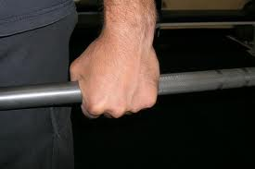

Figure 9
Within the image, the lifter is demonstrating a pronated grip. The lifter’s palms are facing towards their body. Both hands display the same grip. The grip is not mixed. If possible, place both of your hands in front of you, palms down, facing towards your body, and make a fist.

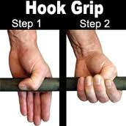

Figure 10
Within this picture, a hook grip is illustrated. As shown with the image, the thumb is placed on the opposite half of the bar, as your palm. Your pointer and middle finger wrap over the thumb, sealing your hand to the bar. Now, instead of making your hand into a fist, cover your thumbs with your pointer and middle finger, demonstrating the hook grip.

Performance Checklist #1
Reviewing the steps taken to grip a straight bar correctly, prior to power cleaning, can you follow the required steps mentioned within this section?

Did you remember to… |  | Yes |  | No
Start with a pronated grip?

Were hands spaced out past shoulder’s width?

Were thumbs clenched by pointer and middle finger?

If you are able to perform this grip properly, then you are ready to proceed into the next part. If you were unable to perform the grip correctly, then review part two again.

Part Three: Working On Mechanics
Being able to grip the bar correctly, you are now ready to learn what all is involved within a power clean. Throughout the fluid motion of a power clean, several exercises are being conducted, whether conscious or not. When performing a power clean, you will perform five basic exercises, a deadlift, jump, shoulder shrug, an upright row, and a front squat.

Deadlift
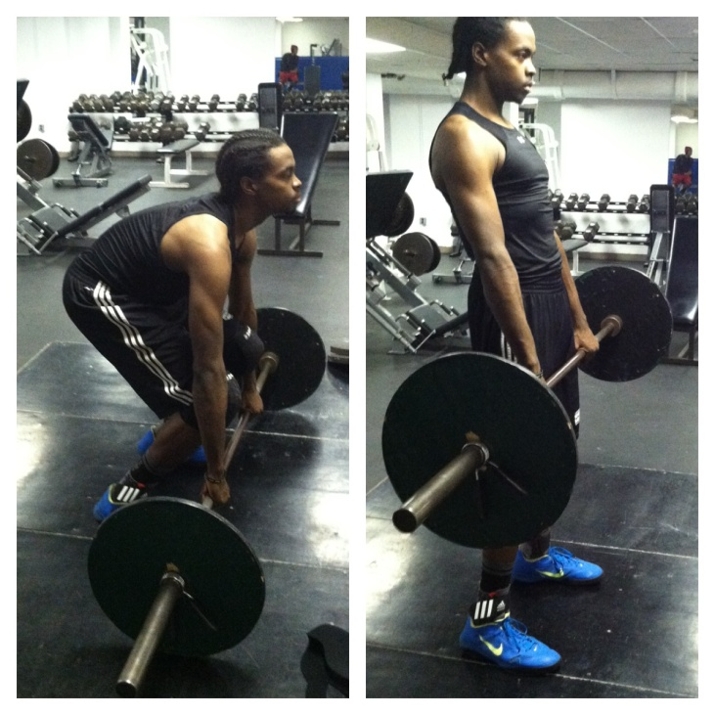
The deadlift is a power lifting exercise, simple in nature. Similar in placement and posture, replicating the positioning of a power clean, a deadlift begins the power clean. Traveling from point A to B, you will place your shins close to bar about shoulder’s width apart, placing your hands slightly further than shoulder’s width apart. Grabbing the bar, you may use either a pronated or mixed grip. When power cleaning though, your grip will be a pronated hook grip. Once your feet and hands are placed, you will correct your posture by bending your knees, allowing your butt to drop to about 110 degrees or 2 o’clock. Then, you will make sure that your arms are directly over the bar, and locked out (straight, no bend in arm). Next, you will straighten your back by sticking out your chest, and tensing your abdomen, while lifting up your head to look straight forward. After exemplifying the correct form, you can then stand straight up with the weight, keeping your back straight throughout the lift until your back is slightly hyper extended. Figure 11

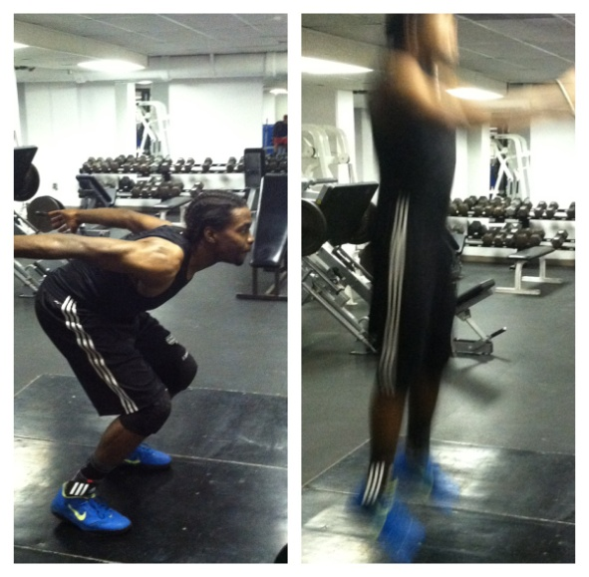
Jump
Succeeding the deadlift, a jump is incorporated. When jumping, with the bar in your hand, you will approach the jump like a standard jump. You will gather yourself once your legs are at one-o’clock. Fiercely driving through the heels of your feet, powerfully popping/thrusting your hips forward, you will then shift your weight from heels to toes, you will become slightly hyper extended and become vertical. Not appearing too difficult, your jump can ultimately determine whether or not you will successfully complete a power clean. Throughout this process, your arms should remain locked out. Figure 12

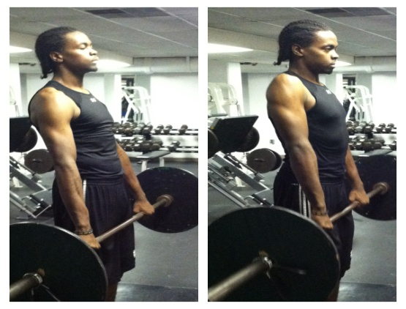
Shoulder Shrug
The rotation of your shoulders in an upward and back motion, through the use of a pronated grip, is known as a shoulder shrug. Within a power clean, this exercise is conducted almost simultaneously with the jump. Before you become vertical, or when your weight has shifted and you are on your toes, you will then powerfully shrug your shoulders. Figure 13

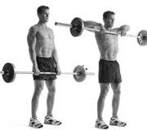
Upright Row
Varying in preferred placement, an upright row can be performed with a grip wider than shoulder’s width apart, or a close grip, being within shoulder’s width. Starting with your arms in a locked out position, you will bend your arms and point your elbows outward. You will raise the bar to your collar bone or throat, keeping the bar close to your body throughout the pull. This portion of the power clean occurs after the shoulder shrug. Figure 14
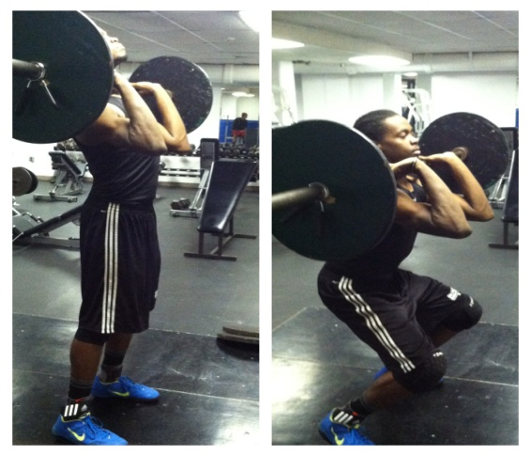
Front Squat
Awkward for most beginners, a front squat is another variation of a squat, where the weight rests across your shoulders in front of your collar bone. Differing from your basic back squat, when performing a front squat, you will receive the bar on your shoulders, crease at hips, and squat. Squatting until your body has surpassed 90 degrees or 3 o’clock, you will then drive up through heels until you are standing erect. The front squat is the concluding exercise in a power clean.
Figure 15

Recapping Over Exercises
So, before you attempt a power clean, you might want to perform these five exercises, making sure that you are able to perform each exercise. Remember, the power clean consists of a deadlift, jump, shoulder shrug, an upright row, and a front squat.

Knowledge Checkpoint #1
Can you arrange the following exercises in rank order?

___________________ A. Upright Row
___________________ B. Deadlift
___________________ C. Front Squat
___________________ D. Jump
___________________ E. Shoulder Shrug

Referencing to the titled exercises within this segment, or recapping over exercises, you can compare your answers with how the exercises were listed in either of the suggested.

Steps within a Power Clean
Now aware of the exercises occurring within a power clean, you can see how the exercises transition. When performing a power clean, eight steps should be applied. Not all steps consist of movement, some steps are more cue focused. So, let’s look at these progressive movements.
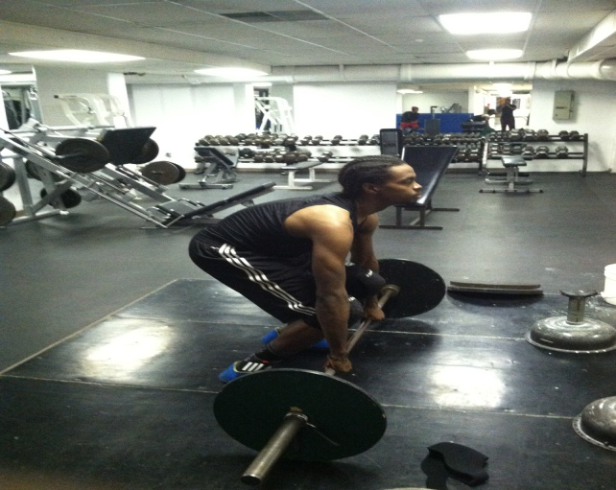

Figure 16
- Make sure you are exemplifying the correct posture, placement, and grip.
- Before starting lift, make sure you inhale deeply before lifting bar.
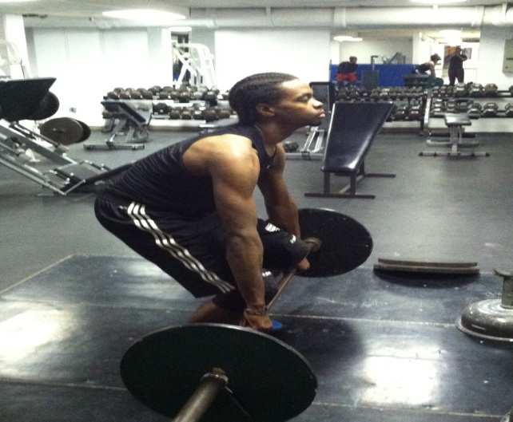

Figure 17
- Keeps arms locked out while lifting bar, imitating a deadlift.

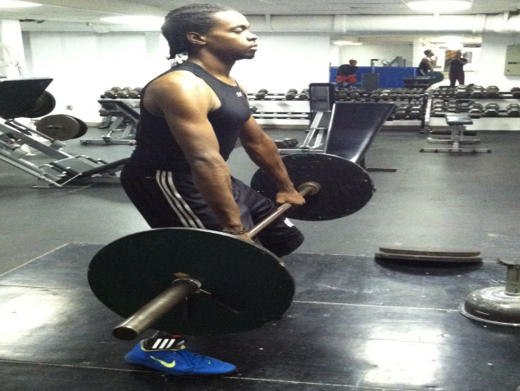

Figure 18
- Once your legs have reached a one o’clock position, you will jump powerfully, shifting weight from heels to toes.

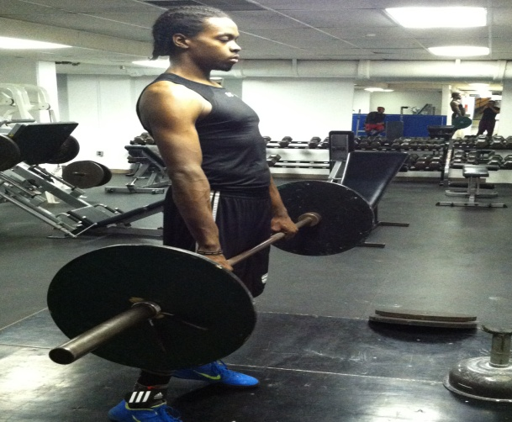

Figure 19
- At the peak of the jump, when body is hyper extended, you will powerfully shrug shoulders back.

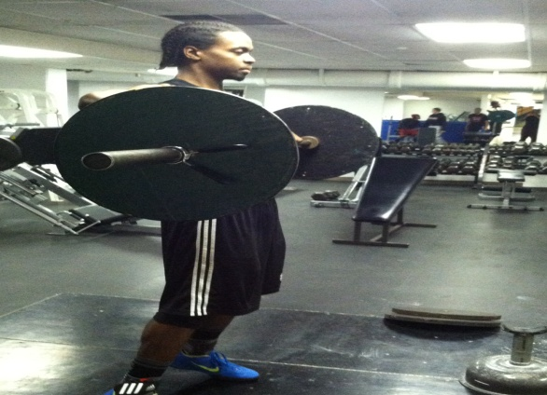

Figure 20

- Bending arms, you will raise bar, performing an upright row.

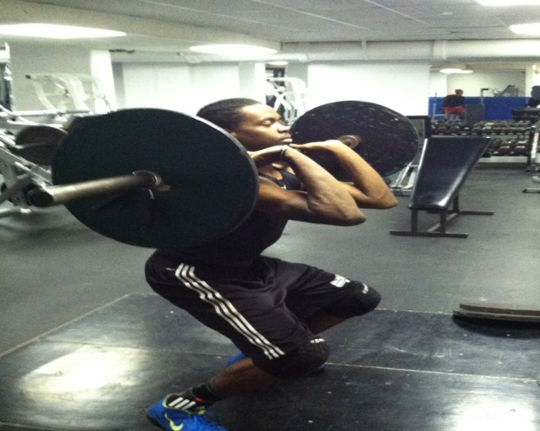

Figure 21
- While bar is still traveling upward, you will drop below bar, and receive the bar, transitioning into a front squat.
- Knees will be bended; weight will be across your shoulders, you will drive through heels till standing erect.

Recapping Over Steps
Looking at the progressive movements within a power clean, you must:
- Make sure you are exemplifying the correct posture, placement, and grip.
- Before starting lift, make sure you inhale deeply before lifting bar.
- Keeps arms locked out while lifting bar, imitating a deadlift.
- Once your legs have reached a one o’clock position, you will jump powerfully, shifting weight from heels to toes.
- At the peak of the jump, when body is hyper extended, you will powerfully shrug shoulders back.
- Bending arms, you will raise bar, performing an upright row.
- While bar is still traveling upward, you will drop below bar, and receive the bar, transitioning into a front squat.
- Knees will be bended, weight will be across your shoulders, and you will drive through heels till standing erect.

Performance Checklist #2
Given the progressive movements occurring within a power clean, which of the following do you suppose will give you complications?

Movements |  |  | Yes | No
Make sure you are exemplifying the correct posture, placement, and grip.
Before starting lift, make sure you inhale deeply before lifting bar.
Keeps arms locked out while lifting bar, imitating a deadlift.
Once your legs have reached a one o’clock position, you will jump powerfully, shifting weight from heels to toes.
At the peak of the jump, when body is hyper extended, you will powerfully shrug shoulders back.
6Bending arms, you will raise bar, performing an upright row.
While bar is still traveling upward, you will drop below bar, and receive the bar, transitioning into a front squat.
Knees will be bended; weight will be across your shoulders, you will drive through heels till standing erect...

Are you envisioning yourself power cleaning? Does it look like this figure?

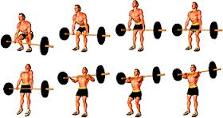

Do’s and Don’ts
Now that you are aware of the movements occurring within the power clean, you can now acknowledge what to do and not to do when cleaning. Pay close attention to the images presented below. The slightest variation of placement or pulling to early can result in a less effective lift, unnecessary dispersal of energy, and possible injuries.

Incorrect Correct
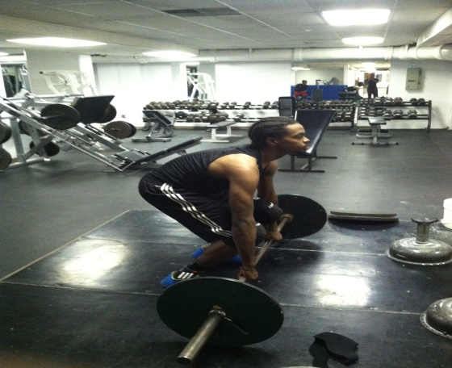
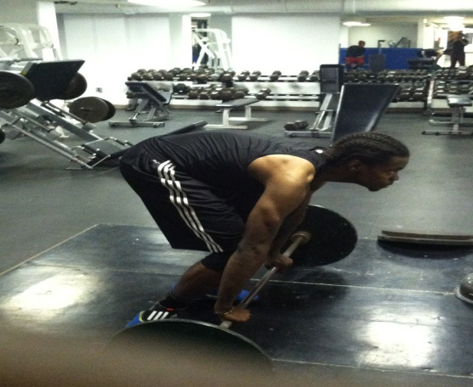

Figure 23 Figure 24
Lifter’s arms are not aligned directly over bar. Lifter’s arms are aligned over bar. Lifter is
displaying correct posture and placement.

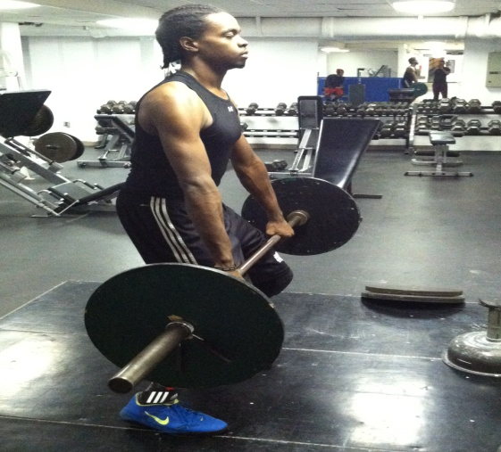
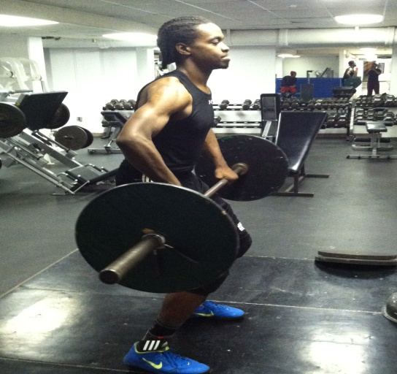
Incorrect Correct

Figure 25 Figure 26
Lifter’s arms are already beginning to bend. Arms are still locked out. Bar is close to
Placing access strain on shoulders. body. Lifter is ready to begin jump.

Incorrect Correct
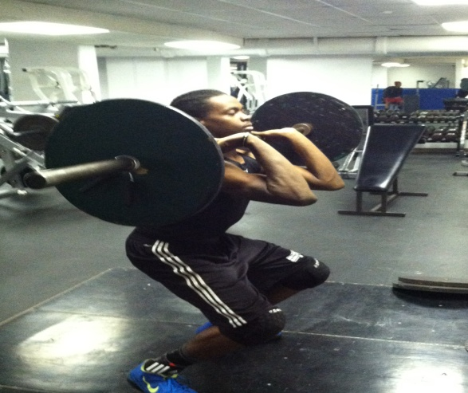
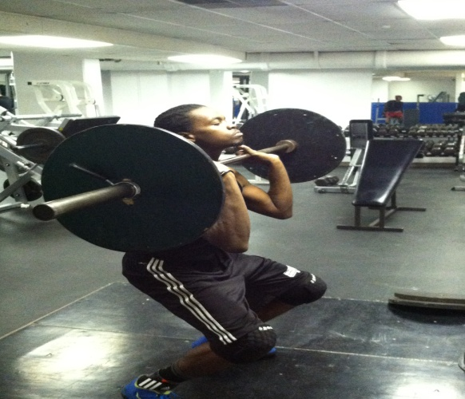

Figure 27 Figure 28
Bar was not received properly. Elbows Bar is received correctly. Elbows are
are not parallel from floor. Again placing parallel from floor. Bar is resting across
additional strain on shoulders. Weight is shoulders. Wrist is bent back.
Not resting across shoulders.

Knowledge Checklist #2
Being able to pinpoint flaws within another’s power clean can be beneficial not only for the person needing correction, but for you as well. Recognizing other’s mistakes helps you critique/analyze yourself more thoroughly. Given the image below, can you determine what mistake(s) occurred?
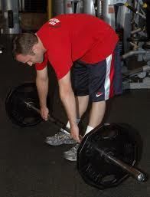

________________________________________________________________________________________________________________________________________________________________________________________________________________________________________________________________________________________________________________________________________________

Once you have answered the checklist, look at the first correct figure. Compare and contrast the two figures (checklist and first correct image) and note whether or not your answer pointed out all of the obvious flaws. If so, continue onto the next part; but if not, review section again.
Part Four: Performing the Power Clean
Now that you are knowledgeable of the grip, exercises, steps occurring within a power clean, and being able to identify between incorrect and correct form, you can now work on performing a power clean. Placement and posture are two main factors responsible for lifting injuries. Not being cautious of the proximity of the bar, being hunched over, bending your arms and jerking the weight off of the ground, all lead to possible injuries predominately in the lower back and shoulders. If you want to focus all of your energy into a power clean, then it will help not having to deplete unnecessary energy due to improper form. Improper form will undoubtedly enhance your likelihood of straining or pulling a muscle. So, before initiating in a bad habit, let’s exonerate that ideal by exemplifying the preferred habit.
Placement Figure 29
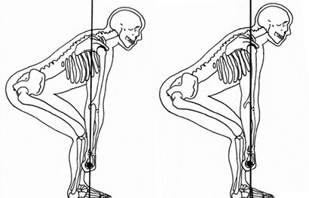
When approaching the bar, you will:
- Center yourself with bar.
- Place your shins about an inch away from bar.
- You will place feet shoulders width apart.
- Make sure your toes are pointed forward.
- You will then place your hands on bar.
- Hands placed slightly more than shoulders width apart.
- You will grip bar with a pronated hook grip.
Incorrect Correct
Posture
Once you are placed, you will:
- Bend your legs, imitating a squat (2 o’clock)
- Make sure arms are locked out.
- Align arms directly over bar.
- Lift head so that you are facing straight ahead.
- Straighten back by poking out chest.
- Tighten abdomen.

Performance Checklist #3
Before even toughing a straight bar, you should demonstrate the placement and posture outlined within the section. In addition to you attempting the correct form, mark whether or not you are following the suggested steps.

Did you remember to…. | Yes | No
Position feet correctly?
Position shins close to bar?
Grip the bar correctly?
Lock out arms?
Is back straight?
Look forward before lifting bar?
Exhale while lifting the bar?
Keep back straight throughout movement?
Rest in hyper extended position?

If you performed the proper placement and posture correctly, mimicking the figures above, and following the steps in the checklist, then you are ready to move to the next section. If not, then review this section again.
Deadlift
After displaying the correct placement and posture, you are now able to perform the deadlift. Described on page 10 of the instruction, a deadlift is a lower back exercise which commences the power clean. Besides this lower back exercise being a movement within a power clean, the deadlift is an excellent exercise in building one’s lower back. Deadlifting can help reconstruct an individual lower back, correcting one’s flexibility and posture. However, if performed incorrectly, a deadlift can cause excruciating pain within your lower back, disabling you to bend over for a period of time until recovered. Straining your lower back will retrogress your physical abilities, as well as elasticity. So take your time with this and build with this exercise, and never sacrifice weight for form.
Figure 30
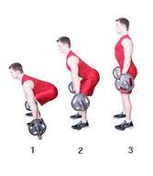
Correct Form
When performing the deadlift, you will:
- Use correct placement and posture.
- Inhale deeply before lifting.
- Exhale when exerting force/lifting
- Drive weight through heels.
- Keep back straight, NOT hunching over.
- Keep legs slightly bent.
- Within power clean, deadlift phase ends once legs are at 1 o’clock and bar is above knees.

Are you performing the deadlift correctly? Compare how you look to figure 30, and follow steps outlined.
Getting Tricky
Now that you are capable of performing a deadlift correctly, you can move into the most difficult segment of the power clean. Perceived as the heart of the clean, you will work on “receiving” the bar. Before you can “receive” the bar though, several steps will occur after you begin the deadlift. Mentioned previously in part three, you will be transitioning from your deadlift into a powerful jump with the forceful thrusting of your hips, into a forceful shoulder shrug, leading to an upright row, resulting in you finishing with a front squat. Now that we know what all is involved, let’s begin breaking down these steps.
Figure 31
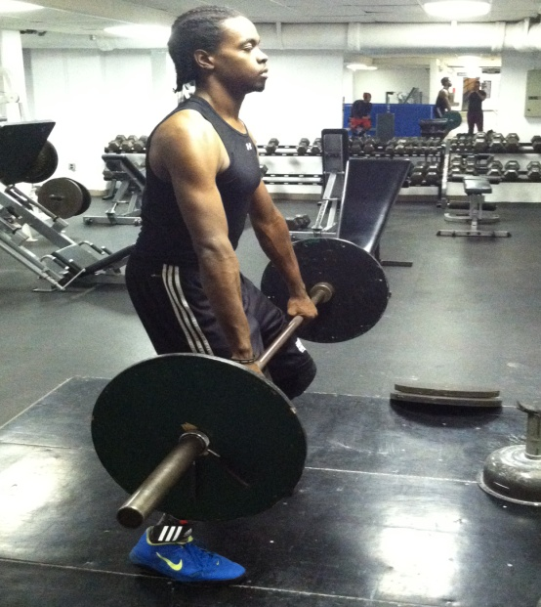
Jump
Before fully completing the deadlift, you will:
- Gather yourself for the jump
- Make sure bar is above knees but not mid-thigh (1 o’clock)
- Arms will remain locked out
- Drive weight powerfully through heels
- Thrust hips forward
- Make sure weight shifts from heel to toe
- Slightly hyper extend body at the peak of toes
- Make sure bar is close to body
Figure 32
Shoulder Shrug
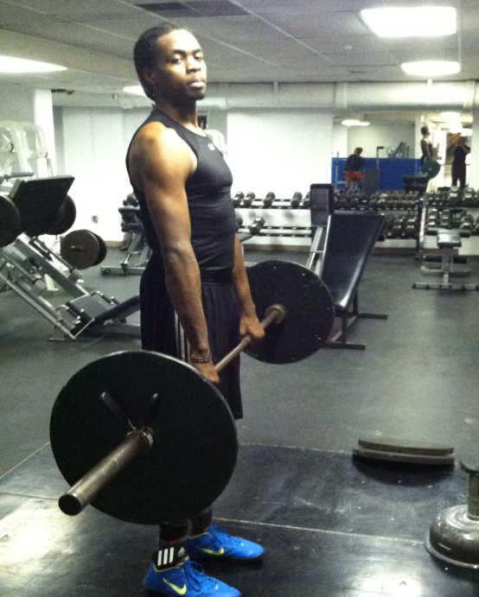
At the peak of toes, almost simultaneously, you will:
- Powerfully shrug shoulder back
- Begin to bend arms.
- Make sure bar is close to body

Upright Row Figure 33
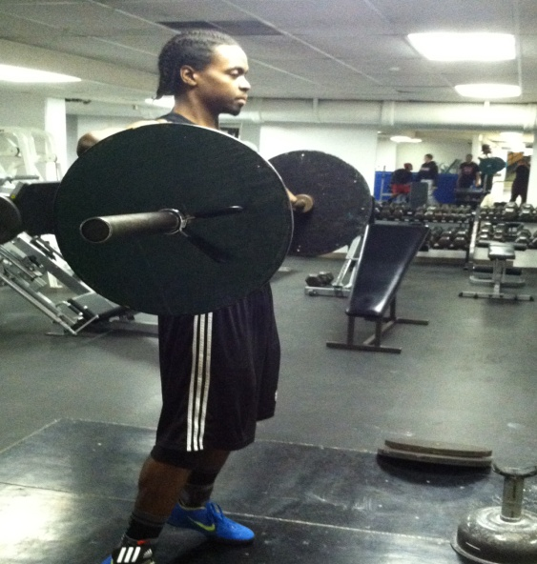
Once your arms have started to bend, you will:
- Continue to bend arms, pulling the bar upward
- Let the bar travel until about chest level
- Make sure bar is close to body

Receive Bar Figure 34
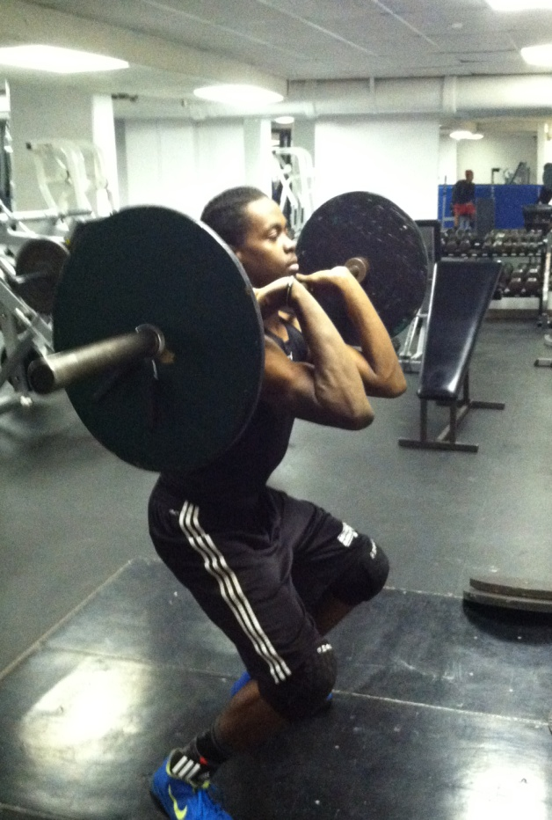
After allowing the bar to travel about chest level, you will:
- Begin to bend knees
- Drop underneath the bar
- Point elbows upward, parallel from floor
- Rotate your wrist, allowing wrist bend back
- Release your grip, letting bar roll onto fingertips
- Allow bar to rest across shoulders in front of chest
Front Squat
After receiving the bar, you will:
- Be in a front squat position
- Make sure you are balanced
- Drive up through heels
- Stand erect once completed.

Performance Checklist #4
Attempt the following steps within this section. Take your time and follow the steps outlined within the review. Provided below is a checklist asking if you remembered to do certain things within this segment. Refer to this checklist after performing these steps multiple times.

Are you….. | Yes | No
Starting with legs slightly bent?
Driving your hips forward as if jumping?
Shrugging shoulders back forcefully?
Keeping the bar close to body while upright rowing?
Receiving bar correctly?

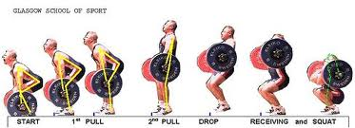
If you are having difficulties within two of the five items in the checklist, then take your time and get acquainted with the correct form. If not, then continue onto the last step.
Putting It All Together
Now that you have completed the most difficult phase of the instruction, you can now put everything together. Beginning with the deadlift, ending with you standing erect with the bar across your shoulders, you should attempt practicing a power clean once you understand the significance of each step.

Movement 1
This image marks the beginning of the lift, prior to lifting the bar. This step is critical. If the grip is not correct, the bar has a chance of slipping out of your hands. If your back is not straightened before lift, you risk pulling your lower back. If shoulders are not aligned over bar, you place more stress on lower back and shoulders.

Movement 2
This movement is the least important of all; however, this movement gauges the weight attempting to be lifted. Speed is not needed within this portion of the lift, rather form is key.

Movement 3
This stage is very important. Within this stage, you will begin the tricky part of the lift. However, where you begin the jump is critical. If you begin to low (by the knee), you will jump forward; yet, if you begin your jump higher then mid-thigh, you will deplete the drive necessary to complete the lift with as much ease as possible. Therefore, it is important to begin jump once bar is at mid-thigh.
Movement 4
The fourth movement tends to be complex for most. It is important to remember though, that you want to elongate your body, resulting in you being on your toes. Logically, the higher that you are able to get, the easier it should be for you to drop underneath the bar, as you pull and transition into a front squat. Remember though, you are going to want to almost simultaneously start shoulder shrugging when shifting from heel to toes.

Movement 5
Within this movement, you have begun your upright row and are beginning to drop underneath the bar. It is very important to keep the bar close to your body. For when the bar is out to far, it requires you to torque your shoulder, and possibly even cause you to lean forward to receive the bar.

Movement 6
You receive bar within this movement. Being able to receive the bar correctly can either make or break your lift. If you are unable to rotate elbows, making them parallel with floor, you have a greater chance of not catching the weight, or placing additional strain on shoulders.

Movement 7
The more you progress in weight, the lower you will need to drop in order to receive the bar. Remember, you are pulling the weight throughout movement 5; however, if the weight is heavy, you may not be capable of pulling the bar up as high, requiring you to drop lower.
Performance Checklist #5
Know that you are aware of the importance of each movement, and capable of performing these movements, you should practice power cleaning. After completing several powers cleans correctly, refer to the checklist below, and assess whether or not you displayed these steps.

Are you…… | Yes | No
Using correct posture/placement?
Exhaling before lifting bar?
Locking out arms?
Performing deadlift correctly?
Thrusting hips forward?
Shoulder shrugging after thrusting hips?
Performing an upright row?
Receiving bar correctly?
Dropping into a front squat when receiving bar?
Standing erect to show weight is controlled?

CONGRATULATIONS!!!
You have successfully completed the instruction. You should give yourself a pat on the back for learning this advanced exercise. Now that you are able to perform a power clean correctly, you will need to complete the assessment provided within your packet. This assessment will examine whether or not you have truly grasped the information within this material. And as a useful tool, all checklists within the instruction will be provided towards the end of the assessment. Good luck!

